AWSRaid
AWS CloudTrail Incident Investigation Report
Authentication compromise • S3 data access • IAM persistence
Prepared by | Alaa Zahra
Platform | CyberDefenders
Lab | AWSRaid
Category | Cloud Forensics / Incident Response
Primary tool | Splunk Enterprise
Evidence | AWS CloudTrail events
Report date | 25 September 2026
Assessment | High severity

Purpose
Document the evidence, analytical method, findings, and defensive lessons from the supplied AWS CloudTrail dataset. All conclusions are bounded by the available lab evidence.

1. Executive Summary
The investigation identified a rapid cloud-account compromise followed by S3 reconnaissance, object retrieval, a security-relevant S3 configuration change, and IAM persistence. The strongest authentication anomaly involved the IAM user helpdesk.luke and source IP 185.192.70.84: nine failed AWS console sign-ins occurred in 33 seconds, followed by a successful login four seconds after the last failure.
After authentication, the compromised identity enumerated S3 buckets, retrieved eight objects from seven buckets, disabled four bucket-level S3 Block Public Access safeguards on backup-and-restore98825501, created the IAM user marketing.mark, and added that user to the Admins group five seconds later.
Incident assessment — High
Confirmed unauthorized access to cloud-stored objects, weakening of storage safeguards, and creation of a privileged persistence account. The evidence includes access to backup, contract, customer-data, design, and secret-related objects.

2. Key Findings
Finding | Result
Compromised IAM user | helpdesk.luke
Primary suspicious login IP | 185.192.70.84
First S3 object access | 2023-11-02 09:55:53 UTC (09:55 in lab format)
Bucket containing the DWG file | product-designs-repository31183937
Bucket with modified public-access safeguards | backup-and-restore98825501
Attacker-created IAM user | marketing.mark
Group assigned to the new user | Admins

3. Scope and Objectives
The evidence source was a Splunk index named aws_cloudtrail containing 4,032 AWS CloudTrail events. The objectives were to identify the compromised identity, reconstruct its activity, determine the affected S3 resources, identify persistence actions, and translate the findings into detection and remediation guidance.
- Identify the compromised IAM user and suspicious authentication source.
- Determine the first confirmed access to an S3 object.
- Identify the S3 bucket containing a DWG design file.
- Identify the bucket whose public-access protections were modified.
- Recover the IAM account created for persistence and its assigned group.
- Build a defensible timeline and map the activity to MITRE ATT&CK.

4. Investigation Methodology
The investigation used a broad-to-narrow approach. Each step answered one analytical question and provided the pivot for the next step.
Step | Analytical question | CloudTrail/Splunk evidence
1 | What services dominate the dataset? | Count events by eventSource.
2 | Which authentication pattern is abnormal? | Review signin.amazonaws.com and aggregate failures.
3 | Did a success follow the failures? | Sort ConsoleLogin events chronologically.
4 | What did the identity do after login? | Pivot on username and suspicious source IP.
5 | Was S3 only enumerated or were objects accessed? | Distinguish ListBuckets from GetObject.
6 | Were storage controls changed? | Review PutBucketPublicAccessBlock and related calls.
7 | Was persistence created? | Review CreateUser and AddUserToGroup.

4.1 Evidence interpretation rules
- Identity attribution used userIdentity.userName and userIdentity.arn; IP alone was not treated as identity proof.
- A blank errorCode/errorMessage field, combined with returned response fields, was treated as evidence that the API call succeeded.
- eventName determined the action: discovery calls were not counted as data access.
- requestParameters identified the target bucket, object key, username, or group.
- eventTime values ending in Z were interpreted as UTC.
- Inferences are explicitly labeled where the evidence does not prove intent or infrastructure ownership.

5. Initial CloudTrail Triage
SPL — event volume by AWS service
index="aws_cloudtrail"
| stats count by eventSource
| sort - count

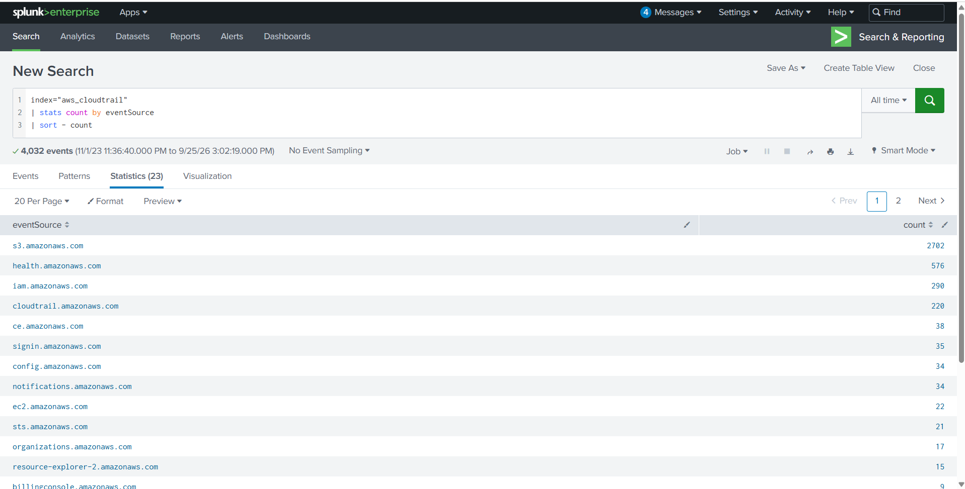
Figure 1. CloudTrail events grouped by AWS event source.
The query produced 23 event sources. S3 generated 2,702 events, followed by AWS Health (576), IAM (290), CloudTrail (220), and AWS Sign-In (35). Event volume is a triage signal, not proof of compromise: S3 was prioritized because it dominated the dataset, while sign-in and IAM were prioritized because they represent identity and persistence activity.

6. Finding 1 — Compromised IAM User

6.1 Why authentication was examined first
Console authentication is a logical starting point because a compromised cloud identity can access many services without exploiting a host. The signin.amazonaws.com event source isolates AWS Management Console authentication activity.
SPL — chronological console logins
index="aws_cloudtrail" eventSource="signin.amazonaws.com"
| table _time eventName userIdentity.arn userIdentity.userName sourceIPAddress userAgent "responseElements.ConsoleLogin" errorMessage
| sort 0 _time

The table command exposes the fields required to answer who authenticated, from where, with which client, and whether the attempt succeeded. The sort 0 _time command preserves the entire result set and orders it from earliest to latest.

6.2 Aggregating failed attempts
SPL — failed logins by identity and source
index="aws_cloudtrail"
eventSource="signin.amazonaws.com"
"responseElements.ConsoleLogin"="Failure"
| stats count AS failed_attempts
min(_time) AS first_seen
max(_time) AS last_seen
values(userAgent) AS user_agents
by userIdentity.userName sourceIPAddress
| convert ctime(first_seen) ctime(last_seen)
| sort - failed_attempts

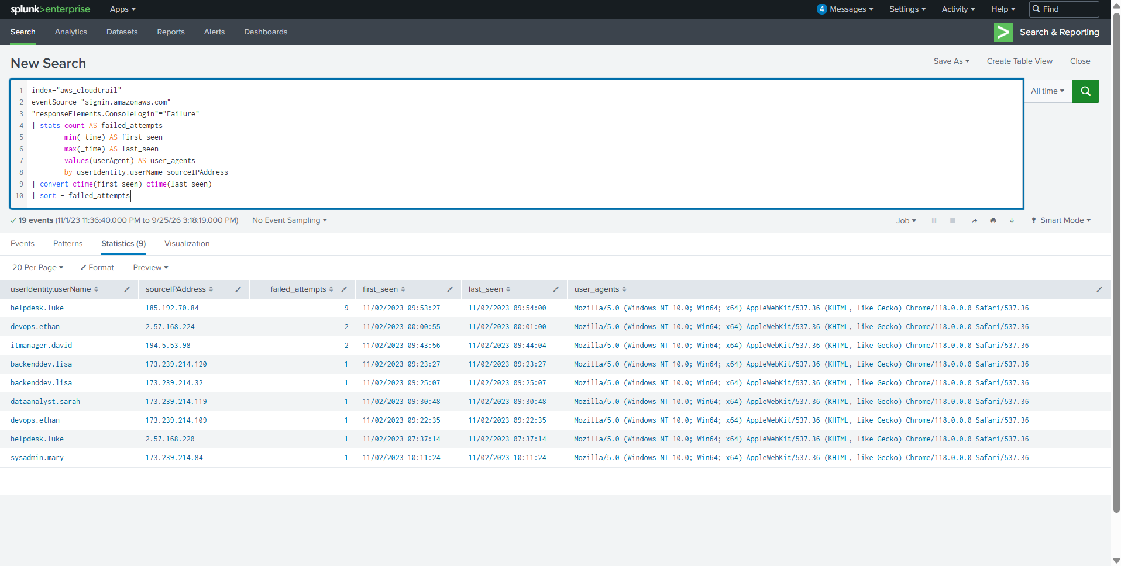
Figure 2. Failed console logins aggregated by user and source IP.
The largest cluster consisted of nine failed attempts against helpdesk.luke from 185.192.70.84 between 09:53:27 and 09:54:00 UTC. The next event for the same identity and source was a successful ConsoleLogin at 09:54:04 UTC.
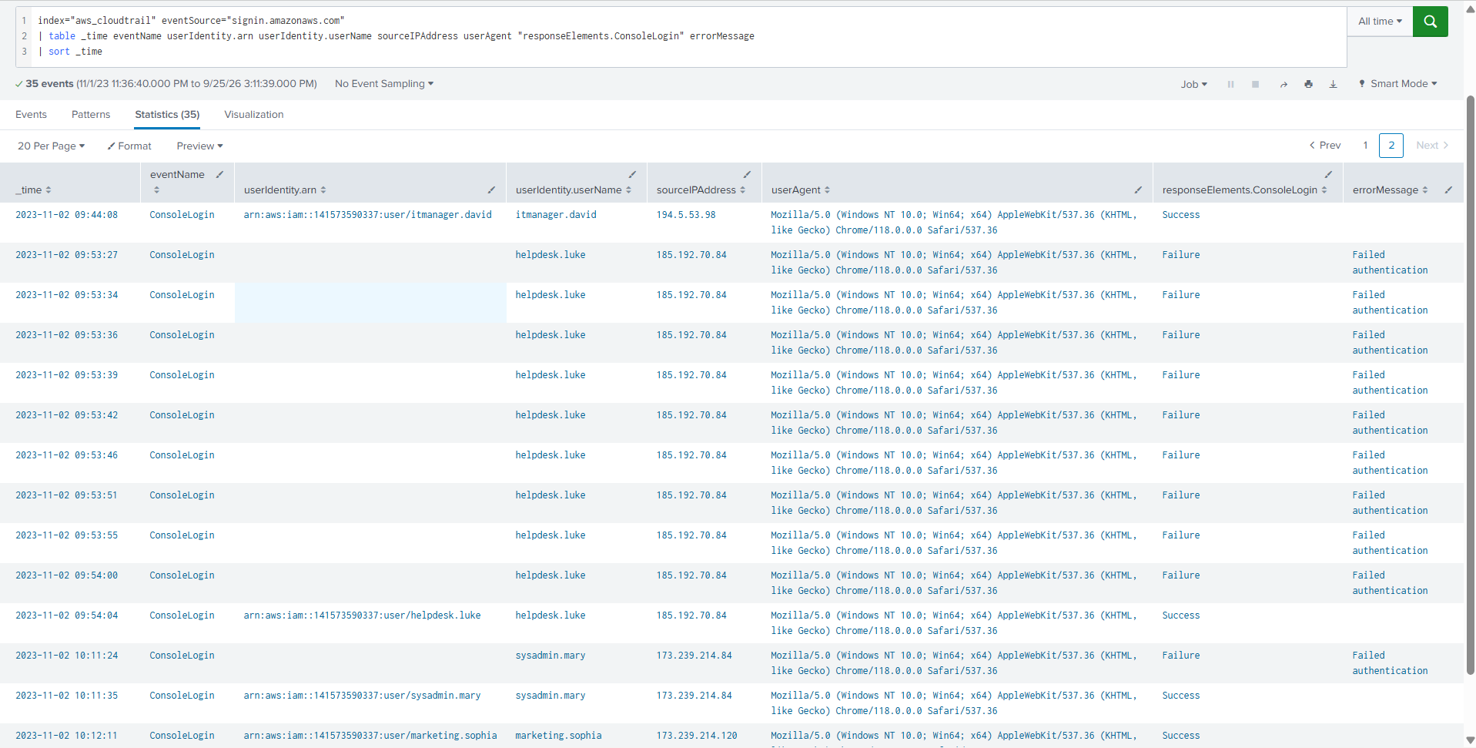
Figure 3. Authentication sequence showing failures followed by a successful login.
Metric | Value
Failed attempts | 9
Failure window | 33 seconds
Last failure | 2023-11-02 09:54:00 UTC
Successful login | 2023-11-02 09:54:04 UTC
Gap to success | 4 seconds
User agent | Windows 10 / Chrome 118

Analytical conclusion
The compromised account was helpdesk.luke. The sequence is strongly consistent with password guessing or use of newly obtained credentials. CloudTrail confirms the failures and success but does not reveal exactly how the correct password was acquired.

7. Scope Pivot — Activity After Authentication
SPL — compromised identity and suspicious-IP scope
index="aws_cloudtrail"
(sourceIPAddress="185.192.70.84" OR userIdentity.userName="helpdesk.luke")
| table _time eventSource eventName userIdentity.userName userIdentity.arn sourceIPAddress userAgent errorCode errorMessage
| sort 0 _time

The pivot returned 480 events. Including the username was essential because subsequent activity did not remain on the original login IP. The same IAM identity appeared from several addresses in the 185.192.70.x range during the incident window.
IP-rotation inference
The close timing, common IAM ARN, and consistent client characteristics suggest rotating proxy/VPN infrastructure or lab-generated address rotation. This is an inference; the available data does not prove ownership of the IPs. Values such as health.amazonaws.com in sourceIPAddress represent AWS service-originated activity and should not be treated as attacker endpoints.

8. Finding 2 — First S3 Object Access

8.1 Discovery is not object access
The compromised identity first called ListBuckets at 09:55:09 UTC. This enumerated available S3 buckets and established discovery behavior, but it did not retrieve a stored object.
SPL — S3 enumeration
index="aws_cloudtrail"
eventSource="s3.amazonaws.com"
eventName="ListBuckets"
userIdentity.userName="helpdesk.luke"
| table _time eventTime eventName userIdentity.arn sourceIPAddress userAgent errorCode errorMessage
| sort 0 _time

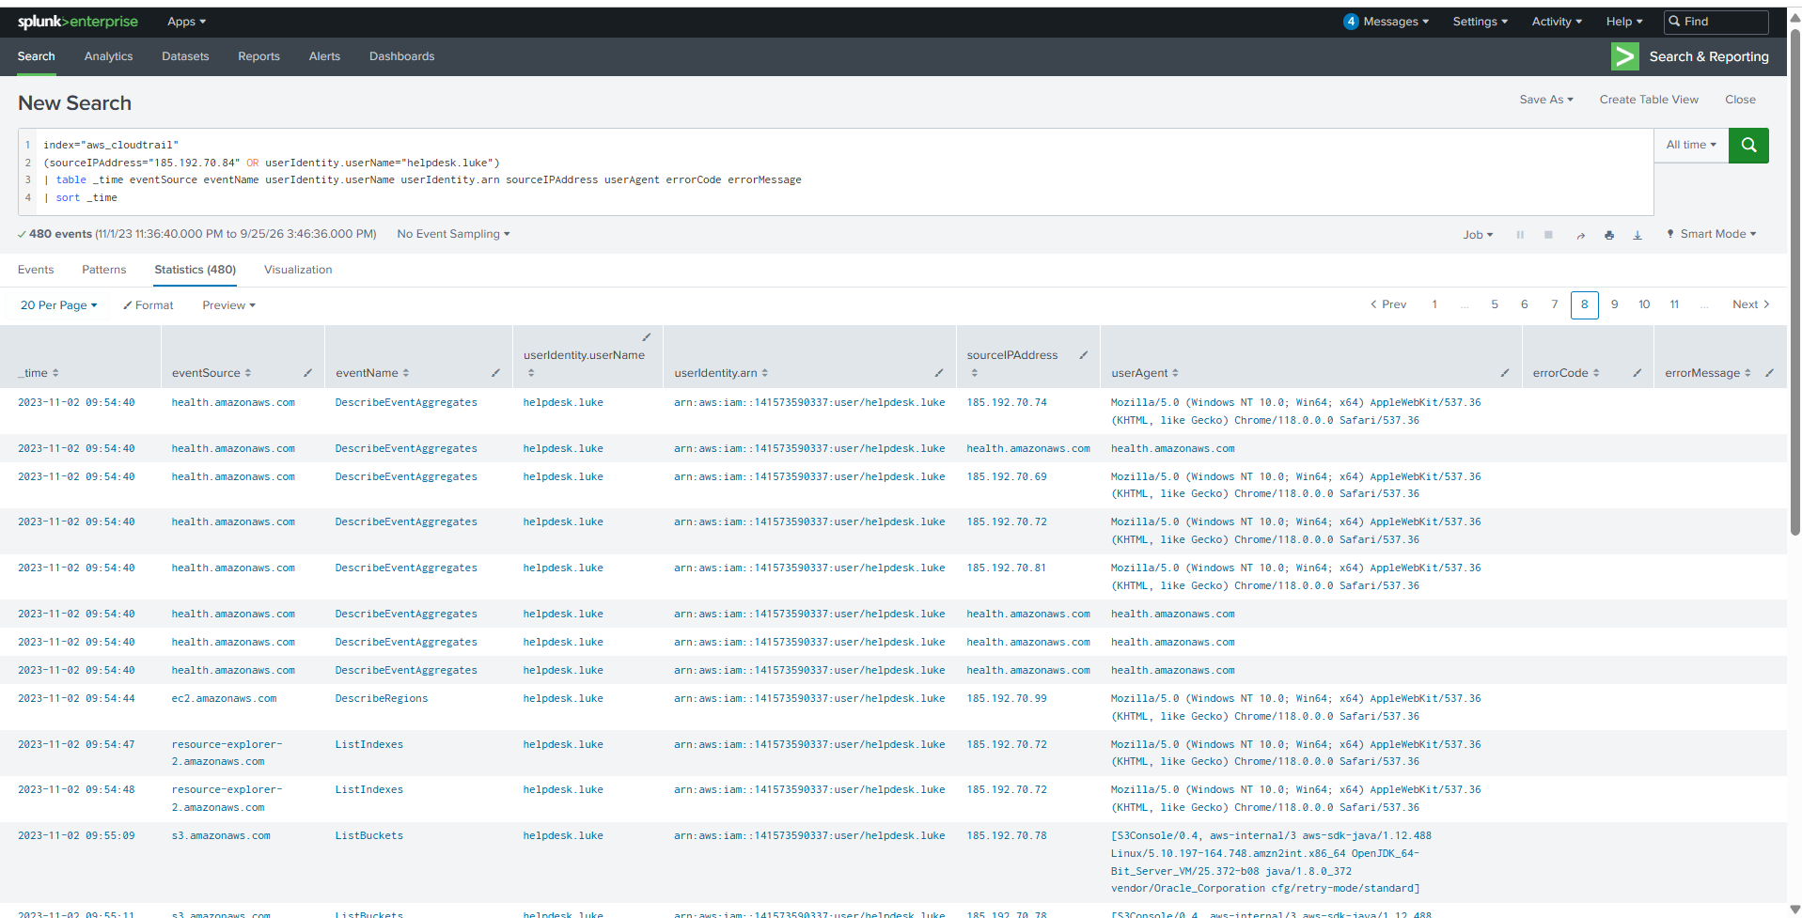
Figure 4. First S3 enumeration by the compromised identity.

8.2 Confirming object retrieval
SPL — S3 object access
index="aws_cloudtrail"
eventSource="s3.amazonaws.com"
eventName="GetObject"
userIdentity.userName="helpdesk.luke"
| table _time eventTime eventName userIdentity.arn sourceIPAddress requestParameters.bucketName requestParameters.key errorCode errorMessage
| sort 0 _time

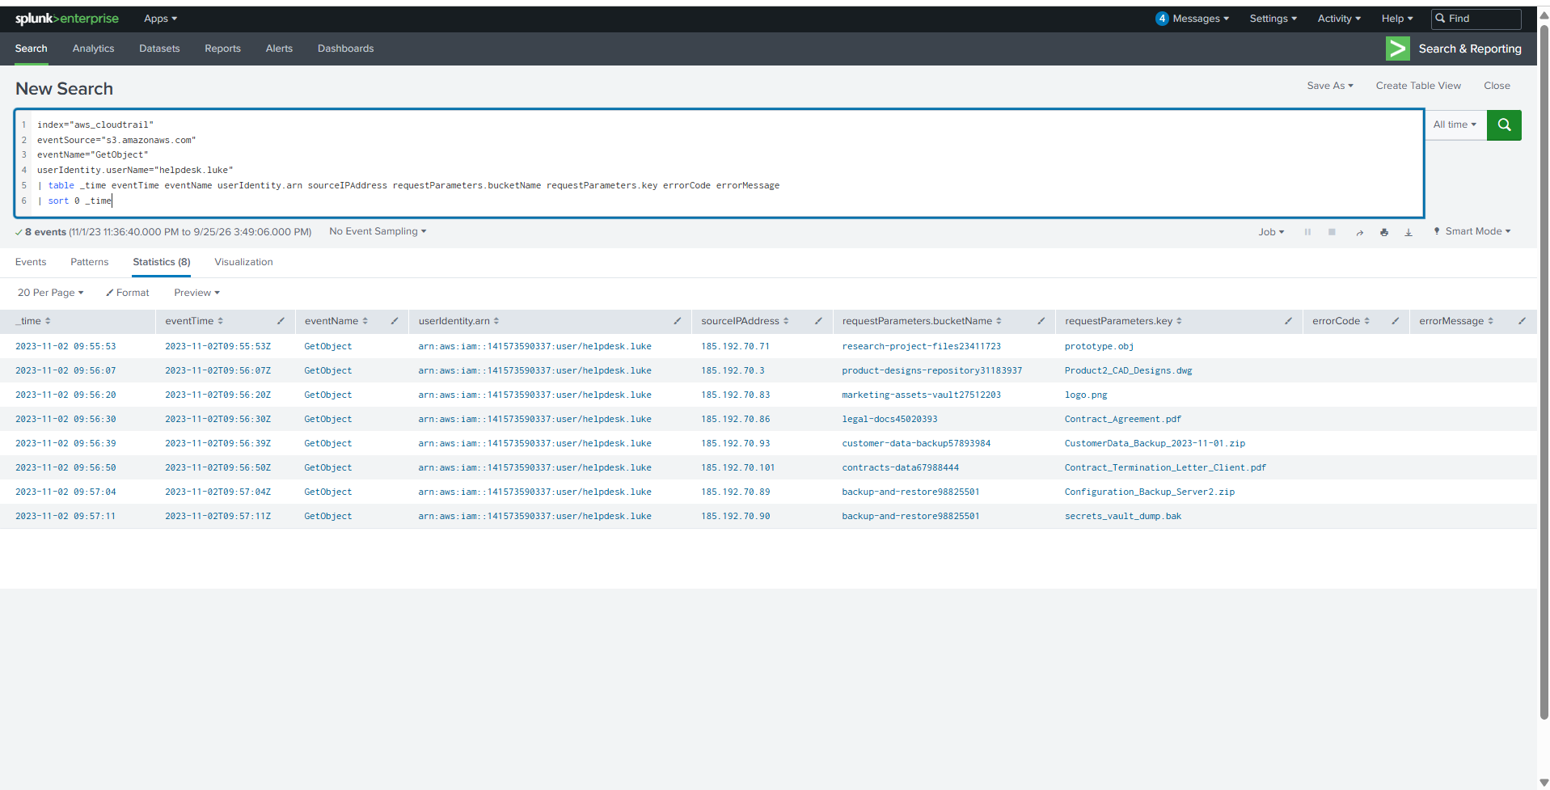
Figure 5. Eight GetObject events attributed to helpdesk.luke.
The earliest GetObject event occurred at 2023-11-02 09:55:53 UTC and retrieved prototype.obj from research-project-files23411723. Because the lab requested YYYY-MM-DD HH:MM, the submitted answer is 2023-11-02 09:55.
Key distinction
09:55:09 marks S3 enumeration (ListBuckets). 09:55:53 marks the first confirmed S3 object access (GetObject). Selecting the earlier timestamp would answer a different question.

9. Finding 3 — Accessed Objects and DWG Bucket
The compromised identity retrieved eight objects from seven buckets in approximately 78 seconds. The rapid cross-bucket sequence suggests targeted collection rather than ordinary interactive browsing.
UTC | Bucket | Object key
09:55:53 | research-project-files23411723 | prototype.obj
09:56:07 | product-designs-repository31183937 | Product2_CAD_Designs.dwg
09:56:20 | marketing-assets-vault27512203 | logo.png
09:56:30 | legal-docs45020393 | Contract_Agreement.pdf
09:56:39 | customer-data-backup57893984 | CustomerData_Backup_2023-11-01.zip
09:56:50 | contracts-data67988444 | Contract_Termination_Letter_Client.pdf
09:57:04 | backup-and-restore98825501 | Configuration_Backup_Server2.zip
09:57:11 | backup-and-restore98825501 | secrets_vault_dump.bak

DWG is a native AutoCAD drawing format commonly used for engineering, architecture, and product-design data. Filtering object keys by extension isolated the relevant access.
SPL — DWG object access
index="aws_cloudtrail"
eventSource="s3.amazonaws.com"
eventName="GetObject"
userIdentity.userName="helpdesk.luke"
requestParameters.key="*.dwg"
| table _time requestParameters.bucketName requestParameters.key sourceIPAddress

Finding
Product2_CAD_Designs.dwg was retrieved from product-designs-repository31183937 at 09:56:07 UTC.

10. Finding 4 — S3 Public-Access Safeguards Modified
SPL — security-relevant S3 configuration changes
index="aws_cloudtrail"
eventSource="s3.amazonaws.com"
userIdentity.userName="helpdesk.luke"
(eventName="PutBucketPublicAccessBlock" OR eventName="DeletePublicAccessBlock" OR eventName="PutBucketAcl" OR eventName="PutBucketPolicy")
| table _time eventName userIdentity.arn sourceIPAddress requestParameters.bucketName requestParameters errorCode errorMessage
| sort 0 _time

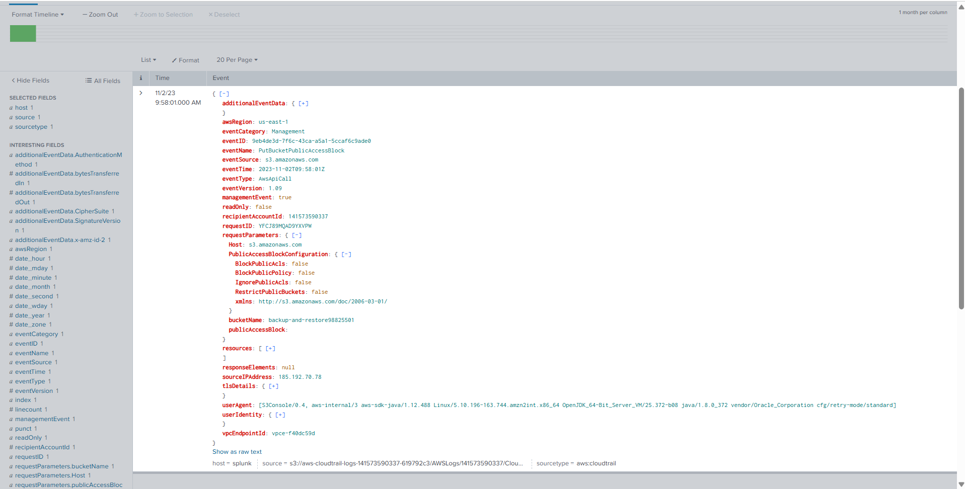
Figure 6. PutBucketPublicAccessBlock request with all four controls set to false.
At 09:58:01 UTC, helpdesk.luke issued PutBucketPublicAccessBlock against backup-and-restore98825501 from 185.192.70.78. The raw event recorded managementEvent=true, readOnly=false, no error, and the following request parameters:
Setting | Recorded value | Security effect
BlockPublicAcls | false | Public ACL submissions are no longer blocked by this bucket-level control.
IgnorePublicAcls | false | Existing or new public ACLs are no longer ignored by this control.
BlockPublicPolicy | false | Public bucket policies are no longer rejected by this control.
RestrictPublicBuckets | false | Public-policy access is no longer restricted by this control.

Precision note
Setting all four bucket-level flags to false weakens the safeguards and permits a public ACL or policy to take effect. This event alone does not prove anonymous exposure because account-level controls and the effective ACL/policy were not provided.

Finding
The affected bucket was backup-and-restore98825501.

11. Finding 5 — Attacker-Created IAM User
IAM CreateUser events were reviewed because new cloud accounts are a common persistence mechanism. The query constrained results to the compromised actor and exposed both the requested username and the returned user ARN.
SPL — IAM user creation
index="aws_cloudtrail"
eventSource="iam.amazonaws.com"
userIdentity.userName="helpdesk.luke"
eventName="CreateUser"
| table _time eventName userIdentity.arn sourceIPAddress requestParameters.userName responseElements.user.arn errorCode errorMessage
| sort 0 _time

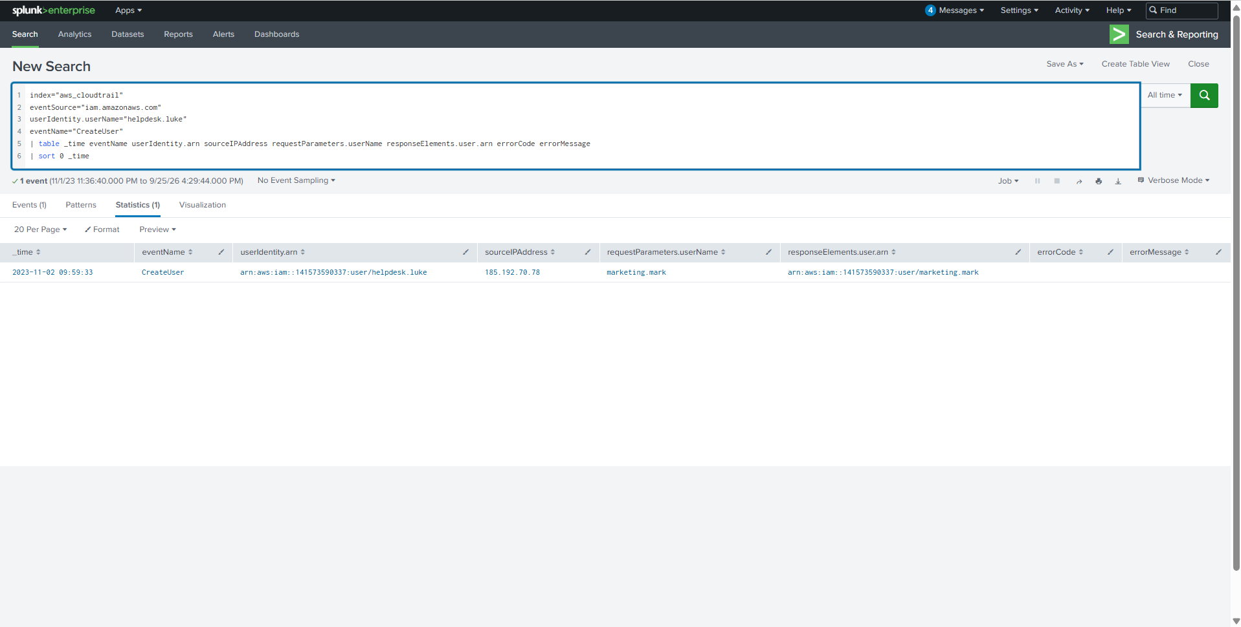
Figure 7. Successful creation of the IAM user marketing.mark.
At 09:59:33 UTC, helpdesk.luke created marketing.mark from 185.192.70.78. The returned ARN arn:aws:iam::141573590337:user/marketing.mark and empty error fields confirm success.
Finding
The attacker-created IAM user was marketing.mark.

12. Finding 6 — Privileged Group Assignment
Creating an account alone does not prove its privilege level. The next step was to search for AddUserToGroup and inspect requestParameters.groupName.
SPL — group membership change
index="aws_cloudtrail"
eventSource="iam.amazonaws.com"
eventName="AddUserToGroup"
requestParameters.userName="marketing.mark"
| table _time eventName userIdentity.arn sourceIPAddress requestParameters.userName requestParameters.groupName errorCode errorMessage
| sort 0 _time

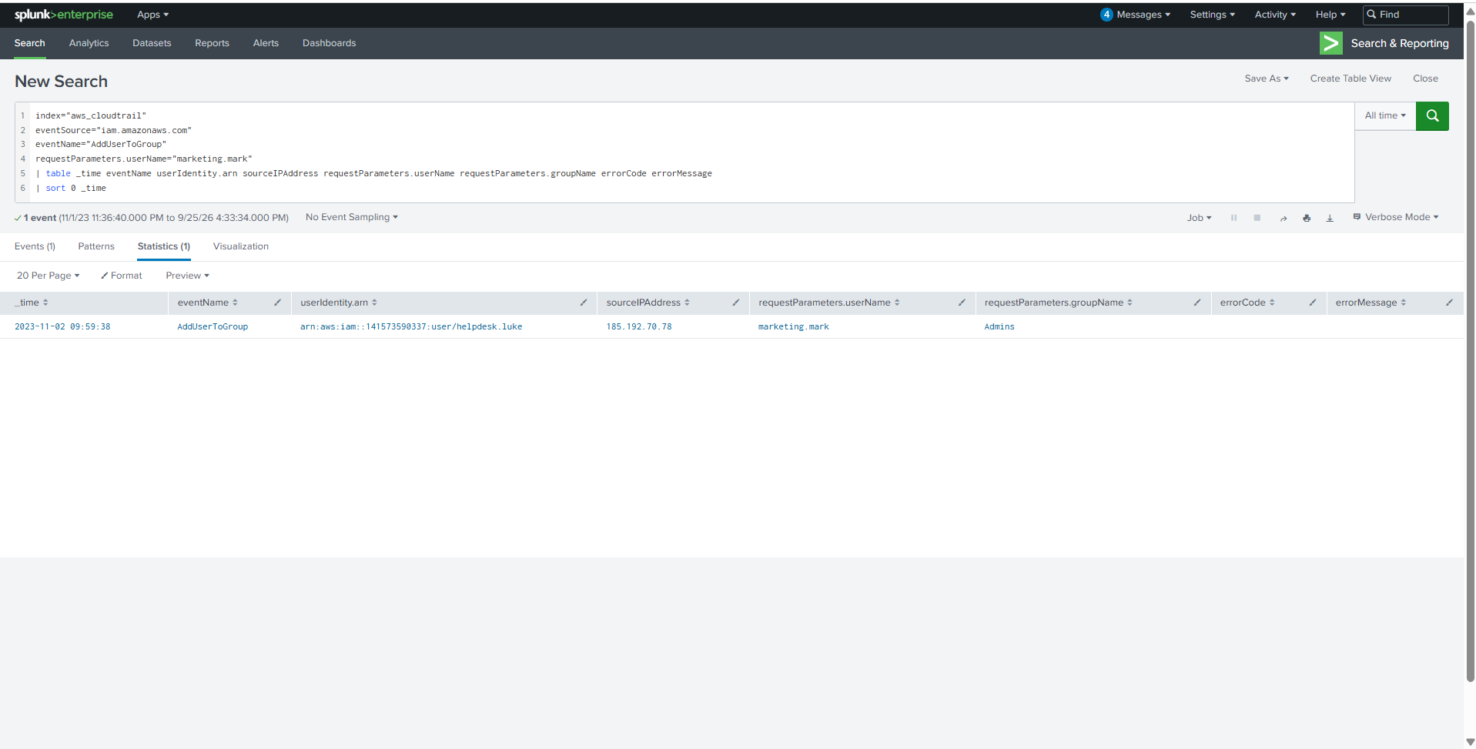
Figure 8. marketing.mark added to the Admins group.
At 09:59:38 UTC—five seconds after creation—helpdesk.luke added marketing.mark to Admins from the same source IP. The absence of an error indicates the action succeeded.
Finding
The new account was added to Admins, establishing a secondary privileged identity for persistence and likely privilege escalation.

13. Reconstructed Incident Timeline
Time (UTC) | CloudTrail event | Evidence-based interpretation
09:53:27–09:54:00 | 9 × ConsoleLogin Failure | Concentrated authentication failures against helpdesk.luke.
09:54:04 | ConsoleLogin Success | Compromised identity successfully authenticated.
09:55:09 | ListBuckets | S3 discovery began.
09:55:53 | GetObject | First confirmed object access: prototype.obj.
09:56:07 | GetObject | Product2_CAD_Designs.dwg retrieved.
09:57:11 | GetObject | secrets_vault_dump.bak retrieved.
09:58:01 | PutBucketPublicAccessBlock | Four bucket safeguards set to false.
09:59:33 | CreateUser | marketing.mark created.
09:59:38 | AddUserToGroup | marketing.mark added to Admins.

Speed of compromise
Only 5 minutes and 34 seconds elapsed between the successful console login and the creation of privileged persistence. The compact timeline supports high-confidence correlation across the authentication, S3, and IAM events.

14. Impact Assessment
Impact area | Evidence | Assessment
Confidentiality | Eight S3 GetObject operations | Confirmed access to design, legal, customer-backup, configuration, and secret-related files.
Integrity / security posture | S3 Block Public Access fields set false | Bucket-level safeguards were weakened; effective public exposure requires additional validation.
Persistence | CreateUser + AddUserToGroup | Secondary privileged IAM identity successfully established.
Credential risk | secrets_vault_dump.bak accessed | Potential downstream credential/key exposure; file contents were not available in the dataset.

15. Indicators of Compromise and Investigation Leads
Type | Value | Context
IAM user | helpdesk.luke | Compromised identity
IPv4 | 185.192.70.84 | Primary suspicious console-login source
IPv4 pattern | 185.192.70.x | Related activity observed during incident window
IAM user | marketing.mark | Attacker-created persistence account
IAM group | Admins | Privileged group assigned to new user
S3 bucket | backup-and-restore98825501 | Controls weakened; two sensitive objects accessed
Object key | Product2_CAD_Designs.dwg | Product-design data
Object key | secrets_vault_dump.bak | Potential secret material

16. MITRE ATT&CK Mapping
The mapping below connects observed behavior to ATT&CK. T1110.001 is presented as a suspected technique because CloudTrail shows the pattern but not the credential-acquisition method.
Tactic | Technique | Evidence
Credential Access | T1110.001 — Password Guessing | Nine failures followed by a success in seconds; technique is strongly indicated, not cryptographically proven.
Initial Access / Persistence | T1078.004 — Valid Accounts: Cloud Accounts | Successful console use of helpdesk.luke.
Discovery | T1619 — Cloud Storage Object Discovery | ListBuckets before targeted GetObject activity.
Collection | T1530 — Data from Cloud Storage | Eight successful S3 object retrievals.
Persistence | T1136.003 — Create Account: Cloud Account | marketing.mark created through IAM.
Persistence / Privilege Escalation | T1098.003 — Additional Cloud Roles | New user added to Admins.

17. Detection Engineering Opportunities
- Alert on repeated ConsoleLogin failures for one account followed by Success within five minutes.
- Correlate a new or unusual console source IP with immediate ListBuckets and GetObject activity.
- Detect rapid GetObject access across multiple buckets, particularly for backup, secret, contract, customer, and design file patterns.
- Alert whenever any PublicAccessBlockConfiguration field is set to false.
- Raise a critical alert for CreateUser followed by AddUserToGroup for a privileged group within a short window.
- Maintain per-user baselines for source network, user agent, AWS service, and time of day.

17.1 High-value Splunk detections
Detection — failures followed by success
index="aws_cloudtrail" eventSource="signin.amazonaws.com"
| eval result=coalesce('responseElements.ConsoleLogin', "Unknown")
| stats count(eval(result="Failure")) AS failures
count(eval(result="Success")) AS successes
min(_time) AS first_seen max(_time) AS last_seen
by userIdentity.userName sourceIPAddress
| where failures >= 5 AND successes >= 1 AND (last_seen-first_seen) <= 300

Detection — S3 public-access safeguards disabled
index="aws_cloudtrail" eventSource="s3.amazonaws.com" eventName="PutBucketPublicAccessBlock"
| search requestParameters.publicAccessBlockConfiguration.*=false
| table _time userIdentity.arn sourceIPAddress requestParameters.bucketName requestParameters.publicAccessBlockConfiguration.*

Detection — user creation followed by group assignment
index="aws_cloudtrail" eventSource="iam.amazonaws.com"
(eventName="CreateUser" OR eventName="AddUserToGroup")
| transaction requestParameters.userName maxspan=10m
| search eventcount>=2
| table _time userIdentity.arn sourceIPAddress requestParameters.userName requestParameters.groupName duration

18. Containment and Remediation
- Disable helpdesk.luke, revoke active sessions, and rotate its console password, access keys, and any related credentials.
- Remove marketing.mark and review every IAM user, group, policy, role, login profile, access key, and token created or changed during the incident window.
- Restore all four S3 Block Public Access settings at the bucket level and verify account- or organization-level controls.
- Inspect effective ACLs and policies for backup-and-restore98825501 and validate whether unauthenticated access occurred.
- Review S3 server access logs or CloudTrail data events for access from identities other than helpdesk.luke after 09:58:01 UTC.
- Classify the eight accessed objects and begin breach-impact assessment, including legal and privacy review where appropriate.
- Assume secrets_vault_dump.bak and configuration backups may contain credentials; rotate exposed secrets and keys.
- Enforce MFA, least privilege, short-lived credentials, and conditional access controls for IAM identities.
- Preserve CloudTrail, S3 access logs, IAM credential reports, and relevant SIEM exports for incident-response evidence.

19. Analytical Limitations
- The dataset proves event occurrence but does not include the content of retrieved S3 objects.
- The exact credential-acquisition method cannot be confirmed from CloudTrail alone.
- The 185.192.70.x address rotation is consistent with shared infrastructure, but ownership was not established.
- Disabling bucket-level Block Public Access controls does not by itself prove anonymous access; account-level controls and effective policies/ACLs were not supplied.
- No host, endpoint, identity-provider, or network telemetry was available to validate activity outside AWS CloudTrail.

20. Conclusion
The supplied CloudTrail evidence supports a coherent and high-confidence compromise chain. The IAM user helpdesk.luke experienced a rapid sequence of failed console logins followed by success, after which the identity enumerated S3, retrieved eight objects, weakened public-access safeguards on a backup bucket, and created a privileged secondary user.
The investigation demonstrates why cloud forensics must correlate identity, API action, target resource, timestamp, source, response, and error fields. The most consequential analytical distinction was separating ListBuckets discovery from GetObject access. This produced the correct first-access timestamp and a defensible incident timeline.

Appendix A — Query Logic Reference
SPL element | Purpose
index="aws_cloudtrail" | Restricts the search to the supplied AWS CloudTrail dataset.
eventSource | Selects the AWS service that generated the event.
eventName | Identifies the API or console action performed.
userIdentity.userName / arn | Identifies the acting cloud identity.
sourceIPAddress | Shows the reported request origin or AWS service hostname.
requestParameters | Reveals the bucket, object, target user, group, or configuration.
responseElements | Contains returned resources or authentication results.
errorCode / errorMessage | Indicates whether AWS rejected the request and why.
stats | Aggregates repeated events to expose patterns.
sort 0 _time | Sorts the full result set chronologically without the default result limit.

Appendix B — References
- CyberDefenders — AWSRaid: https://cyberdefenders.org/blueteam-ctf-challenges/awsraid/
- AWS — What is CloudTrail?: https://docs.aws.amazon.com/awscloudtrail/latest/userguide/
- AWS — Understanding CloudTrail events: https://docs.aws.amazon.com/awscloudtrail/latest/userguide/cloudtrail-events.html
- AWS — Logging Amazon S3 API calls using CloudTrail: https://docs.aws.amazon.com/AmazonS3/latest/userguide/cloudtrail-logging.html
- AWS — Blocking public access to S3 storage: https://docs.aws.amazon.com/AmazonS3/latest/userguide/access-control-block-public-access.html
- AWS IAM API — CreateUser: https://docs.aws.amazon.com/IAM/latest/APIReference/API_CreateUser.html
- AWS IAM API — AddUserToGroup: https://docs.aws.amazon.com/IAM/latest/APIReference/API_AddUserToGroup.html
- MITRE ATT&CK — T1110.001 Password Guessing: https://attack.mitre.org/techniques/T1110/001/
- MITRE ATT&CK — T1078.004 Valid Accounts: Cloud Accounts: https://attack.mitre.org/techniques/T1078/004/
- MITRE ATT&CK — T1619 Cloud Storage Object Discovery: https://attack.mitre.org/techniques/T1619/
- MITRE ATT&CK — T1530 Data from Cloud Storage: https://attack.mitre.org/techniques/T1530/
- MITRE ATT&CK — T1136.003 Create Account: Cloud Account: https://attack.mitre.org/techniques/T1136/003/
- MITRE ATT&CK — T1098.003 Additional Cloud Roles: https://attack.mitre.org/techniques/T1098/003/

