**ABSTRACT**

The front-end development internship at Cognifyz Technologies offered a practical experience, focusing on essential skills in styling, responsiveness, API integration, and interactivity.Task 1 involved form styling and validation, where I designed a form in index.html, styled it with CSS, and implemented client-side validation in script.js to ensure data integrity and provide feedback on errors.In Task 2, Responsive Design was the main focus. Using media queries, I adjusted layouts and element sizes to maintain usability across different screen sizes, improving the user experience on various devices.API Integration was the objective of Task 3, enhancing the site’s functionality by integrating external data sources to provide dynamic content, making the site more interactive and up-to-date.Task 4 centered on creating an Interactive Button. I added a button to index.html with JavaScript code to change the background color upon clicking, demonstrating basic event handling to boost user engagement.This internship experience strengthened my understanding of front-end development and equipped me with skills to create user-friendly, adaptive, and engaging websites.

**TABLE OF CONTENTS**

|  |  |  |
| --- | --- | --- |
| Chapter No | Description | Pg No |
| 1 | About the Organization | 3 |
| 2 | Introduction | 6 |
| 2.1 | Objective of the Tasks | 6 |
| 2.2 | Technologies Used | 8 |
| 2.3 | General Workflow Process | 10 |
| 3 | Design | 11 |
| 4 | Implementation | 14 |
| 5 | Conclusion and Future Work | 32 |
| 5.1 | Conclusion | 32 |
| 5.2 | Future Work | 32 |
| 6 | References | 35 |

**1.ABOUT THE ORGANIZATION**

Cognifyz Technologies is a leading-edge technology solutions provider, dedicated to delivering innovative and impactful IT services to clients across diverse industries.

**1.1 Company Overview:**

Cognifyz Technologies was established with the vision of leveraging technology to enhance business processes and customer experiences.

**1.2 Mission and Vision Mission:**

**Misson:** The company aims to empower businesses through tailored technology solutions that drive efficiency, productivity, and innovation.

**Vision:** Cognify Technologies envisions a future where technology seamlessly integrates with daily business operations, facilitating growth and transformation. **1.3 Core Services:**

**• Web and Software Development:** The company builds custom web applications and enterprise software solutions tailored to meet specific business requirements.

**• Cloud Computing:** Leveraging cloud technologies, Cognifyz helps businesses transition to cloud platforms, enabling them to take advantage of flexible, scalable, and cost-effective infrastructure.

**• Data Analytics and Business Intelligence:** Cognifyz empowers organizations by transforming raw data into actionable insights through advanced tools.

**• Mobile Application Development:** The company develops responsive and robust mobile applications across multiple platforms, ensuring optimal user experience and seamless integration with business processes

• **Enterprise Solutions:** Cognifyz delivers a range of enterprise-grade solutions, from customer relationship management (CRM) to enterprise resource planning.

**1.4 Approach to Innovation:**

At the heart of Cognifyz Technologies' approach is a strong commitment to innovation. The company is continuously exploring new technologies and methodologies to stay ahead of the curve in a rapidly changing tech landscape. Whether it’s adopting the latest front-end frameworks like React or Vue.js, employing agile methodologies for efficient project management, or utilizing AI and machine learning to develop smart solutions, Cognifyz is constantly pushing the boundaries of what technology can achieve.

**1.5 Training and Development:**

Cognifyz Technologies is also recognized for its commitment to fostering talent, especially through its internship programs. Interns at Cognifyz are given handson experience with real-world projects developers and engineers.

**1.6 Culture and Values:**

Cognifyz Technologies fosters a work culture rooted in collaboration, creativity, and excellence. The company encourages its employees and interns to challenge themselves, think critically, and approach problems with innovative solutions. They value teamwork, transparency, and integrity, ensuring a positive and productive work environment where individuals can thrive.

**1.7 Technology Stack:**

1. Programming Languages: Proficient in various programming languages, including Java, Python, JavaScript, C#, and others.

2. Frameworks and Libraries: Familiarity with popular frameworks such as React, Angular, Vue.js, and backend frameworks like Node.js and Django.

**3. Cloud Platforms:** Expertise in cloud platforms like AWS, Microsoft Azure, and Google Cloud for deploying and managing applications.

**4. Database Technologies:** Experience with databases such as MySQL, PostgreSQL, MongoDB, and NoSQL databases for data management.

**1.8 Client Testimonials and Case Studies:**

**• Success Stories:** Showcases successful projects and satisfied clients through case studies and testimonials that highlight the effectiveness of their solutions.

**• Client Partnerships:** Builds long-term relationships with clients by providing consistent support and adapting to their evolving needs.

**1.9 Community Engagement:**

**• Social Responsibility:** Engages in community initiatives and social responsibility programs, contributing to local development and charitable causes. **• Thought Leadership:** Participates in industry events, webinars, and discussions to share knowledge and insights on technology trends and innovations.

**1.10 Future Aspiration:**

Additionally, the company places a strong focus on maintaining ethical standards and delivering sustainable solutions that positively impact both clients and society. Through its technological innovations, Cognifyz aims to contribute to global digital transformation, helping businesses evolve in an increasingly connected world.

**2.INTRODUCTION**

The role of a Front-End Development Intern is a pivotal learning experience designed to bridge the gap between academic studies and practical industry application. As the internet continues to serve as a cornerstone of business and communication, front-end development has become a critical skill set for anyone pursuing a career in technology. A front-end development internship allows aspiring developers to gain hands-on experience in creating, designing, and maintaining websites and web applications. This immersive experience enables interns to apply their knowledge of web technologies to real-world projects, while also learning new techniques and tools used by professionals in the industry.

The primary responsibilities typically revolve around front-end development tasks. Interns are introduced to the key technologies used in modern web development, such as HTML, CSS, JavaScript, and various front-end frameworks like React, Angular, and Vue.js. In a front-end capacity, the intern focuses on the design and layout of web pages, ensuring they are visually appealing, user-friendly, and responsive across different devices. Additionally, interns may be involved in optimizing web performance, enhancing accessibility, and collaborating with designers and back-end developers to ensure a seamless user experience.

**2.1 OBJECTIVE OF THE TASKS**

The primary objective of the tasks undertaken during this front-end development internship was to build a solid foundation in web technologies, focusing on improving proficiency in HTML, CSS, JavaScript, and front-end frameworks. These tasks aimed to provide hands-on experience in creating interactive, responsive, and user-friendly web components, enhancing both the technical and design skills necessary for modern front-end development. Additionally, the internship emphasized learning industry best practices, including efficient code organization and optimization.

* **Task 1: Form Styling and Validation**

To design and style a user-friendly, responsive form using HTML and CSS with client-side validation in JavaScript for real-time feedback. This task focuses on improving form design skills, enhancing user experience, and ensuring secure data entry. The objective is to create an aesthetically pleasing form that upholds data integrity.

* **Task 2: Responsive Design**

To create a web page that offers an optimal viewing experience across various devices, focusing on intuitive navigation and minimal resizing or scrolling. This task involves using CSS media queries, flexible grids, and responsive images to ensure seamless adaptation to different screen sizes.

* **Task 3: API Integration**

To integrate external APIs into a web page to dynamically display data and enhance interactivity, focusing on retrieving and rendering JSON data using JavaScript. This task involves understanding API endpoints, making HTTP requests, and handling responses to ensure seamless data updates. The goal is to improve skills in API consumption and enable real-time data interaction within web applications.

* **Task 4: Interactive Button**

To create a dynamic button using JavaScript that changes color, shape, or displays animations when clicked, enhancing user engagement. This task focuses on event handling, CSS transitions, and animations to make the button visually responsive. The goal is to improve skills in creating interactive UI elements that provide immediate feedback to user actions.

**2.2 TECHNOLOGIES USED**

Together, HTML, CSS, and JavaScript form the trifecta of front-end web development. HTML provides the basic structure and content, CSS enhances the design and layout, and JavaScript adds interactivity and dynamic functionality**.**

**2.2.1 HTML (HyperText Markup Language)**

HTML is the foundational language used for structuring content on the web. It provides the framework that defines the layout and organization of web pages. As a markup language, HTML uses tags to describe elements such as headings, paragraphs, links, images, lists, tables, and more. These tags inform the browser how to display the content on a webpage. Each element is represented by an opening and closing tag, creating a structured and hierarchical document.

**Key features of HTML:**

• Semantic elements: Modern HTML uses semantic tags like `<header>`, `<article>`, `<section>`, and `<footer>` to add meaning to the document structure, making it more readable for both developers and search engines.

• Forms and input elements: HTML supports creating interactive forms that allow users to submit data through various input fields like text boxes, radio buttons, checkboxes, and dropdown menus.

• Media embedding: With HTML, developers can embed multimedia elements such as images (`<img>`), videos (`<video>`), and audio (`<audio>`) directly into webpages.

**2.2.2 CSS (Cascading Style Sheets)**

CSS is a stylesheet language used to control the presentation and design of HTML documents. While HTML provides the structure, CSS is responsible for the look and feel of a webpage, including layout, colors, fonts, spacing, and overall visual aesthetics. By separating content from presentation, CSS allows for more

efficient design and development, making it easier to maintain and update websites.

**Key features of CSS:**

* **Selectors:** CSS targets HTML elements using selectors (e.g., classes, IDs, or tag names), applying specific styles to them.
* **Box Model**: CSS treats each element on a page as a rectangular box, which consists of four areas: content, padding, border, and margin. Understanding the box model is critical for layout and spacing.
* **Responsive Design:** CSS enables websites to adapt to different screen sizes and devices. Using techniques like media queries, developers can create fluid, flexible layouts that work seamlessly on desktops, tablets, and smartphones.
* **Flexbox and Grid Layout:** These modern layout models make it simpler to create complex, responsive designs without relying heavily on floats or positioning.

**2.2.3 JavaScript**

JavaScript is a powerful programming language that allows developers to create dynamic and interactive web applications. While HTML structures the content and CSS styles it, JavaScript adds behavior to the webpage, making it responsive to user input and capable of performing complex operations on the fly. As a client-side scripting language, JavaScript is executed directly in the user's web browser, allowing for fast and responsive interactions without the need for server communication in many cases. Its core functionality includes the following:

* Event Handling: JavaScript allows websites to respond to user inputs, such as mouse clicks, keyboard inputs, or form submissions, by attaching event listeners to HTML element
* Data Validation: JavaScript is frequently used for form validation, checking that the data entered by users (e.g., in registration forms or surveys) meets specific criteria before it is submitted to the server. This enhances the user experience by providing immediate feedback.
* JavaScript Frameworks and Libraries: JavaScript has a rich ecosystem of frameworks and libraries, such as React, Angular which streamline the development of complex user interfaces.

**2.3 GENERAL WORKFLOW PROCESS**

**1. Planning and Structuring:**

* Each task began with defining the requirements and structuring the web components using HTML to create the basic layout.

**2. Styling and Responsiveness:**

* You applied CSS or frameworks like to style the components, ensuring they were responsive across devices.

**3. Adding Interactivity:**

* Finally, you used JavaScript to add dynamic behavior and user interactivity, such as button clicks, alerts, and other interactive features.

**4. Testing and Debugging:**

* Each task involved continuous testing and debugging to ensure that the HTML structure, CSS styling, and JavaScript functionality worked together smoothly.

**3.DESIGN**

**3.1 Task 1: Form Styling and Validation**

This task involves designing a visually appealing form and implementing client-side validation for secure data entry using HTML, CSS, and JavaScript.

**Development Process:**

1. **Requirement Analysis:** Analyzed the need for a well-structured, visually appealing form that ensures data integrity. Identified the essential fields, types of input validation, and error handling required.
2. **Form Structure Design:** Used HTML to structure the form elements, including text fields, dropdowns, checkboxes, and submit buttons. Planned the layout for an intuitive, organized arrangement of form elements.
3. **Styling with CSS:** Styled the form with CSS to create a visually appealing design, using colors, spacing, and font choices that align with modern web aesthetics. Ensured the form is responsive across various screen sizes.
4. **Adding Validation with JavaScript:** Implemented client-side validation with JavaScript to provide real-time feedback on user input (e.g., required fields, valid email format, password strength). Developed logic to display error messages and guide users to correct mistakes before submission.
5. **Testing and Debugging:** Tested the form's responsiveness and validation functionality across different browsers and devices. Verified that the form displayed error messages appropriately and that validation worked accurately for various input scenarios.

**3.2 Task 2: Responsive Design**

To develop a web page that adjusts seamlessly to various screen sizes, providing an optimal viewing experience across devices, while ensuring the layout remains functional and visually appealing on both small and large screens.

**Development Process:**

1. **Requirement Analysis:** Identified the need for a responsive design to improve usability and accessibility on different devices, ensuring users have a consistent experience.
2. **Layout Planning:** Designed a flexible layout structure using CSS grid and flexbox for adaptability across screen dimensions, while maintaining a clean and user-friendly interface.
3. **CSS Media Queries:** Utilized media queries to adjust styling based on screen size, ensuring a consistent appearance on all devices and enhancing the layout's responsiveness.
4. **Responsive Images:** Incorporated responsive images that scale appropriately to prevent layout distortion on smaller screens, improving page load times and user experience.
5. **Testing and Optimization:** Tested responsiveness across various devices and browsers, ensuring intuitive navigation, minimal resizing or scrolling, and optimal performance.

**3.3 Task 3: API Integration**

This task involves integrating external APIs into a web page to fetch and display data dynamically, enhancing the functionality of the site.

**Development Process:**

1. **Requirement Analysis:** Identified the need to enhance the web page with dynamic, real-time data from an external API to improve functionality and user engagement. The data could include information like weather updates, user profiles, or product details.
2. **API Integration:** Used JavaScript (with fetch or XMLHttpRequest) to make API calls, retrieve JSON data, and dynamically display it on the webpage. Implemented error handling to manage failed requests and ensure smooth user experience.
3. **Testing and Debugging:** Ensured the API calls were working correctly by handling errors such as network failures and data retrieval issues. Verified that the data displayed properly across different browsers and devices, ensuring cross-browser compatibility and seamless user interaction. Additionally, optimized the data flow and ensured the page updated efficiently in real-time.

**3.4 Task 4: Interactive Button**

This task involves creating a dynamic button that changes its appearance or performs an action when clicked, enhancing user interaction.

**Development Process:**

1. **Requirement Analysis:** Determined the need for a button that responds to user interactions by changing color, shape, or triggering an animation to provide visual feedback.
2. **Button Design and Structure:** Used HTML to create the button element and CSS for its default appearance and positioning on the page.
3. **Adding Interactivity with JavaScript:** Implemented event listeners in JavaScript to detect click actions, change the button's appearance (color, shape, or animation), and ensure smooth transitions.
4. **Testing and Debugging:** Tested the button for responsiveness across various browsers and ensured the interactivity, including color changes or animations, worked as intended on different devices.

**4. IMPLEMENTATION**

**4.1 Task 1: Form Styling and Validation**

To design a responsive form with CSS and implement client-side validation using JavaScript for accurate and secure data entry.

**Coding:**

**Index.html**

<!DOCTYPE html>

<html lang="en">

  <head>

    <meta charset="utf-8" />

  <link rel="icon" href="%PUBLIC_URL%/favicon.ico" />

    <meta name="viewport" content="width=device-width, initial-scale=1" />

    <meta name="theme-color" content="#000000" />

    <meta

      name="description"

      content="Web site created using create-react-app"

    />

    <link rel="apple-touch-icon" href="%PUBLIC_URL%/logo192.png" />

    <link rel="manifest" href="%PUBLIC_URL%/manifest.json" />

    <title>React App</title>

  </head>

  <body>

    <noscript>You need to enable JavaScript to run this app.</noscript>

    <div id="root"></div>

  </body>

</html>

**Login.css**

@keyframes glow {

    0% {

      box-shadow:

        0 0 20px rgba(14, 181, 117, 0.4),

        0 0 40px rgba(14, 181, 117, 0.6),

        0 0 60px rgba(14, 181, 117, 0.8),

        0 0 80px rgba(14, 181, 117, 0.9);

    }

    50% {

      box-shadow:

        0 0 30px rgba(14, 181, 117, 0.4),

        0 0 60px rgba(14, 181, 117, 0.6),

        0 0 90px rgba(14, 181, 117, 0.8),

        0 0 120px rgba(14, 181, 117, 0.9),

    }

    .orb {position: relative;

    margin: auto;

    width: 200px;

    height: 200px;

    background: rgba(14, 181, 117, 1);

    border-radius: 50%;

    filter: blur(150px);

    box-shadow:

      0 0 20px rgba(14, 181, 117, 0.4),

      0 0 40px rgba(14, 181, 117, 0.6),

      0 0 60px rgba(14, 181, 117, 0.8),

      0 0 80px rgba(14, 181, 117, 0.9);

      animation: glow 2s infinite, blink 0.5s infinite, move 10s ;

       border: 5px solid rgba(14, 181, 117, 0.8);

  }

@media (max-width: 1200px) {

    .orb {

      width: 150px;

      height: 150px;

    }

  }

**OUTPUT :**

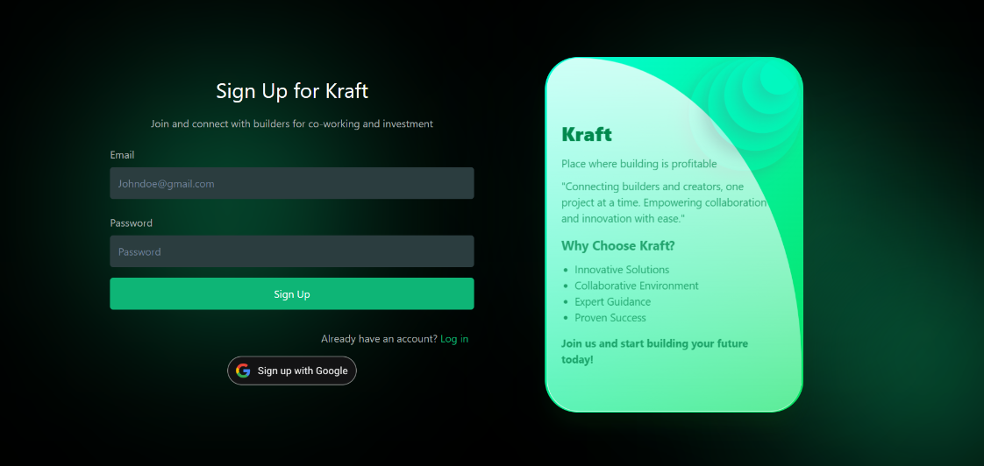

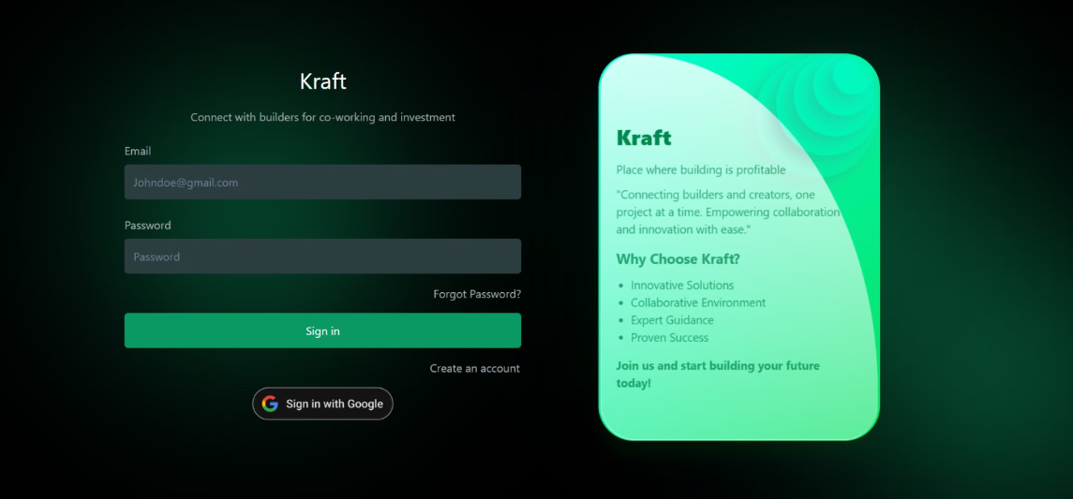

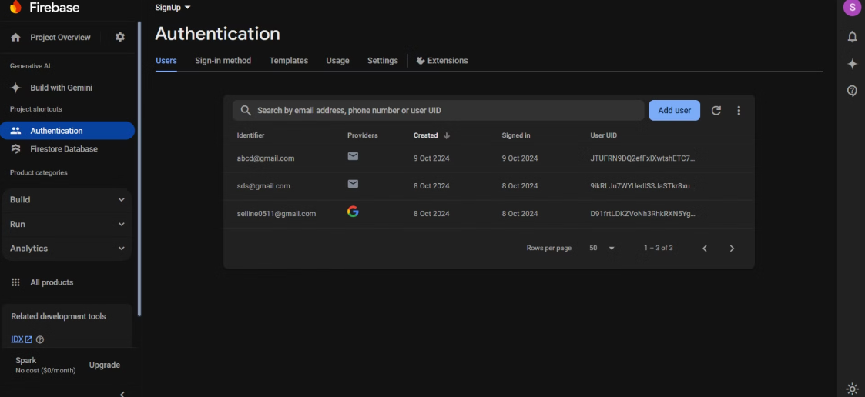

**4.2 Task 2: Responsive Design**

To create a web page that adapts seamlessly to various screen sizes using CSS, ensuring an optimal viewing experience across all devices.

**Coding:**

**Index.html**

<!DOCTYPE html>

<html lang="en">

<head>

<title>Portfolio</title>

<meta charset="utf-8">

<meta name="viewport" content="width=device-width, initial-scale=1, shrink- to-fit=no">

<meta property="og:title" content="Page Tile" />

<meta property="og:description" content="Personal Site" />

<linkhref="https://fonts.googleapis.com/css?family=Poppins:100,200,300,400,500,600,700,800,900" rel="stylesheet">

 <link rel="stylesheet" href="css/animate.css"> <link rel="stylesheet"

href="css/owl.carousel.min.css">

  <link rel="stylesheet" href="css/owl.theme.default.min.css">

  <link rel="stylesheet" href="css/magnific-popup.css">

  <link rel="stylesheet" href="css/aos.css">

  <link rel="stylesheet" href="css/flaticon.css">

<link rel="stylesheet" href="css/icomoon.css">

<link rel="stylesheet" href="css/style.css">

</head>

<body data-spy="scroll" data-target=".site-navbar-target" data-offset="300">

<nav class="navbar navbar-expand-lg navbar-dark bg-dark ftco_navbar ftco-navbar-light site-navbar-target"

        id="ftco-navbar">

        <div class="container">

            <a class="navbar-brand" href="index.html">Selline .  E</a>

            <button class="navbar-toggler js-fh5co-nav-toggle fh5co-nav-toggle"

                data-target="#ftco-nav" aria-controls="ftco-nav" ariexpanded="false">

            <span class="oi oi-menu"></span> Menu

            </button>

<div class="collapse navbar-collapse" id="ftco-nav">

             <ul class="navbar-nav nav ml-auto"

<li class="nav-item">

<a href="#home-section" class="nalink">

<span>Home</span></a></li>

 <liclass="nav-item"><ahref="#about-section"class="nav link"><span>About</span></a></li>

<liclass="nav-item"><ahref="#project-section" class="navlink"><span>Projects</span></a></li>

                    <li class="nav-item"><a href="#resume-section" class="nav-link"><span>Resume</span></a></li>

                    <li class="nav-item"><a href="#footer-section" class="nav-link"><span>Contact</span></a></li>

</ul>

 </div>

</div>

</nav>

<!-- particles -->

 <div id="particles-js"></div>

<section class="hero-wrap js-fullheight">

<!--       <div class="overlay"></div> -->

<div class="container">

<div class="row no-gutters slider-text js-fullheight justify-content-center align-items-center">

 <div class="col-lg-8 col-md-6 ftco-animate d-flex align-items-center">

 <div class="text text-center">

<span class="subheading">Hey! I am</span>

<h1>Selline.E</h1>

<h2>I like

<span class="txt-rotate" data-period="2000”data-rotate='[ "Coding.", "Software Development", "Problem Solving."]'></span>

</h2>

</div>

</div>

<div class="scrollDown">

     <span></span>

                <span></span>

                <span></span>

      </div>

 </div>

 </button>

 <div class="glyphicon glyphicon-arrow-down"></div>

 </section>

<section class="ftco-about img ftco-section ftco-no-pt ftco-no-pb" id="about-section">

 <div class="container">

            <div class="row d-flex no-gutters">

                <div class="col-md-6 col-lg-6 d-flex">

</div>

   </div>

  </section>

**OUTPUT :**

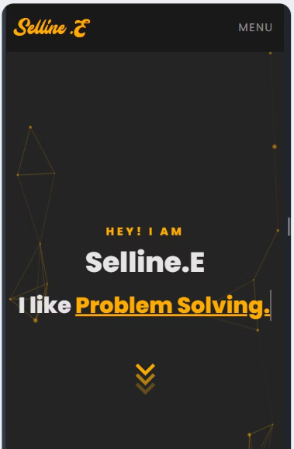

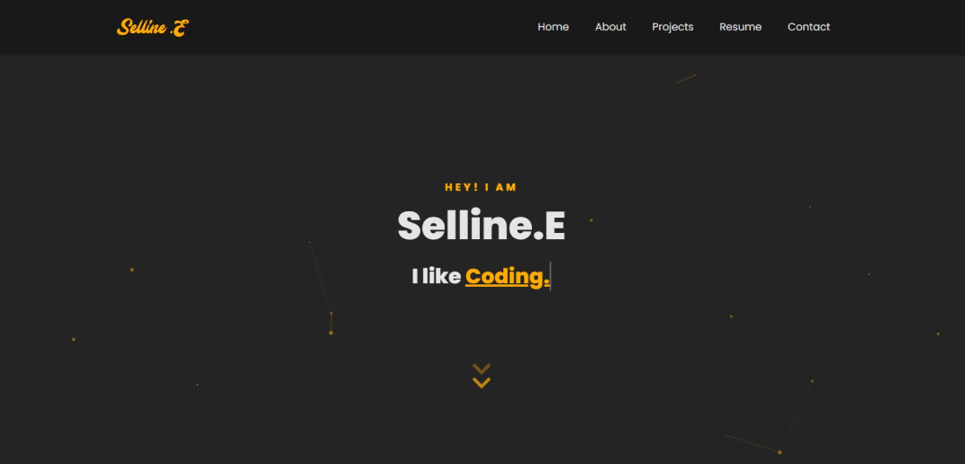

**4.3 Task 3: API Integration**

To integrate external APIs using JavaScript to dynamically fetch and display real-time data on the web page, enhancing functionality and user engagement.

**Coding:**

**Index.html**

<!DOCTYPE html>

<html lang="en">

  <head>

    <meta charset="utf-8" />

    <link rel="icon" href="%PUBLIC_URL%/favicon.ico" />

    <meta name="viewport" content="width=device-width, initial-scale=1" />

    <meta name="theme-color" content="#000000" />

    <meta

      name="description"

      content="Web site created using create-react-app"

    />

    <link rel="apple-touch-icon" href="%PUBLIC_URL%/logo192.png" />

    <link rel="manifest" href="%PUBLIC_URL%/manifest.json" />

    <title>React App</title>

  </head>

  <body>

    <noscript>You need to enable JavaScript to run this app.</noscript>

    <div id="root"></div>

</body>

</html>

**Index.css**

body {

  margin: 0;

  font-family: -apple-system, BlinkMacSystemFont, 'Segoe UI', 'Roboto', 'Oxygen',

    'Ubuntu', 'Cantarell', 'Fira Sans', 'Droid Sans', 'Helvetica Neue',

    sans-serif;

  -webkit-font-smoothing: antialiased;

  -moz-osx-font-smoothing: grayscale;

}

code {

  font-family: source-code-pro, Menlo, Monaco, Consolas, 'Courier New',

    monospace;

}

**Index.js**

import React from 'react';

import ReactDOM from 'react-dom/client';

import './index.css';

import App from './App';

import reportWebVitals from './reportWebVitals';

const root = ReactDOM.createRoot(document.getElementById('root'));

root.render(

  <React.StrictMode>

    <App />

  </React.StrictMode>

);

**OUTPUT :**





**4.4 Task 4: Interactive Button**

To create a dynamic button that changes appearance or triggers an action when clicked, enhancing user interaction and engagement on the web page.

**Coding:**

**Index.html**

<!DOCTYPE html>

<html lang="en">

<head>

<meta charset="UTF-8">

<meta name="viewport" content="width=device-width, initial-scale=1.0">

<title>E-commerce Homepage</title>

<link rel="stylesheet" href="styles.css">

</head>

<body>

<!-- Header -->

<header class="header">

<div class="container">

<h1 class="logo">ShopEasy</h1>

<nav class="nav">

<ul>

<li><a href="#home">Home</a></li>

<li><a href="#products">Products</a></li>

<li><a href="#about">About</a></li>

<li><a href="#contact">Contact</a></li>

</ul>

</nav>

</div>

</header>

<!-- Banner Section -->

<section class="banner">

<h2>Discover Amazing Products</h2>

<p>Quality products at affordable prices.</p>

<a href="#products" class="btn">Shop Now</a>

</section>

<!-- Product Section -->

<section id="products" class="products">

<div class="container">

<h2>Featured Products</h2>

<div class="product-list">

<!-- Product Item 1 -->

<div class="product">

<img src="product1.jpg" alt="Product 1">

<h3>Product 1</h3>

<p>$25.00</p>

<button class="btn">Add to Cart</button>

</div>

<!-- Product Item 2 -->

<div class="product">

<img src="product2.jpg" alt="Product 2">

<h3>Product 2</h3>

<p>$30.00</p>

<button class="btn">Add to Cart</button>

</div>

<!-- Product Item 3 -->

<div class="product">

<img src="product3.jpg" alt="Product 3">

<h3>Product 3</h3>

<p>$45.00</p>

<button class="btn">Add to Cart</button>

</div>

</section>

**Styles.css**

* {

margin: 0;

padding: 0;

box-sizing: border-box;

font-family: Arial, sans-serif;

}

Body

{ color: #333;

line-height: 1.6;

}

.header {

background-color: #333;

color: #fff;

padding: 1rem 0;

}

.header .container {

display: flex;

justify-content: space-between;

align-items: center;

}

.logo

{

font-size: 1.5rem;

}

.product p {

font-size: 1.1rem;

margin-top: 0.5rem;

}

.product {

background: #fff;

border: 1px solid #ddd;

padding: 1rem;

border-radius: 5px;

width: 30%;

padding: 1rem;

margin-bottom: 1.5rem;

text-align: center;

box-shadow: 0 4px 8px rgba(0, 0, 0, 0.1);

transition: transform 0.3s ease;

}

.product:hover {

transform: translateY(-5px);

}

.footer {

background-color: #333;

color: #fff;

padding: 1rem 0;

text-align: center;

}

.footer p

{ margin-bottom: 0.5rem;

}

.footer a {

color: #ff6b6b;

text-decoration: none;

}

**OUTPUT :**



**5.CONCLUSION AND FUTURE WORK**

**5.1 Conclusion**

The internship at Cognifyz Technologies was an invaluable learning experience that significantly expanded knowledge and skills in web development. Through hands-on projects, it provided an opportunity to apply theoretical concepts in practical scenarios, allowing for a deeper understanding of web technologies like HTML, CSS, and JavaScript. The introduction to industry-standard frameworks, such as Bulma, enhanced proficiency in building responsive, user-friendly web applications.

The collaborative environment at Cognifyz Technologies fostered personal and professional growth, enhancing teamwork and communication skills, which are vital for any development project. Constructive feedback from mentors and peers played a key role in sharpening coding and design practices, encouraging a mindset of continuous learning and improvement.

During the internship, a front-end development intern is expected to work closely with experienced developers and project managers, contributing to ongoing projects and receiving mentorship. This mentorship is crucial for interns, as it allows them to learn industry best practices, coding standards, and the importance of teamwork in a professional setting. Interns also gain exposure to the development lifecycle, which includes stages such as planning, designing, coding, testing, debugging, and deploying web applications.

**5.2 Future Work**

In the future, there are plans to build upon the skills and experiences gained during the internship at Cognifyz Technologies. The focus will be on deepening knowledge of web development, particularly through advanced JavaScript

frameworks such as React, Angular, or Vue.js, which will enable the creation of more dynamic and interactive applications. Expanding expertise into full-stack development is also a goal, involving the learning of server-side languages, databases, and APIs to gain a comprehensive understanding of front-end development.

Additionally, there will be an emphasis on enhancing skills in responsive design and mobile-first development to ensure that websites are user-friendly across various devices. Understanding user experience (UX) design principles is essential, with plans to study effective methodologies that help design intuitive and engaging interfaces.

Continuing the use of version control systems like Git is important for collaboration and project management, along with exploring tools like GitHub to improve workflow efficiency. A commitment to lifelong learning and staying current with industry trends will drive engagement in online courses, workshops, and community events. Networking with other professionals in the tech field will also be prioritized, as sharing knowledge and experiences can significantly enhance the development journey.

Overall, the future holds exciting opportunities for growth as a developer, with a strong foundation laid during the internship that has sparked a passion for web development.Future work related to the web development internship at Cognifyz Technologies could focus on the following areas:

1. **Enhancing JavaScript Skills:** Delve deeper into advanced JavaScript features, including ES6+ syntax, async programming, and working with frameworks like React, Angular, or Vue.js to create more interactive and dynamic web applications.
2. **Exploring Full-Stack Development:** Expand knowledge beyond front-end development by learning back-end technologies such Node.js,

Express, and databases like MongoDB or SQL. This will enable the creation of full-stack web applications, integrating both the client-side and server-side seamlessly.

1. **Improving Responsive Design:** Build on the responsive design principles learned during the internship by mastering more complex layout techniques, such as CSS Grid and Flexbox, to ensure that web applications are optimized for a wide range of devices, including mobile, tablet, and desktop.
2. **Advanced Front-End Frameworks:** Further explore and implement popular CSS frameworks like Bulma, Bootstrap, or Tailwind CSS for building clean and efficient front-end designs that follow modern design standards and trends.
3. **Building Real-World Projects:** Use the foundational skills gained during the internship to work on more complex, real-world projects, such as ecommerce sites, portfolio websites, or web-based tools. This will provide hands-on experience in tackling common industry challenges.
4. **Version Control and Team Collaboration:** Continue using Git and explore

collaboration tools like GitHub or GitLab to manage larger projects and contribute to open-source projects. This will help in building teamwork skills and familiarity with collaborative development workflows.

1. **Performance Optimization:** Focus on web performance optimization techniques, such as minimizing load times, using lazy loading for images, and optimizing code for faster execution. This will lead to creating faster and more efficient web applications

**6.REFERENCES**

**1.** [**https://developer.mozilla.org/en-US/docs/Learn/Forms/Form_validation**](https://developer.mozilla.org/en-US/docs/Learn/Forms/Form_validation)

**2.** [**https://chatgpt.com/c/6729f9d7-4e04-800b-9f12-fa0fbecaf0cb**](https://chatgpt.com/c/6729f9d7-4e04-800b-9f12-fa0fbecaf0cb)

**3.**[**https://www.smashingmagazine.com/2011/01/guidelines-for-responsive-web-design/**](https://www.smashingmagazine.com/2011/01/guidelines-for-responsive-web-design/)