***Newspapers Seller Problem***

**Report Component**

**Part 1:**

**Problem formulation:** The problem is about a Newspaper seller that want to know how many bundles of Newspaper to buy every day. And that decision is based on many constraints, one of them is the Newsday type, is it Excellent, Good, or Poor. So, this simulation while answer seller's question.

**Objectives:** To know the optimal # of papers the seller should buy to increase his profit

**Part 2:**

**a -System Components:**

|  |  |
| --- | --- |
| **Newspapers Selling** | **System** |
| **Newspapers** | **Entities** |
| **Buying price, selling price, scrap price, bundles number.** | **Attributes** |
| **Newsday type** | **Activities** |
| **Selling a paper as demanded, Selling a paper as scrap.** | **Events** |
| **Number of sold papers, # of scrap papers** | **State Variables** |

**b -System analysis:**

**b.1**

**Random digit assignment for type of Newsday**

|  |  |  |  |
| --- | --- | --- | --- |
| **Intervals Random digit** | **Cumulative prob.** | **Probability** | **Type of Newsday** |
| **1-18** | **0.18** | **0.18** | **Excellent** |
| **19-60** | **0.6** | **0.42** | **Good** |
| **61-92** | **0.92** | **0.32** | **Fair** |
| **93-00** | **1** | **0.08** | **Poor** |

**Random digit assignment for newspaper demanded**

|  |  |  |  |  |  |  |  |  |
| --- | --- | --- | --- | --- | --- | --- | --- | --- |
| **Random digit intervals** | | | | **Cumulative distribution** | | | | **Demand** |
| **Poor** | **Fair** | **Good** | **Excellent** | **Poor** | **Fair** | **Good** | **Excellent** |  |
| **01-42** | **01-15** | **01-06** |  | **0.42** | **0.15** | **0.06** | **0.00** | **40** |
| **43-70** | **16-37** | **07-15** | **01-07** | **0.7** | **0.37** | **0.15** | **0.07** | **50** |
| **71-84** | **38-65** | **16-31** | **08-15** | **0.84** | **0.65** | **0.31** | **0.15** | **60** |
| **85-94** | **66-83** | **32-50** | **16-27** | **0.94** | **0.83** | **0.5** | **0.27** | **70** |
| **95-99** | **84-93** | **51-78** | **28 - 40** | **0.99** | **0.93** | **0.78** | **0.4** | **80** |
| **0** | **94-98** | **79-90** | **41-62** | **1** | **0.98** | **0.9** | **0.62** | **90** |
|  | **99-0** | **91-97** | **63-85** |  | **1** | **0.97** | **0.85** | **100** |
|  |  | **98-0** | **86-93** |  |  | **1** | **0.93** | **110** |
|  |  |  | **94-0** |  |  |  | **1** | **120** |

**b.2- GUI/ Calendar table (for 20 days):**

**Simulation table for purchase of 80 newspaper**

|  |  |  |  |  |  |  |  |  |  |
| --- | --- | --- | --- | --- | --- | --- | --- | --- | --- |
| **Daily profit** | **Salvage from sale of scrap** | **Lost profits from excess Demand** | **Revenue from sales** | **Demand** | **RN for Demand** | **Type of Newsday** | **RN of Newsday type** | **Day** | |
| **-** | **4.50** | **-** | **35.00** | **50** | **25** | **Fair** | **80** | **1** | |
| **5** | **3.00** | **-** | **42.00** | **60** | **25** | **Good** | **33** | **2** | |
| **10.5** | **1.50** | **-** | **49.00** | **70** | **43** | **Good** | **27** | **3** | |
| **5** | **3.00** | **-** | **42.00** | **60** | **39** | **Fair** | **72** | | **4** |
| **21** | **-** | **2** | **63.00** | **90** | **87** | **Good** | **37** | **5** | |
| **6** | **6.00** | **-** | **28.00** | **40** | **4** | **Good** | **19** | **6** | |
| **36.4** | **-** | **0.6** | **77.00** | **110** | **98** | **Good** | **28** | **7** | |
| **5** | **3.00** | **-** | **42.00** | **60** | **61** | **Fair** | **77** | **8** | |
| **-** | **6.00** | **-** | **28.00** | **40** | **3** | **Fair** | **67** | **9** | |
| **62** | **-** | **-** | **56.00** | **80** | **65** | **Good** | **51** | **10** | |
| **5** | **3.00** | **-** | **42.00** | **60** | **54** | **Fair** | **91** | **11** | |
| **-** | **4.50** | **-** | **35.00** | **50** | **12** | **Good** | **42** | **12** | |
| **-** | **6.00** | **-** | **28.00** | **40** | **10** | **Fair** | **64** | **13** | |
| **10.5** | **1.50** | **-** | **49.00** | **70** | **24** | **Excellent** | **9** | **14** | |
| **10.5** | **1.50** | **-** | **49.00** | **70** | **37** | **Good** | **51** | **15** | |
| **10.5** | **1.50** | **-** | **49.00** | **70** | **70** | **Fair** | **84** | **16** | |
| **10.5** | **1.50** | **-** | **49.00** | **70** | **43** | **Good** | **40** | **17** | |
| **10.5** | **1.50** | **-** | **49.00** | **70** | **32** | **Good** | **31** | **18** | |
| **10.5** | **1.50** | **-** | **49.00** | **70** | **87** | **Poor** | **98** | **19** | |
| **62** | **-** | **-** | **56.00** | **80** | **33** | **Excellent** | **12** | **20** | |
|  |  |  |  |  |  |  |  |  | |

In the simulation process for day 1:

- First, we have to discover the type of such Newsday:

with the help of the random number (Col. 2) we found that the type of the first day is a fair one (Col. 3).

- Second we must find out the amount of demand on such day:

with the help of the random number (Col. 4), we found that the amount of demand on such day is 50 newspapers (Col. 5)

-. The daily profit of that day depends on:

the revenue from sale (Col. 6), the newsman has already 80 newspapers, and he sold 50, so the revenue from sale

Revenue =sold * selling price = 50 * 70 = 3500 $.

-fixed Cost of newspapers:

since that the newsman has already 80 newspapers, so the

**Cost = Purchasing price*newspaper=50*80=4000/100=40$**

note: the newsman will buy 80 newspapers for the following 20 days, and hence the cost of newspapers will remain the same for the rest of the simulated days as a constant value.

-Lost from Excess demand (Col. 7): since that the newsman has already 80 newspapers, and he sold 50, so there is no any loss due to excess demand =0$. ,In case there is lost

**Lost from Excess demand =(#newspaper-#sold) *(selling price-purchasing price)/100**

- Salvage from sale of scrap: newsman has already 80 newspapers, and he sold 50, so there will remain 30 units unsold. These unsold units will be sold as scrap for 15 cent each by the end of the day

**Salvage from sale of scrap = (#newspaper-#sold) * scrap price =30 ×15 = 450/100=4.5 $.**

-Daily profit of that day based on the equation given in the header of the problem: The daily **profit =Profit = [(revenue from sales) – (cost of newspapers) – (lost profit from excess demand) + (salvage from sale of scrap papers)]**

**Part 3:**

**Experimental Design Parameters**:

Experimental design creates a set of procedures to systematically [test a hypothesis](https://www.scribbr.com/statistics/hypothesis-testing/). A good experimental design requires a strong understanding of the system you are studying, There are five key steps in designing an experiment:

* variables and how they are related:

define variables to control it in two ways (**Control Statistically & Control Experimentally)**

-Independent variable: purchase price, sell price, scrap price, demand

-Dependent variable: profit, cost price ,revenue, Lost from Excess demand, Salvage from sale of scrap.

* specific, testable [hypothesis](https://www.scribbr.com/methodology/hypothesis/)

We have 3 hypotheses:

-In case demand less than Available Papers

-In case demand bigger than Available Papers

-In case demand equal Available Papers

* Design experimental treatments to manipulate independent

How you manipulate the independent variable can affect the experiment’s [external validity](https://www.scribbr.com/methodology/internal-vs-external-validity/) – that is, the extent to which the results can be [generalized](https://www.scribbr.com/research-bias/generalizability/) and applied to the broader world , need to decide how **widely** to vary your independent variable.

* Assign subjects to groups, either between-subjects or within-subjects

How you apply your experimental treatments to your test subjects is crucial for obtaining [valid and reliable](https://www.scribbr.com/methodology/reliability-vs-validity/) results.

First, experiment’s[statistical power](https://www.scribbr.com/statistics/statistical-power/) , which determines how much confidence you can have in your results.

Then, [randomly assign](https://www.scribbr.com/methodology/random-assignment/) your subjects. Each group receives a different level of the treatment

Finally, [**control group**](https://www.scribbr.com/methodology/control-group/), which receives no treatment. The control group tells us what would have happened to your test subjects without any experimental intervention.

* Plan how will measure dependent variable

Finally, need to decide how you’ll collect data on your dependent variable outcomes from independent variable . should aim for [reliable and valid](https://www.scribbr.com/methodology/reliability-vs-validity/) measurements that minimize [research bias](https://www.scribbr.com/faq-category/research-bias/) or error.

**Justification of experiment parameters values**

* Variable :

**Control Statistically:** according to average difference measure profit rather than the average profit per treatment group.

**Control Experimentally: using random digit assignment with specific range.**

* [hypothesis](https://www.scribbr.com/methodology/hypothesis/):

case1: there is no loss from excess demand but will have unsold newspaper as scrap

Demand [Day] less than available:

sold = Demand [Day], available =available-Demand [Day], scrap=available ,

Lost from Excess demand =0

Case 2: there is loss from excess demand but will have not unsold newspaper as scrap

Demand [Day] greater than bundles:

sold = bundle, scrap=0, loss from excess demand =(Demand [Day]-sold)

case 3: there is no loss from excess demand either or unsold newspaper as scrap

sold = Demand [Day] , available = 0, scrap=0, loss from excess demand = 0

* treatments to manipulate independent variable for example:

First, you may need to decide how **widely**to vary your independent variable

-sell price: You can choose to increase selling price.

--just slightly above the natural range for study region.

--over a wider range of natural sell price.

--over an extreme range that is beyond any possible natural variation.

Second, you may need to choose how finely to vary your independent variable.

-demand: You can choose to treat demand use as:

--a [categorical variable](https://www.scribbr.com/methodology/types-of-variables/#quantitative-vs-categorical): either as binary (yes/no) or as levels of a factor (no demand use, low demand use , high demand use).

--a [continuous variable](https://www.scribbr.com/methodology/types-of-variables/#quantitative-vs-categoricalhttps://www.scribbr.com/methodology/types-of-variables/) (profit of demand use measured every day).

* Assign subjects to groups

When assigning your subjects to groups, there are two main choices you need to make:

1. A completely randomized design vs a randomized block design.

In a completely randomized design,

every subject is assigned to a treatment group at random.

In a randomized block design

 subjects are first grouped according to a characteristic they share, and then randomly assigned to treatments within those groups.

1. A between-subjects design vs a within-subjects design.

In a [between-subjects design](https://www.scribbr.com/methodology/between-subjects-design/) : individuals receive only one of the possible levels of an experimental treatment.

In medical or social research: you might also use **matched pairs** within your between-subjects design.

In a [**within-subjects design**](https://www.scribbr.com/methodology/within-subjects-design/) : every individual receives each of the experimental treatments consecutively, and their responses to each treatment are measured.

* measure dependent variable

for example: revenue dependent variable

ask for what is selling price and #of sold newspaper

**Part 4:**

**a. Questions:**

1- Determine the optimal number of papers the seller should purchase to increase his profit?

**Ans: Optimal number is 80 Newspapers.**

2- How does the price of selling price and selling unsold scrap price, affect your answer (the optimal number to purchase) in the previous question (1)?

**Ans: while increasing selling price the optimal number to purchase**

**Doesn’t change, on other hand while decreasing selling price the optimal number to purchase increase to 100 newspapers.**

3- How does the size of bundle used to purchase newspapers affect your answer (the optimal number to purchase) in the previous question (1)?

**Answer: When we increase the size of bundle from 20 to 30, the optimal number to purchase increase to 100 newspaper , on other hand while decreasing size of bundle from 20 to 5 the optimal number to purchase no change 80 newspaper.**

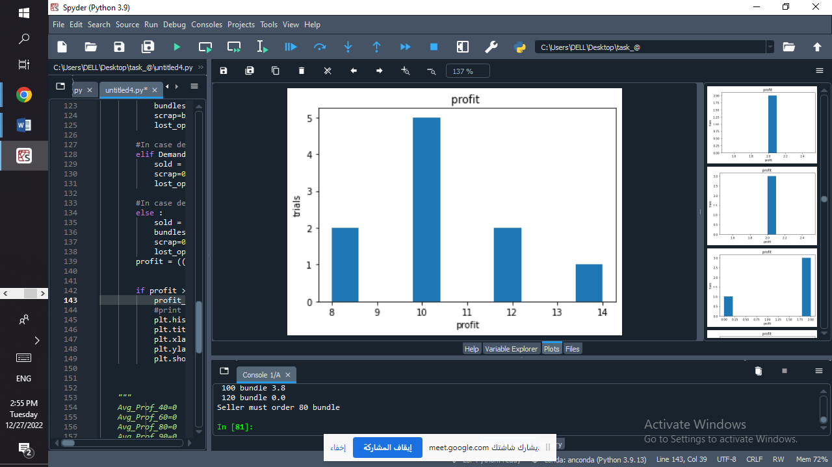 **b. Graphs**

**c. Conclusion**

Experiments are always context-dependent, and a good experimental design will take into account all of the unique considerations of your study system to produce information that is both valid and relevant to your research question.

Profit Dependent variable is affected by the number of papers the seller should purchase based on independent variables like selling, purchase and scrap prices.

Finally, we get that the optimal number of papers the seller should purchase to increase his profit is 80 Newspaper.