Leeds Beckett University

Building Star Schema for Police department

by Ala Mohammed

Content

introduction

Task 1

Version 1

Version 2

SCD

Data Dictionary Star Schema

Data Dictionary - ETL

Task 2

Task 3

References

Appendix

introduction

In this report, we are going to build two Star Schema (SS) to address the data coming from a police department. Version 1 will more sophisticated one which will be addressing the issue of rape and serious sexual offences (RASSO). Version 2 will be simpler SS and will take it further to the coding stage and will implement some Extract Transform Load (ETL). The data is about the crimes that took place in different parts of the UK. Data like when the crime was reported, the type of crime, status of the crime and location. As well as records of different stations and employees. However, in version 2 we are going to be focusing our star schema on a specific KPI. The KPI chosen for this star schema is to identify areas with crime hotspots.
The three reports that this SS support:
- Number of crimes per station per year
- Top three stations with the highest number of crimes
- Number of closed crimes in each station
We have chosen two dimensions for our SS, time and station. For time, it will be necessary to have a line dimension that is going to explain how frequently crimes are happening in registered station. Station dimension will answer the question of where, so our SS is answering the questions of where and when. This is a helpful SS because it is going to give the decision makers an idea of where there is a station with high number of crimes happening at, so they give more resources to the station in order to minimise the number of crimes. For the granularity, due to the computing power we have, we tried to make it as simple as possible. Otherwise, having for example the day as the lowest granularity will help tremendously in identifying which days has the highest reported crimes which could be for instance on weekends and that tell us something about the situation.

Task 1

Version 1
The Crown Prosecution Service (CPS) has published an article in 2021 to address the seriousness of the RASSO and suggest an action plan. CPS demonstrated in the report that the number of RASSO cases are increasing every day and only few of them make it to court. Additionally, to understand how the police is dealing with such cases we have to see the KPIs used to measure the effectiveness of their approaches. According to a paper released by Collage of Police (2023) about the KPIs they use to measure how good their dealing with the RASSO. The paper went though many KPIs that measure different aspects of a crime. In this report we will be focusing on Aim three in the Collage of Police’s report which is reduction and prevention of RASSO. The KPI suggested is ‘Monitor the proportion of named RASSO suspects who are repeat suspects’. This will enable the police officers to identify any pattern with specific individuals.
Now we are going to build a simple star schema (SS) using the suggested report. The SS will have three dimensions and fact table. The fact table can tell you whether the same suspect has been reported in several incidents. The incident_id is the primary key for the fact table and when there are more than one incident_id with the same suspect_id, that will make is_repeat_suspect True. This simple design can help identify individuals with criminal behavioural pattern.

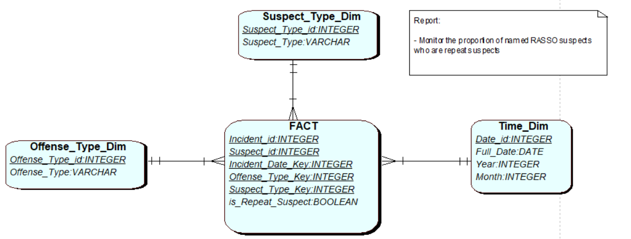
Version 2
The table below shows you how we started on to build our second SS. We started listing all the possible reports that goes with our KPI and then extract the attributes needed for these reports and set the lowest granularity. Then we go to identify all the characteristics of our SS.

List & clarify relevant business question(s) that need to be answered
-Number of crimes per station per year
-Top three stations with the highest number of crimes
-Number of closed crimes in each station
What Dimension tables are required (name them eg time_dim)
Time_dim, station_dim
Identify lowest level of granularity (for each Dimension)
LG for time_dim is year
LG for station_dim is station name
Identify the measures to support the business questions (calculations or facts)
Reported_crimes
Closed_crimes
Define (name, data type) suitable attributes of the Dimension tables
Time_dim:
Time_id INTEGER
Year INTEGER

Station_dim:
Station_id INTEGER
Station_name VARCHAR
Define (name, data type) the Fact table (keys and measures)
Fact_crimes:
Report_id INTEGER PK
Station_id INTEGER FK
Time_id INTEGER FK
Reported_crimes INTEGER
Closed_crimes INTEGER
Draw the Star Schema (using QSEE) and create a table (in word) to illustrate the data for each table in the star schema.
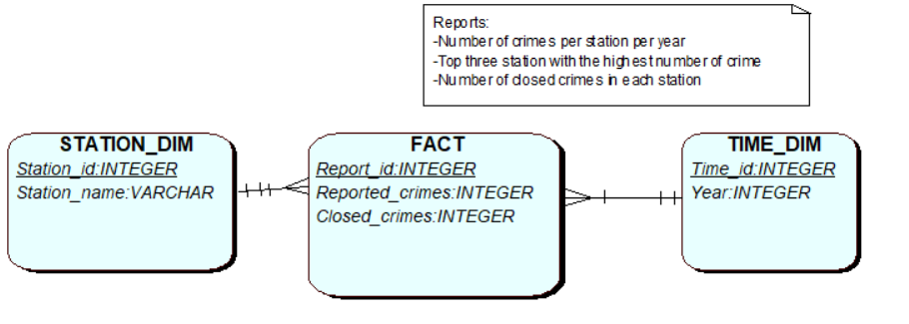

In the table below, we are showing how our SS would look like and how it achieves one our reports. The report is Number of closed crimes per station. we also add an SQL query that is going to produce the table for us.

Example Data in SS:
Time_dim:
Time_id | 1 | 2 | 3 |  | Fact:
Year | 2017 | 2021 | 2022 |  | Report_id | 1 | 2 | 3
 |  |  |  |  | Station_id | 2 | 1 | 3
Station_dim: |  |  |  |  | Time_id | 1 | 3 | 2
Station_id | 1 | 2 | 3 |  | Reported_crimes | 204 | 345 | 100
Station_name | Kings Cross | Lawnswood | Beeston |  | Closed_crimes | 40 | 35 | 15

Select Station_name, closed_crimes From Station_dim a, Fact f Where a.station_id = f.station_id AND Group by Station_name;

SCD

This star schema is also considering where there might be a SCD (slowly changing dimension). Type 1 and 2 are the best options in case the dimension name changed. In this SS, the only factor that could possibly be adjusted is the station dimension. Therefore, in case one of stations name changed let’s say for example Beeston to North Beeston. We can implement type one if the history data are not significant and if not type 2 is best to use. Furthermore, we chose type 2 where we keep the old data and add a new record for the same product with creating a new column in the table called ‘effective_date’ and ‘end_date’. This way we can see when the old name was effective from and when it ends.

Data Dictionary Star Schema  SS Definitions |  |  |  | Mapping/ Data Source
Dimension | Attribute Name | Data Type | Key | Data Sources |  | Data Sources Type | Definition: | Notes
Time_Dim | time_id | NUMBER | Primary | Surrogate key |  | NUMBER | This is the unique Identifier of time, e.g. 1, 2, 3,
 | Year | NUMBER | NO | PL_REPORTED_CRIME.DATE_REPORTED | CRIME_REGISTER.REPORTED_DATE | Date | The year of the crime | Will take data from two sources and be merged in this dimension.
Station_dim | Station_id | NUMBER | Primary | Surrogate key |  | NUMBER | This is the unique Identifier of station e.g. 1, 2, 3,
 | Station_name | VARCHAR | NO | PL_STATION.STATION_NAME | LOCATION.CITY_NAME | VARCHAR | The registered station name | Will take data from two sources and be merged in this dimension.  As well as the DQ issue regarding the naming of the stations.
Fact_crime | Report_id | NUMBER | Primary | Surrogate key |  | NUMBER | This is the unique Identifier of the fact table e.g. 1, 2, 3,
 | Reported_crime | NUMBER | NO | This is a measure table, so it is going to be calculated using two tables:  CRIME_REGISTER and PL_REPORTED_CRIME |  | NUMBER | The total reported crime
 | Closed_crimes | NUMBER | NO | This is a measure table, so it is going to be calculated using two tables:  CRIME_REGISTER and PL_REPORTED_CRIME |  | NUMBER | The crimes that have been closed | There is some data quality issue that has to be dealt with; different input same meaning. E.g. ‘open’ and ‘OPEN’

Extract  Data Dictionary - ETL |  |  |  |  | Transform |  |  | Load
Database Source (s) | Field  Attribute | Data Type | Key | Table Name | Data Quality Check | Data quality Issues | Action Note | SS table | SS Column/Data Type | Key | Notes
PRCS | DATE_REPORTED | Date | No | PL_REPORTED_CRIME | Wrong format | Full year and we need only the year | Transform the data to year only. | Time_dim | Time_id/NUMBER | PK | Sequence population, using a surrogate key
PS_wales |  | Date | No | CRIME_REGISTER | Wrong format | Full year and we need only the year | Transform the data to year only. |  | Year/NUMBER |  | Insert values after fixing the format of the date in the staging area.
Definition: | Is the date when the crime occurred.
Notes: | DATE_REPORTED or REPORTED_DATE exist in both databases but with different name but with same meaning.
PRCS | Location | VARCHAR2 | No | PL_STATION | Inconsistency | Same records but different formats | Used the distinct and upper function to get rid of all the duplication | Station_dim | Station_id/NUMBER | PK | Sequence population, using a surrogate key
PS_wales |  | VARCHAR2 | No | Location | Inconsistency | Same records but different formats | Used the distinct and upper function to get rid of all the duplication |  | Station_name/ VARCHAR2 |  | Data from the two sources has the same DQ issue and needed fixing.
Definition: | The location of the crime.
Notes: | The data is all form places from the UK.

Task 2:
--------------------------------------------------------------
-- Database creation Script

-- Auto-Generated by QSEE-SuperLite (c) 2001-2004 QSEE-Technologies Ltd.

-- Verbose generation: ON

-- note: spaces within table/column names have been replaced by underscores (_)

-- Target DB: SQL2

-- Entity Model :Entity Relationship Diagram

-- To drop the tables generated by this script run -
-- 'C:\Users\alaax\OneDrive - Leeds Beckett University\Modules\Data Science 3\ADS\Assignment_1SS_drop.sql'

--------------------------------------------------------------

-- Drop tables --

DROP TABLE F_reported_crimes;

DROP TABLE station_DIM;

DROP TABLE TIME_DIM;

--------------------------------------------------------------
-- Table Creation --

-- Each entity on the model is represented by a table that needs to be created within the Database.
-- Within SQL new tables are created using the CREATE TABLE command.
-- When a table is created its name and its attributes are defined.
-- The values of which are derived from those specified on the model.
-- Certain constraints are sometimes also specified, such as identification of primary keys.

-- Create a Database table to represent the "FACT" entity.
CREATE TABLE F_reported_crimes(
Report_id INTEGER NOT NULL,
Reported_crimes INTEGER,
Closed_crimes INTEGER,
fk1_station_id INTEGER NOT NULL,
fk2_Time_id INTEGER NOT NULL,
-- Specify the PRIMARY KEY constraint for table "F_reported_crimes_table".
-- This indicates which attribute(s) uniquely identify each row of data.
CONSTRAINT pk_F_reported_crimes PRIMARY KEY (Report_id)
);

-- Create a Database table to represent the "STATION_DIM" entity.
CREATE TABLE STATION_DIM(
Station_id INTEGER NOT NULL,
Station_name VARCHAR(20) NOT NULL UNIQUE,
-- Specify the PRIMARY KEY constraint for table "STATION_DIM".
-- This indicates which attribute(s) uniquely identify each row of data.
CONSTRAINT pk_STATION_DIM PRIMARY KEY (Station_id)
);

-- Create a Database table to represent the "TIME_DIM" entity.
CREATE TABLE TIME_DIM(
Time_id INTEGER NOT NULL,
Year INTEGER NOT NULL UNIQUE,
-- Specify the PRIMARY KEY constraint for table "TIME_DIM".
-- This indicates which attribute(s) uniquely identify each row of data.
CONSTRAINT pk_TIME_DIM PRIMARY KEY (Time_id)
);

--------------------------------------------------------------
-- Alter Tables to add fk constraints --

-- Now all the tables have been created the ALTER TABLE command is used to define some additional
-- constraints. These typically constrain values of foreign keys to be associated in some way
-- with the primary keys of related tables. Foreign key constraints can actually be specified
-- when each table is created, but doing so can lead to dependency problems within the script
-- i.e. tables may be referenced before they have been created. This method is therefore safer.

-- Alter table to add new constraints required to implement the "FACT_STATION_DIM" relationship

-- This constraint ensures that the foreign key of table "FACT"
-- correctly references the primary key of table "STATION_DIM"

ALTER TABLE F_reported_crimes ADD CONSTRAINT fk1_FACT_to_STATION_DIM FOREIGN KEY(fk1_Station_id) REFERENCES STATION_DIM(Station_id);

-- Alter table to add new constraints required to implement the "FACT_TIME_DIM" relationship

-- This constraint ensures that the foreign key of table "FACT"
-- correctly references the primary key of table "TIME_DIM"

ALTER TABLE F_reported_crimes ADD CONSTRAINT fk2_FACT_to_TIME_DIM FOREIGN KEY(fk2_Time_id) REFERENCES TIME_DIM(Time_id);

--------------------------------------------------------------
-- End of DDL file auto-generation
--------------------------------------------------------------

Evidence of the code working:
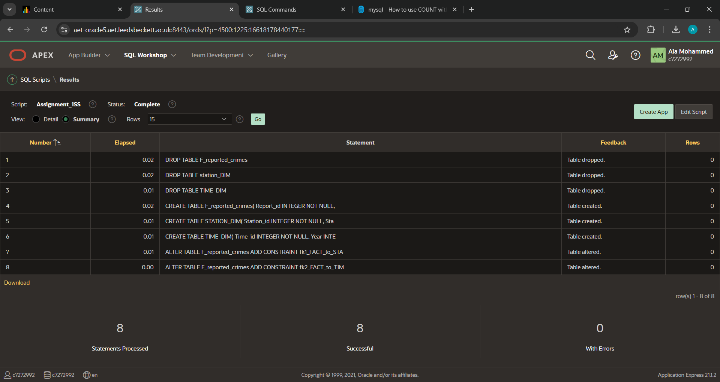

Task 3:

In this task we are going to implement the ETL for our SS. First we run the script generated from task 2 to drop the tables and create them. Then, we can run our ETL script:
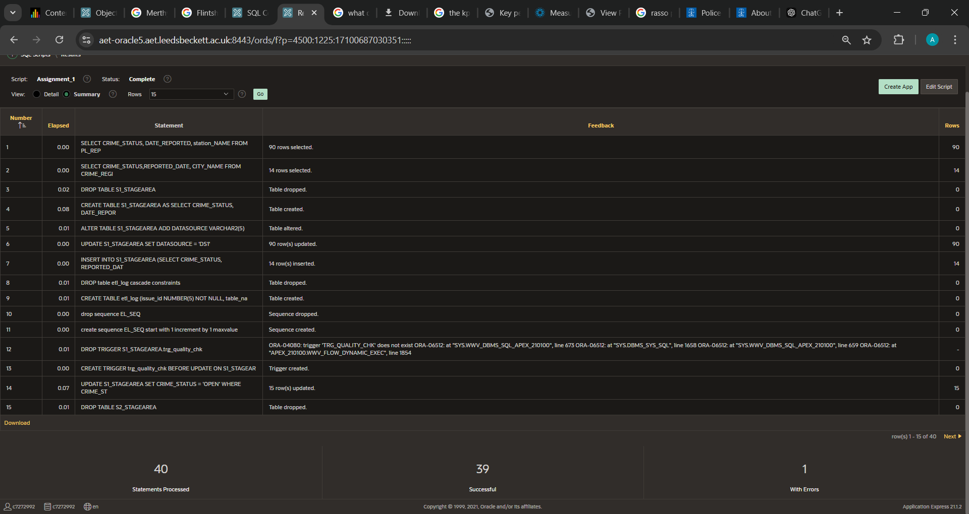

The error is from dropping the trigger statement. See appendix for code.

References

Collage of Policing (2023) Measuring success – key performance indicators for forces. [Online]. UK: Collage of Policing. <https://www.college.police.uk/national-operating-model-rasso/measuring-success-transparency-and-data> [Accessed 20 December 2024]

CPS (2021) Police-CPS Joint National RASSO (Rape and Serious Sexual Offences) Action Plan 2021. [Online].London:CPS. Available from <https://www.cps.gov.uk/publication/police-cps-joint-national-rasso-rape-and-serious-sexual-offences-action-plan-2021> [Accessed 20 December 2024]

Appendix:

-- Extract
-- we are going to extract teh data from PRCS (Data Source 1) and PS_wales (Data Source 2).

-- Data Source 1
SELECT CRIME_STATUS, DATE_REPORTED, station_NAME FROM PL_REPORTED_CRIME R, PL_STATION S
Where R.FK2_STATION_ID = S.STATION_ID;

-- Data Source 2
SELECT CRIME_STATUS,REPORTED_DATE, CITY_NAME FROM CRIME_REGISTER C, LOCATION L
Where L.LOCATION_ID = C.LOCATION_ID;

-- Start and creat Stage area 1:
DROP TABLE S1_STAGEAREA;
CREATE TABLE S1_STAGEAREA AS SELECT CRIME_STATUS, DATE_REPORTED, station_NAME FROM PL_REPORTED_CRIME R, PL_STATION S
Where R.FK2_STATION_ID = S.STATION_ID;

-- add a column that says the source of the data.
ALTER TABLE S1_STAGEAREA
ADD DATASOURCE VARCHAR2(5);
UPDATE S1_STAGEAREA SET DATASOURCE = 'DS1';

INSERT INTO S1_STAGEAREA (SELECT CRIME_STATUS, REPORTED_DATE, CITY_NAME, 'DS2' FROM CRIME_REGISTER C, LOCATION L
Where L.LOCATION_ID = C.LOCATION_ID);

-- Before moving on with qquality checks, we are going to create a trigger that log any changes happen to the data.
DROP table etl_log cascade constraints;

CREATE TABLE etl_log
(issue_id NUMBER(5) NOT NULL,
table_name VARCHAR2(20),
data_error_code NUMBER(5),
issue_desc VARCHAR2(50),
issue_date DATE,
issue_status VARCHAR2(20),
status_update_date DATE);

drop sequence EL_SEQ;
create sequence EL_SEQ
start with 1
increment by 1
maxvalue 10000
minvalue 1;

-- Drop the existing trigger
DROP TRIGGER S1_STAGEAREA.trg_quality_chk;

-- Create the new trigger
CREATE TRIGGER trg_quality_chk
BEFORE UPDATE ON S1_STAGEAREA
FOR EACH ROW
BEGIN
INSERT INTO ETL_log
(issue_id, table_name, data_error_code, issue_desc, issue_date, issue_status, status_update_date)
VALUES
(
EL_SEQ.NEXTVAL,
'S1_STAGEAREA',
'0',
'Quality checks',
SYSDATE,
'completed',
SYSDATE
);
END;
/

-- Data Quality checks and transformation on S1_STAGEAREA:
-- the dealing with the date issue (making it only year)
-- change 'ESCALATE' to 'OPEN'
-- the locations data may have have some dublication

-- Quality cheack - change escalate to open for easier calculation
UPDATE S1_STAGEAREA SET CRIME_STATUS = 'OPEN' WHERE CRIME_STATUS ='ESCALATE';

-- transformation - all dates are in year formate
DROP TABLE S2_STAGEAREA;
CREATE TABLE S2_STAGEAREA AS SELECT CRIME_STATUS, EXTRACT(YEAR FROM DATE_REPORTED) as which_year, STATION_NAME, DATASOURCE FROM S1_STAGEAREA;

-- we are cleaning duplicate values for year
DROP table stage3;
CREATE TABLE stage3 AS
SELECT Distinct(which_year) FROM S2_STAGEAREA GROUP by which_year;

-- Load the data to the SS
DROP sequence time_seq;
create sequence time_SEQ
start with 1
increment by 1
maxvalue 10000
minvalue 1;

INSERT INTO TIME_DIM SELECT time_seq.nextval, WHICH_YEAR FROM stage3;

-- we are cleaning duplicate values for station
-- using the distinct and upper functions to get rid of any redundant.
-- we also did not use S2_STAGEAREA to get the data from becase some locations dont have any records. so we had to take it from the source table.
DROP table stage4;
CREATE TABLE stage4 AS
SELECT Distinct(upper(CITY_NAME)) as station_name FROM location;
INSERT INTO stage4 (SELECT Distinct(upper(STATION_NAME)) FROM Pl_station);

DROP sequence station_SEQ;
create sequence station_SEQ
start with 1
increment by 1
maxvalue 10000
minvalue 1;

INSERT INTO STATION_DIM SELECT station_seq.nextval, STATION_NAME FROM stage4;

-- The fact_claims table

DROP sequence fact_seq;
create sequence FACT_SEQ
start with 1
increment by 1
maxvalue 10000
minvalue 1;

DROP table tmp_crimes;
-- this tmp table contains all data we need, with the year (not the whole date)
-- the sentance that starts with sum is way to calcualte the number of closed crimes in each report.
CREATE TABLE tmp_crimes AS
SELECT
COUNT(*) AS REPORTED_CRIMES,
SUM(CASE WHEN CRIME_STATUS = 'CLOSED' THEN 1 ELSE 0 END) AS CLOSED_CRIMES,
WHICH_YEAR,
STATION_NAME
FROM S2_STAGEAREA
GROUP BY WHICH_YEAR, STATION_NAME
ORDER BY WHICH_YEAR;

-- check the data
SELECT * FROM tmp_crimes;
SELECT * FROM time_dim;
SELECT * FROM STATION_dim;

-- inserting the data into the fact table from time and station dimension and the tem_crime tbale.
INSERT INTO F_reported_crimes (report_id, fk1_station_id, fk2_Time_id, Reported_crimes, Closed_crimes)
SELECT fact_seq.nextval, station_dim.Station_id, time_dim.time_id, tmp_crimes.REPORTED_CRIMES, tmp_crimes.CLOSED_CRIMES
FROM tmp_crimes, time_dim, station_dim
WHERE tmp_crimes.which_year = time_dim.year AND tmp_crimes.STATION_NAME = station_dim.STATION_NAME;

SELECT * FROM tmp_crimes;
SELECT * FROM time_dim;
SELECT * FROM STATION_dim;
select * from F_reported_crimes;
select * from etl_log;

