

Explainable Random Forest: Loan Approval Case study

Ala Mohammed
77272992

A dissertation submitted in partial fulfilment of the requirements of Leeds Beckett University for the degree of BA (Hons)
April 2025

Abstract
This study focuses on the XAI area and trying to implement a post-hoc approach to achieve local interpretability. The case study used is banking loan approval machine learning model for loan approval. For model deployment, a user-friendly web application was designed to introduce the explainable Random Forest model to the users. The web application was built using React Application as frontend and Flask Python as backend. The web application offers explainable methods for non-technical background users like Counterfactual. Visualisation methods were also used to explain the model like Decision Tree.
Declaration
I, Ala Mohammed, hereby declare that this dissertation, titled Explainable Random Forest: Loan Approval Case study, is my own original work and that, to the best of my knowledge, it contains no material previously published or written by another person. I have also properly cited all sources used in this work, and I acknowledge any assistance I received in conducting my research and writing this dissertation. I also declare that this work has not been previously submitted for any other degree or qualification.

Ala Sadeq Saeed Mohammed
Table of Contents
List of Tables i
List of Figures ii
Introduction 1
Literature Review 2
2.1 Introduction to Explainable AI (XAI) 2
2.2 Ante-Hoc vs. Post-Hoc Explainability 4
2.3 Random Forest in Loan Approval 5
2.4 Counterfactual in Explainable AI 6
2.5 Loan Approval Case Studies with XAI 7
2.6 Challenges and Ethical concerns in XAI 7
2.7 Similar Technology 8
Technology review 9
3.1 Counterfactual (CF) 9
3.2 Diverse Counterfactual Explanations (Dice) 10
3.3 Tableau 10
3.3.1 Sneaky Diagram 10
3.3.2 Pie Chart 11
3.3.3 Scatter Plot 11
3.3.4 Radial Chart 12
3.3.5 Dual Line Chart 12
3.4 React Web Application 13
3.5 Flask API 13
Methodology 13
4.1 Introduction 14
4.2 Research Design 15
Implementation 15
5.1 Data Collection and Preparation 15
5.2 Model development 18
5.3 Web Application 19
5.3.1 Home page 19
5.3.2 Loan Approval Form page 20
5.3.3 Dashboard page 21
5.3.4 Model Evaluation page 21
5.4 Limitation 23
Results and Discussion 24
6.1 Testing 24
6.2 Web application results 24
6.3 Recommendation & Future work 25
Conclusion 25
References 27
Originality and Use of GAI Statement 31
Appendix A. use of GAI 31
Appendix B. the Project development 36
9.1 Ethical Approval 36
9.2 Coding snapshot 36
9.2.1 Function summary 36
9.2.2 Function outcome 37
9.3 Risk Register 37
9.4 MoSCoW 38
9.5 Gantt Chart 38
9.6 Project Prototype 39
9.7 GitHub - Python code – 40
9.8 GitHub – Web Application – 41
9.9 Dataset snapshot 41

List of Tables
Table 1: dataset columns 15
Table 2: Model Evaluation 18

List of Figures
Figure 1: AI Market Size 1
Figure 2: Types of interpretabilities (Hassija et al., 2024) 4
Figure 3: Guid for the best XAI techniques (Retzlaff et al., 2024) 6
Figure 4: Source - github.com/interpretml/DiCE 9
Figure 5: Sneaky diagram 11
Figure 6: Pie Chart 11
Figure 7: Scatter plot 12
Figure 8: Radial chart 12
Figure 9: Dual line chart 13
Figure 10: Agile Framework Diagram 14
Figure 11: dataset 16
Figure 12 Data distribution 16
Figure 13: income vs Personal loan 17
Figure 14: Mortgage vs Personal loan 17
Figure 15: Home page 19
Figure 16: Loan Form page 20
Figure 17: Loan Form rejection page 20
Figure 18: Loan Form Approval page 21
Figure 19: Dashboard page (Zoomed out) 21
Figure 20: Model Evaluation page -classification report 22
Figure 21: Model Evaluation page -Confusion Matrix 22
Figure 22: Model Evaluation page -Feature importance 23
Figure 23: Model Evaluation page -Decision tree 23

Introduction
There is no doubt that machine learning (ML) has revolutionised decision-making processes across various sectors, including finance, healthcare, and e-commerce. There were predictions that AI would increase significantly to reach a $190.62 billion market value by 2025, and it exceeded expectations to be $757.58 billion and is expected to reach $3,680.47 billion by 2034, according to Precedence Research (Hassija et al.., 2024). Financial sectors have increasingly adopted ML models to help and support model prediction, such as credit scoring, loan approvals, fraud detection, and risk assessment. Nevertheless, Loan approval is critical to analysing and predicting as it involves decisions that can affect individuals' financial lives. While machine learning algorithms like Random Forests (RF) can offer high predictive performance, they are considered "black-box" models, which give no explanation of the outcome or the logic to support it. This lack of transparency raises critical concerns about fairness, accountability, and trust, particularly when dealing with banking data. With this exponential rise in AI in different areas, accountability issues are concerning the stakeholders. Who will be blamed for wrong decisions made by a machine (Hassija et al.., 2024)? Research also indicates that transparency in model decision-making reduces the risk of discrimination. When stakeholders understand the rationale behind a decision, it becomes easier to identify unjustifiable disparities or trends that may suggest discriminatory practices (Mustafa & Reuben, 2025). As a result, the demand for Explainable Artificial Intelligence (XAI) has grown considerably.
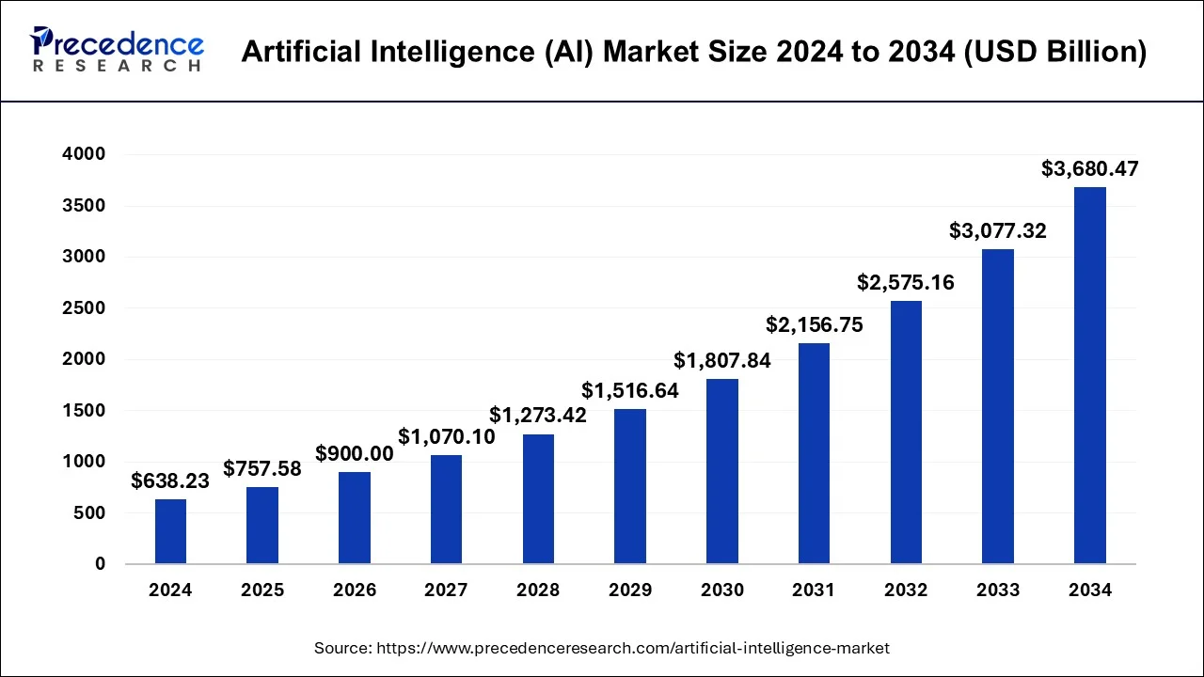
Figure 1: AI Market Size

XAI aims to make machine learning models more transparent and interpretable to technical and non-technical users. It allows stakeholders to understand and effectively deal with AI systems' outputs. Within this field, two main categories of explainability methods have emerged: ante-hoc and post-hoc. Ante-hoc models, such as decision trees and linear regression models, are inherently interpretable by design, and the decision-making process is understandable without the need for XAI techniques. In contrast, post-hoc methods aim to explain complex or opaque models after training.

This study investigates using XAI techniques in an RF model built to predict loan approval outcomes. Random Forest, an ensemble learning method based on decision trees, performs strongly for classification tasks. However, although it is not considered a very complex model like Deep Neural Network (DNN), its ensemble nature makes it less interpretable than a single decision tree, especially as the number of trees and depth increases with the amount of data. Therefore, implementing explainability methods becomes essential for understanding its decision-making process. This is essential, particularly in a field as critical as loan approval, where ethical considerations, regulatory compliance, and customer trust are paramount.

The fundamental goal of this research is to explore the post-hoc explainability approach in the context of a real-world loan approval dataset. Specifically, the study focuses on counterfactual generation to identify which features influence the model's predictions most significantly by using the IF-then statements and how explanations can be communicated effectively to different users, such as loan officers and applicants. The research also aims to assess the application where it supports both technical and non-technical users by providing different features such as dashboards, diverse counterfactuals and decision trees. Model evaluation techniques like accuracy, confusion matrix, and feature importance are also important for model evaluation.

This project will start with Chapter 2, a comprehensive literature review covering all aspects of the study. Chapter 3 is going to discuss the different technologies that have been implemented in this research. Then chapter 4, where the methodology this study has followed and the research design. Chapter 5, a step-by-step guild on how the application was built. Then, discussion and results in chapter 6 to lay out all the findings of the research. Lastly, chapter 7 where the conclusion of this study is.

Literature Review
“Even when such models behave themselves, opacity can lead to a feeling of unfairness. If you were told by an usher, upon entering an open-air concert, that you couldn’t sit in the first ten rows of seats, you might find it unreasonable. But if it were explained to you that the first ten rows were being reserved for people in wheelchairs, then it might well make a difference. Transparency matters.”
-Cathy O’nell

2.1 Introduction to Explainable AI (XAI)
There has not been an agreed definition for whether it is "explainability" or "interpretability", but this study will follow how Retzlaff et al.. (2024) distinguish between the two. They stated that both are correct but answer different questions. "explainability" answers the question of "why", whereas "interpretability" answers the "how". The overall perception of Explainable Artificial Intelligence (XAI) is to make the results of a model understandable to the human perspective. This area of AI is getting popular recently as it is trying to leverage transparency to the Machine Learning (ML) model that's considered a black box (Hassija et al.., 2024). According to Doshi-Velez and Kim (2017), making models explainable builds trust between the user and the machine because users need to understand why the model predicted this specific outcome and the logic behind that. Similarly, Mustafa and Reuben (2025) agree that XAI enhance customer trust in technology, and Human-in-the-loop (HITL) are a better way to utilize XAI in finance.

In some cases, ML is used in sensitive areas like healthcare or autonomous driving, which makes the decision-making process very significant and requires some human intervention (Hassija et al.., 2023; Doshi-Velez & Kim, 2017). XAI, with human involvement in the prediction process, will help the stakeholders identify potential biases or errors in the program. The model can be found discriminatory due to the unbalanced nature of the training data, which can be spotted when the AI is transparent to the user. In some jurisdictions, organizations must explain to the client when AI is involved, which can enhance the user experience. Furthermore, XAI will improve the customer experience and build an interactive and user-friendly platform. XAI will also boost the collaboration between humans and AI as it involves the decision-maker in the decision-making process and helps to understand different aspects of the problem (Doshi-Velez & Kim, 2017).

XAI has evolved since it first started to gain popularity in 2017 through the DARPA (Defense Advanced Research Projects Agency) project that aimed to make ML explainable. The issue of balancing between transparency and accuracy has evolved as well, and therefore, different approaches and techniques have been introduced to deal with this trade-off (Hassija et al.., 2024). A negative correlation between model complexity and transparency makes the problem of bridging the gap between this trade-off not easy. This issue especially signifies where both matter for stakeholders, such as in finance or healthcare. Finding a middle ground for these two is the best option (Mustafa & Reuben, 2025). Global interpretability is an approach that focuses on understanding the whole model and the logic it gained in the training stage. It is more for the technical users as it requires prior knowledge to be understood. The contrast is local explanations when the stakeholder is a client or an end-user with no technical expertise. The explanation will only focus on case-by-case situations, and it is usually easy to understand, like an IF-THEN statement. Visualization methods are also highly appreciated for easier understanding, identifying biases, and debugging the model. Due to the simple presentation of the model's complex relationships between features, most can be comprehended without needing domain expertise. Visual plots can justify a decision in areas like healthcare, finance, and others. Examples of these methods are feature importance, partial dependence plots (PDPs), and saliency maps. Furthermore, the model can take two other different routes, ante-hoc or posthoc, which refers to whether the techniques will be applied before or after the training stage (Hassija et al.., 2024). this report will discuss more in depth about them later on.

Figure 2: Types of interpretabilities (Hassija et al., 2024)

2.2 Ante-Hoc vs. Post-Hoc Explainability
XAI uses different techniques to bridge the gap between accuracy and transparency by implementing two different approaches: ante-hoc (Intrinsic) and post-hoc explainability. The first approach, which is referred to as ante-hoc or Intrinsic, is models that tend to be interpretable due to their structure. The post-hoc approach explains the model after the training stage (Doshi-Velez & Kim, 2017; Retzlaff et al..., 2024). Post-hoc approaches are also divided into model-agnostic and model-specific. Model agnostic techniques can be implemented in any model, and they were introduced to overcome the challenges of model-specific methods. Model-specific methods are only implemented on specific models (Hassija et al.., 2024). According to the study done by Retzlaff et al.. (2024), where they interviewed five participants who were somehow highly exposed to ML models, they found that for tasks that do not require high explanation, precision post-hoc is better but where understanding the model is more priority, but ante-hoc approach is more efficient.

After the training stage, there are many different ways to extract the reasoning from a model. They all lie under the post-hoc methods, which can also be model-agnostic techniques. Model-agnostic is the ability to apply the XAI method to any model regardless of its structure. One of the most common approaches to look at is the feature importance of the model to understand how each variable contributes to the outcome decision. This can be implemented using Shapley values, where the contribution is calculated and assigned to all features according to their significance in the model.
Furthermore, a model-agnostic approach is also known for its efficiency in Scoped Rulers. It is to establish how other features can impact the prediction by adjusting them and reflecting on how the prediction will react to those changes. It is also known for relying on the rule of anchors and using IF-THEN phrases to demonstrate the changes. For visualisation, techniques like LIME (Local Interpretable Model Agnostic explanation) should be explained. However, it is not the best with huge data as it is time and power-consuming.
On the other hand, a WHAT-IF method performs some calculations after the prediction has been made and feedback on the minor change that can change the prediction. This is called the Counterfactual method, which is considered user-friendly and easy to understand for non-technical persons (Retzlaff et al..., 2024). Moreover, LIME is also a widespread method which uses a decision tree.

On the other hand, we have the “glass-box” model, where the explanation is embedded directly into the model structure, providing more transparency in the entire decision-making process. Decision trees (DT) are known for using the structure of if-then-else-rules by splitting the data into different subsets. The human perspective finds the hierarchical and treelike structure to be easily understood. DT can be a post-hoc technique using “Trepan Reloaded”. Secondly, generalised additive models (GAMs) have proven their ability in medical tasks because of their efficiency in obtaining low-dimensional data and human-friendly interpretation. Ante-hoc methods also use the IF-THEN statements to explain their decision, like the Bayesian Rule Lists (BRL) (Retzlaff et al..., 2024).

2.3 Random Forest in Loan Approval
The structure of Random Forest is treelike, and it starts from the root node and splits into different decision nodes till it reaches the leaf node where the decision result is. It uses the Gini index, and the trees' depth depends on the parameter depth. RF can solve regression and classification tasks, and some of its advantages include dealing with unbalanced data with high accuracy and robustness against missing data (Zui et al.., 2019). Therefore, RF variety and accuracy can be a strong candidate for any task. Furthermore, Random Forest seems to outperform other models when implemented in finance (Boddala & Nandipati, 2024; Madaan et al.., 2021; Zhu et al.., 2019). These studies used finance data to predict loan or credit card approval. They used at least two different models, and RF in the three studies had the highest accuracy. Another study showed that Support Vector Machine (SVM) could perform better than RF (Madaan et al.., 2021). However, some argue that it is very hard to nominate a single method as the best approach for machine learning and call for domine research for each model and align the weaknesses and strengths of the model with the domain needs (Breeden, 2021). Some models might be fit for some domains, not others, and vice versa.

RF has some advantages that can help optimise the model further, but they might not be found in other models. Some argue that Random Forest is one of the best machine-learning techniques. This is because of its high accuracy, effectiveness with unbalanced data, and ability to handle missing values in different types. Furthermore, the randomness in its approach works as a strong barrier against overfitting. It also includes feature assessments to validate the most important feature in the model prediction and the least important, as well as the ability to discard outliers in the dataset without the need to delete them(Salman et al.., 2024; Zhu, 2020). This eventually leads to less data preparation time and more analysis as it deals with data flaws very well.

While RF can be a better option when using finance data (Madaan et al.., 2021), Langsetmo and others (2023) where used Random Forest and Fine-Gray models to predict the risk of a hip fracture and competing mortality among elderlies and found out that the standard Fine-model provided similar results with slight difference in predicting risk. Like any other model, RF does have some downsides that could affect the model's performance. Salman and his college have listed some qualities that may reduce implementation efficiency, such as training time. This could happen when dealing with extensive data, and as a result, the model has to create many trees to cover the enormous amount of data, which results in a longer time in the training stage. Moreover, RF machines are poor when trying to capture trends in the dataset (Zhe, 2020). Failed to handle data with rare predictors, high sensitivity to hyperparameters, only takes one type of data, and cannot process images or text data -unstructured data. This shows that RF is a domain-related model that might function better with certain data types in specific domains, like banking, healthcare, stock market and e-commerce (Salman et al.., 2024).

2.4 Counterfactual in Explainable AI
The decision tree provided by Retzlaff et al. (2024) in Figure 3 for how to find the best XAI approach for your task suggests that for loan approval application, Scoped Rules are the best option as it satisfies the two elements of the method being post-hoc for high accuracy and also targeting group are non-technical individuals. However, counterfactual is listed as a technique that requires a technical background. Counterfactuals were introduced in 2019 by et al., and they were inspired by the technique called adversarial perturbations, where small changes happen to the input data to mislead the machine to manipulate predictions and exploit vulnerabilities. Counterfactuals can be defined as finding the closest change from the inputted instance to make the machine predict the desired class. They proposed this technique and claimed that understanding the logic or how the model functions would not be possible, and if it happened, no average user would be able to understand it. Molnar, in his book Interpretable Machine Learning (2020), outlined four requirements that should be satisfied in order to generate counterfactuals. First, the diverse instance has to be as close as possible to the original instance to understand better what would change the model. Secondly, try to change the diverse instance as little as possible from the original instance. Third, the ability to generate more than one counterfactual explanation. Lastly, the features that are proposed to be adjusted have to be things that can be changed. For example, if the machine is saying that the user has to change age, name, gender or address, this means that the model is biased and discriminates. Kean et al., 2021 mention similar points.
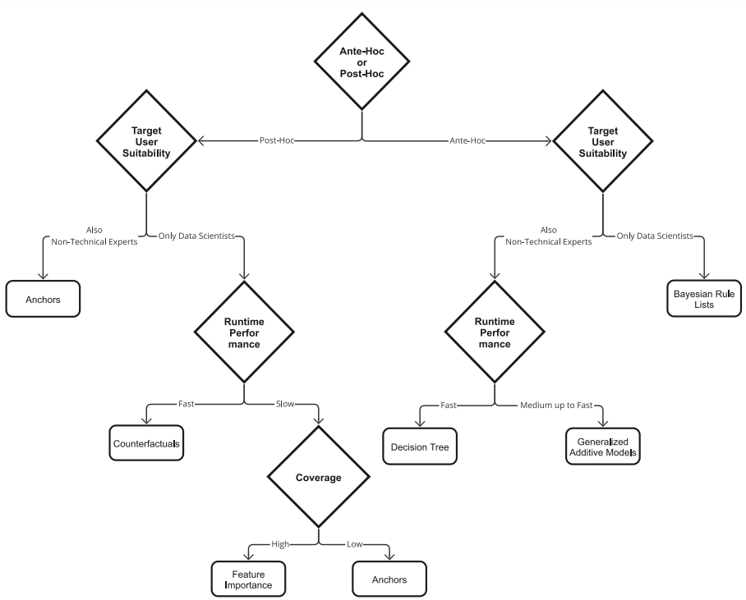
Figure 3: Guid for the best XAI techniques (Retzlaff et al., 2024)

Kean et al. (2021) go through five issues around CF in XAI. They listed five deficits that address not only the computational aspects but also the social ones. i) Most of these studies around CF are on methods where user studies are neglected, and there are fewer studies every year. This might result from the area's rapid expansion, which leads to fewer user test studies. ii) no psychological definition of Plausibility that most of the CF methods are using. Most of them claim that having a more diverse instance than the original will provide a 'plausible' explanation without prior study of what a plausible explanation is and how close the CF should be to being called plausible. iii) while most of the studies claim that having fewer feature differences is better, based on a study showed that users prefer more features in the CF explanation, which takes us back to the lack of user studies. vi) Not many studies provide an inadequate coverage assessment that shows how much the model produces non-feasible CF instances. v) lack of an agreed set of evaluations and less comparative testing needs to change by more comparison studies. As Kean stated, most of these issues can be avoided with more precise studies focusing on what this area needs.

2.5 Loan Approval Case Studies with XAI
Some case studies tried to unbox the ML prediction in the financial domain and make the banking systems more user-centric. Luca and others (2023) proposed a system that manages the entire lifecycle of an ML model, starting from data loading to model evaluation. The system has many features that detect bias and ensure fair prediction. For model development, they used RF, Logistic Regression (LR), Naïve Bayes and others and used F1-score metrics for performance comparison. The UI is developed to be used by loan officers to ensure fairness and accuracy and for applicants to get insights about the model and provide feedback. The feedback loop will help domain experts adjust and refine the model as necessary. Another case study used credit data to classify loan applications using XAI technology. The ML algorithms used in the study are RF, DT, SVM and NN. Different explainable techniques were used, like LIME, SHAP, PDP and others, which proved effective (Ayad et al., 2023). Moreover, this study implemented a Belief-Rule-Base (BRB) framework to offer an RF model that can predict and explain using SHAP with 95% model accuracy. In case of rejection, the applicant will get a written justification of that decision (Azith et al., 2024).

2.6 Challenges and Ethical concerns in XAI
Although XAI introduces many benefits and solves the issue of ambiguous machines when making predictions, trust is an important area developers must consider. As Retzlaff and his colleagues (2024) have laid out, the concept of trust -subjective view- is not only how we understand the machines but also goes beyond that to how safe it is to use them. So, the question is whether the explainable AI will instil trust in AI. A step toward trustable AI is to make these models self-explanatory so users can understand the logic and reasoning behind the prediction. If developers could accomplish that, Hassija et al. (2023) believe that it will result in a rational AI that aligns with human perception, and, therefore, trust is built.

In order to achieve explainability objectives, the model's developers -especially the complex models- need to start thinking about how simplicity can be preserved without interfering with accuracy (Retzlaff et al., 2024). XAI has a trade-off that many developers are trying to minimise. The trade-off varies from simple models like decision trees and linear regression to complex models like deep neural networks and ensemble models. In simple models, the transparency is high but has lower accuracy; for complex models, it is the opposite. Deep neural networks and such models can produce high-accuracy outcomes, but it is hard to produce high interpretation scores due to their complexity (Doshi-Velez & Kim, 2017; Hassija et al., 2023). Such models with high complexity resist any XAI technology. On the other hand, models with less complexity are not as good as DNNs with large datasets and might not generalise properly (Mustafa & Reuben, 2025).

There have been calls for any organisation that uses AI in the decision-making process to provide an explanation under the act of 'right to explain' that is part of the General Data Protection Regulation (GDPR) (Hassija et al., 2024). This will preserve the user's rights and form trust between the user and the machine. Cathy O'nell gave a fantastic example in her book Weapons of Math Destruction, showing how understanding the 'why' behind the decision changes everything. The example is quoted at the beginning of the chapter. It has also been found that XAI can identify any bias in the model, particularly with demographic features, and therefore minimise discrimination (Mustafa & Reuben, 2025), which supports the argument that AI will make using machines fairer and safer with no interior agenda.

2.7 Similar Technology
In terms of technology, in this study, we used the DICE library in Python, but this is not the only package that provides counterfactual sets. Here, we will go through the most common packages that offer ML explanations using counterfactual sets.

Alibi:

One of the biggest libraries that provides functions and techniques that support the XAI field is the Alibi Explain package in Python. It offers a variety of options with different methods and applications. They have both post-hoc and ante-hoc explainers from global methods like PDP, Accumulated Local Effects and others. Some of them support classification and regression tasks, and some only one. Additionally, many Local explanation approaches like counterfactuals, SHAP, and Anchors. Moreover, different types of counterfactuals are set, like counterfactuals with Reinforcement Learning and Guided by Prototypes. Counterfactual Reinforcement Learning is similar to DICE and might have resulted in a similar outcome if implemented in this study ((Klaise et al., 2021).

Rf-counterfactual:

This method was developed by Lalmas and others in 2017 after their study on Tree-based Ensembles was published. This package can handle multiclass classification and generate CF using feature tweaking.

Counterfactual:

This package is similar to the rf-counterfactual package but for the R programming language. It is based on three different studies: multi-objective CF, Nearest Instance CF, and What-if (Dandl et al., 2023).

Others:

Guidotti (2024) has published a comprehensive benchmark study that provides a comparison between all the different approaches and techniques that are around the counterfactual sets generation. The author characterized based on how they get their Cf set, model-agnostic or specific, Data type handling and many other standards. This study can be a complete guide to selecting the best strategy for a case study and guarantee a suitable strategy. Many of the strategies in the paper have an open-source code and can be found in the Taxonomy in the paper.

Technology review

3.1 Counterfactual (CF)
A counterfactual technique will be used for our first attempt to explain our model locally. Counterfactual is one of the most common approaches in XAI as it provides a simple WHAT-IF approach, a simple way to teach kids in schools (Mothilal et al., 2020). Russell (2017) argues that sharing how the models are similar to a restaurant sharing their recipe and, therefore, thinks the model should be explained to a degree. They propose the counterfactual framework to explain the outcome for the user according to the “right to explanation” by the GDBR and preserve the stakeholders' privacy. It does that by adjusting the model's different features to change the model's prediction to the desired class Figure 4. This method effectively identifies biases associated with the model by looking at which feature the model primarily relies on for changing the outcome.

Furthermore, understanding what would make the model change its prediction by creating the same input with small changes. This gives the developer an idea of the priorities of the model. It also achieves the goal of explainable AI, as it prompts for transparency. For instance, the loan approval application will offer insight into the user's result and how they could get approved (Susma, 2024).

Figure 4: Source - github.com/interpretml/DiCE

Nevertheless, counterfactuals can be challenging to implement in some cases. It has been found that it is not the best choice where the model is trained with a large dataset. This is because it is known for its high computational cost. Also, in some cases, the data quality can affect the outcome of the explanations (Susma, 2024). Furthermore, making a causal model in which the machine can understand how different features are connected is very challenging. This results in opaque explanations. Also, the CF are not the best choice always, especially when there is a need for a more extensive understanding of the application, and there is no statistical approach to assess the model’s bias (Russell et al., 2017).

3.2 Diverse Counterfactual Explanations (Dice)

Mothilal and his colleagues (2019) first introduced the framework of Dice to handle counterfactual explanations and optimise them. They took the CF further than Russell first discussed the topic and focused on more than linear ML model techniques. Dice can be applied to any different technique as it is a model-agnostic approach. They also focused on solving some counterfactual issues that minimise its applicability. One of these issues is to make the diverse input actionable, which means that the model will avoid suggestions that involve changing features that cannot be changed. Such as asking an applicant to change their race or asking family members to get a loan.

Additionally, the model can generate multiple CFs that will lead the model to adjust the outcome. As well as ensuring the explanations are realistic and feasible. Each feature weight is calculated using the median absolute deviation (MAD) to measure each feature variability strongly (Mothilal et al.,. 2019).

3.3 Tableau
To provide the user with a better understanding of the data, a Tableau dashboard has been used and implemented in the application. Tableau is software that allows data analysis and manipulation to better understand the data. Five different chats were added to the application.

3.3.1 Sneaky Diagram

This chart demonstrates how each education level corresponds to the income group. Understanding the correlation between education and income will help understand how the model might prefer approving loans to people with higher education as they receive higher income. According to the chart, most applicants have undergraduate degrees, and the most common income group in the data is 50 thousand a year or less.
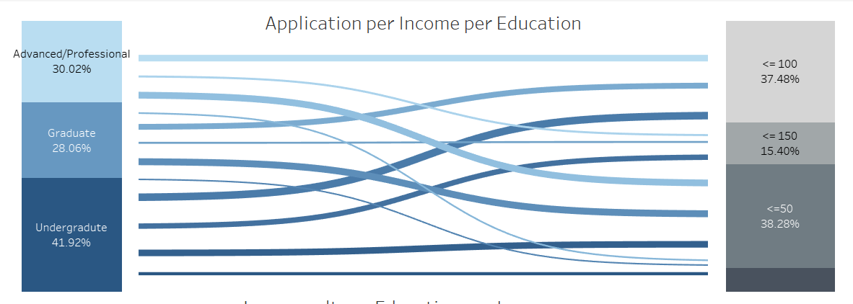
Figure 5: Sneaky diagram

3.3.2 Pie Chart

This pie chart shows the distribution of the data and identifies any imbalances in the data that might affect it. More than 90% of the applicants were rejected, and only around 9% were approved.

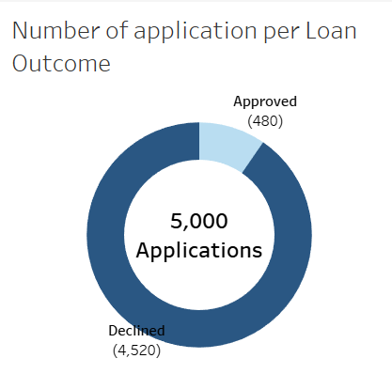
Figure 6: Pie Chart

3.3.3 Scatter Plot

This scatter plot shows the approved and rejected loan applications over education and income. This will identify the correlation between approval and education and income group. There is a clear pattern that having a higher income is more significant than having a higher education.


Figure 7: Scatter plot

3.3.4 Radial Chart

Understanding the age group of the applicants will help identify any trends or patterns in the data. The most common age group of the applicants are around 50 to 59, and the least common age group is 24 to 29, which tells you that the data has a majority of more than 40-year-old applicants.

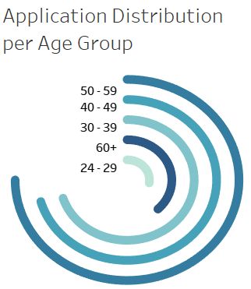
Figure 8: Radial chart

3.3.5 Dual Line Chart

This chart shows that most applicants fall within the 0 to 5 credit card average. A higher average score, especially around 3 to 6.5, gives applicants a better chance of approval.

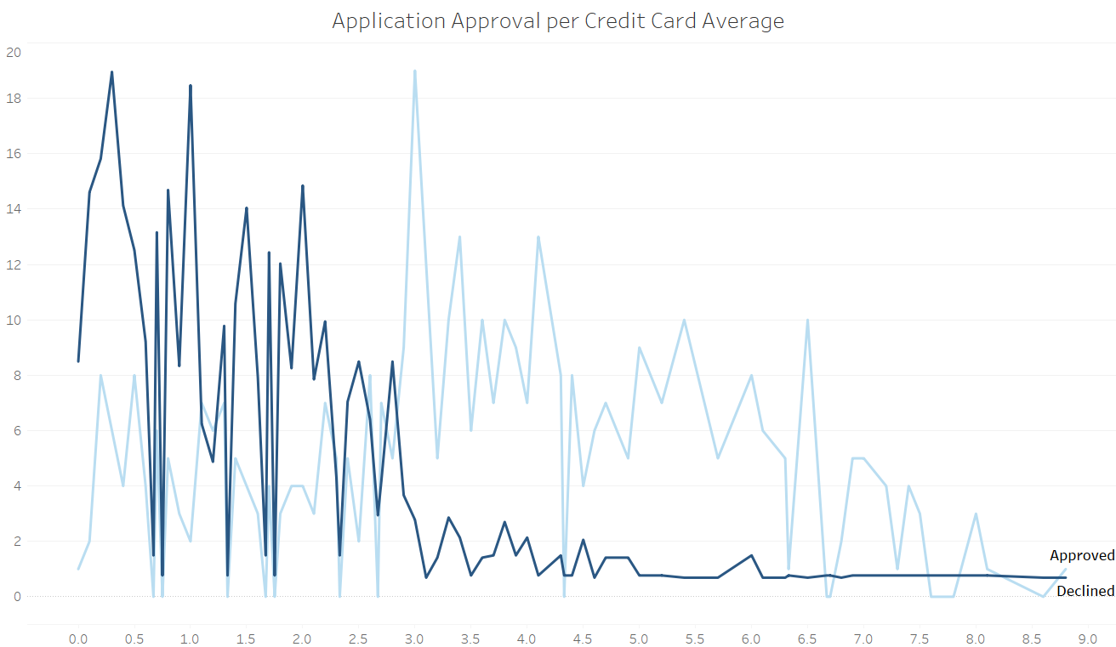
Figure 9: Dual line chart

3.4 React Web Application

React is a JavaScript library that helps build interactive UI and provides many frameworks for easier development. It was chosen for this study for the web development because of its easy implementation and fast rendering and different tools and packages that supported this project needs. Tools like ability to use Python API, design using CSS for a better layout design and the ability to write HTML and JavaScript together for more efficient web development.

3.5 Flask API
Flask was used to help build Python API to render the model from the Python virtual environment to the web application that uses HTML and JavaScript. The API built using the Flask library made utilizing the model and web development easier and faster. This is because the Dice package is only available in Python, so to use a strong web development library like react, which is JavaScript and Dice that relies on Python, using API was the solution for this problem (Prasad, 2023).

Methodology
The application developed in this study consists of four pages, and it aims to provide a fair loan application system that will enhance trust and increase transparency. The evaluation page has evaluation metrics that help understand the model and identify any bias. We used accuracy, recall, F1-score and precision. A confusion matrix plot shows the TP, TN, FP, and FN, which can help understand where the model is performing poorly. A Feature importance plot also assesses how each feature influences the model prediction and an interactive decision tree that can be manipulated to better understand the model’s decisions. On the dashboard page, the data is analyzed using Tableau software. The final page is the loan form page, where the user can put their details and get the results of their application and the CFs.

4.1 Introduction
There are a lot of changes and developments going on throughout this project, and the research is regularly shifting from one aspect to another. Therefore, a flexible and more dynamic approach was needed to implement all the project objectives successfully. The nature of the Agile methodology was chosen due to its iterative and adaptable approach that can overcome any sudden changes in the projects and deal with them effectively. In 2001, Seventeen people introduced agile, and four core values and twelve principles were developed to support delivering incremental development through continuous feedback and collaboration (Beck et al.,2001).

The framework adopted for this case study is the Agile Framework, which is known for its ability to handle changing needs and ambiguity. As the project has clear objectives and a target to achieve -explainable loan approval applications—there are grey areas for getting there in terms of model development and explainable techniques. Because this project is going to try and perform several XAI techniques with an average potential of some methods failing to achieve our target, here comes the necessity of choosing such an extremely flexible framework.
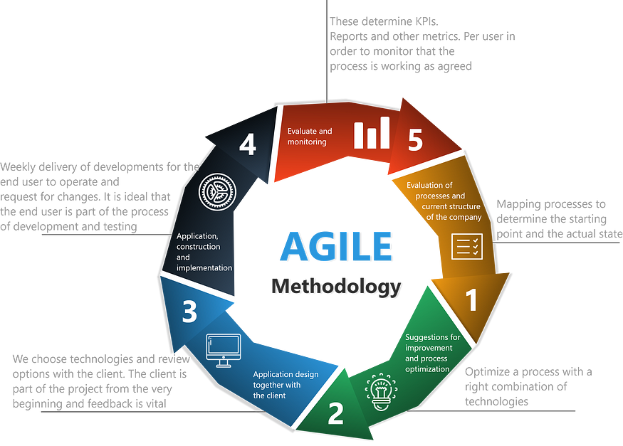
Figure 10: Agile Framework Diagram

4.2 Research Design
The case study will attempt to build an application loan approval that takes the user's answers and gives back the results alongside an explanation and the logic behind the outcome they have received. The model for this study will be a Random Forest as it has proven its robustness and high accuracy. The Random Forest model will be post-hoc explainable using counterfactual sets from DICE packages. These techniques will explain to the user and help them understand why the model came up with this result and how they can change it. The application will be developed using React as the front end and Flask as the back end. Also, APIs are used to support the RF model that is written in Python.

Implementation

5.1 Data Collection and Preparation
The data collected is from Kaggle (2024) about bank clients’ data and the result of their application as `Personal.loan`. There are 14 columns and 5000 rows, with all the variables being numeric values. However, some are binary columns representing 1 for yes and 0 for no, like `CreditCard`. The data has no missing values, and it looks ready for modelling at first glance. However, some columns will be removed from the dataset as they have no contribution to the model. The table below shows each column and what they represent in the dataset.

Table 1: dataset columns
Column | Represents | Type
ID | The unique number of each applicant | Numeric
Age | The age of the applicant | Numeric
Experience | Years of work experience | Numeric
Income | The yearly income of the applicant (in thousands) | Numeric
ZIP.Code | The zip code of the applicant (American address) | Numeric
Family | Number of family members | Numeric
CCAvg | Credit Card Average spending | Numeric
Education | Level of education | Categorical
Mortgage | The mortgage the applicant pays | Numeric
Personal Loan | The result of the loan application | Binary
Securities Account | The possession of a Securities Account | Binary
CD.Account | The possession of a Certificate of Deposit Account | Binary
Online | The possession of Online banking account | Binary
Credit Card | The possession of Credit Card account | Binary

Some columns will not add any value to the model as they carry no valuable information for this case study, so removing them from the dataset will enhance the model and improve prediction. The columns that will be removed are ID and ZIP.Code because neither offers any additional insights into the model. Moreover, Experience has some negative values that may be a typo in the column. Therefore, assuming it is a typo and impossible to have a negative number as a value for Experience, all the negative numbers have been converted to positive using their absolute value.

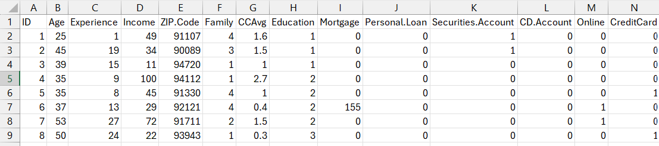
Figure 11: dataset

As we can see from the plot below, the data is extremely imbalanced with 4520 rejection and 480 approval which could affect the model prediction.
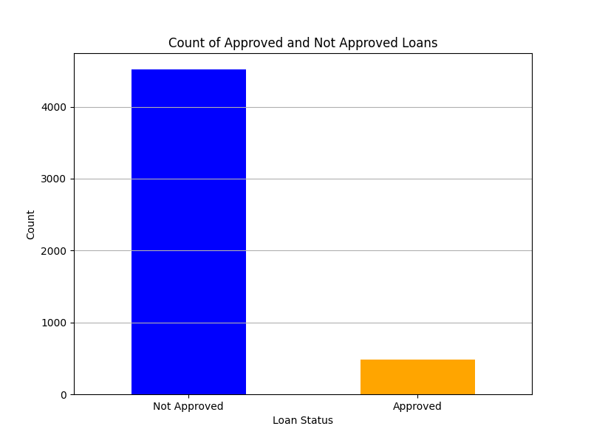
Figure 12 Data distribution
This graph shows that customers with an average of 140k income have better acceptance rate than those with 60k average income.
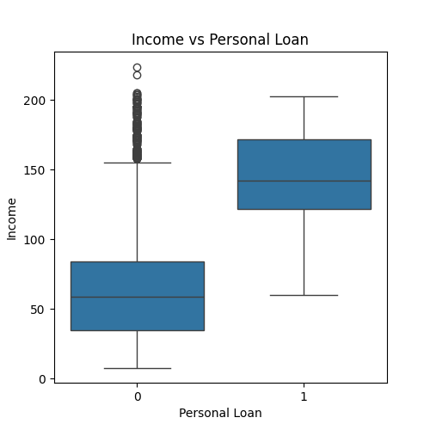
Figure 13: income vs Personal loan
Surprisingly, Mortgages do not affect the loan's result. It is more likely to be rejected if you have a small mortgage than when you have a higher one. This might be because of the nature of the data and where it comes from. For example, some banks do not prefer to lend money to full-time students like LLOYDS, but others do not mind approving loans to full-time students as long as they have fulfilled all requirements, like HSBC.
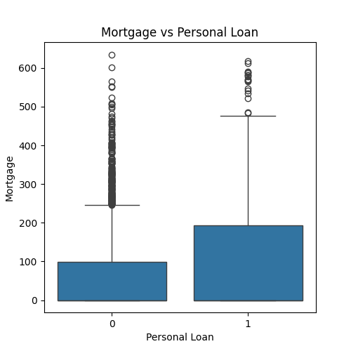
Figure 14: Mortgage vs Personal loan

The Random Oversampling technique will be used to deal with the extreme imbalance in the dataset. Random oversampling is an approach for dealing with imbalanced data and achieving balance to help the model predict accurately. This will help in decreasing false negatives. Random Oversampling balances the data by duplicating an existent record from the minority (1 = Approved) and adding it to the data (Ashraf, 2023). This approach has been followed because, as the graph demonstrated earlier, there is a considerable gap between approval and decline, and approval data are less than a thousand, so it is better to oversample than undersample decline records. Undersampling is the opposite of oversampling, which removes instances from the majority class (Tamanna, 2023).

5.2 Model development
To develop our model, we used a variety of packages in Python, such as Pandas, Sklearn, and RandomForestClassifier from Sklearn. The model trained on 75% of the data and left the rest for testing. Then, encode the categorical variables using the category_encoders package. The categorical variables can be found in the table above. Lastly, the model was trained to set max_depth at 5 to avoid overfitting. The model achieved a very high accuracy score of 98%. A cross-validation accuracy was examined to check for overfitting, ,and the model scored approximately 97%,, indicating no overfitting. However, this might be that the data has a clear pattern and some dominant variable in the dataset. The feature importance identified is that three columns have most of the model’s weights.

Additionally, other evaluation metrics, such as kappa, log loss AUC, and ROC, were used to evaluate the model. They all reflected good results. Look at the table below for more information about the model evaluation.

Table 2: Model Evaluation
Techniques | Result | Interpretation | Sklearn function
Accuracy | 98% | The model accurately predicted 98% of the test set. | Classification report
Cross validation score | 97% | Higher number means the model is preforming and generalize very well. | Cross val score
Log loss | 0.159 | Low value means the model is giving accurate probabilities. | Log loss
AUC score | 0.99 | Demonstrates a very confident model with strong distinction between class 1 and 0. | Roc auc score

The feature importance Figure 22 shows that three variables have most of the model’s attention when making a prediction. Considering the case study loan approval, let us see if they make sense. First is income, which is expected when applying for a loan. Second is the credit card average, which measures the average spent by a person using their credit card. Third, education might correlate with income. Furthermore, the confusion matrix shows that the model predicts the TP and FN well. Look at Figure 21.

The three steps to build the model are to set up the data, train the model, and start generating CF. First, identify the numeric and categorical variables and assign them to var. Then, we use this variable to distinguish between the continuous and categorical variables to implement the encoder for the categorical features (InterpretML, nd). For optimizing the model, we have found that opposite is the suitable desired_class in our case study as it uses the opposite classification result, which means approved. For the hyperparameters, proximity_weight is how close the CF should be to the original input, and the default value is 0.2; diversity_weight is how diverse each CF is compared to each other, and the default value is 5.0(Mothilal et la, 2020). In order to be able to manipulate them two, the method must be genetic. When setting the method to random or kdtree, the function generate_counterfacute ignores them. Look at the (Appendix 9.2.1) from the function brief to understand more. However, setting these to improve the model to any number would not change the output of the function. Even when inputting numbers like thousands to see if the error will be raised, nothing happens, and the model performs normally. This problem has also been noticed by Mothilal et al.. (2021) when using a dice package. Therefore, we have discarded them from the model as they do not add value to the model.

Additionally, the experience range was restricted due to the model occasionally suggesting a large number for the experience. However, the features_to_var was used to prevent the model from suggesting unrealistic outcomes like decreasing age or increasing family members. Therefore, all the features were added to the list except Age and Family. The mortgage has also been removed from the list as the model keeps suggesting that having a higher mortgage is better, which does not make sense for getting a loan.

The final result of the model provides two different diverse CFs. Increasing the total CFs produced will eventually impact the diversity of each CF, especially with the random method. This example shows the query instance, which is the instance that the model predicts will have a decline outcome. The diverse counterfactual set consists of suggested changes to achieve the desired class. Refer to (Appendix 9.2.2) for the function’s outcome.

5.3 Web Application

5.3.1 Home page

In the first page, the user will see the home page that shows everything in the application. Provide a small explanation of each page and a navigation bar in the top for easier movement between the pages.

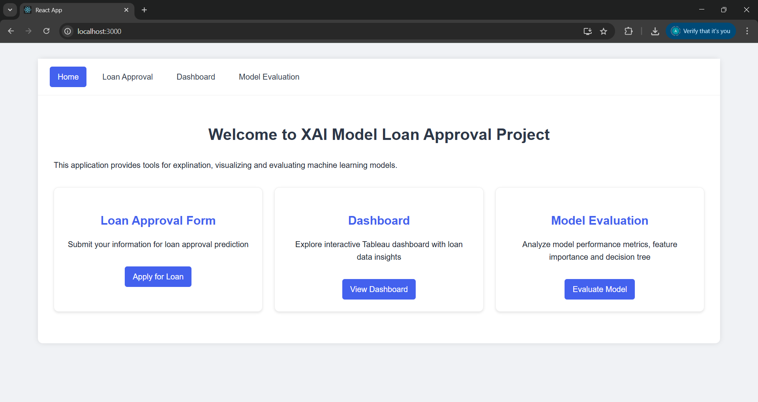
Figure 15: Home page

5.3.2 Loan Approval Form page

The second page is where the user can try to fill out the loan approval form and get the result of their application along with the CFs in case of rejection. The form is divided into two sections: Personal Information and Financial Information. There are two buttons at the bottom of the page for resting the form and submitting the form. When submitting the form, the page will show the probability of the application getting approved and if it is less than 50%, decline and if it is more than 50%, will be approved. In case of rejection, a message like the one in the image below tells how to improve the application by providing CFs that can change the model prediction. The message will pop up if the loan is approved, telling the user that the application has been approved.

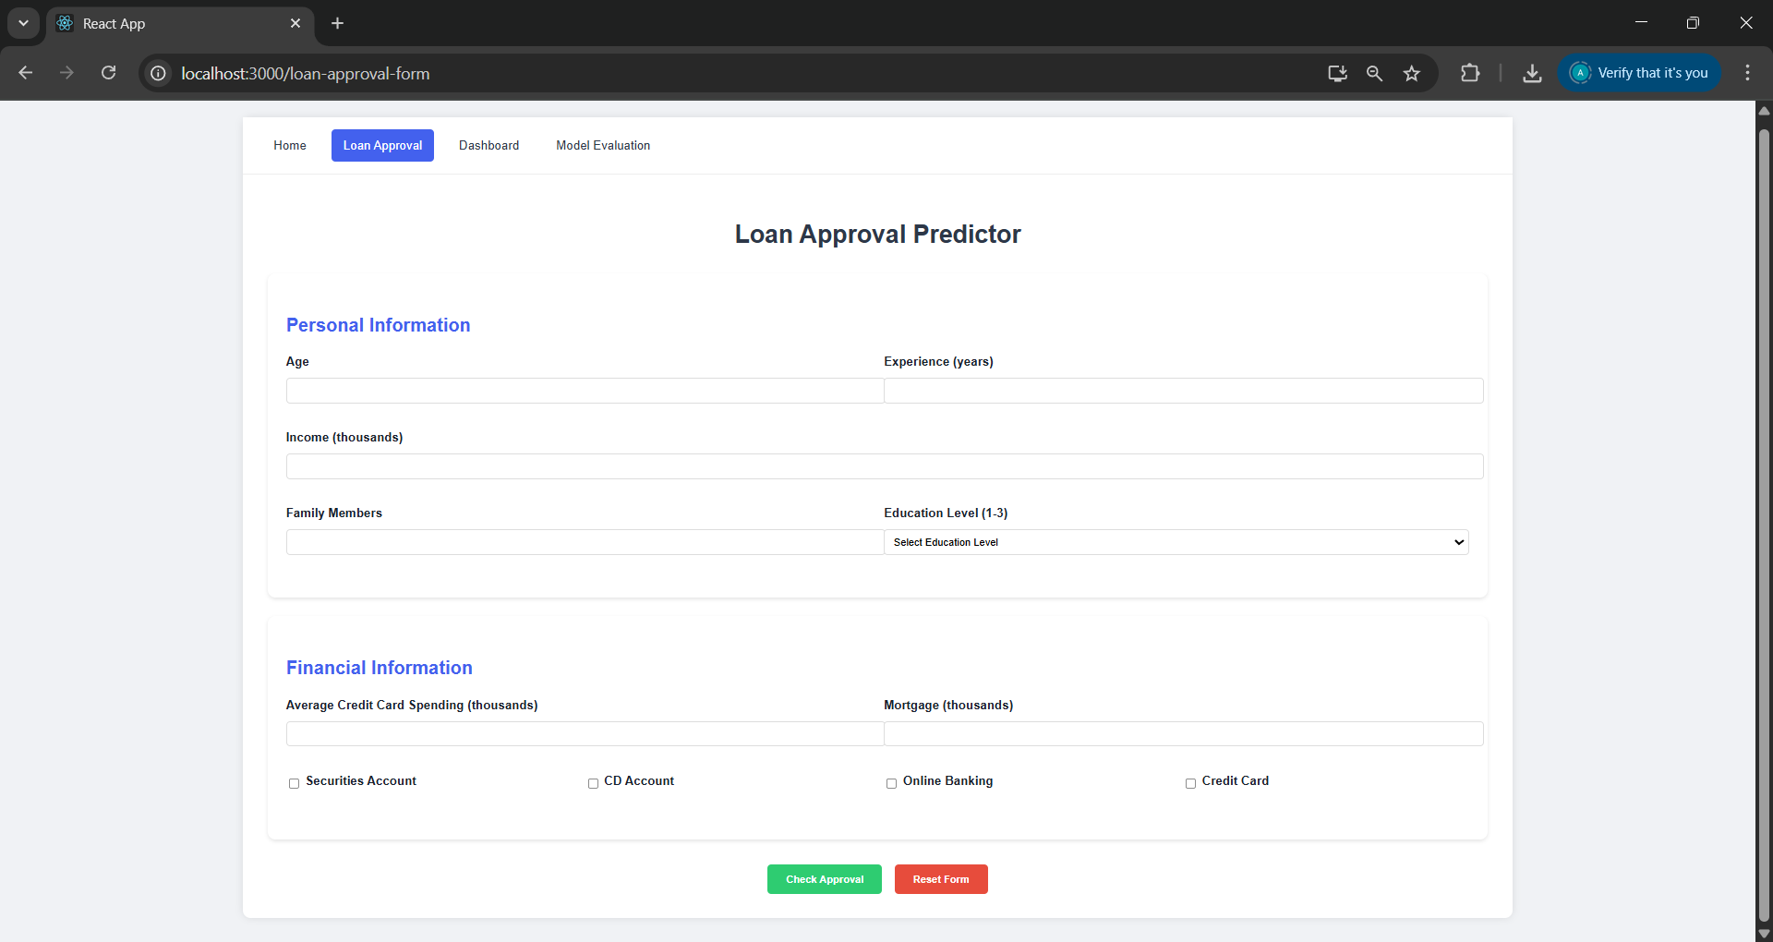
Figure 16: Loan Form page

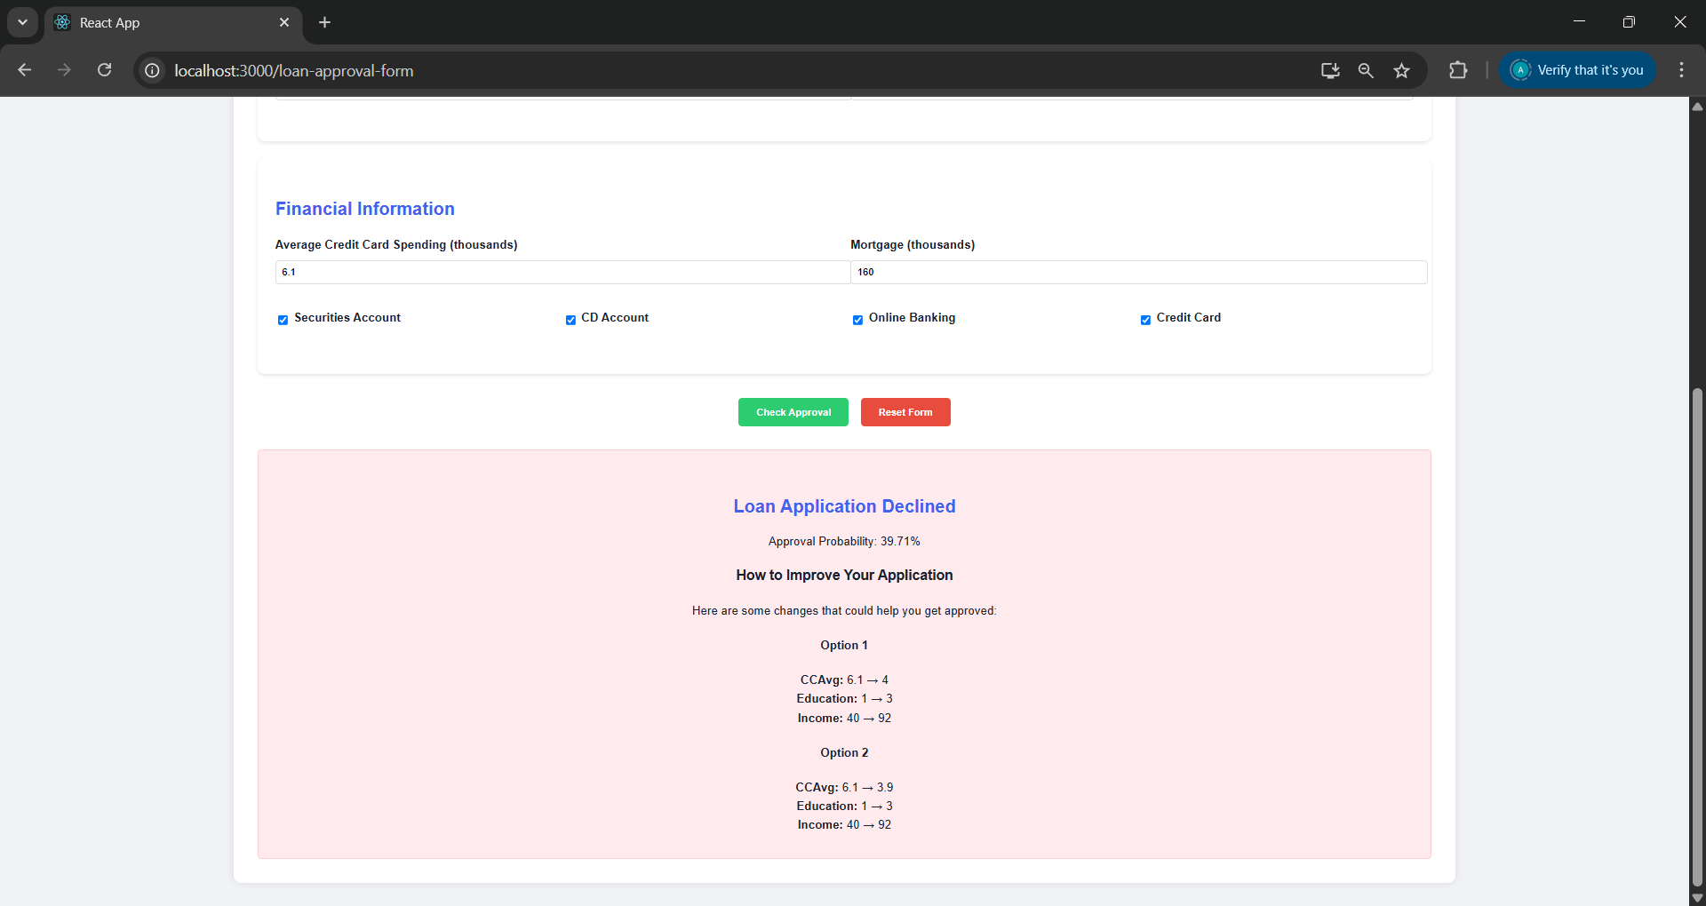
Figure 17: Loan Form rejection page
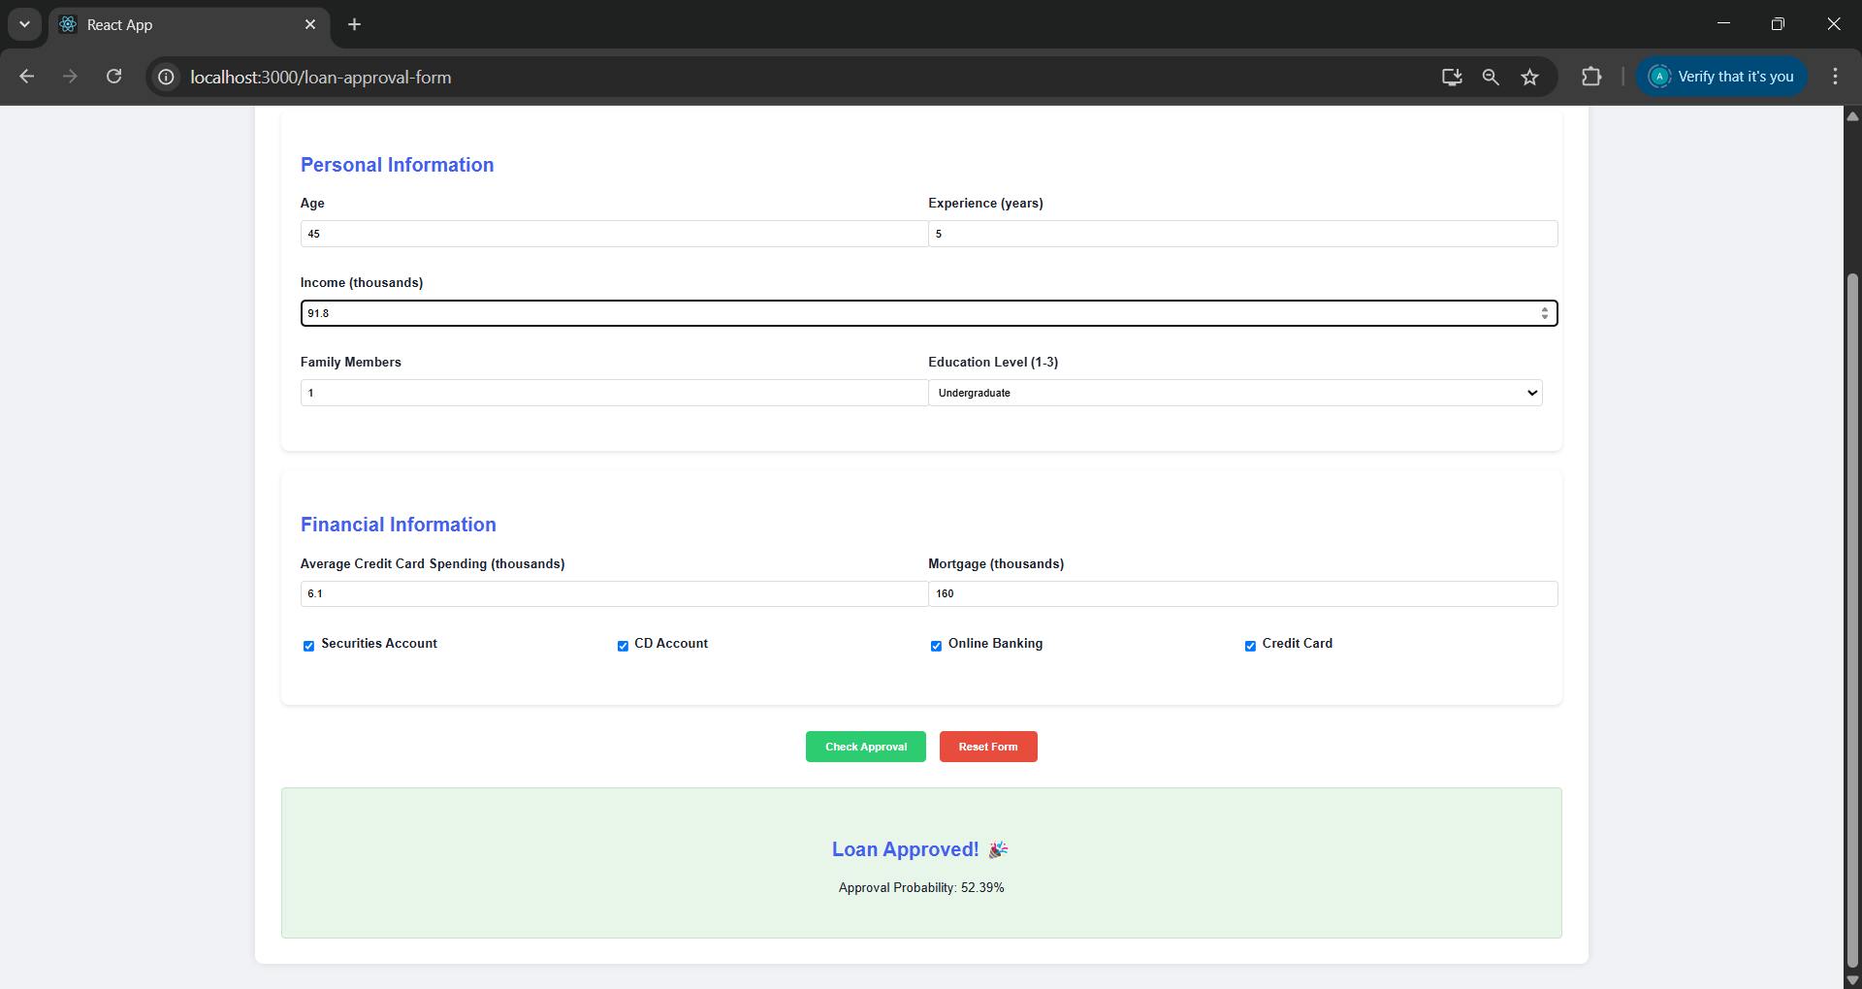
Figure 18: Loan Form Approval page

5.3.3 Dashboard page

The third page is the dashboard, where the user can understand the data batter and play around with the interactive dashboard that uses API.
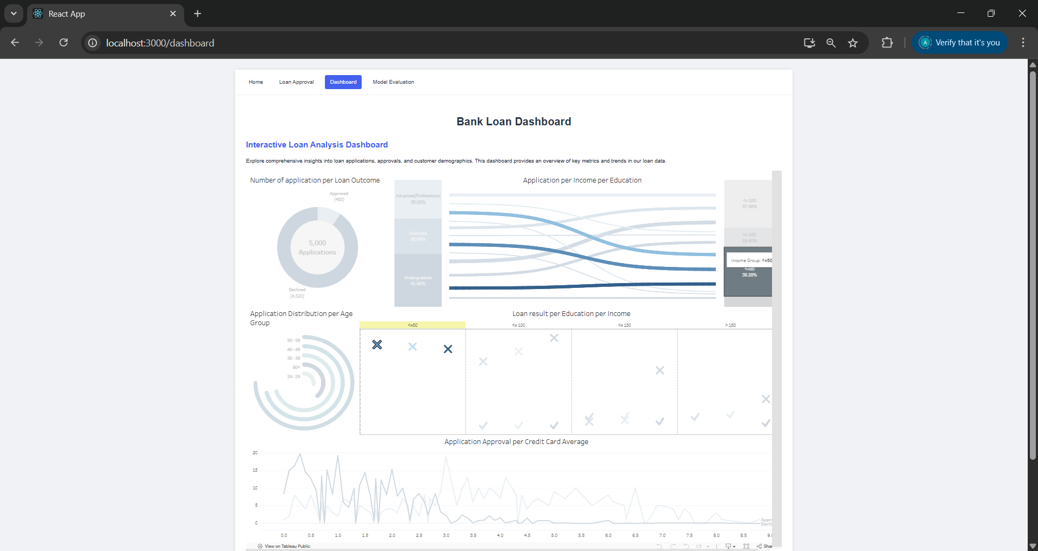
Figure 19: Dashboard page (Zoomed out)

5.3.4 Model Evaluation page

Four elements were used to evaluate the model performance for the model evaluation page. First, the classification report consists of measurements such as precision, recall, F1-score, and accuracy. Also, the confusion matrix shows how the model performs in each matrix element. Feature importance is important for better feature analysis and understanding which features the model relies on the most. Lastly, an interactive Decision Tree shows the tree's leaf nodes and root nods, and the user can change the depth of the tree for easier visualization and click on any plot for a closer look at it.

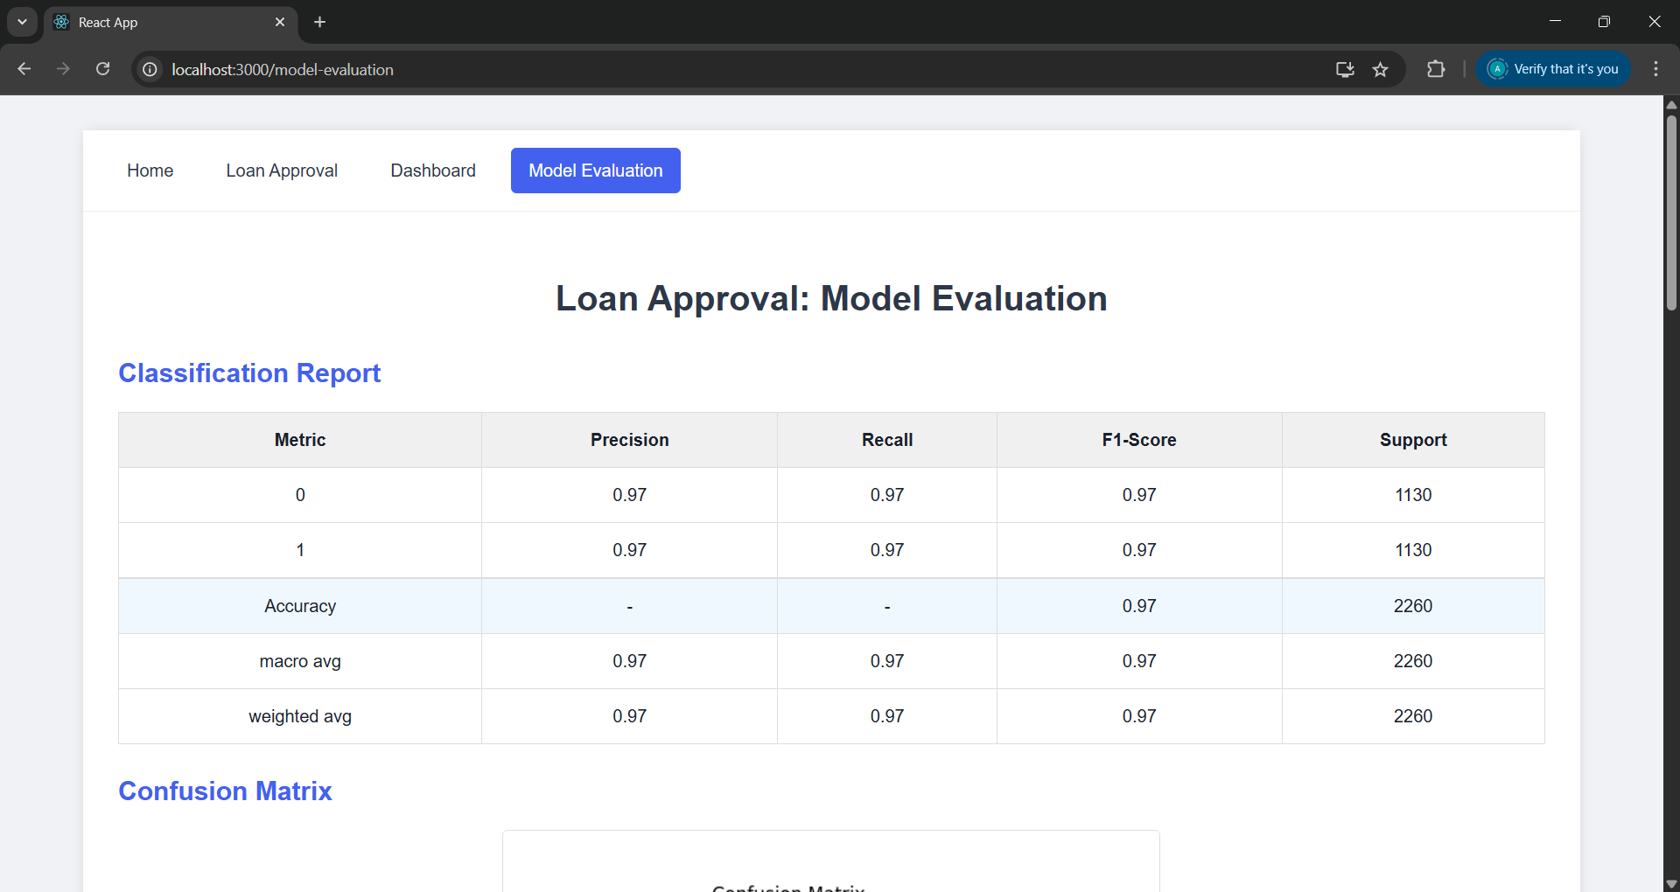
Figure 20: Model Evaluation page -classification report

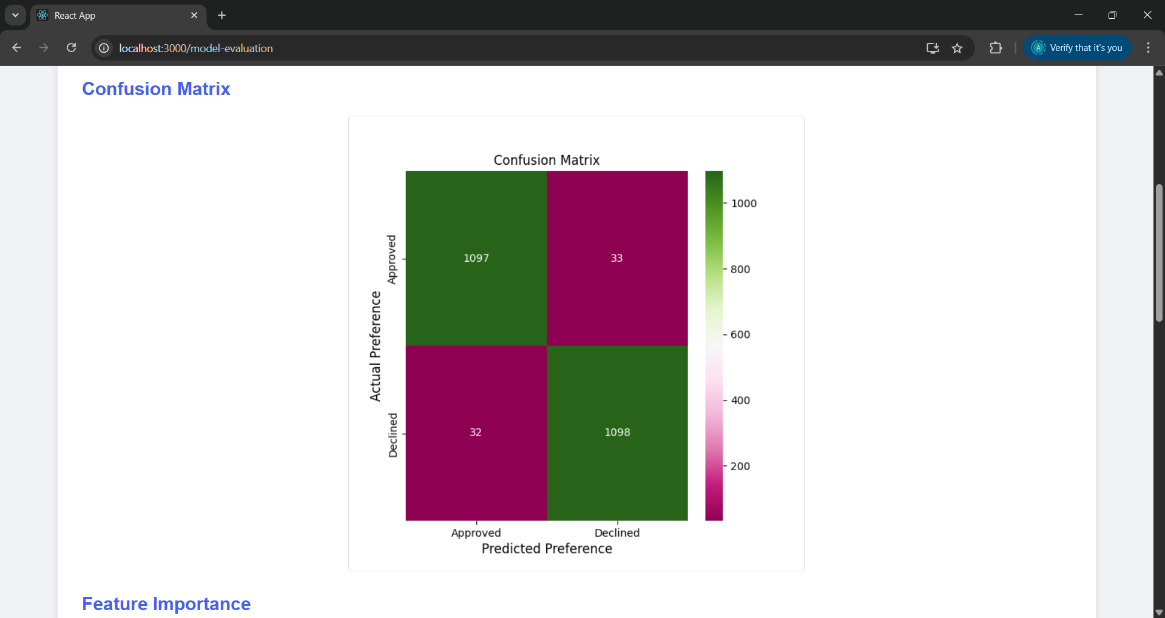
Figure 21: Model Evaluation page -Confusion Matrix
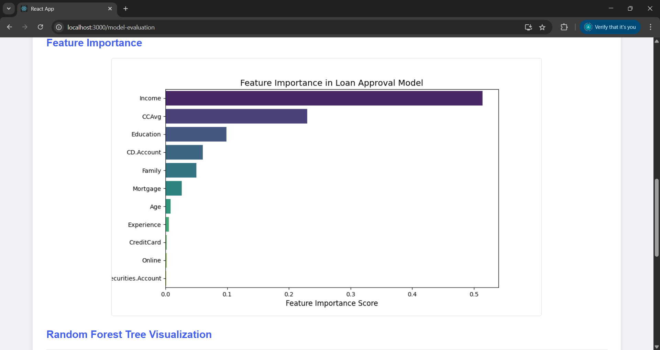
Figure 22: Model Evaluation page -Feature importance
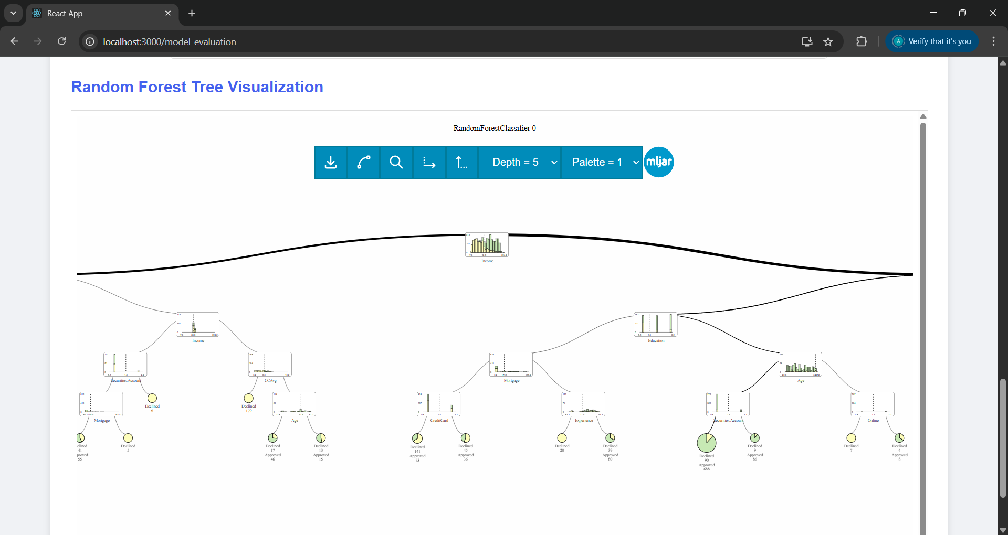
Figure 23: Model Evaluation page -Decision tree

5.4 Limitation
While trying to make counterfactual explanations using the Dice library, some issues required extra reading and consulting to understand the problem. The issue was the installation of the Dice package using the PyCharm environment. After reading about it, the issue was that the dice dose was not installed in Python 3.12 (PyPI, nd). This is not the core problem, but this prevented the installation of an older version of Pandas 1.2.4 that was associated with Dice 0.11 (PyPI, nd; InterpretML, 2023). therefore, an older version of Python was used to solve this issue. Moreover, there were some minor problems the code went through due to using an older version of Python. Furthermore, feature_weights could have been used to optimize the model further. Furthermore, most of the parameters in the Dice function do not affect the model, which prevented the improvement of the model by using a hyperparameter.

The UI was basic due to time constraints that limited the ability to learn more advanced techniques in HTML and CSS. This also affected the dashboard page, where the dashboard might not fill in the container and have to scroll left and right to see the whole chart. Also, enhance the loan form by adding better input fields.

Results and Discussion

6.1 Testing
A different test was implemented to determine how this application would handle these errors. For the loan form, the application handles invalid inputs with a friendly message that tells the user what they can put as input when they insert an invalid value. For example, age cannot be negative and not something below 18, as many banks do not approve loans for individuals under 18. So, a message will tell them to insert at least 18 in this section. Additionally, experience and credit card average spending are set to minimum of 0 where family and income are set to at least 1.

Furthermore, for education, the user must choose between the three options provided: undergraduate, graduate, and advanced/professional. Although this is significantly limiting to the user because some might not even have an undergraduate level, this has been kept due to being compatible with the model training data, which has only three values: 1, 2, and 3. Assuming 1 is undergraduate, 2 graduate and 3 advanced/professional.

Another feature that supports the form is that the form will not be submitted if at least one field is not filled with the correct value. This is to avoid any crash that might happen to the model due to inaccurate values. Also, at the bottom of the page, there are two buttons: rest and submit. Rest deletes everything in the form; even if everything is clear, nothing happens if clicked again. Clicking submit multiple times might give different CF outcomes.

6.2 Web application results
The application does most of the tasks that were initially set.
- It provides a friendly interface that the user can use without any prior knowledge.
- Clear headings for each page will help with more straightforward navigation.
- Model explanation and evaluation using various techniques.
- Transparent and interactive graphs that enhance model explainability and clarity.
- A case study-related dashboard for a better understanding of the data used in the study.
Overall, the project is functional, practical and serves the purpose of the case study. However, some features were initially intended to be instilled in the application but were discarded due to the lack of time and knowledge.

6.3 Recommendation & Future work
Although this application has achieved most of the tasks set, some were ignored and appended due to some limitations. One of the most important features that had to be ignored was the global explainability of the model. This could have been implemented using PDP charts, feature-based. Adding this to the study will serve, especially the technical users, to understand how the model predicts the loan outcome. Adding a page for advanced exploratory data analysis to uncover any hidden pattern the data might have gives a clearer picture of the feature correlation. Moreover, an additional page could have been added to explain and summarise the whole project and features. In terms of the web application design, the application can be redesigned to ensure better sizes of the shapes and containers. Adding a more colourful layout will improve the webpage's appearance and style.

Conclusion
This study investigates the role of explainable artificial intelligence in the context of a Random Forest classifier applied to a loan approval case study. The primary objective was to build an explainable RF model for loan approval to evaluate their effectiveness in enhancing transparency, interpretability, and trustworthiness in baking decision-making systems. There is an increasing reliance on AI algorithms for accurate predictions to support decision-making in areas such as credit assessment, loan approval, and insurance. The need for interpretable models has never been more critical with the increased demand for accurate, accountable and reliable models. This research approaches this need by providing practical insights into how XAI methods can be implemented and assessed in a real-world scenario.

The Random Forest model used in this study achieved strong predictive performance, accurately classifying loan applicants into two categories. However, the true focus was on making these predictions interpretable from the human perspective. The post-hoc method used for this study supported non-technical users by providing simple and easy-to-understand interpretation techniques. Counterfactuals are considered user-friendly approaches as they use the IF-Then statements to explain the prediction, which suggests to the user how to improve their application by adjusting different features.

One of the key observations of this study is that post-hoc approaches offer the strength of simplicity for loan approval cases. Implementing counterfactuals in the banking sector will increase trust between applicants and machines. However, ante-hoc methods could support stakeholders' understanding of their model, making sure that no bias or discrimination is involved in the model’s prediction.

Despite these contributions, the research is not without limitations. The dataset used was relatively constrained in size and feature complexity, which needed to go through some balancing techniques, which may limit the generalizability of the results. Furthermore, data columns do not have all the information needed to predict accurately. For instance, building a loan model would involve information about the user's marital status, number of dependents, loan amount, interest rate and residential status. All this information is not involved in the data collection, and having them might result in more realistic and accurate predictions.

Additionally, the project's scope was confined to the Random Forest model, leaving out other machine learning techniques that might be valuable, like deep neural networks, K-nearest neighbours, and support vector machines. Future research could expand on this work by integrating explainability into more complex models and comparing them in loan case studies. Also, for future research that could improve the counterfactual field, it is important to compare technologies like Alibi, Dice, and rf-counterfactual performance in generating counterfactuals using different evaluation techniques.

In conclusion, this project contributes to the growing field of XAI by demonstrating how explainability can be applied and evaluated within a Random forest machine learning model used for financial decision-making. By bridging the gap between AI-driven decision-making and human interpretability, this work highlights the importance of building machine learning systems for loan applications that are accurate, transparent, and accountable. As machine learning continues to shape decision-making processes across various industries, ensuring these systems are explainable will be vital in maintaining fairness, trust, and regulatory compliance.

References
Ashraf, A. (2023) Oversampling — Handling Imbalanced Data. Medium, 23 December [Online blog]. Available from: <https://medium.com/@abdallahashraf90x/oversampling-for-better-machine-learning-with-imbalanced-data-68f9b5ac2696> [Accessed 1 June 2025].
Ayad, O., Hegazy, A.-El. F. and Dahroug, A. (2023) A Proposed Model for Loan Approval Prediction Using XAI. Nile Journal of Communication and Computer Science [Online], 6 (1) December, pp. 1–11. Available from: <https://njccs.journals.ekb.eg/article_344392.html> [Accessed 22 November 2024].
Azith, Y., Sushma, D. and Swathi, A. (2024) REVOLUTIONIZING LOAN APPROVALS WITH EXPLAINABLE AI. IPE Journal of Management [Online], 14 (2249–9040). Available from: <https://www.apgcu.edu.in/pdf/mba-publications/2024-18-2.pdf> [Accessed 6 March 2025].
Bank Loan Approval - LR, DT, RF and AUC (2024) [Online]. Kaggle. Available from: <https://www.kaggle.com/datasets/vikramamin/bank-loan-approval-lr-dt-rf-and-auc> [Accessed 17 October 2024].
Breeden, J. (2021) A Survey of Machine Learning in Credit Risk. The Journal of Credit Risk [Online]. Available from: <https://www.risk.net/journal-of-credit-risk/7878976/a-survey-of-machine-learning-in-credit-risk> [Accessed 15 March 2025].
Dice-Ml: Generate Diverse Counterfactual Explanations for Any Machine Learning Model. (n.d.) [Online]. Available from: <https://github.com/interpretml/DiCE> [Accessed 19 December 2024].
Diverse Counterfactual Explanations (DiCE) for ML — DiCE 0.11 Documentation (n.d.) [Online]. Available from: <https://interpret.ml/DiCE/readme.html#diverse-counterfactual-explanations-dice-for-ml> [Accessed 20 December 2024].
Doshi-Velez, F. and Kim, B. (2017) Towards A Rigorous Science of Interpretable Machine Learning [Online]. arXiv. Available from: <https://arxiv.org/abs/1702.08608> [Accessed 26 November 2024].
Guidotti, R. (2024) Counterfactual Explanations and How to Find Them: Literature Review and Benchmarking. Data Mining and Knowledge Discovery [Online], 38 (5) September, pp. 2770–2824. Available from: <https://link.springer.com/10.1007/s10618-022-00831-6> [Accessed 6 March 2025].
Hassija, V., Chamola, V., Mahapatra, A., Singal, A., Goel, D., Huang, K., Scardapane, S., Spinelli, I., Mahmud, M. and Hussain, A. (2024) Interpreting Black-Box Models: A Review on Explainable Artificial Intelligence. Cognitive Computation [Online], 16 (1) January, pp. 45–74. Available from: <https://link.springer.com/10.1007/s12559-023-10179-8> [Accessed 18 June 2025].
History: The Agile Manifesto (2001) [Online]. Available from: <https://agilemanifesto.org/history.html> [Accessed 24 October 2024].
Hofheinz, A., Dandl, S., Binder, M. and Casalicchic, G. (2023) Counterfactuals: An R Package for Counterfactual Explanation Methods. The R Journal [Online]. Available from: <https://dandls.github.io/counterfactuals/index.html> [Accessed 23 November 2024].
Keane, M. T., Kenny, E. M., Delaney, E. and Smyth, B. (2021) If Only We Had Better Counterfactual Explanations: Five Key Deficits to Rectify in the Evaluation of Counterfactual XAI Techniques [Online]. In: Proceedings of the Thirtieth International Joint Conference on Artificial Intelligence, August 2021. Montreal, Canada: International Joint Conferences on Artificial Intelligence Organization, pp. 4466–4474. Available from: <https://www.ijcai.org/proceedings/2021/609> [Accessed 22 December 2024].
Klaise, J., Looveren, A. V., Vacanti, G. and Coca, A. (2021) Alibi Explain: Algorithms for Explaining Machine Learning Models. Journal of Machine Learning Research [Online], 22 (181), pp. 1–7. Available from: <http://jmlr.org/papers/v22/21-0017.html> [Accessed 1 April 2025].
Kommiya Mothilal, R., Mahajan, D., Tan, C. and Sharma, A. (2021) Towards Unifying Feature Attribution and Counterfactual Explanations: Different Means to the Same End [Online]. In: Proceedings of the 2021 AAAI/ACM Conference on AI, Ethics, and Society, July 21, 2021. Virtual Event USA: ACM, pp. 652–663. Available from: <https://dl.acm.org/doi/10.1145/3461702.3462597> [Accessed 10 March 2025].
Langsetmo, L., Schousboe, J. T., Taylor, B. C., Cauley, J. A., Fink, H. A., Cawthon, P. M., Kado, D. M., Ensrud, K. E., and for the Osteoporotic Fractures in Men (MrOS) Research Group (2023) Advantages and Disadvantages of Random Forest Models for Prediction of Hip Fracture Risk Versus Mortality Risk in the Oldest Old. JBMR Plus [Online], 7 (8) August, p. e10757. Available from: <https://academic.oup.com/jbmrplus/article/7/8/n/a/7612304> [Accessed 22 March 2025].
Madaan, M., Kumar, A., Keshri, C., Jain, R. and Nagrath, P. (2021) Loan Default Prediction Using Decision Trees and Random Forest: A Comparative Study. IOP Conference Series: Materials Science and Engineering [Online], 1022 (1) January, p. 012042. Available from: <https://iopscience.iop.org/article/10.1088/1757-899X/1022/1/012042> [Accessed 20 March 2025].
Molnar, C. (2020) Interpretable Machine Learning. Lulu.com.
Mothilal, R. K., Sharma, A. and Tan, C. (2020) Explaining Machine Learning Classifiers through Diverse Counterfactual Explanations [Online]. In: Proceedings of the 2020 Conference on Fairness, Accountability, and Transparency, January 27, 2020. Barcelona Spain: ACM, pp. 607–617. Available from: <https://dl.acm.org/doi/10.1145/3351095.3372850> [Accessed 27 June 2025].
Mustafa, F. and Reuben, J. (2025) The Role of Explainable AI in Autonomous Financial Systems: Balancing Fairness, Transparency, and Efficiency. [Online]. Available from: <https://www.researchgate.net/profile/Joshua-Reuben-2/publication/388614511_The_Role_of_Explainable_AI_in_Autonomous_Financial_Systems_Balancing_Fairness_Transparency_and_Efficiency/links/679e7f35645ef274a45ae6ba/The-Role-of-Explainable-AI-in-Autonomous-Financial-Systems-Balancing-Fairness-Transparency-and-Efficiency.pdf> [Accessed 20 June 2025].
Nandipati, V. S. S. and Boddala, L. V. (2024) Credit Card Approval Prediction : A Comparative Analysis between Logistic Regression, KNN, Decision Trees, Random Forest, XGBoost [Online]. Available from: <https://urn.kb.se/resolve?urn=urn:nbn:se:bth-26717> [Accessed 19 October 2024].
Pandas: Powerful Data Structures for Data Analysis, Time Series, and Statistics (n.d.) [Online]. Available from: <https://pandas.pydata.org> [Accessed 12 February 2025].
Prasad, A. (2023) How to Use Python Code in Your React App (React + Flask Tutorial) [Online]. Avinash Prasad’s Blog. Available from: <https://blog.avionmission.com/how-to-use-python-code-in-your-react-app-react-flask-tutorial> [Accessed 7 December 2025].
Purificato, E., Lorenzo, F., Fallucchi, F. and De Luca, E. W. (2023) The Use of Responsible Artificial Intelligence Techniques in the Context of Loan Approval Processes. International Journal of Human–Computer Interaction [Online], 39 (7) April, pp. 1543–1562. Available from: <https://www.tandfonline.com/doi/full/10.1080/10447318.2022.2081284> [Accessed 3 April 2025].
Retzlaff, C. O., Angerschmid, A., Saranti, A., Schneeberger, D., Röttger, R., Müller, H. and Holzinger, A. (2024) Post-Hoc vs Ante-Hoc Explanations: xAI Design Guidelines for Data Scientists. Cognitive Systems Research [Online], 86 August, p. 101243. Available from: <https://linkinghub.elsevier.com/retrieve/pii/S1389041724000378> [Accessed 4 February 2025].
Salman, H. A., Kalakech, A. and Steiti, A. (2024) Random Forest Algorithm Overview. Babylonian Journal of Machine Learning [Online], 2024 June, pp. 69–79. Available from: <https://mesopotamian.press/journals/index.php/BJML/article/view/417> [Accessed 14 February 2025].
Sugano, Y. (2020) DiCE -ML Models with Counterfactual Explanations for the Sunk Titanic-. Analytics Vidhya, 1 October [Online blog]. Available from: <https://medium.com/analytics-vidhya/dice-ml-models-with-counterfactual-explanations-for-the-sunk-titanic-30aa035056e0> [Accessed 14 October 2024].
Susma, R. (2024a) Decoding Machine Learning Decisions: The Power of Dice_ml Counterfactuals. Medium, 3 July [Online blog]. Available from: <https://medium.com/@susmar1304/decoding-machine-learning-decisions-the-power-of-dice-ml-counterfactuals-49b699712972> [Accessed 14 October 2024].
Susma, R. (2024b) Making Sense of AI: Counterfactual Explanations Demystified. Medium, 25 June [Online blog]. Available from: <https://medium.com/@susmar1304/making-sense-of-ai-counterfactual-explanations-demystified-fc4bfefe226d> [Accessed 14 October 2024].
Tamanna (2023) Handling Imbalanced Datasets in Python: Methods and Procedures. Medium, 18 October [Online blog]. Available from: <https://medium.com/@tam.tamanna18/handling-imbalanced-datasets-in-python-methods-and-procedures-7376f99794de> [Accessed 13 December 2024].
Tolomei, G., Silvestri, F., Haines, A. and Lalmas, M. (2017) Interpretable Predictions of Tree-Based Ensembles via Actionable Feature Tweaking [Online]. In: Proceedings of the 23rd ACM SIGKDD International Conference on Knowledge Discovery and Data Mining, August 4, 2017. Halifax NS Canada: ACM, pp. 465–474. Available from: <https://dl.acm.org/doi/10.1145/3097983.3098039> [Accessed 11 February 2025].
Wachter, S., Mittelstadt, B. and Russell, C. (2017) Counterfactual Explanations Without Opening the Black Box: Automated Decisions and the GDPR. SSRN Electronic Journal [Online]. Available from: <https://www.ssrn.com/abstract=3063289> [Accessed 1 June 2025].
Wysocki, R. K. (2010) Adaptive Project Framework: Managing Complexity in the Face of Uncertainty. Upper Saddle River, N.J: Addison-Wesley.
Zhu, L., Qiu, D., Ergu, D., Ying, C. and Liu, K. (2019) A Study on Predicting Loan Default Based on the Random Forest Algorithm. Procedia Computer Science [Online], 162, pp. 503–513. Available from: <https://linkinghub.elsevier.com/retrieve/pii/S1877050919320277> [Accessed 14 June 2025].
Zhu, T. (2020) Analysis on the Applicability of the Random Forest. Journal of Physics: Conference Series [Online], 1607 (1) August, p. 012123. Available from: <https://iopscience.iop.org/article/10.1088/1742-6596/1607/1/012123> [Accessed 14 June 2025].

Originality and Use of GAI Statement
DECLARATION OF GENERATIVE AI USE:

I DID use Generative AI technology in the development, writing, or editing of this assignment. I have included a copy of the reference used, and the output generated in the Appendix section.

Appendix | Generative AI Tool (e.g. ChatGPT) | How generative AI Tool was used | Reference
A use of GAI | GPT-4-turbo | Asked for a brief summary of the XAI sector. | OpenAI. (2025). ChatGPT (GPT-4-turbo, September 2025 version) [Large language model]. https://chat.openai.com
A use of GAI | GPT-4-turbo | Asked for how for ways to develop a web application | OpenAI. (2025). ChatGPT (GPT-4-turbo, September 2025 version) [Large language model]. https://chat.openai.com
A use of GAI | Claude 3.7 Sonnet | To fastest way to learn JavaScript, HTML and CSS for web developing. | Anthropic. (2025). Claude (Claude 3.7 Sonnet) [Large language model]. https://claude.ai

Appendix A. use of GAI

INPUT:
give me a summary of the XAI field

OUTPUT:
Sure! Here's a concise summary of the Explainable Artificial Intelligence (XAI) field:

- 🔍 What is XAI?
Explainable Artificial Intelligence (XAI) refers to techniques and methods that make the outputs of AI models understandable and interpretable to humans. It's especially important when AI decisions impact critical areas like healthcare, finance, and law.

- 🎯 Goals of XAI:
- Transparency – Make the decision-making process visible.
- Interpretability – Allow users to understand and trust model predictions.
- Accountability – Ensure responsible AI use.
- Debugging – Help developers improve models.

- 🧠 Types of XAI Approaches:
- 1. Ante-hoc (Inherently Interpretable Models):
- Models designed to be transparent from the start.
- Examples: Decision Trees, Rule-Based Models, Linear Models.
- 2. Post-hoc (Explain after Prediction):
- Applied after training complex "black-box" models.
- Examples: LIME, SHAP, Partial Dependence Plots, Counterfactual Explanations.

- 🧰 Popular XAI Techniques:
- LIME (Local Interpretable Model-agnostic Explanations) – Explains individual predictions by approximating the model locally.
- SHAP (SHapley Additive exPlanations) – Uses game theory to assign feature contributions.
- Feature Importance – Ranks features based on their impact.
- Counterfactuals – Shows "what if" scenarios.
- Surrogate Models – Simplified models that mimic black-box behavior.

- 🏥 Applications of XAI:
- Healthcare – Transparent diagnosis support.
- Finance – Fair credit scoring.
- Legal – Justifiable decisions.
- Autonomous Systems – Safe and accountable AI behavior.

- ⚠️ Challenges:
- Trade-off between accuracy and interpretability.
- Lack of standard evaluation metrics for explanations.
- Human factors – ensuring explanations are understandable to diverse users.

INPUT:
ways to develop a web application
OUTPUT:
Absolutely! Here's a quick summary of the 4 common ways to develop a web application:

- 1. Traditional Full-Stack
- Example: Flask + HTML/CSS + MySQL
- All-in-one: Backend renders pages and handles logic.
- Best for: Simpler apps and beginners.

- 2. SPA with Separate Frontend & Backend
- Example: React (frontend) + Flask/Node (backend)
- API-based: Frontend talks to backend via REST/GraphQL.
- Best for: Modern, dynamic apps.

- 3. Low-Code / No-Code Platforms
- Example: Bubble, Webflow
- Drag & drop: Build apps visually with little to no code.
- Best for: Fast prototyping or non-coders.

- 4. JAMstack
- Example: Next.js + Headless CMS + APIs
- Static-first: Pages are pre-built, dynamic via APIs.
- Best for: Fast, secure sites with occasional updates.

Let me know if you want help choosing the best one for your needs!

INPUT:
Tell me what the fastest way is to learn JavaScript and HTML and CSS for web application
OUTPUT:
- Fastest Way to Learn JavaScript, HTML, and CSS for Web Development
Here's a streamlined approach to quickly learn these essential web technologies:
- 1. Start with HTML and CSS Basics (1-2 weeks)
- Learn basic HTML structure and common elements first
- Move to CSS fundamentals (selectors, properties, box model)
- Practice by building simple static pages
- Resources: freeCodeCamp's responsive web design curriculum, MDN Web Docs
- 2. Learn JavaScript Fundamentals (2-3 weeks)
- Focus on core concepts: variables, data types, functions, conditionals, loops
- Learn DOM manipulation to connect JS with HTML/CSS
- Practice with simple interactive elements (form validation, toggles)
- Resources: JavaScript.info, Eloquent JavaScript
- 3. Project-Based Learning (ongoing)
- Build small, complete projects from scratch
- Start with simple projects like a to-do list, calculator, or weather app
- Gradually increase complexity as you progress
- 4. Learn a Framework (after basics are solid)
- Consider React, Vue, or Angular once you understand vanilla JS
- Focus on one framework rather than trying to learn multiple simultaneously
- 5. Accelerated Learning Tips
- Code daily, even if just for 30 minutes
- Use spaced repetition for concepts you struggle with
- Join communities (Discord, Reddit r/learnprogramming) for help
- Participate in coding challenges
- Explain concepts to others (rubber duck debugging)
- Use browser dev tools to experiment and debug
Would you like me to elaborate on any specific area or suggest some beginner-friendly projects to practice with?

Appendix B. the Project development

9.1 Ethical Approval
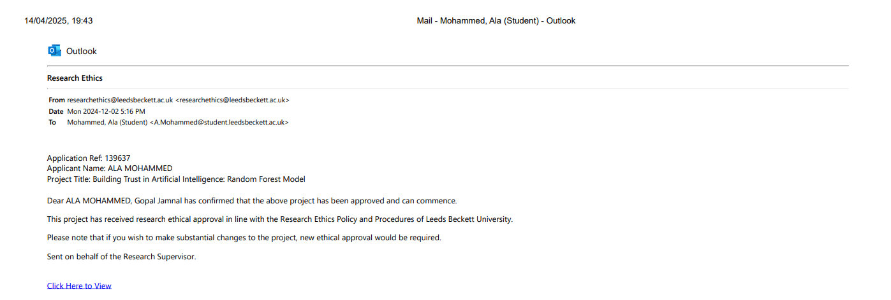
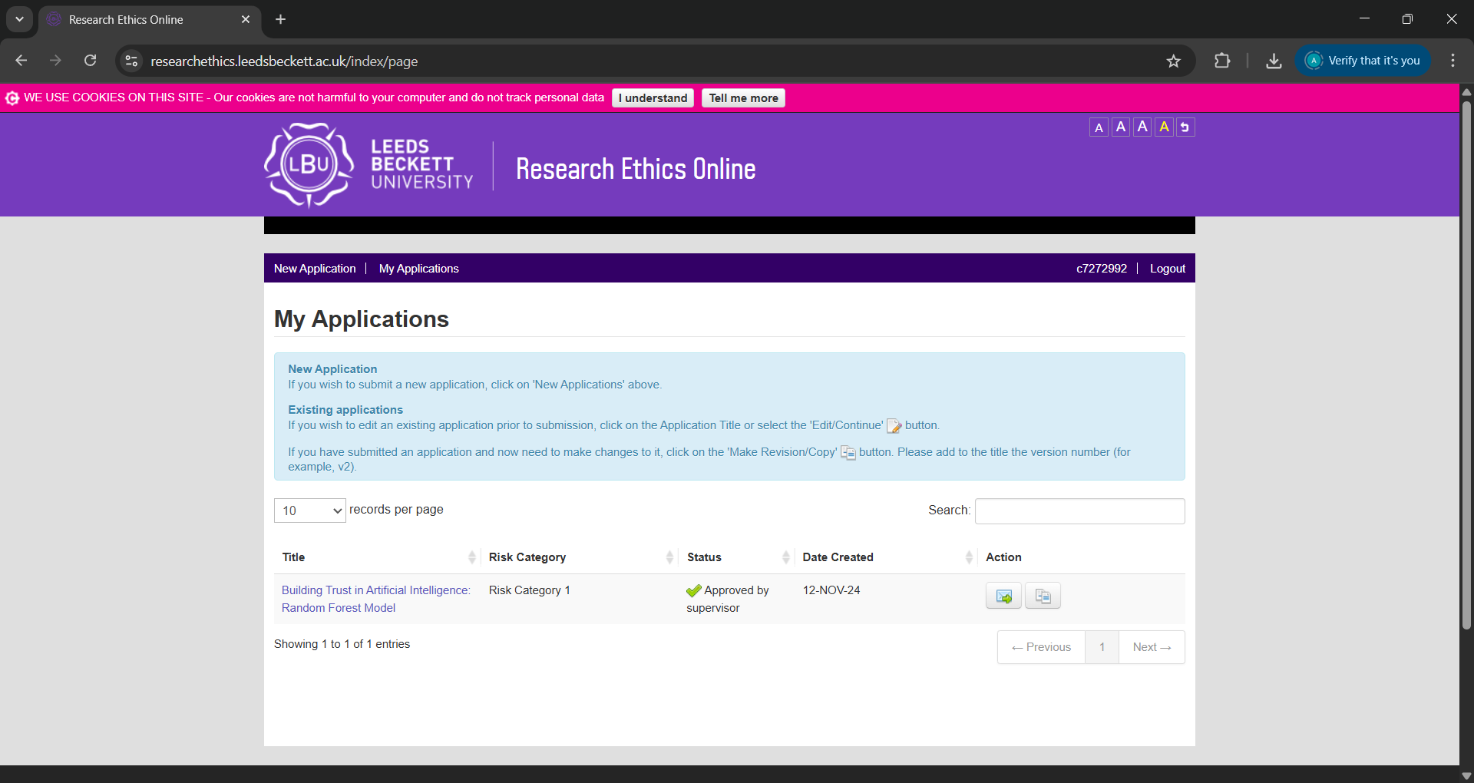

9.2 Coding snapshot

9.2.1 Function summary

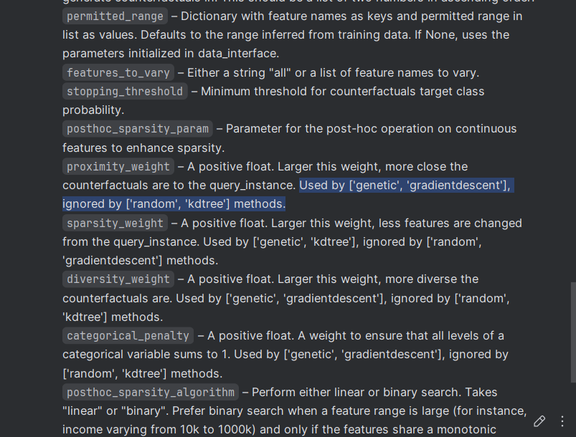

9.2.2 Function outcome

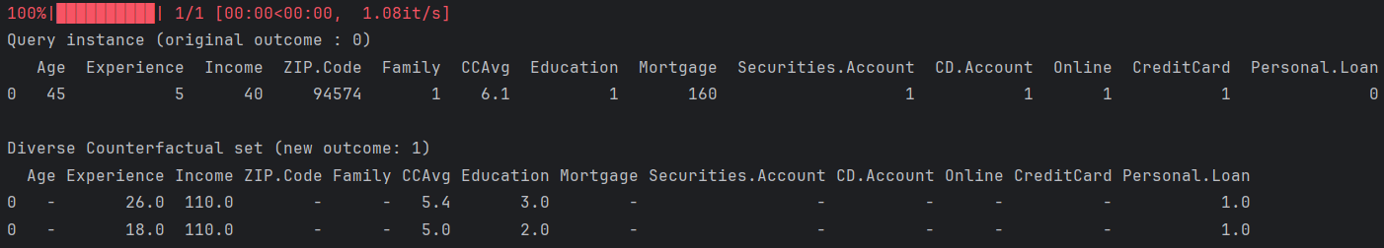

9.3 Risk Register
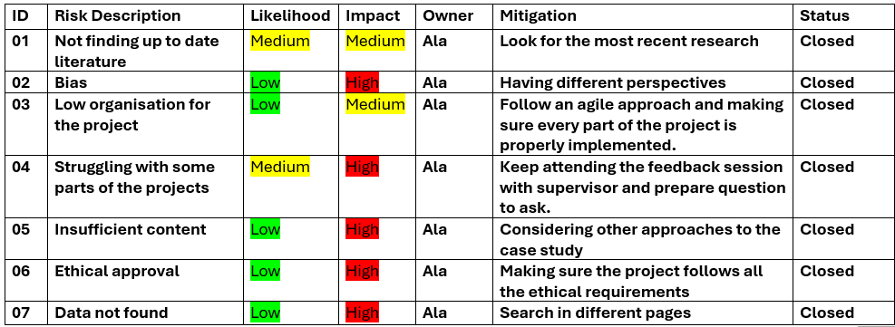

9.4 MoSCoW
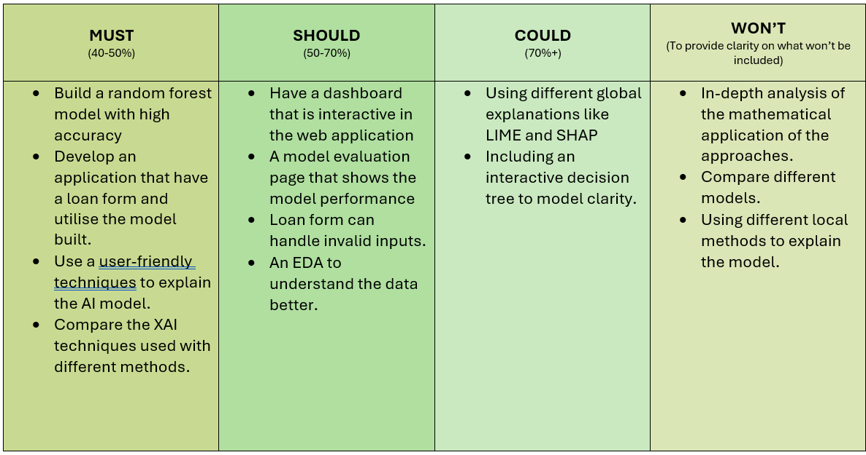

9.5 Gantt Chart

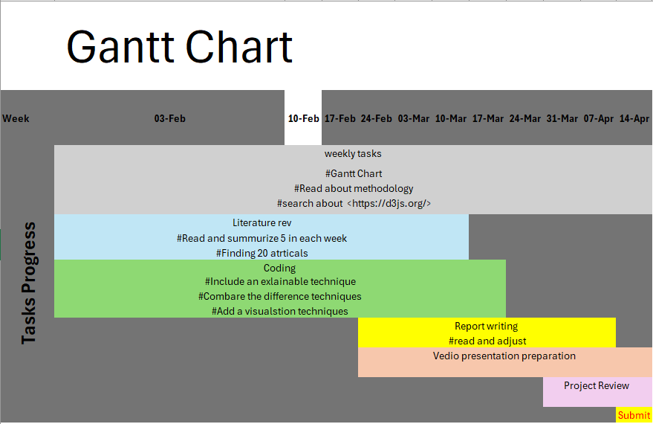

9.6 Project Prototype
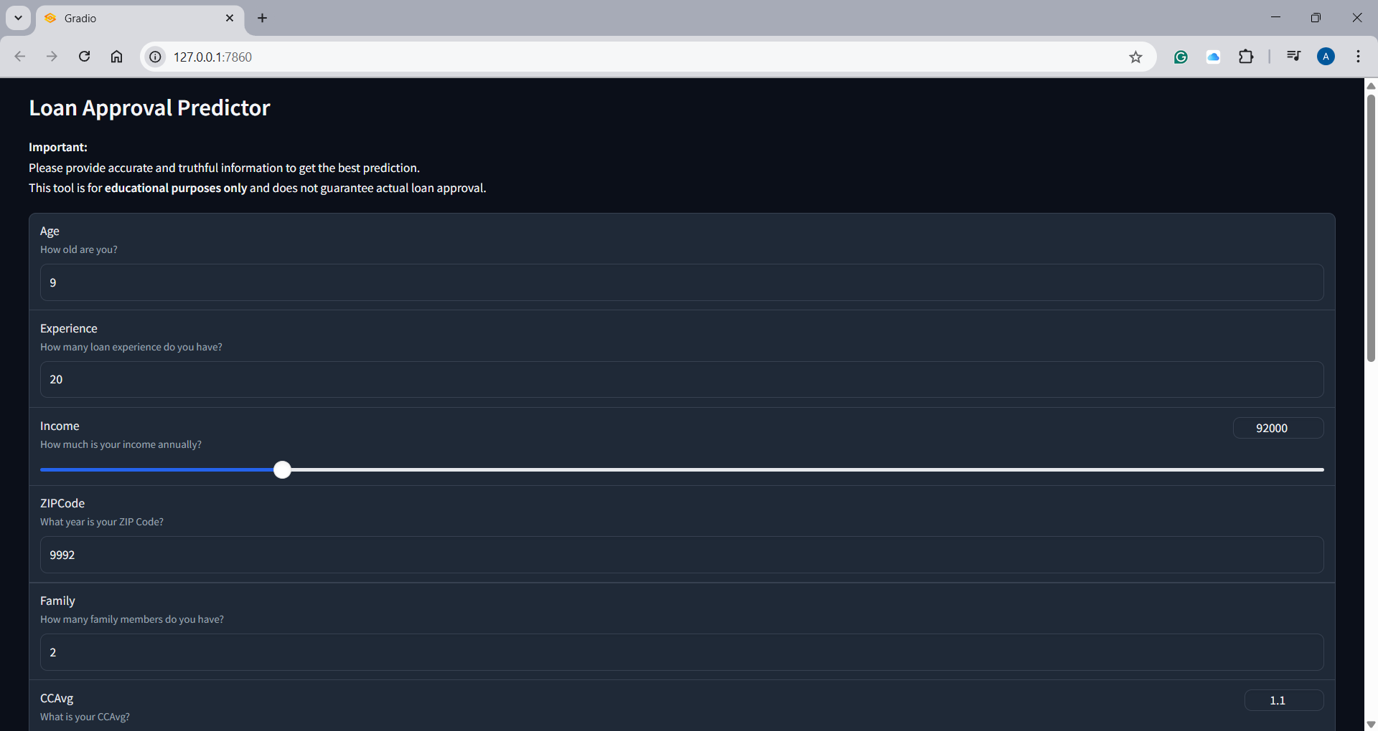
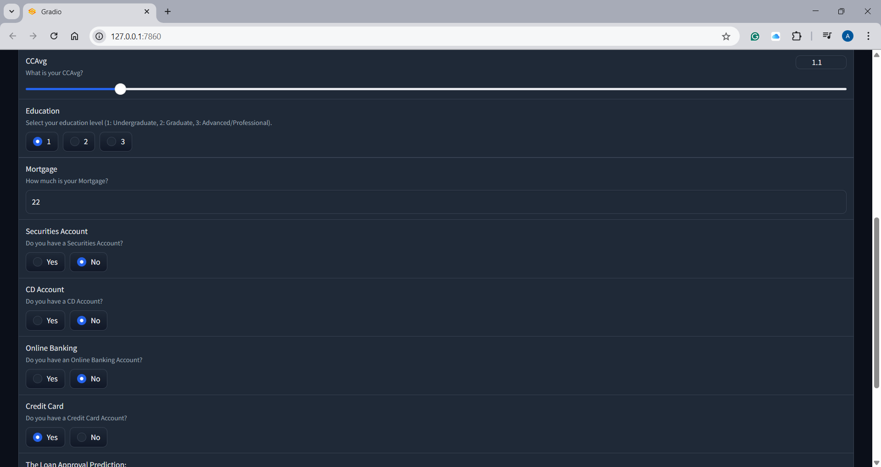
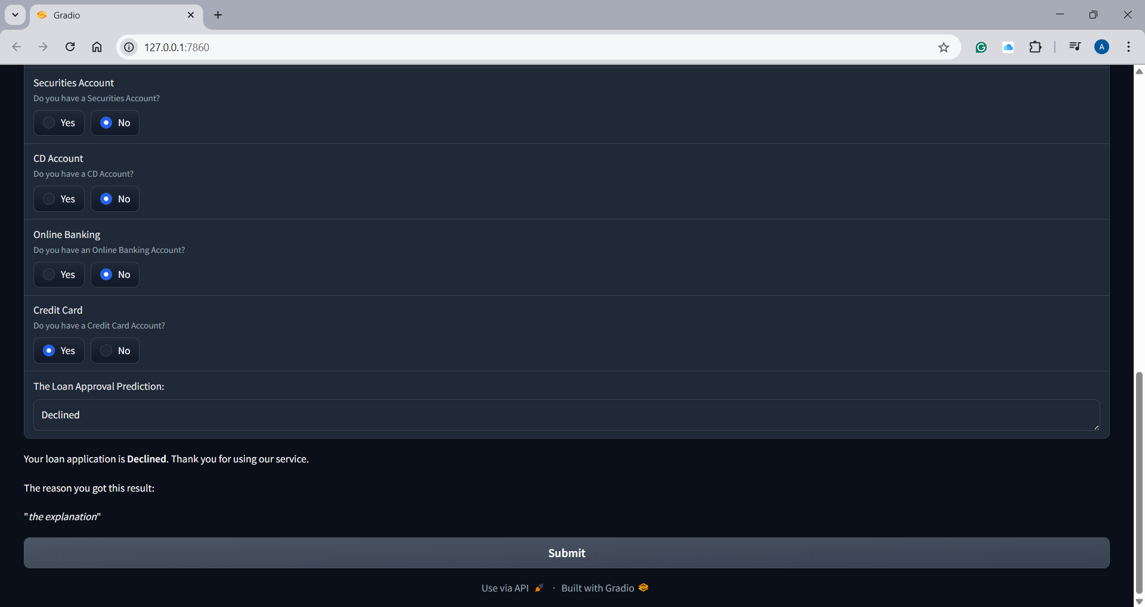

9.7 GitHub - Python code –
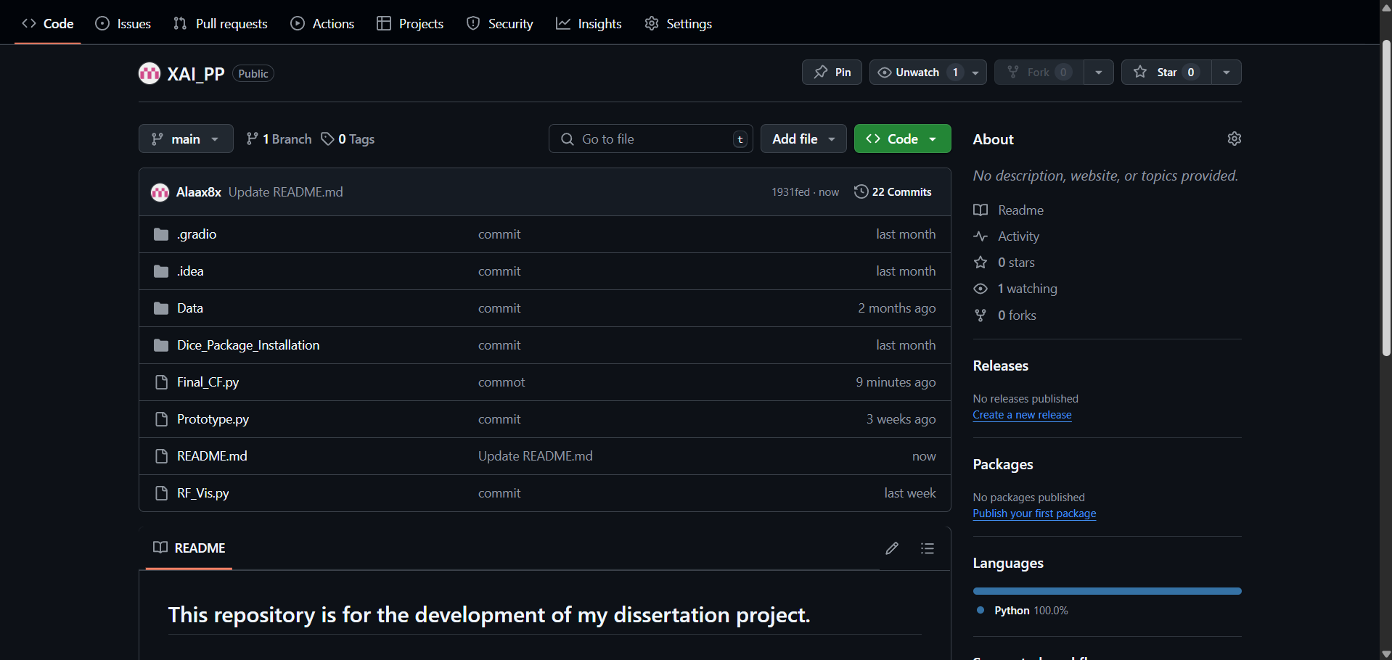

9.8 GitHub – Web Application –
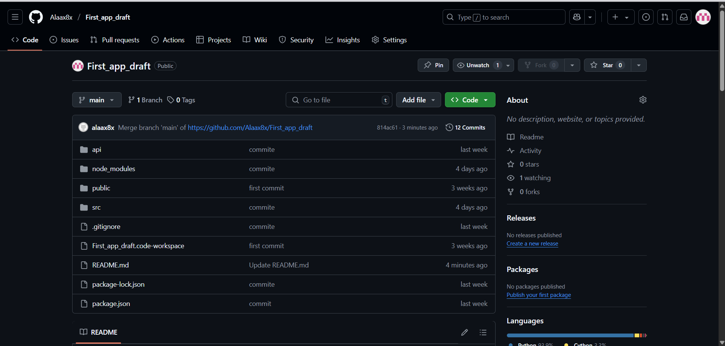

9.9 Dataset snapshot


