 | https://icons8.com/icons/set/account | Account and about us icon
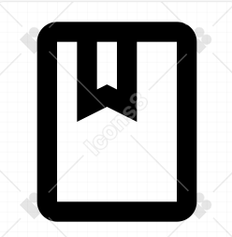 | https://icons8.com/icons/set/book | Booking icon
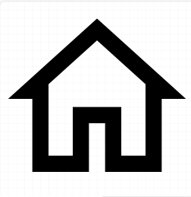 | https://icons8.com/icons/set/home | Home icon
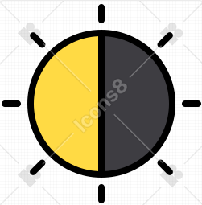 | https://icons8.com/icons/set/contrast | Contrast icon
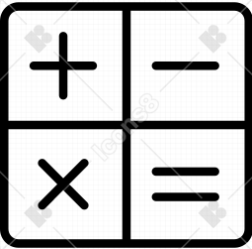 | https://icons8.com/icons/set/calculator | Calculator icon

