**Inventory System Documentation**

Below are the scripts details for inventory system:

* **InventoryItem.cs**

This class contains the blueprint for inventory item and is a scriptable object. Will contains all data related to item.

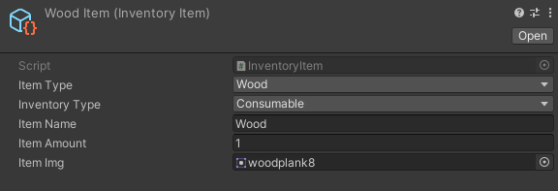

* **Inventory.cs**

This class is a scriptable object and will holds all inventory items for player in a dictionary called itemList.

This class has following functions:

1. **AddItemInventory (InventoryItem item)**

Takes InventoryItem object as item and adds it to inventory

1. **RemoveItemAmount (InventoryItem item)**

Takes InventoryItem object as item and removes it from inventory

1. **GetItemName (InventoryItem item)**

Takes InventoryItem object as item and returns name

1. **GetItemAmount (InventoryItem item)**

Takes InventoryItem object as item and returns amount in inventory

1. **GetItemImg (InventoryItem item)**

Takes InventoryItem object as item and returns item sprite

1. **GetListOfItems()**

Returns dictionary with inventory items

* **InventoryItemObject.cs**
  + This class is monobehavior which will reside in scene on inventory objects.

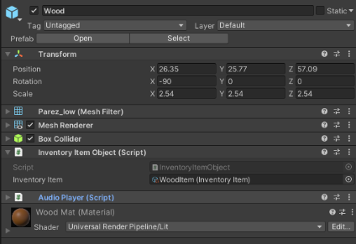

* **InventoryEventChannelSO.cs**
  + This is an inventory event. When ever any item is added or removed from inventory it will raise and inform all other scripts i.e, UI scripts that inventory is updated.
* **InventorySetUp.cs**

This script will be planted on player and when ever player interact with inventory object this script will add inventory object to the inventory and destroy the object in scene.

* **InventoryGUISetUp.cs**

This script will be planted on InventoryItem prefab and when ever inventoryItem is added in UI, this script will setup initial information for the item in UI.

* **DisplayInventoryUI.cs**

This script will be planted on panel in canvas and will help to load and show particular type of inventory items in UI.

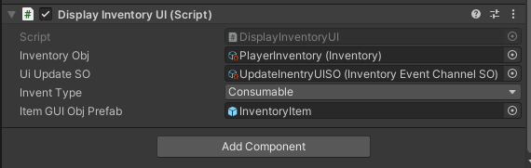

**That’s All**

**Thank You 😊**