Aim Of Project

MUSA ALABOUD –190706822

ABDULHAMID BARAKAT -190706817

In this project, we will start with the first step by using the Arduino program, then

We will integrate and synchronize the various electronic devices we have. Once

that is done, we will upload the website to a server to receive information from

Arduino so that people can access to see this information. The project's goal is

to verify the location and status of anyone carrying this device, and this idea came

after recent events in Turkey, such as earthquakes, where it became difficult to

know the location and status of missing people

Requirement

we should have a piece Microcontroller

after that we should have a piece GPS

and also Pulse Sensor

we must have a Server to show all INFO on it

Clint to see INFO

Electrical Circuit Drawing

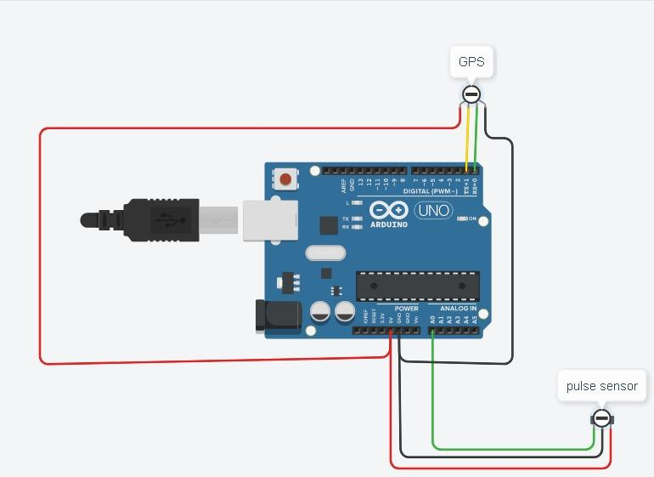

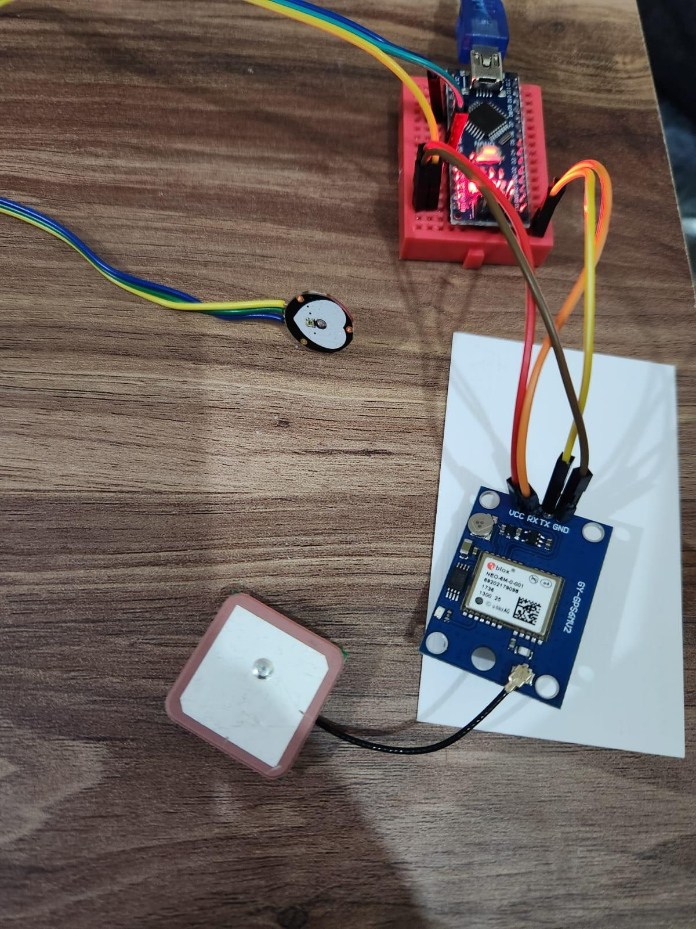

First Test For Pulse sensor

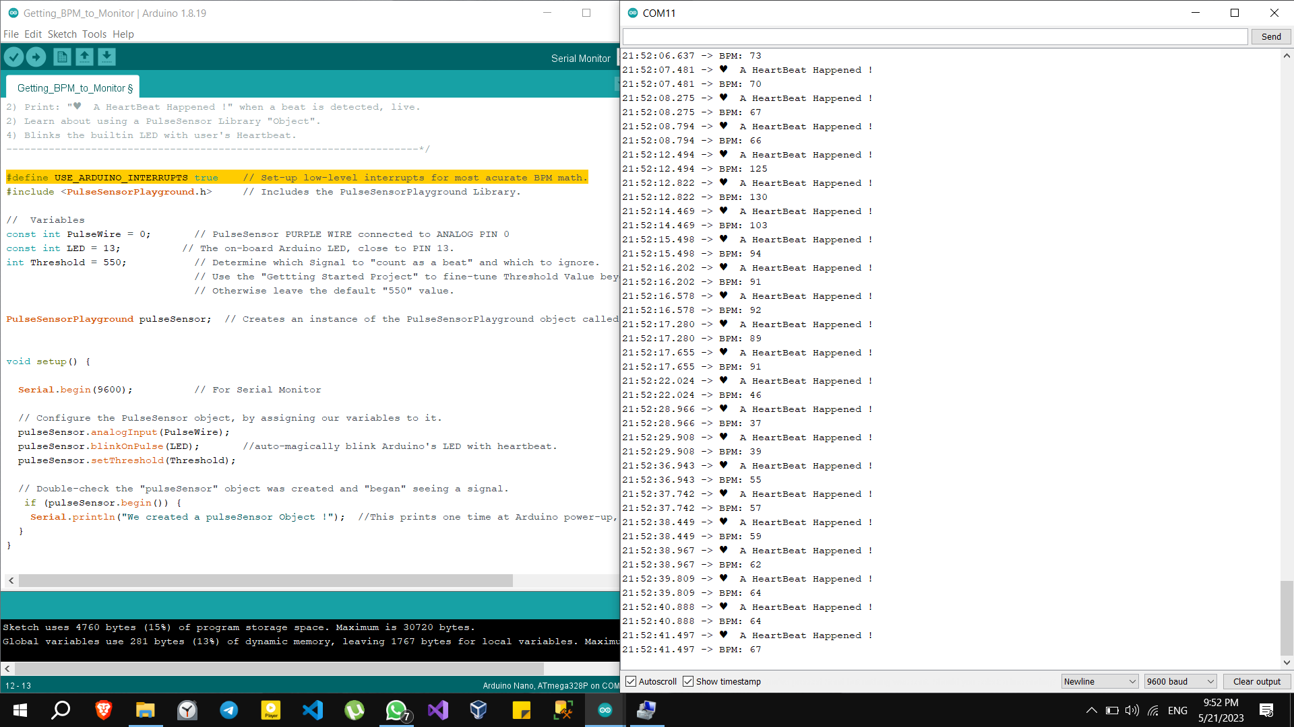

First Test For GPS sensor

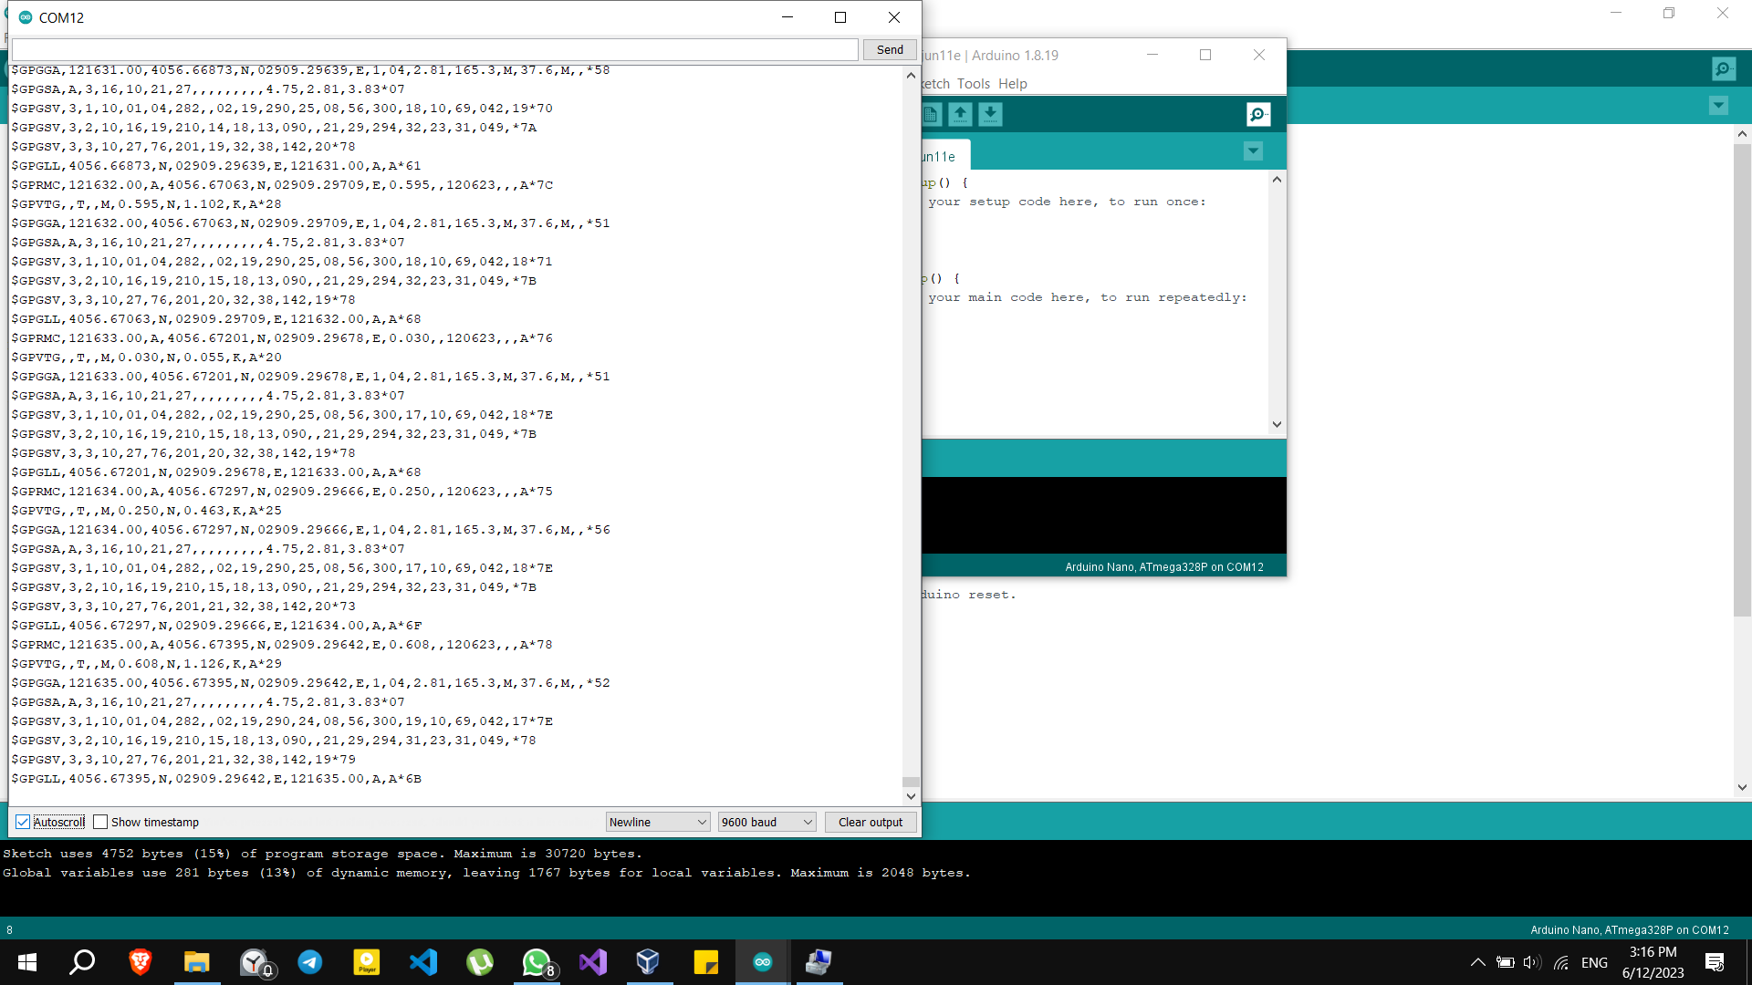

Database table

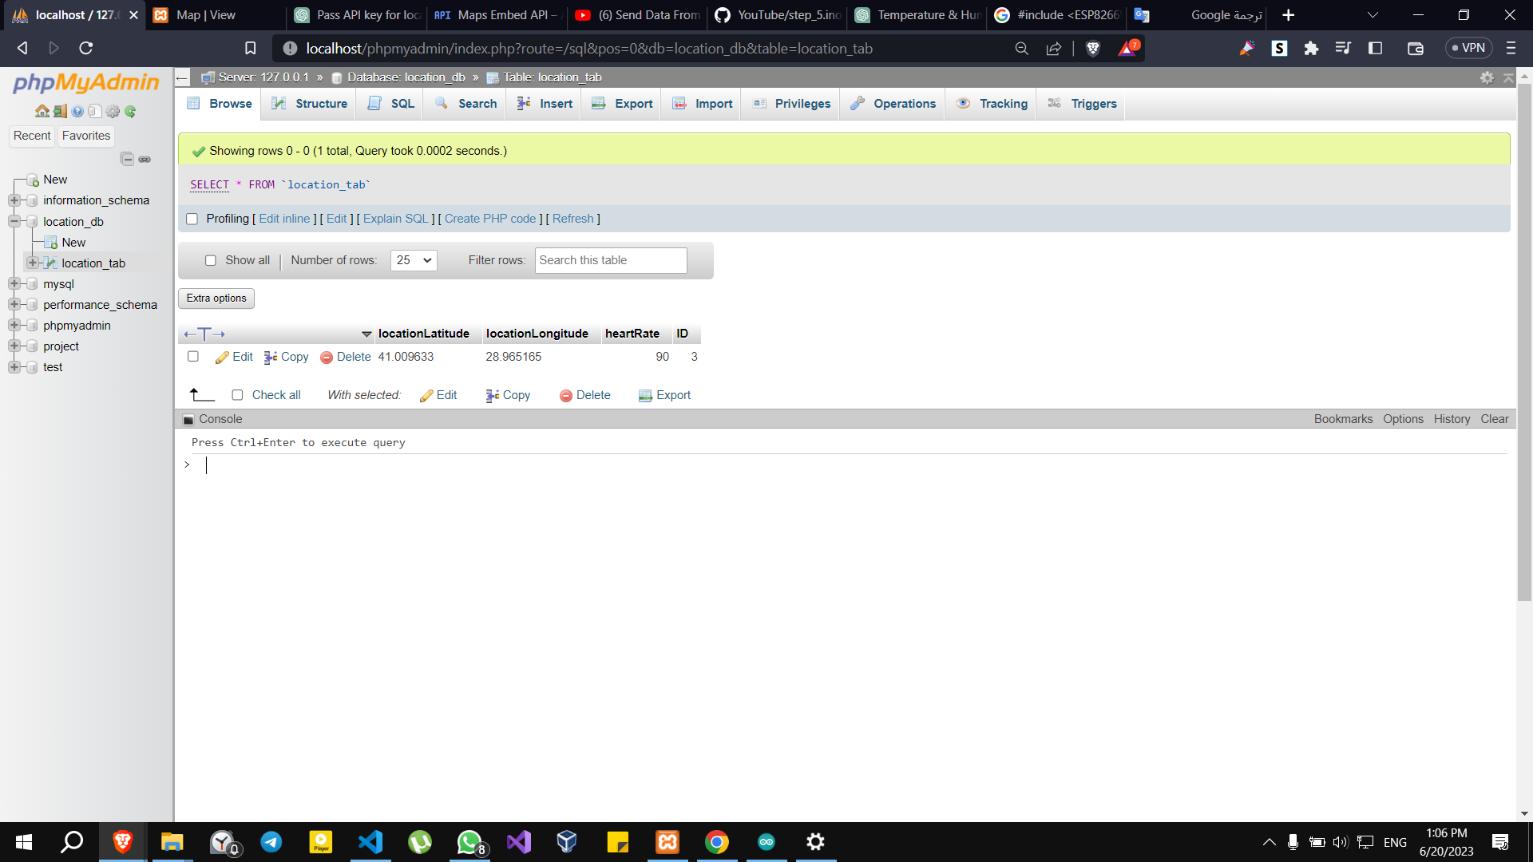

WebPage to show the result from database

