**FCIS – Ain Shams University**

**Credit Hour Programs (CHP)**

**Final Assessment**

**Academic year: 2019/2020**

**Academic Semester: Spring 2020**

* Research thesis replaces the final written exam
* The research is individual
* Each part/component of the research has a weight
* Research submission is online in electronic format
* Due date is the date announced by faculty/program administration’s schedule
* Research should be submitted in announced Student Template
* Plagiarism checking will be applied. Research is subject to rejection in such case

**RESEARCH THESIS**

|  |  |
| --- | --- |
| ProgramLevel | Swe2 |
| Course Code | CSY 350 |
| Course Title | Microprocessors & Assembly Language |

|  |  |
| --- | --- |
| Instructor(s) **Research Title***:* | Dr. Karim EmaraPolynomial Equation Evaluator |

THIS PAGE IS THE DOCUMENT COVER PAGE

YOU ARE **NOT ALLOWED** TO WRITE YOUR NAME, OR REVEAL YOUR IDENTITY THROUGH ANY OF THE DOUCMENT PAGES

YOU ARE ONLY ALLOWED TO FILL IN THE GIVEN INFORMATION

CHP - Spring 2020

# **User manual**

When you run the code message “Enter your equation” will appear and than you should enter the equation in format such as “X^2+2*X-3” or “X^3-15*X” and also it can have spaces like this “X^2 + 2*X -3” or “X^3-15*X”

And you can write Multiply as * like ”2*x” or nothing like “2x” you can write X in upper or lower case ,the constants number should write in the last end of the equation enter Enter key ,than the message “Enter x-value” will appear than you can enter x value as (signed integer)

Than the result of Equation will appear next message “Result=”.

# **High-level flowchart of the program logic**

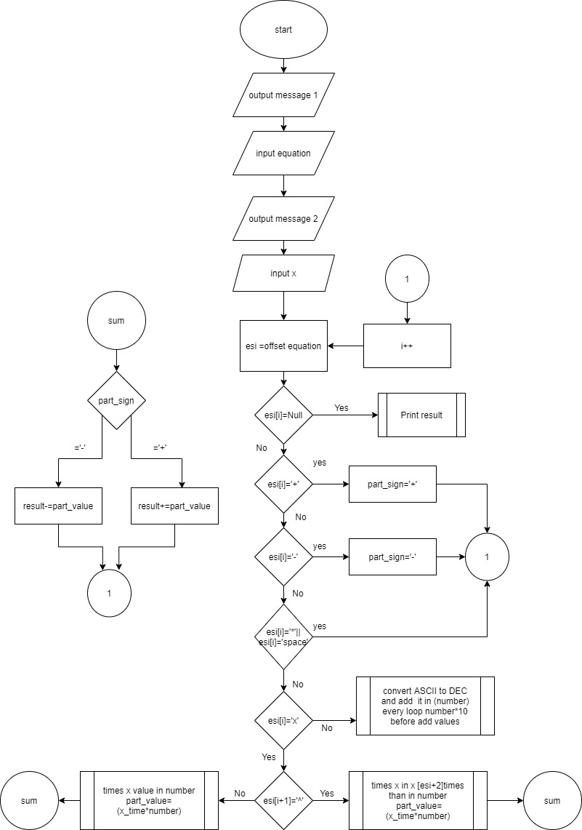

# **main procedures**

main proc: Read equation from user and x-value

calc proc: calculate the equation using x-value by check the string bytes and convert it to numbers and mathematics process.

Sum proc: summation the result of part to the total Result Depend on the part sign if it’s ‘+’ adding to total Result if its ‘-’ subtraction from total Result

# **Screen shot of runs**

1.X^2 + 2*X – 3 when x= 2

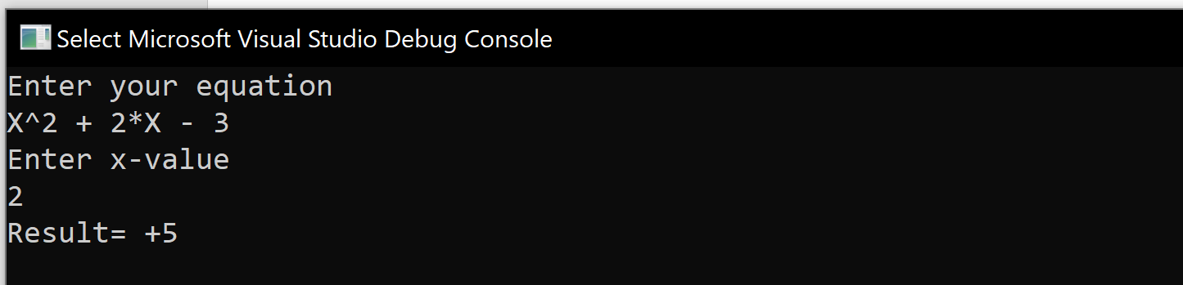

2.X^6 + 4*X^2 + 3*X + 5 when x=-3

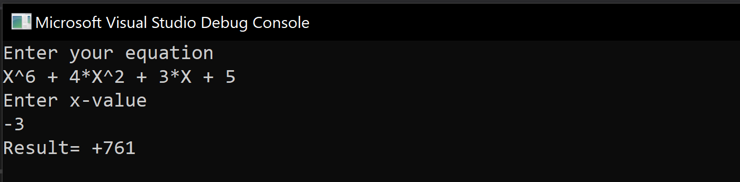

3. -2*X^2+2*X-3 when x=5

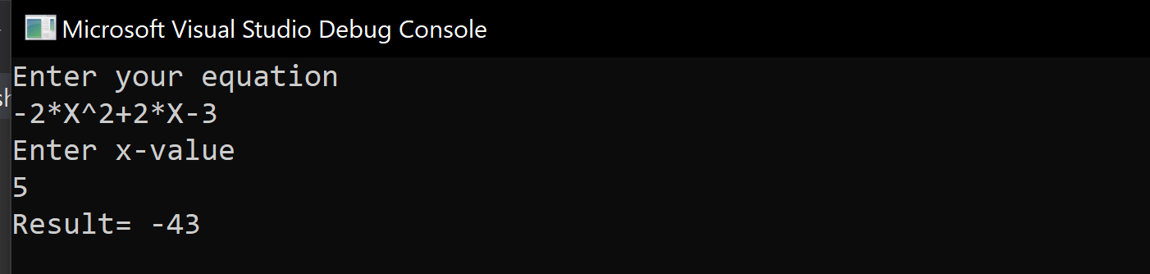

4. 5x+X^2-2 when x=-2

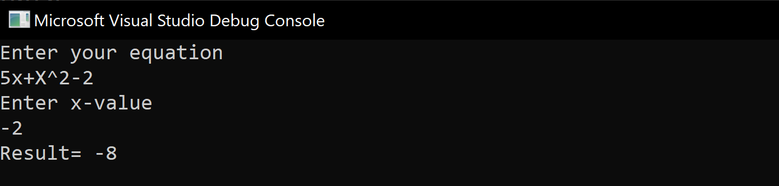

5. X^3-15*X when x=-3

