
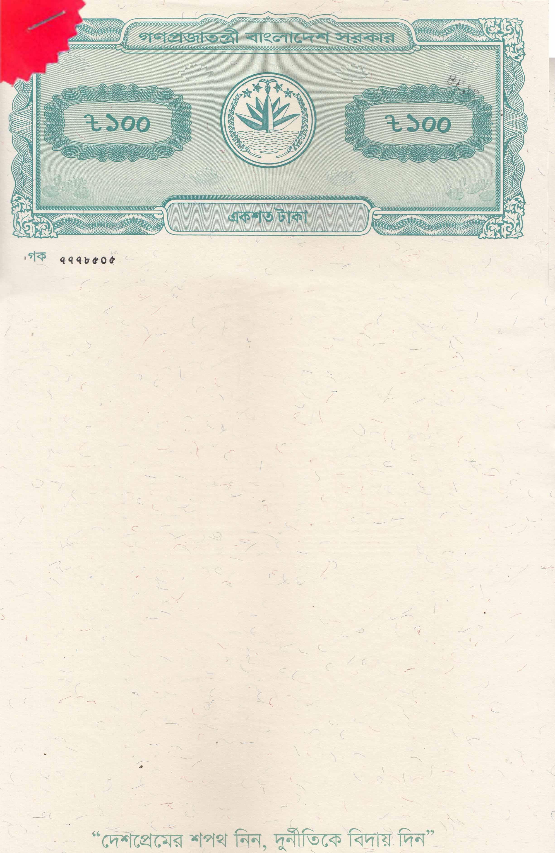
Before the Notary Public, Dhaka, Bangladesh
Student Declaration
By
Way of Affidavit

I, KHONDOKER SADI MAHAMUD, son of Mst Samsun Nahar, Date of birth: 15 May 1996, Passport No: A06051409, Permanent address: HOUSE NO, 59 D A, FLAT NO 3A4, DARUSSALAM APRTMENT, DARUS SALAM, MIRPUR 1216, DHAKA, Bangladesh, do hereby solemnly affirm and declare as follows:

I shall enter in New Zealand to pursue my Master of Early Childhood Education at New Zealand Tertiary College, located in Greenlane, Auckland 1546, New Zealand. My Student ID: 271003592.

- During my stay I undertake not to enter any sort of employment beyond the conditions of my study permit. I confirm that my mother sponsoring my education, and she will cover all financial responsibilities, including tuition fees, living expenses, and any other related costs throughout the duration of my studies.
- I undertake not to visit any other country without a valid entry visa and re-entry visa. I undertake that I could be refused entry.
- I also undertake not to breach any of the conditions of my permission to remain in New Zealand.
- I acknowledge that should I breach any of the conditions of my Student Visa, my case will be received no consideration and will result to my deportation

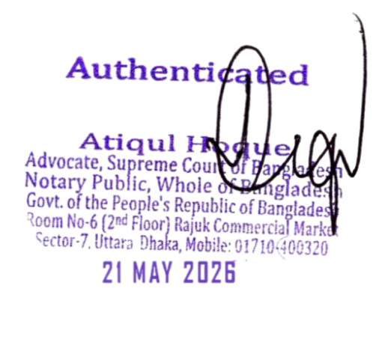

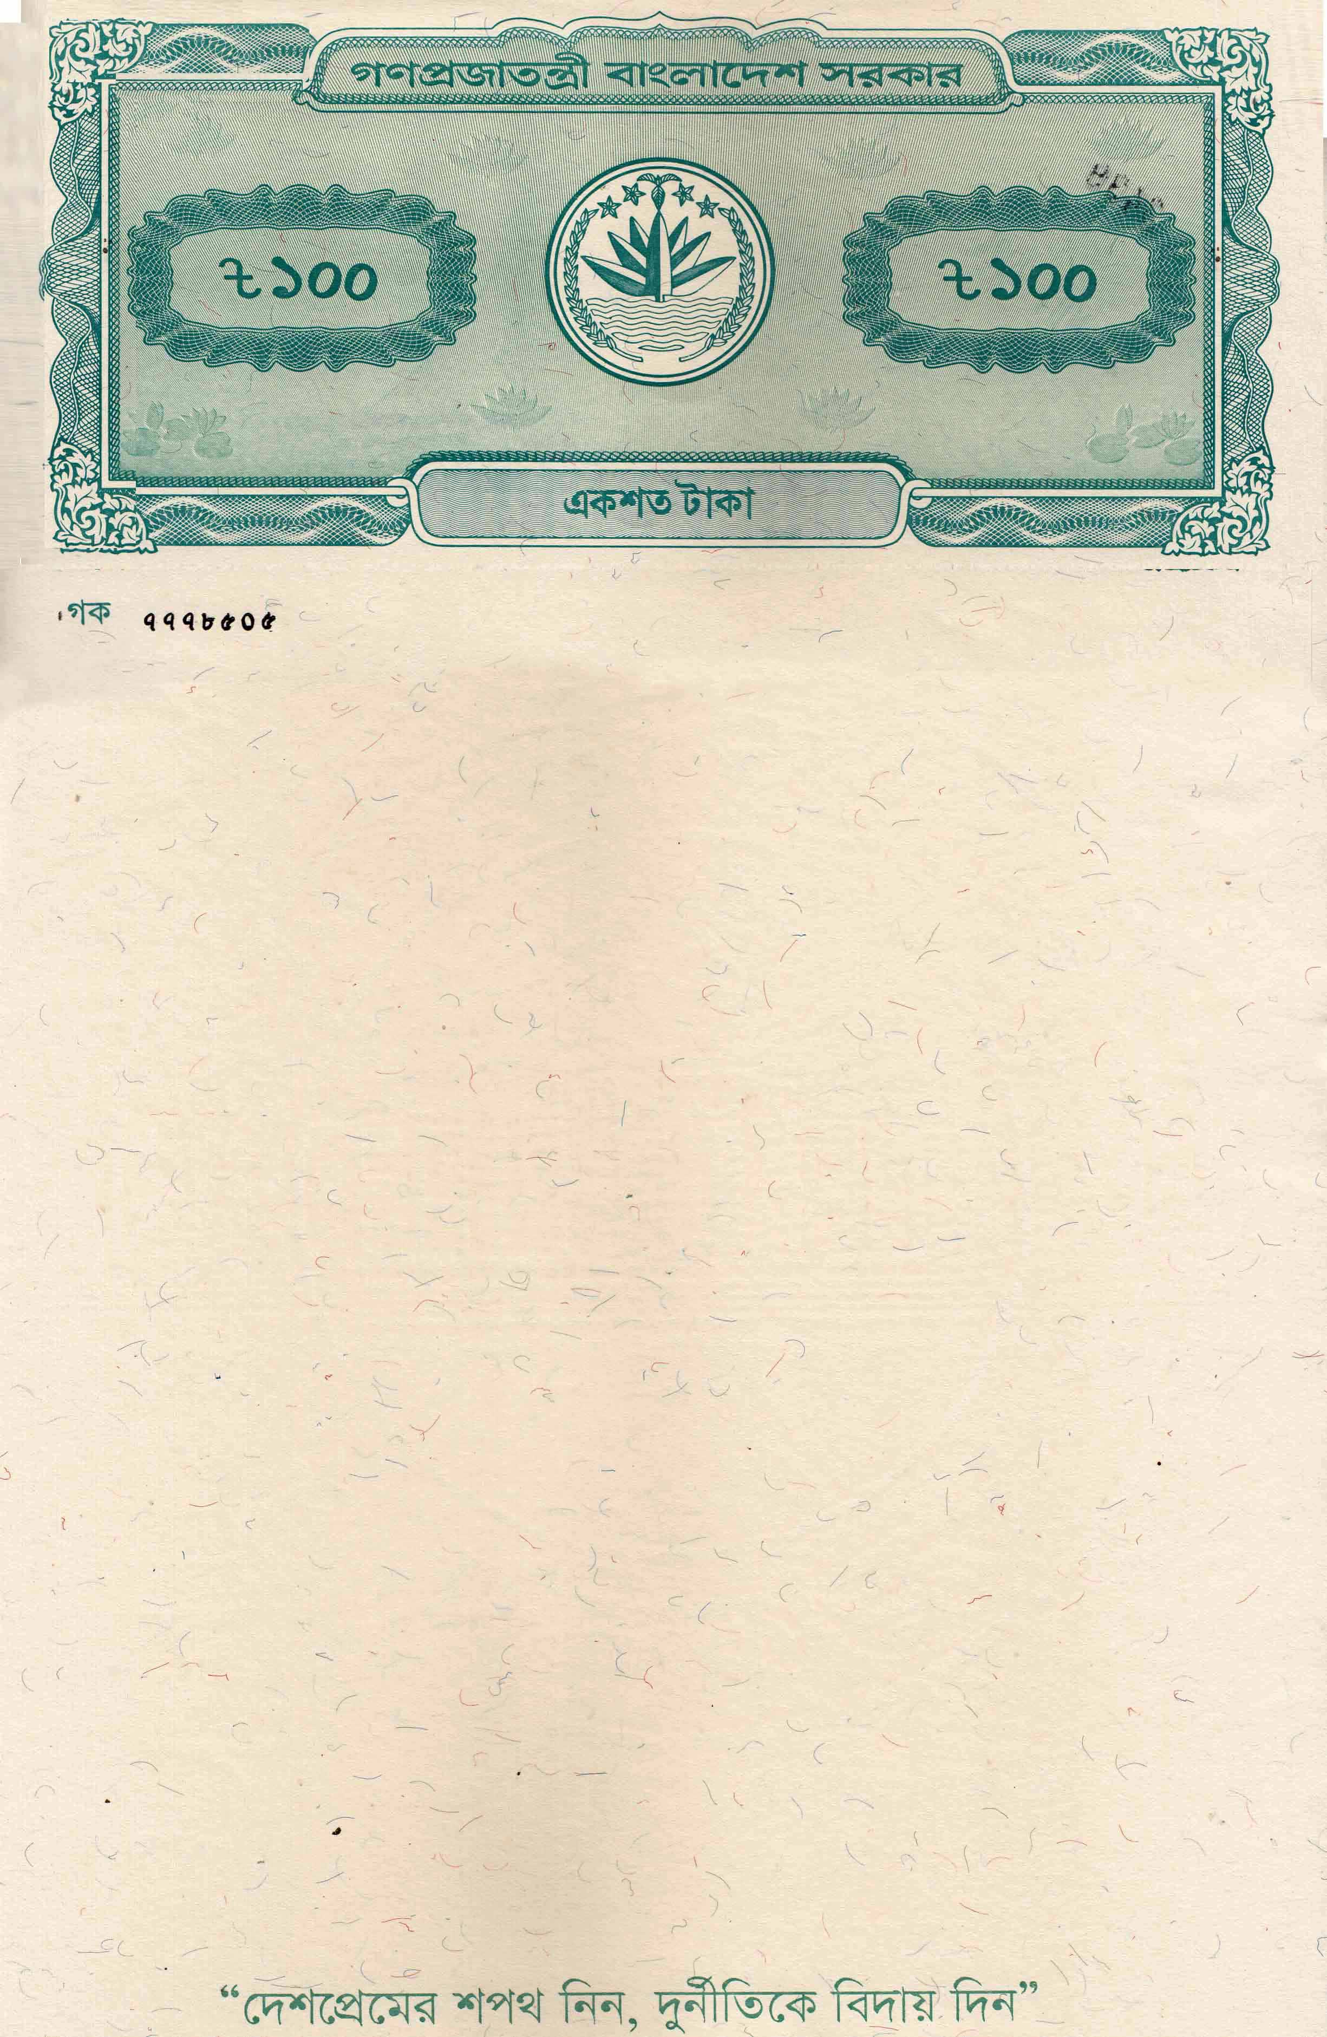

- I also undertake to return to my home country Bangladesh on completion of my studies at Master of Early Childhood Education at New Zealand Tertiary College, located in Greenlane, Auckland 1546, New Zealand.

That, the statements made above are true and correct to the best of my knowledge and belief and in witness here of I swear and sign this affidavit in front of Notary Public

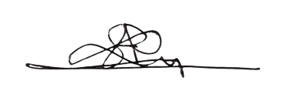


KHONDOKER SADI MAHAMUD
(Deponent)

The deponent is known to me and identified by me and he signed in my presence.


.
.

