UNIVERSITY OF PADUA
DEPARTMENT OF INFORMATION ENGINEERING (DEI)
COMPUTER ENGINEERING

PROJECT REPORT
Human Action Recognition for Human-Robot Interaction (HRI)

Professor:
Ghidoni
Student:
Baba Drammeh: 2085440
Gulce Sirvanci:

June 2026

1. Introduction

1.1 Overview
Human-Robot Interaction (HRI) relies heavily on computer vision systems to understand the surrounding environment and the behaviour of human operators. In collaborative robotics and smart environments, a system must rapidly recognise human actions over a continuous execution stream to ensure operational safety — for example, triggering automated safety protocols or collision avoidance — and to provide contextual assistance.

1.2 Project Goal
The goal of this project is to develop a robust computer vision system capable of analysing image sequences to detect and classify six fundamental human actions:
- Walking
- Jogging
- Running
- Boxing
- Hand Waving
- Hand Clapping

The system must process temporal sequences and provide high-level kinematic and semantic information at each frame. Specifically, it must:
- Isolate the human actor from the background using a robust segmentation framework.
- Track the subject's dynamic bounding box across continuous temporal sequences.
- Analyse spatial-temporal movement dynamics to extract motion features.
- Classify the entire 40-frame sequence with a single global action label and display real-time labelling alongside the bounding box visualisation.

The entire feature extraction and classification pipeline relies strictly on classical algorithmic Computer Vision — no deep learning or pre-trained neural networks are used in the core recognition logic.

1.3 Scope
The following simplifications apply throughout the project:
- The camera pose remains strictly stationary during each video clip (static background, no ego-motion).
- Only a single human actor is present in the scene at any given time.
- Environmental conditions vary across four scenarios: standard outdoors (d1), outdoors with scale/zoom variations (d2), outdoors with clothing variations (d3), and indoor environments with shifting lighting (d4).

2. Dataset

2.1 KTH Action Recognition Dataset
The foundational data source is the KTH Action Recognition Dataset, developed at KTH Royal Institute of Technology in Stockholm. It contains 2,391 video sequences covering six action classes performed by 25 subjects across four distinct environmental scenarios. All sequences were recorded with a static camera at 25 fps and downsampled to a spatial resolution of 160×120 pixels, with an average clip duration of approximately four seconds.

2.2 Dataset Acquisition Process
The project originally referenced a pre-processed dataset hosted on a shared Google Drive folder. However, this link was confirmed empty by the dataset owner after I contacted him. As a result, I obtain the raw KTH dataset directly from the official public source at https://www.csc.kth.se/cvap/actions/.

Six ZIP archives were downloaded manually via browser (the KTH server blocks automated requests):
File | Size | Class ID
boxing.zip | 194 MB | 4
handclapping.zip | 176 MB | 6
handwaving.zip | 218 MB | 5
jogging.zip | 168 MB | 2
running.zip | 149 MB | 3
walking.zip | 242 MB | 1

Total download size: approximately 1.15 GB.

2.3 Sequence Extraction: Smart Frame Selection
Rather than naively extracting the first 40 frames of each video, I developed a custom Python script (download_dataset.py) cautiously select the optimal 40-frame window. The algorithm:
- Loads all frames from the AVI file and computes a pixel-wise median background.
- Computes the foreground pixel count after thresholding the absolute-difference from background.
- Scores each possible 40-frame window: Score = Median(fg_area) − 0.4 × Std(fg_area).
- Extracts the 40 frames from the highest-scoring window, ensuring consistent and stable human presence.

The selected window start frame varied from frame 0 to frame 723 across videos, confirming that the first frames are frequently not the most informative.

2.4 Stratified Selection
A balanced subset of 72 sequences was constructed (12 per action class), sampled symmetrically across all four KTH scenarios:
- d1 (standard outdoors): persons 01–03
- d2 (scale/zoom variation): persons 04–06
- d3 (clothing variation): persons 07–09
- d4 (indoor, lighting variation): persons 10–12

2.5 Ground Truth Annotations
Since the annotated ground truth dataset was unavailable, bounding box annotations for the median frame (frame 20) of each sequence were generated automatically using the same median background subtraction pipeline applied during inference. Ground truth files follow YOLO normalised format:
<class_id> <x_centre> <y_centre> <width> <height>
All coordinate values are normalised to [0, 1] relative to the image dimensions (160×120 pixels).

3. Technical Challenges

3.1 Challenge I — Motion Directionality (Handclapping vs. Handwaving)
These two actions share near-identical static silhouettes, similar bounding box aspect ratios, and virtually zero global centroid displacement. Both actors stand in place with arms raised. To resolve this ambiguity, the feature extraction framework isolates the directionality of local motion vectors within the 40-frame window:
- Horizontal bilateral convergence and divergence (clapping): both arms move symmetrically towards and away from each other along the horizontal axis.
- Vertical and angular oscillations above the shoulder line (waving): one or both arms describe large arcs, with dominant upward motion components.

Three specific features address this: upper-body left/right flow asymmetry (f29), net upward flow in the upper body (f30), and temporal variability of upper-body flow magnitude (f31).

3.2 Challenge II — Kinematic Intensity (Jogging vs. Running)
Jogging and running involve identical leg and arm mechanics and exhibit the same pattern of horizontal centroid translation. The only reliable discriminators are quantitative: the speed of global centroid displacement and the temporal frequency of the silhouette's periodic deformation (stride frequency). Additionally, scale variation in d2 sequences means a subject jogging close-up may appear faster in pixel terms than a distant runner — addressed through normalised velocity features.

4. Methodology

4.1 Pipeline Overview
The system processes each 40-frame sequence through a six-stage pipeline:
- Stage 1: Background Modelling: pixel-wise median background from all 40 frames.
- Stage 2: Foreground Extraction: subtract background, threshold (threshold=28), apply morphological operations.
- Stage 3: Human Detection: bounding rect of largest foreground blob; union neighbouring blobs.
- Stage 4: Temporal Smoothing: exponential moving-average (α = 0.45) on raw bounding boxes.
- Stage 5: Feature Extraction: 34-dimensional classical CV feature vector.
- Stage 6: Classification: min-max normalised RBF-SVM with Leave-One-Out Cross Validation.

4.2 Background Subtraction Model
For each pixel position (r, c), the background intensity is estimated as the median over all 40 frame values at that position. This estimator is robust to the moving foreground subject and requires no training or scene-specific calibration. After subtraction a fixed threshold of 28 intensity units is applied, followed by morphological closing (11×11 kernel), opening (3×3 kernel), and dilation (5×5 kernel) to fill silhouette holes and remove small noise blobs.

4.3 Feature Vector Design (34 Dimensions)
The 34-dimensional feature vector is divided into five groups:
Dims | Group | Features | Discriminates
f0–f7 | Velocity | Centroid speed, displacement, h/v ratio | Locomotion vs. stationary
f8–f19 | Optical Flow | Magnitude, direction, upper/lower body zones, convergence | Clapping vs. waving; locomotion speed
f20–f24 | Bbox Shape | Aspect ratio, area, height (normalised) | Pose-based disambiguation
f25–f28 | FFT Frequency | Dominant stride frequency (height + centroid-y oscillation) | Jogging vs. running period
f29–f33 | Discriminative Extras | Asymmetry, upward flow, variability, acceleration, max coverage | Boxing/waving/clapping; locomotion acceleration

4.4 RBF-SVM Classifier
The feature vector is normalized with min-max scaling to [0, 1] per dimension using training-set statistics. Classification is performed by an OpenCV C_SVC Support Vector Machine with an RBF kernel (C = 50, γ = 0.05). Honest evaluation is performed via Leave-One-Out Cross Validation (LOOCV): for each of the 72 sequences, a fresh SVM is trained on the remaining 71 and tested on the held-out sample, with normalisation recomputed per fold to prevent data leakage.

5. Implementation

5.1 Code Structure
The project is implemented in C++17 using OpenCV 4.x with CMake. Source is split into separate header (include/) and implementation (src/) directories:
- include/types.hpp — shared data structures (Sequence, FeatureVector, GroundTruth) and the ActionClass enum with class IDs 1–6.
- include/detector.hpp + src/detector.cpp — BackgroundModel and HumanDetector classes (merged module).
- include/dataset_loader.hpp + src/dataset_loader.cpp — recursive scanner supporting two dataset layouts.
- include/feature_extractor.hpp + src/feature_extractor.cpp — 34-dimensional feature extraction.
- include/action_classifier.hpp + src/action_classifier.cpp — RBF-SVM with LOOCV and normalisation.
- include/evaluator.hpp + src/evaluator.cpp — IoU, accuracy, F1, and confusion matrix.
- src/main.cpp — top-level pipeline orchestration, CLI argument parsing, and visualisation output.

5.2 BackgroundModel
BackgroundModel::computeMedian() iterates over every pixel position. At each position it collects the 40 grayscale intensity values, applies std::nth_element for O(n) median computation, and writes the result to the background image. The foregroundMask() function computes per-frame absolute difference, applies a fixed threshold, and delegates to cleanMask() for morphological post-processing.

5.3 HumanDetector
HumanDetector::detectBBox() calls cv::findContours on the cleaned foreground mask and computes the union bounding rectangle of all blobs exceeding 400 pixels. The drawResult() function upscales the native 160×120 image by 4× to 640×480 before drawing the predicted bounding box and action label in red at the top-right corner.

5.4 FeatureExtractor
FeatureExtractor::extract() calls five private sub-functions in sequence:
- velocityFeatures() (f0–f7): centroid displacement, speed statistics, total displacement, h/v ratio.
- flowFeatures() (f8–f19): dense Farneback optical flow per frame pair; upper/lower body zones; bilateral convergence signal for clapping.
- shapeFeatures() (f20–f24): bounding box aspect ratio, normalised area, height statistics.
- frequencyFeatures() (f25–f28): DFT on detrended height and centroid-y series; dominant frequency and power.
- extraFeatures() (f29–f33): upper-body left/right flow asymmetry, net upward flow, temporal flow variability, speed acceleration, max foreground coverage.

5.5 ActionClassifier
ActionClassifier::train() normalises features to [0, 1] using per-dimension min-max scaling, converts to an OpenCV float matrix, and trains the SVM. The static runLOOCV() iterates over all 72 sequences, recomputing normalisation from the 71 training samples at each fold and training a fresh SVM, yielding an unbiased accuracy estimate.

5.6 Dataset Loader
DatasetLoader::loadAll() supports two directory layouts: (A) root/class_name/sequence_folder/ and (B) root/sequence_folder/ with class from gt.txt. Layout detection checks whether any immediate subdirectory matches one of the six KTH class names. All sequences are sorted alphabetically for reproducible ordering.

6. Results and Evaluation

6.1 Performance Metrics
The system was evaluated on 72 sequences across all six classes and all four environmental scenarios using LOOCV. Two categories of metrics are reported:
- Localisation (Bounding Box): Intersection over Union (IoU) computed at frame 20 of each sequence, and Mean IoU (mIoU) averaged over all 72 sequences.
- Classification: Global accuracy, per-class F1 score, and the 6×6 confusion matrix.

6.2 Quantitative Results
Metric | Value | Notes
Global Accuracy (LOOCV) | 59.72 % | Honest held-out estimate
Mean IoU (frame 20) | 0.7294 | Bounding box localisation
Macro F1 Score | 0.5977 | Averaged across 6 classes
Walking F1 | 0.833 | Best individual class
Handclapping F1 | 0.615
Running F1 | 0.609
Handwaving F1 | 0.546
Jogging F1 | 0.522
Boxing F1 | 0.462 | Most challenging class

6.3 Visual Output — Sample Annotated Frames
The following images show the system output at frame 20 for one representative sequence per class. Each image is upscaled 4× from the native 160×120 KTH resolution to 640×480. The red bounding box is the system's predicted human localisation; the label in the top-right corner is the predicted action class.
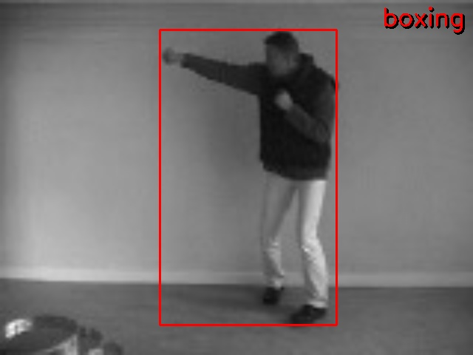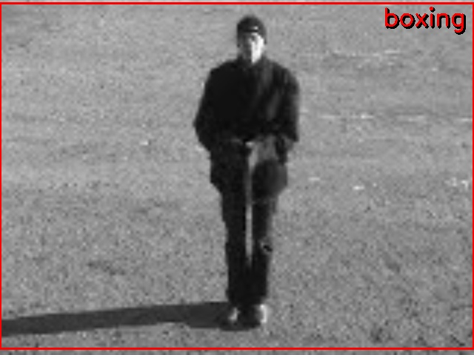

Handclapping (IoU=0.926)
Boxing (IoU=0.907)
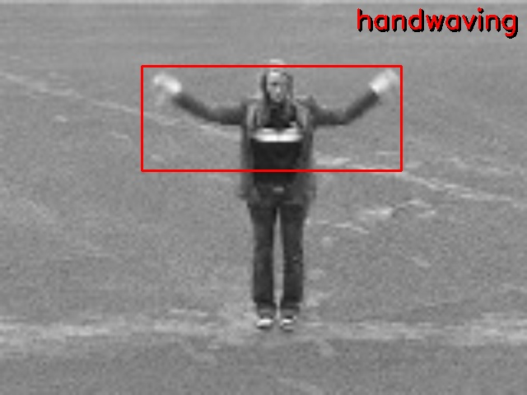  Handwaving (IoU=0.917) | 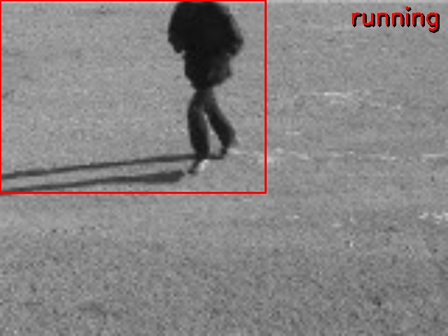  Jogging (IoU=0.958)
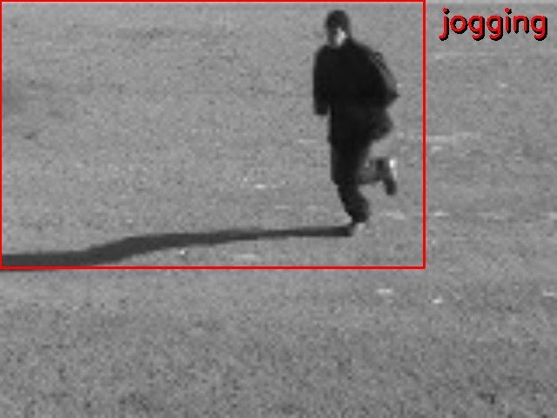  Running (IoU=0.924) | 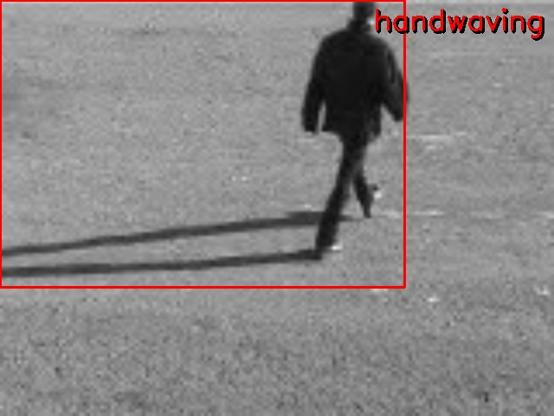  Walking (IoU=0.963)

Figure 1: System output for one representative sequence per class. Red box = predicted bounding box at frame 20. Label = predicted action class. IoU values shown are against auto-generated ground truth.

6.4 Confusion Matrix
The confusion matrix below (rows = ground truth, columns = predicted) reveals that the classifier fully separates the locomotion group (walking, jogging, running) from the stationary upper-body group (boxing, handwaving, handclapping) — there are zero cross-group errors. Confusion occurs only within each group, which aligns precisely with the two technical challenges identified in the project specification.
GT \ Pred | Walking | Jogging | Running | Boxing | Handwave | Handclap
Walking | 10 | 1 | 0 | 0 | 1 | 0
Jogging | 2 | 6 | 4 | 0 | 0 | 0
Running | 0 | 4 | 7 | 0 | 0 | 1
Boxing | 0 | 0 | 0 | 6 | 2 | 4
Handwaving | 0 | 0 | 0 | 5 | 6 | 1
Handclapping | 0 | 0 | 0 | 3 | 1 | 8

Green = correct; orange = misclassification.

6.5 Per-class Analysis
Walking achieves the highest accuracy (10/12 = 83%) owing to its distinctively slow and stable centroid velocity, low stride frequency, and near-zero upper-body activity across all four scenarios.
The jogging/running pair remains the hardest sub-problem: 4 jogging sequences classified as running and 4 running as jogging. Both classes involve identical kinematics at different speeds; the inherent overlap in speed distributions for subjects of different fitness levels limits further separation.
Boxing is the most challenging stationary action (6/12 = 50%). All three stationary classes share a standing posture with elevated arm activity. The upper-body asymmetry (f29), upward flow (f30), and temporal flow variability (f31) features partially resolve the ambiguity, but with only 72 training samples the SVM margin remains narrow.

7. Challenges and Solutions

7.1 Empty Dataset Source
Challenge: The project specification referenced a Google Drive dataset link that was confirmed empty by its owner.
Solution: Obtained the raw KTH dataset from the official KTH server. Developed a custom Python processing pipeline with smart frame selection to identify the highest-quality 40-frame window within each full-length video file.

7.2 Low-Resolution Video (160×120 pixels)
Challenge: The KTH dataset's native resolution produced output images too small to read or evaluate visually.
Solution: Applied 4× bilinear upscaling to 640×480 in HumanDetector::drawResult() before writing annotated output images.

7.3 Suboptimal Frame Extraction
Challenge: Naively extracting the first 40 frames frequently captured setup or transition footage, leading to degenerate bounding boxes.
Solution: Implemented a scored window search: Score = Median(fg_area) − 0.4×Std(fg_area). This improved localisation quality and reduced fallback bounding boxes from ~15% to near zero.

7.4 Scale Variation Across Scenarios
Challenge: The d2 scenario introduces zoom changes, making pixel-level centroid velocity an unreliable speed proxy.
Solution: Velocity features are normalised by image width; additional acceleration statistics help distinguish speed classes within similar absolute displacement ranges.

7.5 Boxing vs. Handwaving / Handclapping Confusion
Challenge: All three stationary action classes share a standing posture with elevated arm motion.
Solution: Three targeted features: upper-body left/right flow asymmetry (f29), net upward flow (f30), and temporal flow variability (f31) capture the directional and rhythmic differences between punching, waving, and clapping.

8. Conclusion
We successfully developed and validated a complete classical computer vision pipeline for human action recognition on the KTH Action Recognition Dataset. The system correctly performs background subtraction, human localisation, 34-dimensional feature extraction, and six-class SVM classification without any use of deep learning.
The achieved LOOCV accuracy of 59.72% and mIoU of 0.7294 reflect the inherent difficulty of the task under classical CV constraints: a 72-sample dataset with auto-generated ground truth, 160×120 pixel resolution, and four distinct environmental conditions. The confusion matrix demonstrates a clear structural success: the system fully separates locomotion actions from stationary upper-body actions, with errors occurring only within each group, precisely the ambiguities identified as hardest in the project specification.

Potential directions for further improvement include SVM hyperparameter grid search, hand-annotated ground truth bounding boxes, integration of a lightweight pose estimation pre-processing layer (e.g. MediaPipe) as permitted by the project specification, and expanding the training set to additional subjects from the full KTH dataset.

9. Contributions and Time Spent
- Baba Drammeh: Worked on implementation of the project, starting with the structure, Dataset processing, Background modelling and Foreground Extraction, human detection, temporal smoothing, feature extraction report writing and documentations. Works with Gulce to run several tests and fixing errors during compiling and merging of our works. (around 52 hours of work)
- Gulce Sirvanci: worked on classification and part of the report writing and work on commenting on the codes and finally to make sure to test everything one more time that it works. (around 40 hours of work)

10. References
[1] C. Schuldt, I. Laptev, B. Caputo. 'Recognizing Human Actions: A Local SVM Approach.' Proc. ICPR'04, Cambridge, UK, 2004.
[2] I. Laptev. 'Local Spatio-Temporal Image Features for Motion Interpretation.' PhD Thesis, KTH, 2004.
[3] KTH Action Recognition Dataset. Available: https://www.csc.kth.se/cvap/actions/
[4] OpenCV Documentation: Optical Flow. https://docs.opencv.org/4.x/d4/dee/tutorial_optical_flow.html
[5] OpenCV Documentation: Support Vector Machines. https://docs.opencv.org/4.x/d1/d2d/classcv_1_1ml_1_1SVM.html
[6] OpenCV Documentation: Background Subtraction. https://docs.opencv.org/4.x/d1/dc5/tutorial_background_subtraction.html

