Project Objective:

The objective of this project is to collect, merge, and analyze COVID-19 vaccination data from various sources, including Our World in Data GitHub repository, to gain insights into the global vaccination progress. The project aims to provide a comprehensive dataset that includes country-level vaccination information, such as the total number of vaccinations, people vaccinated, people fully vaccinated, daily vaccinations, and more. This dataset will be used for research and analysis to understand vaccination trends and their impact on public health.

Design Thinking Process:

1. **Understanding the Problem**: The project starts with a clear understanding of the problem: the need for a consolidated and reliable dataset on COVID-19 vaccinations. This involves identifying the key data sources, data fields, and the format in which data is available.

2. **Data Cleaning and Preprocessing**:

- Data quality is assessed to handle missing values, outliers, and inconsistencies.

- Data preprocessing techniques are applied to ensure that the data is in a consistent format for analysis.

3. **Data Analysis and Visualization**:

- The cleaned dataset is analyzed to extract meaningful insights.

- Visualizations and statistical analysis are performed to understand trends, distribution, and correlations within the data.

4. **Development Phases**:

a. **Data Cleaning and Preprocessing**:

- Address missing values by imputation or removal, depending on the nature of the data.

- Handle outliers and inconsistencies in the data.

- Convert data types to ensure consistency.

b. **Data Analysis and Insights**:

- Explore the dataset to identify vaccination trends, such as the daily vaccination rate, cumulative total, and coverage per hundred.

- Generate visualizations, including time series charts, maps, and statistical summaries.

- Identify patterns, anomalies, and key statistics.

c. **Documentation and Reporting**:

- Create documentation that explains the data sources, cleaning processes, and analysis methods used.

- Generate reports or dashboards to present the findings in an accessible and informative manner.

d. **Maintenance and Updates**:

- Establish a process for regular data updates to keep the dataset current.

- Implement version control to track changes and updates to the dataset.

By following these design thinking principles and development phases, the project aims to provide valuable insights into the global COVID-19 vaccination efforts and contribute to informed decision-making and public health strategies.

GRAPHICAL VISUALIZATION

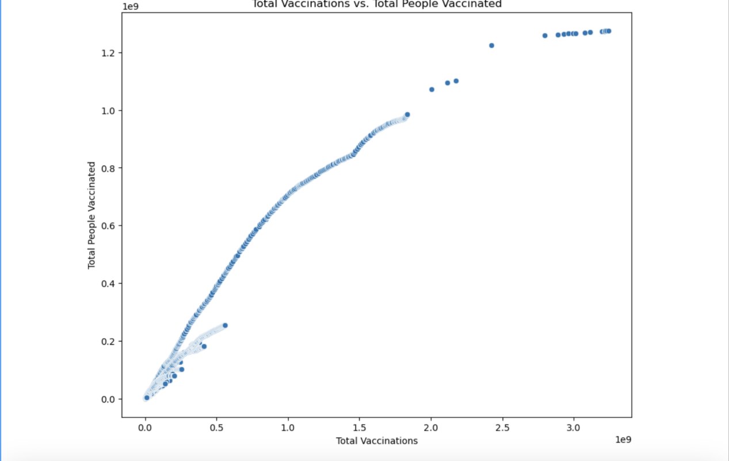

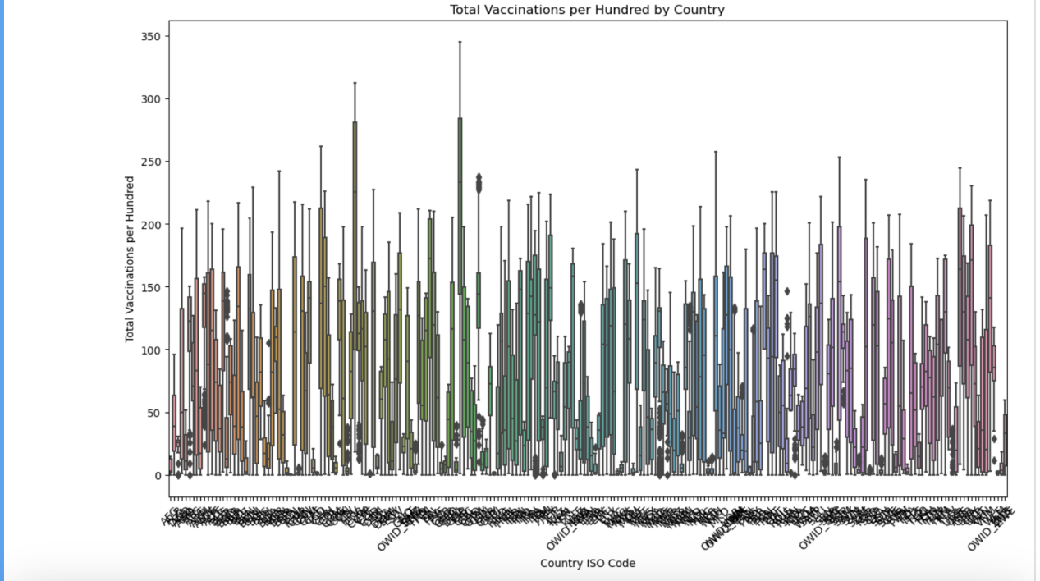

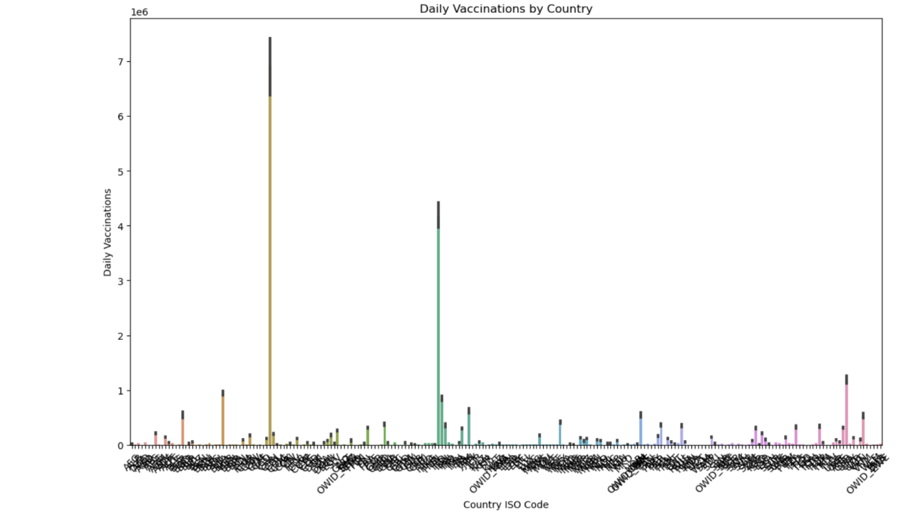

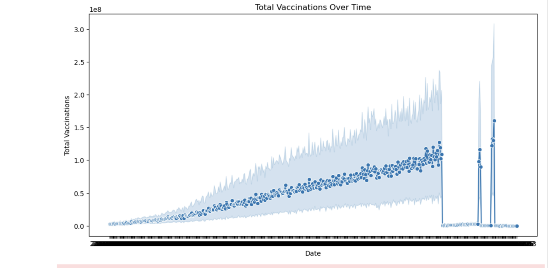

STATISTICAL REPRESENTATION

<class 'pandas.core.frame.DataFrame'>

RangeIndex: 86512 entries, 0 to 86511

Data columns (total 15 columns):

# Column Non-Null Count Dtype

--- ------ -------------- -----

0 country 86512 non-null object

1 iso_code 86512 non-null object

2 date 86512 non-null object

3 total_vaccinations 43607 non-null float64

4 people_vaccinated 41294 non-null float64

5 people_fully_vaccinated 38802 non-null float64

6 daily_vaccinations_raw 35362 non-null float64

7 daily_vaccinations 86213 non-null float64

8 total_vaccinations_per_hundred 43607 non-null float64

9 people_vaccinated_per_hundred 41294 non-null float64

10 people_fully_vaccinated_per_hundred 38802 non-null float64

11 daily_vaccinations_per_million 86213 non-null float64

12 vaccines 86512 non-null object

13 source_name 86512 non-null object

14 source_website 86512 non-null object

dtypes: float64(9), object(6)

memory usage: 9.9+ MB

None

total_vaccinations people_vaccinated people_fully_vaccinated \

count 4.360700e+04 4.129400e+04 3.880200e+04

mean 4.592964e+07 1.770508e+07 1.413830e+07

std 2.246004e+08 7.078731e+07 5.713920e+07

min 0.000000e+00 0.000000e+00 1.000000e+00

25% 5.264100e+05 3.494642e+05 2.439622e+05

50% 3.590096e+06 2.187310e+06 1.722140e+06

75% 1.701230e+07 9.152520e+06 7.559870e+06

max 3.263129e+09 1.275541e+09 1.240777e+09

daily_vaccinations_raw daily_vaccinations \

count 3.536200e+04 8.621300e+04

mean 2.705996e+05 1.313055e+05

std 1.212427e+06 7.682388e+05

min 0.000000e+00 0.000000e+00

25% 4.668000e+03 9.000000e+02

50% 2.530900e+04 7.343000e+03

75% 1.234925e+05 4.409800e+04

max 2.474100e+07 2.242429e+07

total_vaccinations_per_hundred people_vaccinated_per_hundred \

count 43607.000000 41294.000000

mean 80.188543 40.927317

std 67.913577 29.290759

min 0.000000 0.000000

25% 16.050000 11.370000

50% 67.520000 41.435000

75% 132.735000 67.910000

max 345.370000 124.760000

people_fully_vaccinated_per_hundred daily_vaccinations_per_million

count 38802.000000 86213.000000

mean 35.523243 3257.049157

std 28.376252 3934.312440

min 0.000000 0.000000

25% 7.020000 636.000000

50% 31.750000 2050.000000

75% 62.080000 4682.000000

max 122.370000 117497.000000