**Jira Software:-**

Jira Software is a project management tool that helps teams track issues, plan sprints, and collaborate on projects. It is a popular tool for agile teams, and it can be used to manage a variety of projects, including software development, IT service management, and product management. Jira Software has a number of features that make it a powerful tool for project management.

**Features:-**

**Issue tracking:** Jira Software allows you to track issues, such as bugs, tasks, and feature requests. You can create custom fields to track specific information about each issue, and you can use filters to find the issues that you are interested in.

**Sprint planning:** Jira Software allows you to plan sprints, which are short periods of time during which you will work on a specific set of issues. You can create a sprint backlog, which is a list of the issues that you will work on during the sprint.

**Collaboration: Jira** Software allows you to collaborate with your team on projects. You can comment on issues, assign issues to team members, and track the progress of issues.

**Reporting:** Jira Software allows you to generate reports on your projects. These reports can help you to track the progress of your projects, identify bottlenecks, and make decisions about your projects.

Jira Software is a powerful tool that can help teams track issues, plan sprints, and collaborate on projects. If you are looking for a project management tool that can help you to improve the way your team works, then Jira Software is a good option.

**Benefits:-**

**Increased visibility:** Jira Software provides a central location for teams to track issues and progress. This helps to increase visibility and collaboration, and it can help to identify and resolve issues more quickly.

**Improved productivity:** Jira Software can help teams to be more productive by providing a way to track time, manage tasks, and collaborate on projects.

**Improved quality:** Jira Software can help teams to improve the quality of their work by providing a way to track issues and defects.

**Increased compliance:** Jira Software can help teams to comply with regulations by providing a way to track issues and risks.

**Workflow:-**

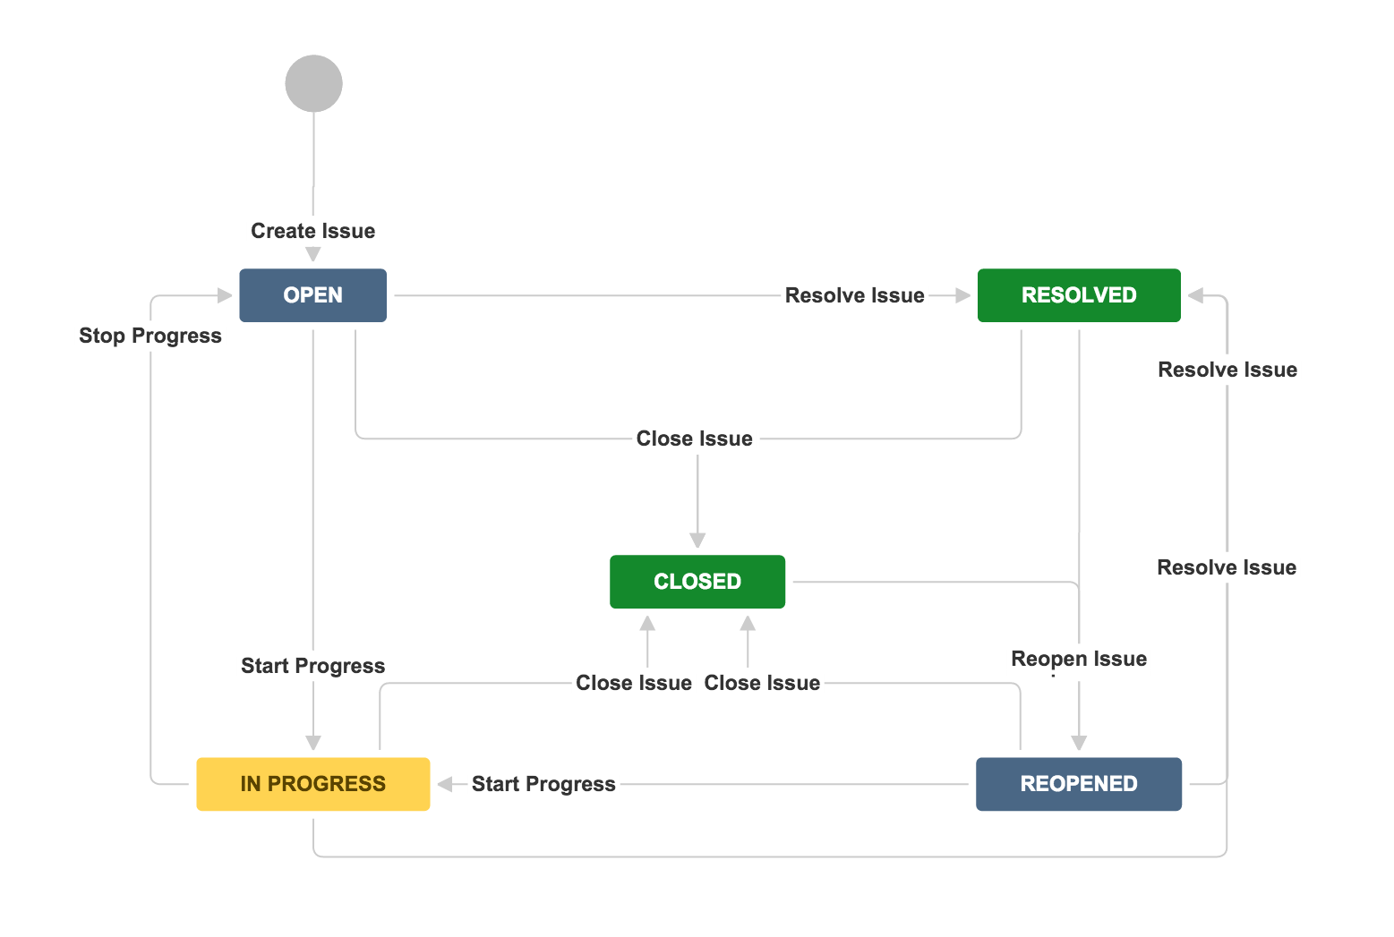

**Repository:-**

A Jira Software repository is a collection of issues and other artifacts related to a software project. It can be used to track the progress of the project, manage tasks, and collaborate with team members.

Jira Software repositories are stored in the cloud and can be accessed from anywhere. They are also integrated with a variety of other tools, such as development tools, issue tracking systems, and project management tools.

**Steps:-**

1. Go to the Jira Software website and **sign in**.
2. Click on the **Projects** tab.
3. Click on the **Create Project** button.
4. Select the **Software Development** project type.
5. Enter a **name** for your project.
6. Select a **project template**.
7. Click on the **Create Project** button.

Once you have created a Jira Software repository, you can start adding issues, tasks, and other artifacts. You can also start collaborating with team members by assigning issues and tasks.

**Modules:-**

Jira modules are a way to extend the functionality of Jira. They can be used to add new features, change the look and feel of Jira, or integrate with other systems.

**Types:-**

**Built-in modules: -** Built-in modules are provided by Atlassian and are included with the Jira installation.

**Third-party modules: -** Third-party modules are created by other developers and can be installed from the Atlassian Marketplace.

**Examples:-**

* **Jira Automation:** This module allows you to automate tasks in Jira, such as creating issues, assigning issues, and changing issue statuses.
* **Jira Portfolio:** This module allows you to manage projects and their dependencies in Jira.
* **Jira Service Desk:** This module allows you to create and manage service requests in Jira.

**Benefits:-**

* **Increased functionality:** Jira modules can be used to add new features to Jira, such as the ability to track time or integrate with other systems.
* **Improved flexibility:** Jira modules can be used to change the look and feel of Jira, or to add new functionality that is not available in the core product.
* **Reduced costs:** Jira modules can be a cost-effective way to add new features to Jira, as they are often less expensive than developing custom code.

**Keys of Jira Software:-**

* **Issue tracking:** Jira allows you to create and track issues, such as bugs, tasks, and feature requests.
* **Project management:** Jira can be used to manage the entire project lifecycle, from planning and initiation to execution and closure.
* **Bug tracking:** Jira can be used to track bugs and defects in software products.
* **Reporting:** Jira can generate reports on a variety of data, such as issue status, project progress, and team performance.
* **Integrations:** Jira can be integrated with a wide variety of other software applications, such as version control systems, development tools, and communication tools.

**Benefits of Jira Software:-**

* **Improved visibility:** Jira provides a central location for teams to track their work. This helps to improve visibility and collaboration.
* **Increased efficiency:** Jira can help teams to streamline their workflows and processes. This can lead to increased efficiency and productivity.
* **Improved communication:** Jira can help teams to communicate more effectively. This can help to reduce misunderstandings and improve collaboration.
* **Reduced costs:** Jira can help teams to reduce costs by eliminating the need for manual tracking and reporting.

**Grouping and Categorizing Concepts:-**

Jira allows you to group and categorize issues in a number of ways. This can help you to organize your work and make it easier to find the information you need.

* **Projects:** You can create projects to organize your issues by product, team, or customer.
* **Issue types:** You can create issue types to categorize your issues by type, such as bug, task, or feature request.
* **Components:** You can create components to categorize your issues by part of the product, such as a feature, a module, or a database.
* **Labels:** You can add labels to your issues to categorize them by any criteria you choose, such as priority, severity, or environment.

**Users, Groups, Roles:-**

**Users** can be created and managed in the Jira administration console. Groups can be created and managed in the Jira administration console or by using the Jira API. Roles can be created and managed in the Jira administration console or by using the Jira API.

**Groups** can be assigned to roles. This allows all members of the group to have the permissions of the role. For example, a group of developers can be assigned to the "Developer" role. This will allow all members of the group to create and edit issues.

**Roles** can be assigned to projects. This allows users who have the permissions of the role to access the project. For example, the "Developer" role can be assigned to the "Project A" project. This will allow all developers who have the "Developer" role to access the "Project A" project.

**Benefits:-**

* **Increased security:** Users, groups, and roles can be used to control access to Jira. This can help to protect sensitive data and prevent unauthorized access.
* **Improved efficiency:** Users, groups, and roles can be used to automate tasks. This can help to save time and improve efficiency.
* **Increased flexibility:** Users, groups, and roles can be easily modified to meet the needs of your organization. This can help you to adapt to changes in your business.

**Key Concepts:-**

Jira Software is a project management tool that helps teams track issues, manage tasks, and collaborate on projects. It is based on four key concepts:

* **Issues:** An issue is a task, bug, or other work item that needs to be completed. Issues can be assigned to team members, have due dates, and be tracked through their lifecycle.
* **Projects:** A project is a collection of issues that are related to a common goal. Projects can have budgets, timelines, and other resources associated with them.
* **Boards:** A board is a visual representation of a project. Boards can be used to track the progress of issues, assign tasks, and communicate with team members.
* **Workflows:** A workflow is a set of rules that define how issues can move through a project. Workflows can be used to control the flow of work, ensure that issues are completed in a timely manner, and prevent issues from falling through the cracks.
* **Reporting:** Jira Software can generate reports on the progress of projects, the status of issues, and the workload of team members.
* **Integrations:** Jira Software can be integrated with a variety of other tools, such as development tools, issue tracking systems, and project management tools.
* **Customization:** Jira Software can be customized to meet the specific needs of teams.

**Scrum:-**

Jira Software can be used to create Scrum boards that visualize the work that needs to be done in a sprint. The board typically has three columns: To Do, In Progress, and Done. Issues are moved from left to right as they progress through the sprint. Jira Software also provides a number of features that can be used to support Scrum, such as sprint planning, daily stand-ups, and sprint reviews.

**Workflow:-**

1. **Sprint planning:** The team meets to plan the sprint. This includes discussing the goals of the sprint, the work that needs to be done, and the resources that will be needed.
2. **Daily stand-up:** The team meets daily to discuss the progress of the sprint. This helps to ensure that the team is on track and that any problems are identified early.
3. **Sprint development:** The team works on the tasks that were identified in the sprint planning meeting.
4. **Sprint review:** The team demonstrates the work that was completed in the sprint to the stakeholders. This gives the stakeholders an opportunity to provide feedback and to make sure that the work meets their needs.
5. **Sprint retrospective:** The team reflects on the sprint and identifies ways to improve the process. This helps to ensure that the team is continuously learning and improving.

**Kanban:-**

Jira Software can be used to create Kanban boards that visualize the work that is flowing through a system. The board typically has multiple columns, each representing a different stage of work. Issues are moved from column to column as they progress through the system. Jira Software also provides a number of features that can be used to support Kanban, such as work-in-progress limits and cycle time tracking.

**Workflow:-**

1. **Identify the work:** The first step is to identify the work that needs to be done. This can be done by creating a list of tasks or by using a kanban board.
2. **Visualize the work:** Once the work has been identified, it needs to be visualized. This can be done by creating a kanban board or by using a project management tool.
3. **Limit work-in-progress:** Once the work has been visualized, it is important to limit the amount of work that is in progress at any given time. This helps to ensure that the team is not overloaded and that work is flowing smoothly through the system.
4. **Optimize flow:** Once the work-in-progress limits have been set, it is important to optimize the flow of work. This can be done by identifying bottlenecks and by making changes to the process.