|  |  |
| --- | --- |
| **EX.NO : 1(C)** | **C++ CONSTRUCTORS AND DESTRUCTORS** |
| **DATE** |

# PROGRAM STATEMENT :

To write a C++ program to display "Im a default constructor" using a default constructor

# ALGORITHM:

1. Start the program.
2. Define a class Cont with a default constructor that prints "I'm a default constructor".
3. In the main function, create an object c of class Cont, which calls the default constructor and displays the message.
4. End the program.

# PROGRAM :

#include<iostream> using namespace std; class Cont{

public:

Cont (){

cout<<"Imadefault constructor";

}

};

int main()

{

Cont c; return 0;

}

# OUTPUT :

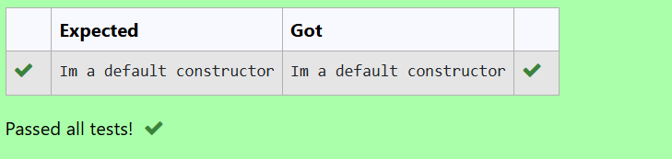

**RESULT :**

Thus, the C++ program to display "Im a default constructor" using a default constructor is created successfully.