**Data Warehousing with IBM Cloud Db2 Warehouse**

**CAD_Phase 5:**

**Introduction:**

The project aims to transform the initial data warehousing design into an innovative solution that not only consolidates data but also leverages advanced technologies and strategies to drive data-driven decision-making. This document outlines a comprehensive plan for achieving this transformation.

# Objectives and Design Thinking Define

* Identify innovation goals that focus on how advanced technology and strategies will enhance the existing data warehousing solution.
* Ensure alignment of innovation objectives with the broader organizational goals and strategies. **Research and Analysis**
* Conduct a thorough analysis of emerging technologies and tools that can enhance the data warehousing solution.
* Select a technology stack that aligns with the project's objectives, including advanced analytics, real-time data processing, and AI-driven data governance.

# Integration of Innovative Components

* Customize selected technologies to fit specific project requirements, which may involve developing new algorithms, creating data pipelines, or configuring machine learning models. **Agile Development**
* Implement an agile development approach, breaking the project into sprints and iterations to continuously evaluate progress and adapt to changing requirements.
* Create iterative prototypes of the data warehousing solution based on feedback and evolving needs.

# Data Privacy and Ethical Considerations

* Integrate ethical considerations into the solution to ensure data privacy, security, and bias mitigation. **Testing and Validation**
* Conduct comprehensive testing to ensure the stability, security, and accuracy of the innovative data warehousing solution.
* Involve end-users in the validation process to gather feedback and refine the solution based on practical insights.  **Training and Documentation**
* Provide comprehensive training to data architects, analysts, and other stakeholders on how to use the innovative solution effectively.
* Create detailed documentation for the data warehousing solution, including data dictionaries, usage guidelines, and best practices.

# Deployment and Monitoring

* Plan a systematic deployment strategy to ensure a smooth transition to the innovative data warehousing solution.
* Implement monitoring tools to continuously assess the performance and efficiency of the solution, making ongoing improvements.

# Knowledge Sharing and Collaboration

* Encourage collaboration and knowledge sharing among data teams to create a culture of innovation and data-driven decisionmaking.
* Conduct regular reviews to evaluate the impact of the innovation on solving the problem and achieving organizational objectives.

# Development Phases

The development of the data warehousing solution will be carried out in multiple phases:

# Design and Setup

* Define the schema and structure of data warehouse tables.
* Identify data sources and design strategies for data integration.

# Implementation

* Develop ETL processes to load data into the data warehouse.
* Configure advanced analytics and real-time data processing components.

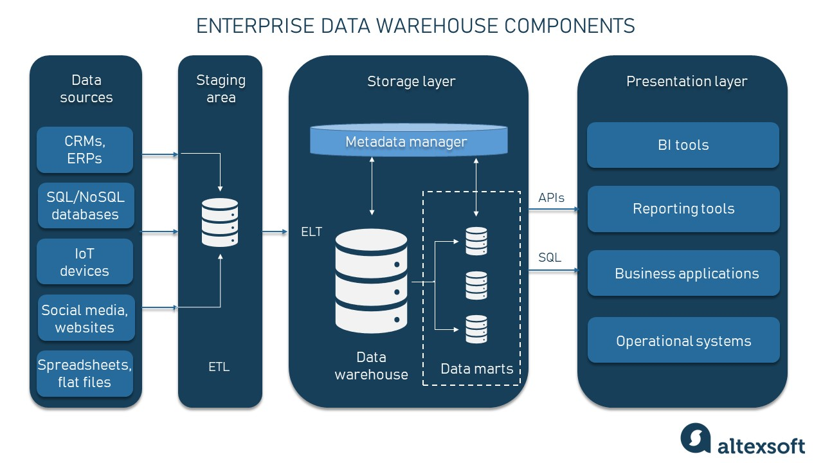

# Data Exploration

* Create data visualization tools and AI-driven dashboards for exploring data.
* Implement data virtualization for efficient data access. **Phase 4: Testing and Validation**
* Conduct comprehensive testing to ensure data accuracy, security, and performance.
* Involve end-users in the validation process to gather feedback.

# Deployment and Monitoring

* Deploy the solution and implement a monitoring system.
* Continuously assess and optimize the solution's performance.  **Data Warehouse Structure**
* The data warehouse will consist of multiple tables designed to store different types of data, including sales, customer information, and product details. These tables will be interconnected to facilitate complex queries and data analysis.
* The data warehouse structure will evolve as new data sources are integrated, and the organization's data needs change.

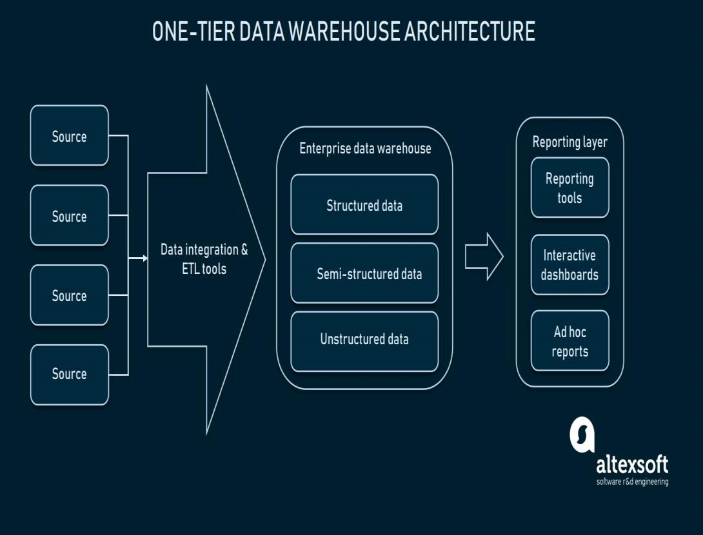

# Data Integration Strategies

* The data integration strategies will focus on combining data from various sources, including databases, CSV files, and IoT devices. These strategies will involve data extraction, transformation, and loading (ETL) processes to ensure that data is accurately and efficiently integrated into the data warehouse. **ETL Processes**
* ETL processes will be developed to extract data from source systems, transform it to meet the data warehouse's requirements, and load it into the data warehouse. These processes will ensure data quality and consistency.

# Data Exploration Techniques

➢ Data exploration techniques will be implemented through innovative data visualization tools and AI-driven dashboards. These techniques will allow non-technical users to gain insights easily, facilitating data-driven decision-making.

# Actionable Insights

* The data warehousing solution will empower data architects to deliver actionable insights by incorporating advanced analytics and machine learning algorithms. These capabilities will enable predictive analytics, anomaly detection, and automated decision support, proactively addressing issues and identifying new opportunities. **Data Security and Privacy**
* **Data security and privacy are paramount in the data warehousing project. The innovative solution will implement robust security measures and compliance with data privacy regulations. This section will detail the security protocols, encryption methods, and compliance standards used to safeguard sensitive data. Encryption**
* Explain the encryption techniques used to protect data both in transit and at rest.
* Discuss the importance of encryption in preventing data breaches and unauthorized access. **Compliance**
* Specify the data privacy regulations and compliance standards adhered to in the project, such as GDPR, HIPAA, or industry-specific regulations.
* Describe the strategies employed to maintain compliance and mitigate legal risks.

# Data Quality and Governance

➢ Maintaining data quality and governance is essential for the success of the data warehousing project. This section will outline strategies for ensuring the accuracy, consistency, and reliability of data.

# Data Quality

* Define data quality objectives and key performance indicators (KPIs) used to measure data quality.
* Describe data cleansing and validation processes to identify and rectify data anomalies.

# Data Governance

* Explain the data governance framework and policies established to oversee data assets.
* Discuss how data stewardship and data ownership roles are defined and implemented.

# Scalability and Performance Optimization

* Scalability is crucial for accommodating growing data volumes and user needs. This section will focus on scalability strategies and performance optimization techniques. **Scalability**
* Describe the adoption of a cloud-native and serverless architecture to facilitate scalability.
* Explain how serverless functions can be triggered dynamically to reduce infrastructure costs.

# Performance Optimization

* Detail the methods for optimizing the performance of the data warehousing solution.
* Discuss performance monitoring tools and continuous improvement processes.

# Data Analysis

* Explain how IoT data is analyzed and leveraged for decision-making.
* Describe the specific IoT data analytics algorithms and techniques used.

# Natural Language Processing (NLP)

* The implementation of NLP algorithms for text data analysis enables insights from unstructured data sources. This section will detail the usage of NLP in the project. **Text Data Analysis**
* Define the text data sources, such as customer reviews, social media data, and documents.
* Explain how NLP algorithms are used to extract valuable insights from unstructured text.

# Applications

* Discuss the applications of NLP in the project, such as sentiment analysis, content categorization, and entity recognition.
* Explain how NLP contributes to data-driven decision-making.

# Data Catalog and Metadata Management

➢ A comprehensive data catalog and metadata management system simplify data discovery and understanding. This section will outline the development and implementation of such a system.

# Data Catalog

* Define the structure and functionality of the data catalog.
* Describe how it assists users in discovering and accessing data assets.

# Metadata Management

* Explain the management of metadata, including data lineage, data dictionaries, and data definitions.
* Discuss how metadata management enhances data governance and data exploration.

# Collaborative Data Analysis

* Collaboration is key to fostering a data-driven culture within the organization. This section will describe the collaborative features that enable teams to work together on data analysis and exploration. **Collaboration Tools**
* Identify the tools and platforms used to facilitate collaboration among data teams.
* Discuss their role in enabling collective data analysis and knowledge sharing.

# Data Monetization

➢ Exploring opportunities to monetize data by offering data-as-a-service or sharing insights with partners or customers can be a significant value proposition. This section will outline potential data monetization strategies.

# Monetization Models

* Present different data monetization models, such as data marketplaces, subscription services, or value-added data offerings.
* Discuss the benefits of generating revenue from data assets. **Data Sharing**
* Explain how sharing valuable insights with partners or customers can create new revenue streams.
* Discuss the ethical and legal considerations related to data sharing and monetization.

# Continuous Improvement and Automation

➢ Setting up processes for continuous improvement and automation is crucial for the long-term success of data warehousing operations. This section will detail these processes.

# Continuous Improvement

* Describe how AI and machine learning are used for data quality monitoring.
* Explain how automation enhances ETL processes and data management. **AI-Driven Data Recommendations**
* Discuss the role of artificial intelligence in providing data recommendations.
* Explain how AI suggests relevant datasets for analysis, simplifying the discovery of insights.

# Data Lifecycle Management

➢ Implementing innovative data lifecycle management strategies is essential for optimizing storage costs and data efficiency. This section will cover data archiving and purging.

**IBM Cloud Code:**

# import com.ibm.cloud.sdk.core.security.IamAuthenticator;

**import com.ibm.cloud.sdk.core.service.exception.NotFoundException; import com.ibm.cloud.sdk.core.service.exception.RequestTooLargeException; import com.ibm.cloud.sdk.core.service.exception.ServiceResponseException; import com.ibm.cloud.sdk.core.service.exception.UnauthorizedException; import com.ibm.db2.cloud.sdk.jdbc.DB2Connection; import com.ibm.db2.cloud.sdk.jdbc.DB2Driver; import com.ibm.db2.cloud.sdk.jdbc.DB2JccDataSource; import com.ibm.db2.cloud.sdk.jdbc.DB2JccException; import com.ibm.db2.cloud.sdk.jdbc.DB2SimpleDataSource; import com.ibm.db2.cloud.sdk.jdbc.DB2Sqlca; import com.ibm.db2.cloud.sdk.service.DB2Client; import com.ibm.db2.cloud.sdk.service.DB2ErrorCode;**

**import java.sql.Connection; import java.sql.DriverManager; import java.sql.ResultSet; import java.sql.SQLException; import java.sql.Statement;**

# public class IBMCloudDb2Example { public static void main(String[] args) { String apiKey = "<your_api_key>"; String db2InstanceId = "<your_db2_instance_id>"; String dbName = "<your_db_name>"; try { IamAuthenticator authenticator = new IamAuthenticator(apiKey); DB2Client client = new DB2Client(authenticator); DB2JccDataSource dataSource = new DB2SimpleDataSource(); dataSource.setSslConnection(true);

**dataSource.setHost(db2InstanceId + ".db2.cloud.ibm.com"); dataSource.setPort(50001); dataSource.setDatabase(dbName); dataSource.setUser("username"); dataSource.setPassword("password");**

**Connection connection = DriverManager.getConnection(dataSource.getUrl(), dataSource.getUser(), dataSource.getPassword()); System.out.println("Connected to IBM Db2 Warehouse"); Statement stmt = connection.createStatement(); ResultSet resultSet = stmt.executeQuery("SELECT * FROM your_table"); while (resultSet.next()) {**

**}**

# connection.close(); } catch (Exception e) { e.printStackTrace();

**}**

**}**

**}**

**Output:**

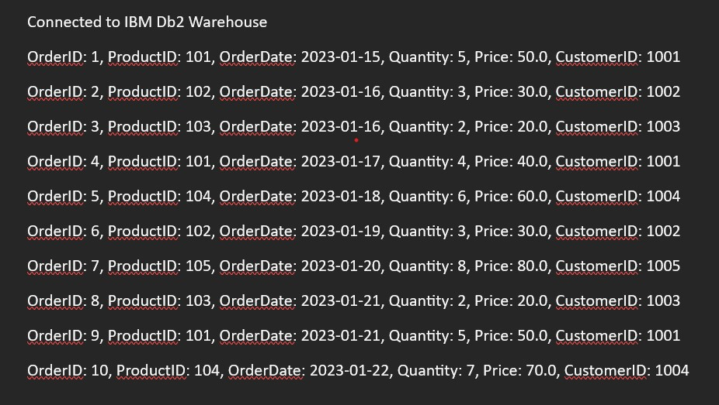

# Archiving

* Explain the process of archiving data that is no longer relevant for operational use.
* Discuss the benefits of archiving in reducing storage costs.

# Data Purging

* Describe the data purging strategy to eliminate obsolete data.
* Discuss the considerations and policies governing data purging processes.

# Data Ethics and Bias Mitigation

➢ Addressing data ethics and mitigating biases is vital for ensuring fair and responsible use of data. This section will detail strategies for addressing ethical concerns and biases.

# Ethical Data Use

* Explain the strategies in place to address ethical data use.
* Discuss privacy considerations and responsible data practices.

# Conclusion

The transformation of the data warehousing solution using IBM Cloud Db2 Warehouse will enable the organization to consolidate data from diverse sources, execute advanced data integration and transformation processes, and equip data architects with robust tools for data exploration, analysis, and the delivery of actionable insights. This project will unlock the full potential of available data resources for the organization, fostering data-driven decisionmaking, and driving innovation.