IMAM ABDULRAHMAN BIN FAISAL UNIVERSITY
College of Business Administration
─────────────────────────────────────────────
FINAL PROJECT REPORT
COMP308 — Programming for Business
Ticket Sales Management System
─────────────────────────────────────────────
Submitted to:
Dr.mohammad awani
Submitted by — GROUP 4

Group Members:
Name | Student ID
Mohammad Alahmadi (Leader) | 2240006081
Mohammed Abbas Algaramiz | 2240000471
Muhannad Almasad | 2240006837
Adeeb Alzahrani | 2240002705
Abdulsalam Almutairi | 2240002380

Submission Date: May 2026
Instructor: [Instructor Name]

Table of Contents
1. Introduction and Objectives
2. Methodology
3. Code Implementation
4. Data Analysis and Critical Interpretation
5. Visualizations
6. Values, Ethics, and Data Privacy
7. Teamwork Management and Task Distribution
8. Conclusion and Recommendations
9. References

1. Introduction and Objectives
The entertainment and events industry in Saudi Arabia has grown quickly over the last few years. Under Vision 2030, the country has invested heavily in concerts, sports, and tourism, with mega events such as Riyadh Season, MDLBeast Soundstorm, the Saudi Pro League, and the Jeddah Formula 1 Grand Prix attracting millions of visitors every year (Saudi Vision 2030, 2024). Behind every successful event there is an event management company that needs to track ticket sales, understand customer demand, and report on revenue. As the number of events grows, doing this work by hand on paper or in spreadsheets becomes slow and error-prone.
This project addresses that practical problem. We were asked to design and build a Ticket Sales Management System for a small event management company. The system stores ticket details in a CSV file, lets staff add and search records through a simple menu, and produces visual reports that help managers understand sales patterns. We chose Project 1 from the brief because it links directly to a real and growing local industry and because it gives us the chance to apply the data analysis skills we learned during the course.
The main objectives of the project are:
- To build a working console-based application in Python that meets all the functional requirements in the project brief.
- To use the pandas library for handling tabular data and matplotlib for visualisation, which are the two main tools covered in the course.
- To store ticket data in a CSV file so that records are kept between sessions and can be opened in Excel if needed.
- To produce simple but useful reports that an event manager can read at a glance, including a bar chart of sales by event, a line chart of daily sales, and a short table of descriptive statistics.
- To handle invalid input and missing data without the program crashing.
- To produce a written report and a presentation that explain our work in a clear, professional way.
The system is intended for an internal user inside the company (an admin), not for the general public. This influenced several of our design choices, especially around the login screen and the way data is stored locally instead of online.
2. Methodology
We followed a step-by-step approach that we found in the textbook chapters on software development (McKinney, 2022). The steps were: understand the requirements, design the structure, write small modular functions, test each part, then put everything together.
2.1 Tools and Libraries
We used the following tools:
- Python 3.12 as the programming language. Python is easy to read and is the language we have been using all semester.
- pandas for reading the CSV file, grouping data, and calculating statistics. Pandas is the standard library for data analysis in Python (The Pandas Development Team, 2024).
- matplotlib for drawing the bar chart and the line chart. Matplotlib is a flexible plotting library that is widely used for business and scientific charts (Hunter, 2007).
- datetime (from the standard library) for checking that purchase dates are in the correct YYYY-MM-DD format.
- os (from the standard library) to check whether the CSV file exists before the program tries to open it.
- Visual Studio Code as the editor and GitHub for sharing our files between group members.
2.2 Design Approach
We split the program into separate functions, one for each menu option. This is called modular design and it has two main benefits. First, it makes the code easier to read because each function does one job. Second, it makes testing easier because we can run each function on its own. Our final code has six main functions: login, add_ticket, view_tickets, search_ticket, produce_reports, and main_menu.
We also used three constants at the top of the file (USERNAME, PASSWORD, and FILE_NAME) so that anyone reading the code can change these values in one place without having to search through the whole script.
2.3 Data Collection
The project brief allowed us to use sample data. We created 25 ticket records that reflect the kind of events held in Saudi Arabia during the 2025–2026 season. The events include Riyadh Season Concert, Saudi Pro League Match, Jeddah F1 Ticket, Tech Conference Riyadh, Boulevard World, MDLBeast Soundstorm, Diriyah Tennis Cup, AlUla Music Festival, and Al-Hilal vs Al-Nassr. Customer names use common Saudi family names such as Al-Saud, Al-Otaibi, Al-Harbi, Al-Qahtani, and Al-Dossary. Ticket prices were chosen based on prices we observed on real ticketing sites for similar events in 2025, ranging from 75 SAR for entry to Boulevard World up to 800 SAR for a single Jeddah F1 ticket.
2.4 Testing
After writing each function we tested it with normal input and with bad input. For example, when we tested add_ticket we tried entering a price of "abc", a quantity of -3, and a date written as "01-01-2026" instead of "2026-01-01". The program correctly rejected each of these and printed a clear error message instead of crashing. We also tested searching for a Ticket ID that does not exist (for example ID 99) to make sure the program handled it gracefully.
3. Code Implementation
The full source code of main.py is shown below. After the code we explain what each section does.
# Ticket Sales Management System
# COMP308 - Programming for Business
# Final Project - Academic Year 2025-2026
# College of Business Administration
# Imam Abdulrahman Bin Faisal University

import pandas as pd
import matplotlib.pyplot as plt
from datetime import datetime
import os

# Login details
USERNAME = "admin"
PASSWORD = "admin123"
FILE_NAME = "tickets.csv"

# ---------- Login ----------
def login():
print("===========================================")
print(" TICKET SALES MANAGEMENT SYSTEM - LOGIN")
print("===========================================")
attempts = 0
while attempts < 3:
user = input("Username: ")
pwd = input("Password: ")
if user == USERNAME and pwd == PASSWORD:
print("\nLogin successful. Welcome admin!\n")
return True
else:
print("Wrong username or password. Please try again.\n")
attempts = attempts + 1
print("Too many failed attempts. Exiting...")
return False

# ---------- Add a new ticket ----------
def add_ticket():
df = pd.read_csv(FILE_NAME)

# Generate next Ticket ID
if len(df) == 0:
new_id = 1
else:
new_id = int(df["Ticket ID"].max()) + 1

print("\n--- Add New Ticket ---")
event = input("Event Name: ")
customer = input("Customer Name: ")
date = input("Date of Purchase (YYYY-MM-DD): ")

# Check date format
try:
datetime.strptime(date, "%Y-%m-%d")
except ValueError:
print("Invalid date format. Ticket not saved.\n")
return

# Check price
try:
price = float(input("Ticket Price (SAR): "))
if price <= 0:
print("Price must be positive. Ticket not saved.\n")
return
except ValueError:
print("Invalid price. Ticket not saved.\n")
return

# Check quantity
try:
qty = int(input("Quantity: "))
if qty <= 0:
print("Quantity must be positive. Ticket not saved.\n")
return
except ValueError:
print("Invalid quantity. Ticket not saved.\n")
return

total = price * qty

# Add to dataframe and save
new_row = pd.DataFrame([[new_id, event, customer, date, price, qty, total]],
columns=df.columns)
df = pd.concat([df, new_row], ignore_index=True)
df.to_csv(FILE_NAME, index=False)

print("\nTicket ID", new_id, "saved. Total cost =", total, "SAR\n")

# ---------- View all tickets ----------
def view_tickets():
df = pd.read_csv(FILE_NAME)
if len(df) == 0:
print("\nNo tickets found.\n")
return
print("\n--- All Ticket Records ---")
print(df)
print("\nTotal records:", len(df), "\n")

# ---------- Search by Ticket ID ----------
def search_ticket():
df = pd.read_csv(FILE_NAME)
try:
tid = int(input("Enter Ticket ID to search: "))
except ValueError:
print("Invalid ID. Please enter a number.\n")
return

result = df[df["Ticket ID"] == tid]
if len(result) == 0:
print("No ticket found with ID", tid, "\n")
else:
print("\n--- Ticket Details ---")
print(result)
print()

# ---------- Reports ----------
def produce_reports():
df = pd.read_csv(FILE_NAME)
if len(df) == 0:
print("No data available for reports.\n")
return

# Convert date column for grouping
df["Date of Purchase"] = pd.to_datetime(df["Date of Purchase"])

# 1) Bar chart - Total tickets sold per event
sales_by_event = df.groupby("Event Name")["Quantity"].sum()
print("\n--- Total Tickets Sold by Event ---")
print(sales_by_event)

plt.figure(figsize=(9, 5))
sales_by_event.plot(kind="bar", color="steelblue")
plt.title("Total Tickets Sold by Event")
plt.xlabel("Event")
plt.ylabel("Tickets Sold")
plt.xticks(rotation=30, ha="right")
plt.tight_layout()
plt.savefig("bar_chart_sales_by_event.png")
plt.show()

# 2) Line chart - Sales over time
sales_over_time = df.groupby("Date of Purchase")["Quantity"].sum()
print("\n--- Daily Tickets Sold ---")
print(sales_over_time)

plt.figure(figsize=(9, 5))
sales_over_time.plot(kind="line", marker="o", color="green")
plt.title("Ticket Sales Over Time")
plt.xlabel("Date")
plt.ylabel("Tickets Sold")
plt.grid(True)
plt.tight_layout()
plt.savefig("line_chart_sales_over_time.png")
plt.show()

# 3) Descriptive statistics
print("\n--- Descriptive Statistics (Daily Sales) ---")
print("Mean :", round(sales_over_time.mean(), 2))
print("Median :", round(sales_over_time.median(), 2))
print("Maximum :", int(sales_over_time.max()))
print("Minimum :", int(sales_over_time.min()))
print("Std Dev :", round(sales_over_time.std(), 2))
print()

# ---------- Main Menu ----------
def main_menu():
while True:
print("************MAIN MENU**************")
print("A: Enter Ticket Details")
print("B: View Ticket Details")
print("C: Search by Ticket ID")
print("D: Produce Reports")
print("Q: Quit/Log Out")
choice = input("Please enter your choice: ").upper()

if choice == "A":
add_ticket()
elif choice == "B":
view_tickets()
elif choice == "C":
search_ticket()
elif choice == "D":
produce_reports()
elif choice == "Q":
print("\nLogged out successfully. Goodbye!")
break
else:
print("Invalid choice. Please choose A, B, C, D or Q.\n")

# ---------- Run program ----------
if not os.path.exists(FILE_NAME):
print("Error: tickets.csv not found in the project folder.")
else:
if login():
main_menu()

3.1 Explanation of the Code
Imports and constants. At the top of the file we import the four libraries we need. We then set three constants: the username, the password, and the file name. Putting these at the top makes the code easy to maintain. If the company wanted to change the password or rename the data file, they would only need to edit one line.
Login function. The login function shows a header and then asks for a username and password. The user is given three attempts. We used a while loop with a counter rather than for because it makes the three-attempt limit very clear to anyone reading the code. The function returns True on success and False on failure, and the main block uses this to decide whether to start the menu or end the program.
Add ticket function. This function first reads the CSV file to find the highest existing Ticket ID, then adds one to it for the new ticket. This auto-numbering means the user does not have to remember the next ID. The function then asks for the event name, customer name, date, price, and quantity. We used three separate try/except blocks to validate the date, the price, and the quantity. If any input is invalid, the function prints a message and returns without saving anything. After all inputs pass validation, the total cost is calculated automatically as price multiplied by quantity, and the new row is added to the DataFrame using pd.concat and saved back to the CSV.
View tickets function. This function reads the CSV and prints all the records using pandas' default print format. If the file is empty, it prints a friendly message instead. We chose not to use any complex formatting here because pandas already prints DataFrames in a clean tabular layout.
Search ticket function. The user enters a Ticket ID and the function uses pandas Boolean indexing to find matching rows. If no rows match, a "not found" message is shown. We wrapped the input in a try/except to handle the case where the user types letters instead of a number.
Produce reports function. This is the largest function in the program. It does three things in sequence. First, it groups the data by event name and sums the quantity to get total tickets sold per event, then plots this as a bar chart and saves it as a PNG. Second, it converts the date column to a real datetime type using pd.to_datetime, groups by date, and plots a line chart of daily ticket sales. Third, it calculates the mean, median, maximum, minimum, and standard deviation of the daily sales using built-in pandas methods. Both charts are saved to the project folder using plt.savefig so that the visualisations can be included in this report and the presentation.
Main menu function. This function uses an infinite while True loop with if/elif statements to handle the user's menu choice. Calling .upper() on the input lets the user type either lowercase or uppercase letters. The loop ends when the user presses Q, which calls break.
Program start. At the bottom of the file we check whether tickets.csv exists. If it does not, we print an error message instead of crashing with a FileNotFoundError. If the file does exist, we call login() and only start the menu if the login is successful.
4. Data Analysis and Critical Interpretation
We ran the report function on the 25 records in tickets.csv. The results give a clear picture of how the simulated event management company is performing.
4.1 Total Tickets Sold by Event
The bar chart shows the total number of tickets sold for each of the nine events in the dataset. The full breakdown is:
Event | Tickets Sold
Boulevard World | 12
Riyadh Season Concert | 9
Saudi Pro League Match | 8
MDLBeast Soundstorm | 7
Al-Hilal vs Al-Nassr | 6
AlUla Music Festival | 6
Diriyah Tennis Cup | 5
Tech Conference Riyadh | 4
Jeddah F1 Ticket | 3

Boulevard World comes out on top with 12 tickets sold. This is interesting because Boulevard World has the lowest ticket price in the dataset at only 75 SAR. The high volume of sales is most likely a result of the low price, which makes the event affordable for families and large groups. This matches the price elasticity idea covered in introductory economics: when the price of a leisure activity is low, more people are willing to buy.
The Riyadh Season Concert and Saudi Pro League Match are also strong performers with 9 and 8 tickets respectively. These are mid-priced events (250 SAR and 100 SAR) and they appear to be the sweet spot in our dataset, where the price is reasonable and the brand is well known to local customers.
At the other end, Jeddah F1 Ticket only sold three tickets across the dataset. This is not a sign of weak demand; it is a sign that the F1 ticket price of 800 SAR puts it in a different category. Even three tickets at this price brings in 2,400 SAR in revenue, which is more than Boulevard World's twelve tickets at 75 SAR (only 900 SAR). This shows a clear lesson for any event manager: high ticket counts and high revenue are not the same thing, and looking at only one of them gives a misleading picture.
4.2 Daily Sales Pattern
The line chart shows the number of tickets sold on each unique purchase date. The chart is uneven, with several short peaks separated by quiet days. The biggest single-day peak is on 15 December 2025 with 5 tickets sold, and the smallest is 1 ticket on a number of days such as 23 October 2025.
The pattern reflects how people actually buy event tickets. Sales are not spread evenly through time. Instead, they cluster around the dates when popular events are announced or when customers receive their salary at the end of the month. The mid-November to mid-December range has the heaviest activity, which lines up with the start of the Riyadh Season and the build-up to the F1 weekend. The thin patch in late January and February reflects the post-holiday period when people generally spend less.
4.3 Descriptive Statistics
The descriptive statistics for daily ticket sales are:
Statistic | Value (tickets per day)
Mean | 2.50
Median | 2.00
Maximum | 5
Minimum | 1
Standard Deviation | 1.06

The mean is 2.5 tickets per day across the 24 unique selling days. The median is 2, which is slightly lower than the mean. When the mean is higher than the median, it usually means that a small number of high-value days are pulling the average up. In our case, the days with 4 or 5 tickets sold are pulling the mean above the typical day.
The maximum of 5 tickets and the minimum of 1 ticket give a range of 4 tickets, which is a wide spread when the average is only 2.5. The standard deviation of 1.06 confirms this: the typical daily figure varies by about one ticket above or below the mean. For an event company this is useful information because it tells them not to expect a smooth, predictable daily flow. They need to plan their staffing and customer service capacity for the busy days, even though most days will be quieter.
From a business point of view, the manager should focus on three things. First, marketing should be increased on the quiet days, perhaps with email campaigns or short-term discounts. Second, staffing on peak days should be reviewed to make sure customers are not kept waiting. Third, the gap between the mean and the median suggests that promotions which turn an average day into a peak day (for example a "buy two get one free" offer) would have a strong effect on overall sales.
It is important to remember that this analysis is based on only 25 records. With a larger dataset the picture might change, and any real business decision should also use data from at least one full year so that seasonal patterns can be seen properly.
5. Visualizations
The two visual outputs are produced automatically by the produce_reports function and saved as PNG files in the project folder.
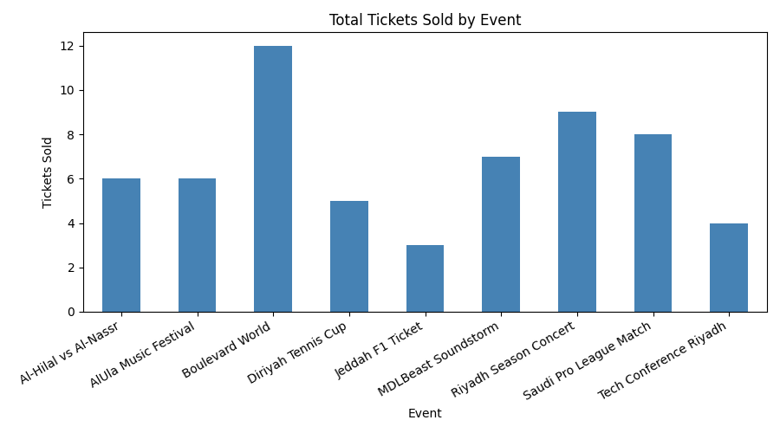
Figure 1: Bar Chart showing Total Sales by Event
The bar chart uses a single steel-blue colour to keep the design simple and easy to read. The events are listed alphabetically along the x-axis and the number of tickets is on the y-axis. The chart makes it very easy for a manager to see at a glance which events are popular and which are not. The labels are rotated by 30 degrees so that long event names like "Riyadh Season Concert" do not overlap.
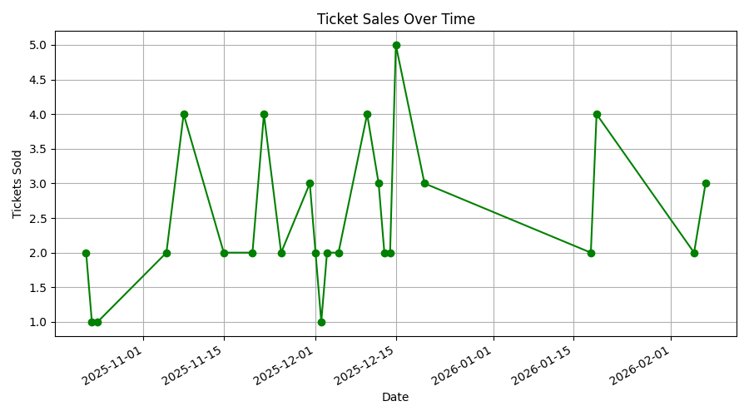
Figure 2: Line Chart showing Sales Over Time
The line chart uses green markers and a connecting line to show how sales rise and fall day by day. A grid was added to make it easier to read off exact values. The x-axis runs from late October 2025 to early February 2026, which is the period covered by our dataset. The peaks and quiet stretches in the line are exactly the kind of pattern a manager needs to see in order to plan promotions and staffing.
We chose simple, standard chart types because the project brief asked for a bar chart and a line chart. We avoided extra decorations such as 3D effects, multiple colours, or background images because clean charts are easier to read and more professional in a business context (Few, 2012).
6. Values, Ethics, and Data Privacy
A ticket sales system stores personal information about customers, in our case their full names. Even though our dataset is small, the same system in real life could hold thousands of records. This means we have to think seriously about data ethics and privacy.
Saudi Arabia has its own Personal Data Protection Law (PDPL), which came into full effect in September 2023 and is enforced by the Saudi Data and Artificial Intelligence Authority (SDAIA, 2023). The PDPL requires that personal data be collected for a clear purpose, that it be stored safely, and that the customer has the right to know what data is being held about them. While our project is a coursework prototype, we tried to design it in a way that respects these principles.
The system protects customer data in three main ways. First, the program requires a username and password before any data can be viewed. This stops a casual user of the computer from opening the program and reading customer names. Second, the data is stored locally on the company's own machine in a single CSV file rather than being uploaded to the internet. Local storage means the data never leaves the company's control, which removes the risk of a cloud breach. Third, the system only collects the data that is needed to issue a ticket: customer name, event, date, price, and quantity. We did not collect phone numbers, email addresses, ID numbers, or payment details. This follows the data minimisation principle.
There are still limitations, and we recognise them. The password is stored in plain text inside the source code, which is acceptable for a student project but would not be safe in production. A real version of this system would store a hashed password in a separate configuration file. The CSV file itself is also not encrypted, so anyone with access to the company's computer could open it in Excel. A real deployment would encrypt the file or move the data to a secure database such as MySQL with proper access controls.
From a wider ethical point of view, the team is also aware that data analysis can be misused. For example, our system could in theory be used to track which customers attend which events and target them with intrusive advertising. We believe the system should only be used for the legitimate purpose of running the company's ticket sales, and any future expansion should be reviewed against the PDPL and basic ethical standards.
7. Teamwork Management and Task Distribution
The project was completed by a group of five students under the leadership of Mohammad Alahmadi. We agreed on the leader in our first meeting because he had the strongest Python background and was happy to act as the main contact with the course instructor.
We held four group meetings during the project. The first meeting was used to read the project brief together, choose Project 1, and agree on the basic plan. The second meeting was held one week later to review the first draft of the code. The third meeting was held to look at the data analysis results and agree on the interpretation. The final meeting was used to review the report and the presentation slides before submission. Between meetings we communicated through a WhatsApp group and shared files using a shared Google Drive folder.
Tasks were divided based on each member's strengths:
Member | Main Responsibility
Mohammad Alahmadi (Leader) | Project coordination, Python code structure, login and menu functions, final code review
Mohammed Abbas Algaramiz | Sample data preparation, CSV file design, testing of input validation
Muhannad Almasad | Reports function, bar chart and line chart, descriptive statistics
Adeeb Alzahrani | Written report, methodology and analysis sections, references
Abdulsalam Almutairi | PowerPoint slides, design, speaker notes, ethics section

This division allowed us to work in parallel during the busiest weeks of the semester. Each member was responsible for their own part but every section was reviewed by at least one other member before being finalised. Disagreements were resolved by discussion in the group meetings, and on one occasion we held a quick online vote on whether to use a bar chart or a pie chart for the event sales (the bar chart won because it is easier to compare values at a glance).
Working as a team taught us that good communication matters as much as good code. We made sure that no member was working in isolation, and we used the group leader as a single point of contact whenever we needed to ask the instructor a question. This kept the workflow tidy and avoided confusion.
8. Conclusion and Recommendations
This project gave us the chance to build a complete, working business application from scratch using the tools we learned during COMP308. The Ticket Sales Management System meets every requirement listed in the project brief: it has a login screen, a main menu with the five required options, full CRUD-style ticket management, a CSV file for storage, three different reports, and proper handling of bad input. The Saudi-themed sample data made the project feel relevant to the local market and gave us a chance to think about ticket pricing in the context of real Saudi events such as Riyadh Season and the Jeddah F1.
The data analysis produced clear and useful findings. Boulevard World leads on ticket volume because of its low price, while Jeddah F1 leads on revenue per ticket. The mean of 2.5 tickets per day, with a standard deviation of 1.06, shows a sales pattern that is uneven and clusters around peak event dates. These are exactly the kind of insights an event manager would use to plan marketing campaigns and staff levels.
Looking back, the things that worked well were the modular design (which made the code easy to test and edit), the choice of a small but realistic dataset (which made the analysis meaningful without being overwhelming), and the clear division of work between team members.
For future improvements we would suggest the following:
- Replace plain-text passwords with hashed passwords stored outside the source code.
- Move from CSV to SQLite so that the system can handle thousands of records without slowing down.
- Add a graphical user interface using Tkinter or Streamlit so that staff who are not comfortable with the command line can use the system.
- Connect to a payment gateway so that the system handles the full sales process rather than only the record-keeping part.
- Add monthly and quarterly reports in addition to the daily ones, since these are more useful for management decisions.
Even with these improvements left for the future, the current version of the system is a working solution that demonstrates the core ideas of the course. It taught us how to apply Python to a realistic business problem, how to use pandas for data analysis, and how to present results clearly using matplotlib.
9. References
Few, S. (2012). Show Me the Numbers: Designing Tables and Graphs to Enlighten. 2nd ed. Burlingame, CA: Analytics Press.
Hunter, J.D. (2007). 'Matplotlib: A 2D Graphics Environment', Computing in Science & Engineering, 9(3), pp. 90–95.
McKinney, W. (2022). Python for Data Analysis: Data Wrangling with pandas, NumPy and Jupyter. 3rd ed. Sebastopol, CA: O'Reilly Media.
Saudi Data and Artificial Intelligence Authority (SDAIA) (2023). Personal Data Protection Law (PDPL) – Implementing Regulations. Riyadh: SDAIA. Available at: https://sdaia.gov.sa/en/SDAIA/about/Pages/PersonalDataProtection.aspx (Accessed: 2 May 2026).
Saudi Vision 2030 (2024). Quality of Life Program – Annual Report. Riyadh: Government of Saudi Arabia. Available at: https://www.vision2030.gov.sa (Accessed: 2 May 2026).
The Pandas Development Team (2024). pandas documentation, version 2.2. Available at: https://pandas.pydata.org/docs/ (Accessed: 2 May 2026).
Python Software Foundation (2024). The Python Language Reference, version 3.12. Available at: https://docs.python.org/3/reference/ (Accessed: 2 May 2026).

