Final Project
SmartHub APP

Group 2

Name | ID
Mohammed Abbas Algaramiz | 2240000471
Mohammed Alahmadi | 2240006081
Hussain Alshakhs | 2240006922
Muhannad Amasad | 2240006837

TASK | ASSIGNED TO | PROGRESS | START | END
Milestone 1
Business Problem & Soultion | All members | 100% | 4/8/26 | 4/9/26
UI/UX | All members | 100% | 4/9/26 | 4/10/26
Web Prototype | All members | 100% | 4/10/26 | 4/11/26
About Us & Contact Pages | All members | 100% | 4/11/26 | 4/12/26
GitHubRepo & README | All members | 100% | 4/12/26 | 4/13/26
Milestone 2
Index.html | All members | 100% | 5/6/26 | 5/6/26
login.html | All members | 100% | 5/7/26 | 5/7/26
contact.html | All members | 100% | 5/11/26 | 5/11/26
dashboard.html | All members | 100% | 5/7/26 | 5/11/26
pricing.html | All members | 100% | 5/8/26 | 5/11/26
script.js | All members | 100% | 5/12/26 | 5/15/26
auth.js & stlye.css | All members | 100% | 5/13/26 | 5/16/26
Report&PPTX | All members | 100% | 5/14/26 | 5/15/26

Table of Contents
Executive Summary 4
Business Problem & Solution 4
The Business Problem: 4
The Proposed Solution: 4
User Interface and User Experience (UI/UX): 4
Technical Implementation: 4
SmartHub Transaction Graph 6
User Interface Description Home Page: 7
Code Functionality: 8
User Interface Description Pricing Page: 8
Code Functionality: 8
User Interface Description Contact Page: 9
Code Functionality: 9
User Interface Description Login Page: 9
Code Functionality: 10
Conclusion: 11

Executive Summary
SmartHub is a smart business solutions platform designed to support small and medium-sized enterprises (SMEs) with digital tools. The platform has achieved success by offering a fully functional prototype featuring secure user authentication, dynamic data management, and a professional, responsive user interface.

Business Problem & Solution

The Business Problem:
Micro-businesses and independent sellers on platforms like Instagram and WhatsApp struggle with managing customer orders manually. Tracking bank transfer receipts, collecting accurate shipping addresses through endless chats, and manually updating inventory leads to human errors, lost sales, and a frustrating customer experience.

The Proposed Solution:
A lightweight, user-friendly order management web application. Sellers can create a simple product link to put in their social media bio. Customers use the link to view products, place orders, enter shipping details, and upload payment receipts. All data is automatically organized in a centralized, easy-to-read dashboard for the seller to process efficiently.
Smart Hub Website: At the top of the page, under "Navigation," you'll find the website address. On the left, there are four links on the right: Home, Pricing, Contact, and Login.

User Interface and User Experience (UI/UX):
Quality is a key design focus for us, ensuring the prototype meets modern website design standards. CSS was adopted for the platform's visual layout. The brand's primary color, dark purple, is strategically used for interactive elements on a white background for clarity. For a consistent experience across different devices, the layout is redesigned to ensure responsiveness across various devices and systems. Interactive elements: Smooth scrolling, seamless transitions, and dynamic alert components provide immediate visual feedback to the user, especially during form submissions and authentication processes.

Technical Implementation:
The project adhered strictly to semantic web standards and best practices for front-end. development:
Semantic HTML: The document structure relies on semantic tags such as <header>,
<main>, <section>, and <footer> to enhance accessibility, code readability, and
structural logic.
Modular JavaScript: Logic is separated into distinct files (auth.js for Firebase integration
and script.js for DOM manipulation and state management), improving code
maintainability.
State Management: The LocalStorage API is effectively used to persist user sessions
and contact queries without requiring a dedicated database backend, enabling a fully functional offline-capable prototype.
Version Control & Deployment: Code was managed through GitHub and deployed
continuously via Netlify, establishing a modern web development workflow.

SmartHub Transaction Graph

User Interface Description Home Page:
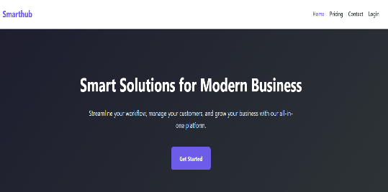
The page has four sections:
The first section is titled "Smart Solutions for Modern Businesses," with the text "Simplify your workflow, manage your customers, and grow your business with our integrated platform." It also includes a "Get Started" button that takes you to the pricing page.
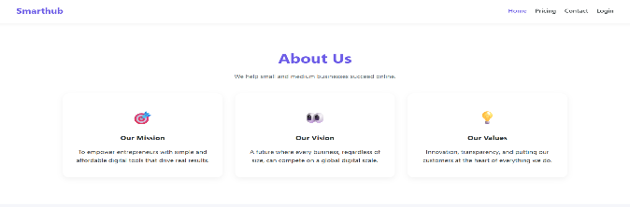
The second section contains information about the website and our service goals. The title is "About Us." Below this title are three cards, each with a title and text. The first card is titled "Our Mission: Empowering entrepreneurs with simple, affordable digital tools that deliver tangible results." The second is titled "Our Vision: A future where every company, regardless of size, can compete on a global digital scale." The third is titled "Our Values: Innovation, Transparency, and putting our customers at the heart of everything we do."
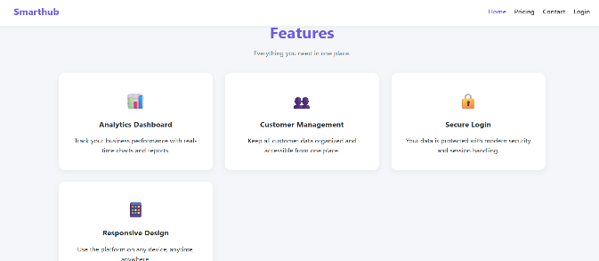
The third section is titled "Features," and below this title are four cards that describe these features. The first card is titled "Data Analytics Dashboard" – "Monitor your business performance with charts and real-time reports." The second card is "Customer Management" – "Keep all your customer data organized and easily accessible from one place." The third card is "Secure Login" – "Your data is protected by the latest security and session management technologies." The fourth card is "Responsive Design" – "Use the platform on any device, anytime, anywhere."
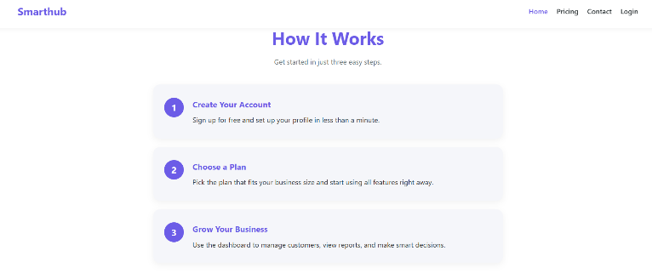
The fourth section is titled "How It Works" with a three-step guide: the first is "Create Your Account" – "Sign up for free and create your profile in under a minute." The second is "Choose a Plan" – "Choose the plan that suits your business size and start using all the features immediately." The third is "Grow Your Business" – "Use the dashboard to manage customers, view reports, and make smart decisions."

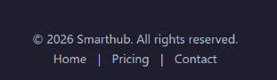
Below is a footer having copyright information and links to navigate the site's pages.

Code Functionality:
Session Detection: The primary functional script on this page is the updateNavForSession() function found in script.js. When the page loads, it checks the browser's localStorage for an active userSession object.
Dynamic Navigation: If the system detects that a user is currently logged in, it dynamically selects the "Login" link in the navigation bar, changes its text to "Dashboard," and updates the href attribute to route directly to dashboard.html.

User Interface Description Pricing Page:
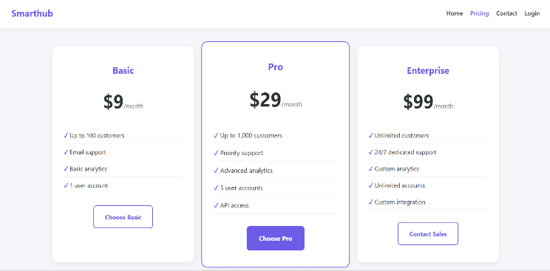
It has two sections. The first section features simple and transparent pricing with the text "Choose the plan that suits your needs. No hidden fees." The second section contains the plans with details: The first plan is the Basic Plan ($9 per month, up to 100 clients, email support, basic analytics, one user account) with a button labeled "Choose the Basic Plan." The second plan is the Professional Plan ($29 per month, up to 1,000 clients, priority support, advanced analytics, 5 user accounts, API access) with a button labeled "Choose the Professional Plan." The third plan is the Enterprise Plan ($99 per month, unlimited clients, 24/7 dedicated support, customized analytics, unlimited accounts, and custom integration).

Code Functionality:
Contextual Routing: The buttons on these cards act as functional routers. The Basic and Professional plans direct the user to login.html to initiate the account creation process. Because the Enterprise plan requires custom integration, its button directly routes the user to contact.html to speak with sales.
Navigation State: Like the Home page, the script.js file runs the navigation check to swap the "Login" button for "Dashboard" if the user is authenticated.

User Interface Description Contact Page:
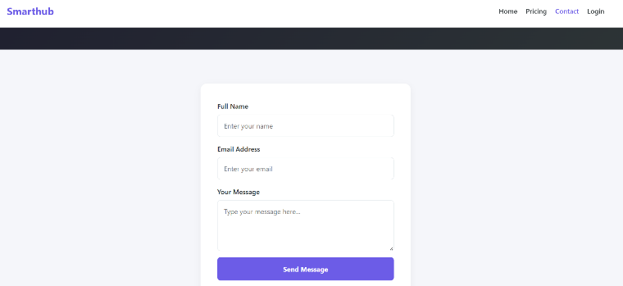
The page contains two sections. The first section has titled "Contact Us" and includes the text "We'd love to hear from you. Send us a message and we'll get back to you as soon as possible." The second section contains a table with fields that the user must enter: the first is their full name, the second is their email address, and the third is the message they wish to send. Clicking on any of the fields (Full Name, Email Address, or Your Message) will take you to the corresponding field to fill it in.

Code Functionality:
Event Handling: The form is powered by the handleContact(e) function in script.js. When the user clicks "Send Message," it uses e.preventDefault() to stop the page from reloading.
Data Validation: The script extracts the trimmed values from the inputs and checks if any are empty. If so, it triggers the showAlert() function to display a red error message.
Local Data Storage (Mock Backend): If validation passes, the script retrieves an array called contactMessages from localStorage. It creates a new message object containing the user's input and a generated timestamp, pushes it to the array, and saves it back to the browser's storage.
Feedback & Reset: Finally, it displays a green success alert ("Thank you! Your message has been received.") and uses .reset() to clear the form fields automatically.

User Interface Description Login Page:
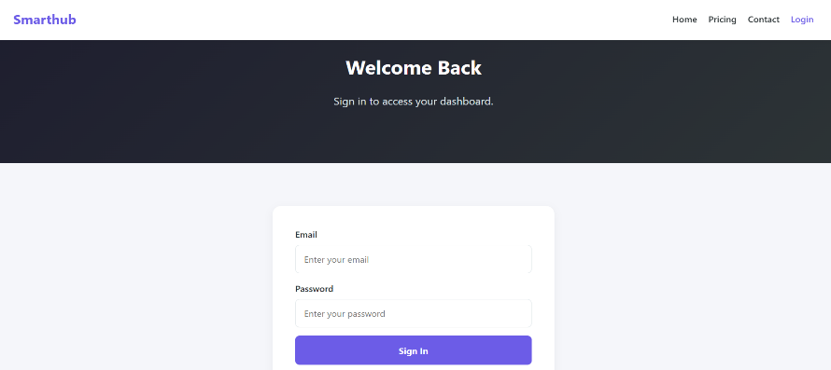
The sign-in page has two sections. The first section is titled "Welcome Back" and includes the text "Sign in to access your dashboard." The second section contains the sign-in process. There are two requirements for signing in: email and password. Use this field if you already have an account.
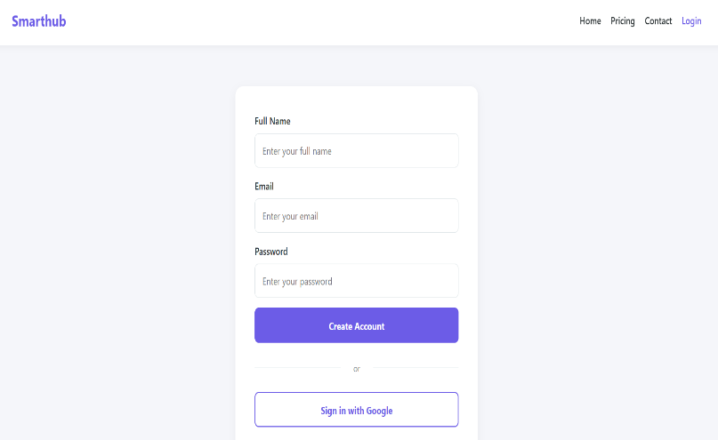
Signing in with your Google account: Clicking this will open a new window with a list of your Google accounts. Select the account you previously created and sign in. If you haven't
created an account before, you'll need to sign up. When signing up, you'll need to add your name, email address, and password.

Code Functionality:
This page relies entirely on auth.js and the Firebase SDK to manage secure authentication.
Dynamic UI Toggling: The toggleMode(e) function handles switching between Login and Registration states. When switched to "Sign Up," it removes the form-field-hidden CSS class from the "Full Name" input, updates the main header text, and changes the submit button's label.
Validation & Submission: The handleSubmit(e) function validates the form before pinging Firebase. For new accounts, it ensures the "Full Name" is provided and enforces a strict minimum password length of 8 characters. Firebase Integration: * Sign Up: Calls auth.createUserWithEmailAndPassword(). Upon success, it immediately updates the user's Firebase profile to include their display name.
Sign In: Calls auth.signInWithEmailAndPassword() to authenticate returning users. Google OAuth: The signInWithGoogle() function instantiates a GoogleAuthProvider() and calls signInWithPopup(), allowing Firebase to handle the third-party token exchange securely.
Session Management: Upon successful login or registration, the saveSession() function packages the user's name, email, and login timestamp into an object, saves it to localStorage, and automatically redirects the browser to dashboard.html. Error Handling: If Firebase throws an error (e.g., wrong password, email already in use), a custom errorMessages dictionary translates the technical error code into a user-friendly message, which is then displayed via the showError() UI function.

Conclusion:
SmartHub is a responsive, web-based order management platform designed to help small businesses and social media sellers streamline their workflow by replacing manual chat-based order tracking with a centralized dashboard and a simple customer-facing product link. Built following modern semantic web standards using HTML, CSS, and modular JavaScript, the platform ensures a high-quality user experience with dynamic navigation and seamless transitions. The website consists of a Home page outlining its core mission and features, a Pricing page with contextual routing for its Basic, Professional, and Enterprise tiers, and a functional Contact page that uses LocalStorage as a mock backend to validate and securely save inquiries. Finally, authentication is robustly handled via the Firebase SDK, offering secure email/password and Google OAuth login options, dynamic form toggling, intelligent error handling, and automatic dashboard redirection for active sessions.

