Guidance on use of SNOMED CT and LOINC together

OCTOBER 2014

Date: 2014-10-14

Version: 0.30  
Status: DRAFT

Table of Contents

1 Introduction 4

1.1 Purpose of this guide 4

1.2 Who should read this guide 4

1.3 Background and Scope 5

1.4 Overview 5

2 Short Introduction to SNOMED CT 6

2.1 Features of SNOMED CT 6

2.2 Benefits of SNOMED CT 10

3 Short Introduction to LOINC 12

3.1 Features of LOINC 12

3.2 Benefits of LOINC 19

4 Cooperative work overview 20

4.1 Cooperative work overvieW 20

4.2 Map Correlation and Origin Reference Set 20

4.3 EXpression Association Reference Set 24

4.4 Benefits of products of the Cooperative Work 30

5 Guidance on Use of SNOMED CT and LOINC Together 32

5.1 Relevant Clinical Scenarios 32

5.2 Practical guidance on uses of SNOMED CT and LOINC 33

5.3 Practical uses of Part Maps and Expression Associations 52

6 Appendix 59

**Copyright and Acknowledgements**

The document is draft publication of the International Health Standards Development Organisation (IHTSDO), the association that owns and maintains SNOMED Clinical Terms. IHTSDO acknowledges the work undertaken by BITAC in preparing this guide under contract to IHTSDO.

This version of the document is not a formally approved IHTSDO specification.

© Copyright 2014 International Health Standards Development Organisation (IHTSDO), all rights reserved.

SNOMED, SNOMED CT and IHTSDO are registered trademarks of the International Health Standards Development Organisation. SNOMED CT licensing information is available at [www.ihtsdo.org/licensing](http://www.ihtsdo.org/licensing). For more information about IHTSDO and IHTSDO Membership, please refer to [www.ihtsdo.org](http://www.ihtsdo.org) or contact us at [info@ihtsdo.org](mailto:info@ihtsdo.org).

This material contains content from LOINC® (http://loinc.org). The LOINC table, LOINC codes, and LOINC panels and forms file are copyright © 1995-2014, Regenstrief Institute, Inc. and the Logical Observation Identifiers Names and Codes (LOINC) Committee and available at no cost under the license at http://loinc.org/terms-of-use.

This material contains example content from HL7 specifications which is copyright HL7, Ann Arbor, Michigan. See www.hl7.org for further details.

# Introduction

## Purpose of this guide

This guide provides advice on combined use of SNOMED CT and LOINC.

## Who should read this guide

This guide should be read by anyone involved in deciding the ways in which different terminologies including SNOMED CT and LOINC are used within a clinical information system, laboratory information or any associated systems, specifications or standard. These people fall into two broad categories:

1. End users of applications that use (or may in future use) SNOMED CT and LOINC. *These people need:*

* To be aware of the importance and benefits of effectively combining the use of SNOMED CT and LOINC to meet their requirements for entry, communication, retrieval and use of clinical and laboratory information.
* To understand their own data entry requirements in order to appreciate and make use of the potential benefits of integrated use of SNOMED CT and LOINC.

This guide provides:

* A high-level description of the features and benefits of SNOMED CT and LOINC and the added benefits of effective combined use.
* Specific guidance on use of the two terminologies in ways that make use of their strengths and the added value provided by links developed between them.

1. Designers and developers of software applications, services and related standards to support effective collection, communication and use of clinical and laboratory information; and those involved in evaluating or procuring such systems and services.

These people need:

* To understand the range of features supported by SNOMED CT and/or LOINC likely to be important for their users.
* To be able to develop systems that use SNOMED CT and LOINC together in ways that support the delivery of systems that meet user requirements and deliver practical benefits.

This guide provides:

* Guidance on approaches to use of SNOMED CT and LOINC which identify high-level approaches that minimize overlap and maximize synergy between the terminologies.
* High-level guidance on possible ways to utilize the maps and associations being developed as part of cooperative work between IHTSDO and Regenstrief Institute.
* Summaries of use cases of different ways of combining SNOMED CT and LOINC, that offer examples of evidence for the approaches recommended in this guidance.

## Background and Scope

In July 2013, IHTSDO and Regenstrief Institute Inc. (RII) signed a long-term agreement to begin cooperative work linking their leading global health care terminologies: Logical Observation Identifiers Names and Codes, or LOINC, and SNOMED Clinical Terms. This agreement will help improve safety, functionality and interoperability for the rapidly growing number of clinicians who manage and exchange health data with electronic medical records.

The agreement builds on and complements the strengths of both organizations and terminologies. The cooperative work will link the rich clinical semantics of SNOMED CT to LOINC codes, which provide extensive coverage of laboratory tests and some types of clinical measurements. By aligning how the two terminologies represent the attributes of tests and some measurements, this collaboration will provide users a common framework within which to use LOINC and SNOMED CT.

Like IHTSDO, Regenstrief is a not-for-profit organization that seeks to enhance the effective delivery of health care. The organizations believe it makes sense to work together to limit duplication of effort and focus limited resources on enhancements that serve the practical needs of the growing number of users of LOINC and SNOMED CT.

The agreement defines a long-term, broadly scoped, working relationship. To underline the long-term commitment of both organizations, the new agreement will be in force for at least 10 years. The organizations’ immediate focus is laboratory testing as well as some basic clinical measurements, and they intend to expand into other areas of mutual interest in the future.

As part of the cooperation agreement between IHTSDO and RII it was agreed that the organizations would develop joint guidance on ways in which SNOMED CT and LOINC should be used together. This guidance document is limited to the scope of the agreement and thus principally covers laboratory investigations along with vital signs and anthropomorphic measurements.

## Overview

The guide starts with short introductions to SNOMED CT and LOINC followed by an overview of the cooperative work to bring them closer. These sections identify the potential benefits of using SNOMED CT and LOINC together.

The remainder of the guide consists of advice on how to make effective combined use of SNOMED CT and LOINC in ways that recognize the scope and strengths of the two terminology resources. The guidance also considers ways to deliver added-value by using the links between SNOMED CT and LOINC developed as part of the cooperative work.

# Short Introduction to SNOMED CT

## Features of SNOMED CT

This section contains a high-level overview of SNOMED CT with some additional information in areas of direct relevance to subsequent chapters of this guide. For a more complete introduction to SNOMED CT see the SNOMED CT Starter Guide (<http://snomed.org/starterguide.pdf>) and for more detailed information refer to the SNOMED CT Document Library (http://snomed.org/doc).

### Introduction

SNOMED CT is a clinical terminology with global scope covering a wide range of clinical specialties, disciplines and requirements. As a result of its broad scope, one of the benefits of SNOMED CT is a reduction of specialty boundary effects that arise from use of different terminologies or coding systems by different clinicians or departments. This allows wider sharing and reuse of structured clinical information. Another benefit of SNOMED CT is that the same data can be processed and presented in ways that serve different purposes.

SNOMED CT allows a range of different options for immediate retrieval and subsequent reuse to address immediate and longer-term clinical requirements and the requirements of other users. The nature of SNOMED CT hierarchies allows information to be selectively retrieved and reused to meet different requirements at various levels of generalization (e.g. retrieval of subtypes of |lung disorder| or |bacterial infection| would both include |bacterial pneumonia|).

### Scope

SNOMED CT has a broad scope of coverage. It includes concepts representing the wide range of types of information that need to be recorded in clinical records. As a result, practitioners from different disciplines and specialties can use SNOMED CT to record appropriate data at different stages in the delivery of patient care.

### Components

SNOMED CT components consist of concepts, terms and relationships that enable effective representation of clinical information.

***Concepts:*** Every concept represents a unique clinical meaning, which is referenced using a unique, numeric and machine-readable SNOMED CT identifier. The identifier provides an unambiguous unique reference to each concept and does not have any ascribed human interpretable meaning.

***Descriptions:*** A set of textual descriptions are assigned to every concept. These provide the human readable form of a concept.

***Relationships:*** A relationship represents an association between two concepts. Relationships are used to logically define the meaning of a concept in a way that can be processed by a computer.

These components are supported by **reference sets** (refsets). Refsets are resources that can be used to customize and configure the terminology for use in a particular country, organization, specialty or data entry situation.

### Hierarchies

SNOMED CT concepts are related to one another within a subtype hierarchy. At the top of this hierarchy are general concepts referred to as top-level concepts. Most of the clinically relevant concepts in SNOMED CT fall under one of the following top-level concepts:

* Clinical finding
* Physical object
* Procedure
* Physical force
* Situation with explicit context
* Event
* Observable entity
* Environments and geographical locations
* Body structure
* Social context
* Organism
* Staging and scales
* Substance
* Qualifier value
* Pharmaceutical / biologic product
* Record artefact
* Specimen

### Concept Model

SNOMED CT concepts are also related to one another by defining relationships which represent characteristics of the meaning of a concept. Each of these relationships represents the value of an attribute. SNOMED CT currently uses more than fifty defining attributes, each of which is identified by a concept.

The set of rules that defines the types of relationships permitted between concepts is referred to as the concept model. These rules specify the set of concepts to which an attribute can be applied (the ‘domain’ of the attribute) and the permitted set of values for each attribute (the ‘range’ of the attribute).

From the perspective of the overlaps between SNOMED CT and LOINC the most significant parts of the concept model are the subtypes of:

* 363787002 | Observable entity |
* 386053000 | Evaluation procedure |

However in addition to this, concept s from several other SNOMED CT concept model domains provide non-numeric values that can be applied to a range of tests represented by LOINC Terms.

### Description Logic

SNOMED CT relationships are validated and normalized using description logic (DL). The use of DL ensures logical consistency in the formal computer processable definitions of SNOMED CT concepts. This includes generation of a subtype hierarchy that is consistent with all the defining relationships. As a result, SNOMED CT is able to support more complete and consistent meaning-based retrieval than a terminology, classification or code system that is not validated using a formal logic.

### Expressions

SNOMED CT can represent clinical information by using concept identifiers as simple codes in a patient record or message. However, it is also possible to express more detailed information by combining concepts into a postcoordinated SNOMED CT expression.

SNOMED CT support of the postcoordination technique allows additional clinical detail to be represented if required. For example, |pneumococcal pneumonia| has a |finding site| of |lung structure|, which can be refined to |right upper lobe of lung|.

Postcoordination greatly increases the depth of detail that SNOMED CT can represent without having to include every possible specific site for every possible disorder via a concept. For example, the concept |bacterial pneumonia| has a defining relationship specifying its |causative agent| as |bacteria| and this can be refined to |Streptococcus pneumoniae|.

SNOMED CT expressions are a structured combination of one or more concept identifiers used to represent a clinical idea in a logical manner, which is automatically processable. Expressions are represented using the SNOMED CT compositional grammar, which is a lightweight syntax for the representation of SNOMED CT expressions.

Description logic allows alternative representations of the same or similar information to be recognized and compared. For example, |pneumococcal pneumonia| refined by |finding site| |right upper lobe of lung| can be computed to have the same meaning as |right upper lobe pneumonia| refined by |causative agent| |Streptococcus pneumoniae|.

### Usage

SNOMED CT is widely recognizes as the leading global healthcare terminology. In more than 25 IHTSDO Member countries SNOMED CT can be used under a free license. SNOMED CT is also used in more than forty non Member countries with low cost licenses for usage. The up to date list of Members is shown at <http://ihtsdo.org/members>.

Within the USA, SNOMED CT has been adopted for use in problem list and quality measures as part of the Centers for Medicare and Medicaid Services Electronic Health Record (EHR) “Meaningful Use” incentive program as specified in the Standards and Certification Criteria. SNOMED CT is also a core element in national EHR initiative in many other IHTSDO Member countries and is widely used in healthcare communication standards including HL7 and IHE.

### Maintenance, governance and licensing

SNOMED CT is maintained by IHTSDO, a not-for-profit association that is owned and governed by its national Members. More than twenty-five countries are Members of IHTSDO, and more join every year.

The International Edition of SNOMED CT is licensed by IHTSDO and updates are distributed every six months. The tab delimited release files include versioning data that allows changes to be tracked and supports generation of views of any earlier release.

### National extension and customization

SNOMED CT is designed to support national extensions that enable addition of local translations and/or dialect variants, without undermining the global representation of meaning using SNOMED CT concept identifiers. Extensions also allow addition of national or local content specific to a particular region or use case.

Customizations represented using the SNOMED CT reference set mechanism allow sharable configuration to address local, specialty or organizational requirements.

## Benefits of SNOMED CT

Many of the benefits of SNOMED CT arise from key features of the terminology described in the previous section including global reach, broad clinical scope, logic based design, extensibility and configurability to support language and other national, regional or organizational requirements.

It is widely recognized that use of an Electronic Health Record (EHR) improves communication and increases the availability of relevant information. The added-value of storing and communicating this information using SNOMED CT to represent clinical information is that this enables meaning-based retrieval. The benefits arising from this range from increased opportunities for real time decision support to more accurate retrospective reporting for research and management.

### Use of SNOMED CT Benefits Individuals

SNOMED CT enabled clinical health records benefit individuals by:

* Enabling relevant clinical information to be recorded using consistent, common representations during a consultation.
* Enabling guideline and decision support systems to check the record and provide real-time advice, for example, through clinical alerts.
* Supporting the sharing of appropriate information with others involved in delivering care to a patient through data capture that allows understanding and interpretation of the information in a common way by all providers.
* Allowing accurate and comprehensive searches that identify patients who require follow-up or changes of treatment based on revised guidelines.
* Removing language barriers (SNOMED CT enables multilingual use).

### Use of SNOMED CT Benefit Populations

SNOMED CT enabled clinical health records benefit populations by:

* Facilitating early identification of emerging health issues, monitoring of population health and responses to changing clinical practices.
* Enabling accurate and targeted access to relevant information, reducing costly duplications and errors.
* Enabling the delivery of relevant data to support clinical research and contribute evidence for future improvements in treatment.
* Enhancing audits of care delivery with options for detailed analysis of clinical records to investigate outliers and exceptions.

### Use of SNOMED CT Supports Evidence-Based Healthcare

SNOMED CT enabled health records inform evidence based health care decisions by:

* Enabling links between clinical records and enhanced clinical guidelines and protocols.
* Enhancing the quality of care experienced by individuals.
* Reducing costs of inappropriate and duplicative testing and treatment.
* Limiting the frequency and impact of adverse healthcare events.
* Raising the cost-effectiveness and quality of care delivered to populations.

# Short Introduction to LOINC

## Features of LOINC

### Introduction

This section contains a high-level overview of LOINC with some additional information in areas of direct relevance to subsequent chapters of this guide. For a more complete introduction to LOINC and supporting resources see <http://loinc.org/get-started>.

Logical Observation Identifiers Names and Codes ([LOINC](http://loinc.org/)®) is a terminology standard for identifying laboratory tests and other measurements. It specifies universal codes, names, and other attributes for laboratory results as well as clinical reports, physical exam findings, survey instruments and other observations. It was developed to enable the exchange and pooling of results from diverse sources in order to enhance clinical care, outcomes management and research.

### Scope

LOINC codes include laboratory and other clinical observations. The laboratory portion of LOINC includes measurements made on specimens, such in chemistry, hematology, serology, microbiology (including parasitology and virology), toxicology, cell counts, antibiotic susceptibilities, and more. The clinical portion of LOINC includes codes for observations made on patients and populations. LOINC has codes for observations like vital signs and a wide range of other clinical observations. Vital signs and anthropomorphic measurement are included in the scope of the cooperation agreement. Other clinical domains are not currently included in the scope of the agreement with IHTSDO.

LOINC includes codes that identify test observations (e.g. blood culture, antibiotic sensitivity)**.** Other code systems, including SNOMED CT, often provide values that can be applied to represent results (e.g. staphylococcus, amoxicillin). If we consider the observation as a question and the observation values as answers, LOINC provides codes for the questions and SNOMED CT provides codes for many of the non-numeric answers.

### Maintenance, governance and licensing

LOINC is owned, maintained and licensed by the Regenstrief Institute, Inc. (RII). RII is a non-profit medical research organization associated with Indiana University School of Medicine. LOINC is available free of charge subject to the license conditions and terms of use <http://loinc.org/terms-of-use>. Updated versions are released twice a year. The LOINC web search tool is available at <http://search.loinc.org/>. The LOINC database and a free browsing and mapping program, the Regenstrief LOINC Mapping Assistant (RELMA®), can be downloaded from <http://loinc.org/downloads>.

### Usage

LOINC is widely adopted, and the user community continues to grow rapidly. The worldwide LOINC community presently has more than 34,000 users in 163 countries (see <http://loinc.org/atlas>).

Within the USA, LOINC has been adopted by large reference laboratories, health information exchanges, healthcare organizations, insurance companies, research applications, and several national standards initiatives and programs. In particular, LOINC was adopted as the standard for laboratory orders and results as part of the Centers for Medicare and Medicaid Services Electronic Health Record (EHR) “Meaningful Use” incentive program as specified in the Standards and Certification Criteria.

Outside the USA, LOINC has also been adopted as a national standard in more than 25 countries. In addition, there are many large data exchanges using LOINC around the world.

### Structure

Each test is represented by a formal six-part LOINC name and assigned a LOINC code, which is a number with a check digit (see Table 1). Each code is also assigned an observation class (e.g., chemistry, hematology, and radiology); related names (to assist searches of the database); and other attributes.

For most classes of laboratory observations, there is also a “short name” (less than 40 characters long), and a Long Common Name that is more clinician friendly.

### LOINC Terms, Codes and Axes

LOINC fully-specified names (including laboratory test results, clinical measurements, and results of other diagnostic studies) are defined in terms of six major axes as described in Table 2: 1. Component name, 2. Property, 3. Time, 4. System, 5. Scale, and 6. Method. The fully-specified (formal) LOINC name must include entries for the first five major axes; the method axis is included only when the method distinction makes an important difference to the clinical interpretation of the result.

Four additional minor axes are challenge information; adjustments; supersystem, e.g., fetus, blood product; and time operators (maximum, minimum, last, first), which are only used when relevant. The challenge axis is the most complex of the minor axes and includes the amount, route, and timing (e.g., oral glucose tolerance test). The details about these other axes can be found in the LOINC Users ‘Guide.

Examples of LOINC terms are shown in Table 1.

Table 1. Examples of laboratory LOINC codes and formal LOINC names.

|  |  |
| --- | --- |
| **LOINC Code** | **LOINC name (Component name:Property:Time:Specimen:Scale:Method)** |
|
| 2951-2 | SODIUM:SCNC:PT:SER/PLAS:QN |
| 2955-3 | SODIUM:SCNC:PT:UR:QN |
| 2956-1 | SODIUM:SRAT:24H:UR:QN |
| 2164-2 | CREATININE RENAL CLEARANCE:VRAT:24H:UR:QN |
| 1514-9 | GLUCOSEˆ2H POST 100 G GLUCOSE PO:MCNC:PT:SER/PLAS:QN |
| 3665-7 | GENTAMICINˆTROUGH:MCNC:PT:SER/PLAS:QN |
| 17863-2 | CALCIUM.IONIZED:MCNC:PT:SER/PLAS:QN |
| 2863-9 | ALBUMIN:MCNC:PT:SNV:QN:ELECTROPHORESIS |

(<http://www.clinchem.org/content/49/4/624.full.pdf> )

Table 2. Formal model for constructing LOINC fully specified names

|  |  |
| --- | --- |
| **Axis Name** | **Description/Example** |
|
| Component name | The analyte or attribute being measured or observed. E.g., sodium, body weight. |
| (Kind of) Property | Differentiates kinds of quantities relating to the same substance. E.g., mass concentration, catalytic activity. |
| Time (Aspect) | Identifies whether the measurement is made at a point in time or a time interval. E.g. 24H for a urine sodium concentration. |
| System | The specimen, body system, patient, or other object of the observation. E.g. cerebral spinal fluid, urine, radial artery. |
| (Type of) Scale | The scale or precision that differentiates among observations that are quantitative, ordinal (ranked choices), nominal (unranked choices), or narrative text. |
| (Type of) Method | An optional axis that identifies the way the observation was produced. It is used only when needed to distinguish observations that have clinically significant differences in interpretation if made by different methods. |

(<http://www.ncbi.nlm.nih.gov/pmc/articles/PMC3376691/pdf/nihms355669.pdf> )

LOINC creates only those combinations that have clinical relevance in laboratory medicine. Terms are not created by blind permutations. Regenstrief (with guidance from the LOINC committee) reviews new code requests carefully to make sure that only meaningful LOINC codes that can be pragmatically used by the LOINC community are added to the database.

### LOINC Parts

The atomic elements that comprise a fully-specified LOINC name are called LOINC “Parts”. Each fully-specified name will consist of 5 or 6 parts (depending on whether the Method is important for interpreting the result), each with a part type corresponding to one of the major axes described above. Each LOINC Part is also assigned an identifier (that begins with the prefix “LP”), and internally Regenstrief maintains links between the full LOINC term and the Parts that comprise it. Regenstrief uses LOINC Parts in many aspects of LOINC development, such as: adding synonymy, building hierarchies, creating alternate display names, linking descriptive text, and more.

The Parts and their linkages are not distributed as part of the main LOINC table, but they are part of the content used by the RELMA program.

LOINC “part” concepts (e.g. *sodium*) serve as building blocks for the description of tests and observations, in association with a set of semantic relations. For example, *Sodium:SCnc:Pt:Ser/Plas:Qn*, the laboratory test in which the molar concentration of sodium is measured in the plasma (or serum) is identified by 2951-2. The list of relations of this concept to other concepts (“parts”) is shown in Table 3 and Table 4. For example, the “part” concept *Sodium* is linked to this test by the relationship *component*.

Table 3. Example of the relation of the LOINC code 2951-2 to LOINC Part codes

|  |  |  |
| --- | --- | --- |
|  | **LOINC Code** | **LOINC Name** |
| **LOINC Term** | 2951-2 | **Sodium [Mass or Moles/volume] in Serum or Plasma** |
| **Part Type** | **Part No.** | **Part Name** |
| Component | LP15099-2 | Sodium |
| Property | LP6860-3 | SCnc [Substance Concentration] |
| Time | LP6960-1 | Pt [Point in time (spot)] |
| System | LP7576-4 | Ser/P1as [Serum or Plasma] |
| Scale | LP7753-9 | Qn |
| Method |  |  |

(<http://www.ncbi.nlm.nih.gov/pmc/articles/PMC2655945/> )

Table 4 Example of the relation of the LOINC code 5778-6 to LOINC Part codes

|  |  |  |
| --- | --- | --- |
|  | **LOINC Code** | **LOINC Name** |
| **LOINC Term** | 5778-6 | **Color of Urine** |
| **Part Type** | **Part No.** | **Part Name** |
| Component | LP28806-5 | Color |
| Property | LP6886-8 | Type |
| Time | LP6960-1 | Pt [Point in time (spot)] |
| System | LP7681-2 | Urine |
| Scale | LP7750-5 | Nom [Nominal] |
| Method |  |  |

The LOINC terminology does not use description logic. However, the formal definitions provided by LOINC all conform to the 6-axis template (described in Table 2) and make use of named semantic relations.

In addition to creating codes for single tests, measurements, or observations, LOINC also defines concepts to represent collections of discrete elements such as panels (batteries), forms, and data sets.

For example, a CBC/FBC test (complete/full blood count) is expected to deliver a set of results for different components including leukocytes, erythrocytes, hemoglobin, hematocrit, etc.

### Hierarchy tree structure

Regenstrief creates hierarchies to organize LOINC terms based on a structured arrangement of LOINC elements (also known as parts).RELMA has 5 selectable hierarchy trees that are commonly used to narrow the search limits returned:

* Class
* Multiaxial (component/system)
* System (specimen)
* Component
* Method

The LOINC hierarchy group LOINC concepts by specifying the parent-child relationship between the elements used in one (or more of the axes).

Most often, the hierarchies are used to restrict searches performed using RELMA.

The Multiaxial hierarchy organizes LOINC codes based on more than one of the LOINC name axes. For laboratory tests, it organizes first by the Component and then by the System. The Multiaxial Hierarchy is distributed as an accessory file that is part of the LOINC release.

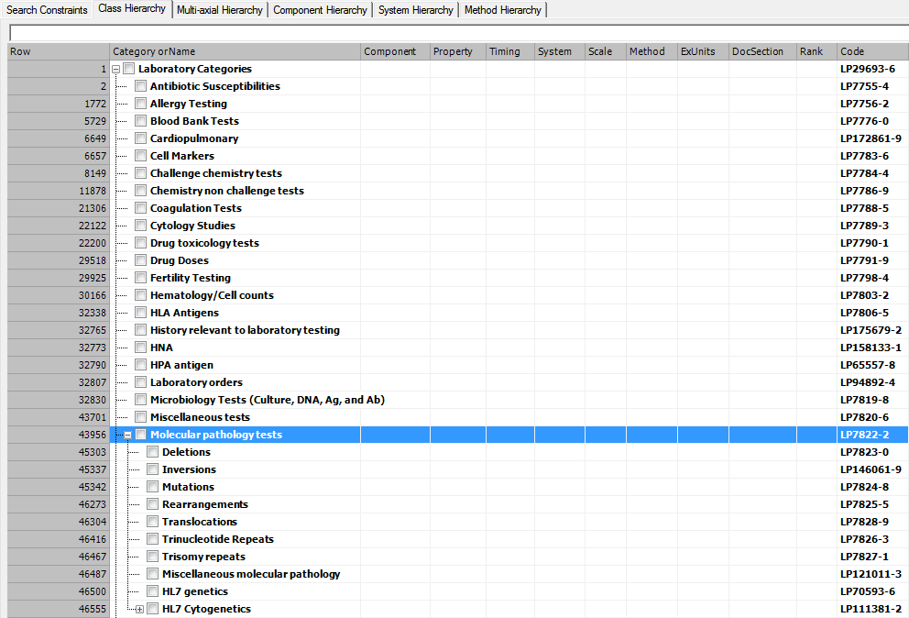

Figure 1. Class hierarchy showing Class classification of laboratory tests

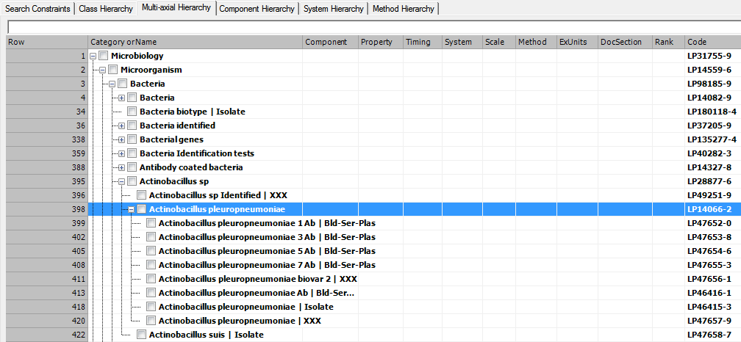

Figure 2. Multiaxial hierarchy of LOINC showing relations in Microbiology parts of component

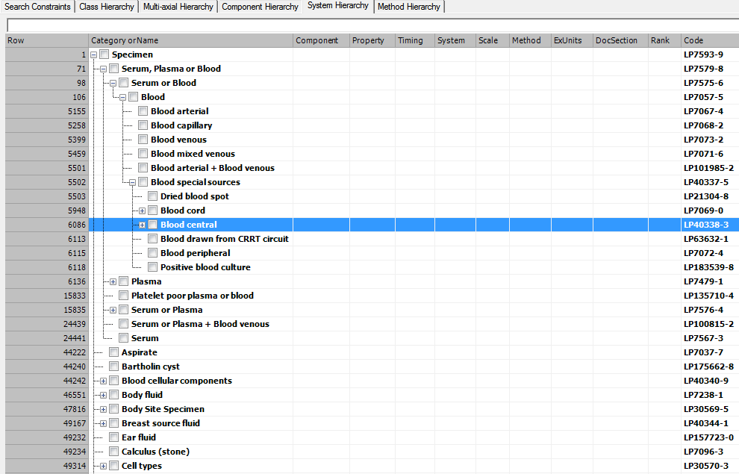

Figure 3. Multiaxial hierarchy of LOINC showing relations in system ax: specimen

#### References

McDonald CJ, Huff SM, Suico JG, Hill G, Leavelle D, Aller R, Forrey A, Mercer K, DeMoor G, Hook J, Williams W, Case J, Maloney P. LOINC, a universal standard for identifying laboratory observations: a 5-year update. Clin Chem. 2003 Apr;49(4):624-33. <http://www.clinchem.org/content/49/4/624.full.pdf>

Vreeman DJ, Chiaravalloti MT, Hook J, McDonald CJ. Enabling international adoption of LOINC through translation. J Biomed Inform. 2012 Aug;45(4):667-73.

<http://www.ncbi.nlm.nih.gov/pmc/articles/PMC3376691/pdf/nihms355669.pdf>

Bodenreider O. Issues in mapping LOINC laboratory tests to SNOMED CT. AMIA Annu Symp Proc. 2008 Nov 6:51-5.

<http://www.ncbi.nlm.nih.gov/pmc/articles/PMC2655945/pdf/amia-0051-s2008.pdf>

Steindel S, Loonsk JW, Sim A, Doyle TJ, Chapman RS, Groseclose SL. Introduction of a hierarchy to LOINC to facilitate public health reporting. Proc AMIA Symp. 2002:737-41.

<http://www.ncbi.nlm.nih.gov/pmc/articles/PMC2244475/pdf/procamiasymp00001-0778.pdf>

Adamusiak T, Bodenreider O. Quality assurance in LOINC using Description Logic. AMIA Annu Symp Proc. 2012;2012:1099-108.

<http://www.ncbi.nlm.nih.gov/pmc/articles/PMC3540427/pdf/amia_2012_symp_1099.pdf>

## Benefits of LOINC

Vocabulary standards like LOINC and SNOMED CT demonstrate the “[network effect](http://en.wikipedia.org/wiki/Network_effect)”. That is, they become more valuable as more people use them. LOINC is the most widely used laboratory code system, and its benefits continue to grow as adoption spreads. Regenstrief develops LOINC using best practices in terminology development. The development approach keeps the content coverage broad and current in the domains of interest.

As a result, LOINC users find many benefits because it:

* Enables comparability and analysis of consolidated laboratory result data. Many EHR health information exchange projects are using LOINC to pool and compare clinical lab results. Such analyses can be for the same patient across different laboratories or the same test across many patients.
* Facilitates integration of laboratory tests and reporting units across disparate lab systems within the same health delivery system. For example, LOINC facilitates the communication between hospital-based clinical labs and their reference clinical labs.
* Enables more efficient electronic ordering of tests from multiple laboratories.
* Supports all commonly used lab tests and the majority of tests done in specialty areas. In case a LOINC code is missing because it does not exist in the current version, an agile process for submitting new codes ensures that it will be created and published in the next update, always considering that the code is pragmatically useful in the Clinical lab global community.
* Facilitates increased access to laboratory test results across the continuum of care and reduces the need to repeat laboratory tests by providing a universal identifier for lab tests across care sites and systems.
* Improves quality and timeliness of laboratory results and interpretations since tests can be reviewed electronically.
* Accelerates secondary uses of clinical results for other purposes such as public health reporting, quality measurement, and other kinds of analyses.
* Allows global communication, but has support for local implementation with features like language translations.

# Cooperative work overview

## Cooperative work overvieW



Figure 4. Overview of Cooperative Works – including maps, associations and content

## Map Correlation and Origin Reference Set

### Purpose

The *Map correlation and origin type* pattern is used to meet the requirements for representation of maps between SNOMED CT concepts and codes in another code system where the following requirements apply.

1. A requirement to indicate the degree of correlation between the SNOMED CT concept and the LOINC target code.
2. A requirement to indicate whether a concept or code was added to either code system as a result of the mapping process and in this case to indicate in which code system the concept or code originated.
3. No requirements for mapping rules or advice to be included with each map.

### Design

The *Map correlation and origin type reference set* has been designed to meet the requirements as they apply to the maps between LOINC Part Codes and SNOMED CT concepts. The requirements related to representation of map correlation and content origin are clearly stated in the cooperation agreement between IHTSDO and Regenstrief Institute as signed in July 2013.

As there is no requirement for mapping rules or advice, the *Simple map type pattern* is used as the foundation for this reference set pattern.

Two component references are added to this pattern to meet the additional requirements. These are as follows:

* **correlationId** attribute – added to meet requirement (a).
  + The intended use of this attribute is the same as for the correlationId as specified in the “Complex Map Type Reference Set” and the “Extended Map Type Reference Set”.
* **contentOriginId** attribute – added to meet requirement (b).
  + This attribute has not been used before but is also included in the design of the “Expression Association Reference Set” specified in this document.

### Map Correlation and Origin Reference Set Data Structure

| **Field** | **Data type** | **Purpose** |
| --- | --- | --- |
| **id** | UUID | A 128 bit unsigned integer, uniquely identifying the reference set member. |
| **effectiveTime** | Time | Specifies the inclusive date at which this change becomes effective. |
| **active** | Boolean | Specifies whether the member's state was active or inactive from the nominal release date specified by the effectiveTime field. |
| **moduleId** | SCTID | Identifies the member version's module. Set to a child of |Module| within the metadata hierarchy. |
| **refsetId** | SCTID | Identifies the reference set. |
| **referencedComponentId** | SCTID | A reference to the SNOMED CT concept being mapped to/from the LOINC Part Code. |
| **mapTarget** | String | The value of the LOINC Part Code to which the concept is mapped. |
| **attributeId** | SCTID | A reference to the SNOMED CT concept representing the attribute to which the referencedComponentId applies. Usually this will be derived from the LOINC Part Type.  In some cases, where there is overloading or non-alignment of Part Types relative to the SNOMED CT Observables Model there may be additional rows mapping the LOINC Part Code to another referencedComponentId which is a value for a different SNOMED CT attribute. |
| **correlationId** | SCTID | The correlation between the SNOMED CT concept and the LOINC Part Code.  Values are selected children of 447247004  | SNOMED CT source code to target map code correlation value|   * Exact match * Broad (SNOMED CT) to narrow LOINC * Narrow (SNOMED CT) to broad (LOINC) * Partial overlap |
| **contentOriginId** | SCTID | Indication of whether concept was initially in one of the terminologies (LOINC or SNOMED CT) and added to the other as part of mapping or was in both terminologies at the outset. Values are subtype children of 705116007 | Original code system source for linked content value|   * Originally in LOINC * Originally in SNOMED CT * Originally in both LOINC and SNOMED CT |

### Metadata

#### Refset Name

* 900000000000454005 |Foundation metadata concept|
  + 900000000000455006 |Reference set|
    - 705111002|Map correlation and origin type reference set|
      * 705112009|LOINC Part map reference set|

*Values for correlationId*

Suggestion is use of current values set.

* 447247004 |SNOMED CT source code to target map code correlation value|
  + 447559001 |Broad to narrow map from SNOMED CT source code to target code|
  + 447557004 |Exact match map from SNOMED CT source code to target code|
  + 447558009 |Narrow to broad map from SNOMED CT source code to target code|
  + 447560006 |Partial overlap between SNOMED CT source code and target code|

*Values for contentOriginId*

* 705116007 | Original code system source for linked content value|
  + 705117003 |Originally in LOINC|
  + 705118008 |Originally in SNOMED CT|
  + 705119000 |Originally in both LOINC and SNOMED CT|
  1. Code to Expression Reference Set

***Purpose***

The *Code to Expression type reference set* is used meet the requirements for representation of associations between codes in another code system and SNOMED CT expressions, where the following requirements apply:

1. Some or all of the codes in the other code system cannot be mapped to an individual SNOMED CT concept but can be associated with (i.e. mapped to) a postcoordinated SNOMED CT expression which convey the same meaning, or at least a similar meaning.
2. A requirement that IHTSDO shall not systematically add missing content to enable a single SNOMED CT identifier to represent the meaning represented by the codes in the other code system.
3. A requirement to indicate the degree of correlation between the code in the other code system and the SNOMED CT expression.
4. A requirement to indicate the code in the other code system was created before any single concept representation in SNOMED CT or whether the single concept representation in SNOMED CT predated the creation of the association.
5. No requirements for mapping rules or advice to be included with each association or map.

***Design***

The *Code to Expression type reference set* is designed to meet the requirements as they apply to the associations between LOINC Term Codes and SNOMED CT expression.

The cooperation agreement between IHTSDO and Regenstrief Institute as signed in July 2013 does not permit systematic addition of SNOMED CT concepts based on LOINC Terms. Instead, LOINC Term Codes are associated with SNOMED CT expressions that have the same meaning. If a LOINC Term is recognized as having the same meaning as an existing SNOMED CT concept the associated expression will be precoordinated (e.g. an expression containing a single conceptId).

This requirement cannot be met by simply expanding an existing *reference set* pattern since there is a significant change to the required functionality. The reason for this is the SNOMED CT end of the association is an expression rather than a single component identifier. An expression is a variable length string and cannot be represented using a 64-integer (the datatype of the referencedComponentId).

With that exception the requirements are similar to those of the *Map correlation and origin type* pattern. Therefore, this is used as the foundation from which modifications have been made to meet these requirements.

After detailed discussion of a range of options, the decision has been made that for the Technology Preview release the referencedComponentId will be included and will be populated by a SNOMED CT concept identifier referring to a new concept 705114005 | LOINC Code System (qualifier value)|. This value can be ignored, as it does not convey any relevant information. The advantage of this approach is that it retains the Reference Set file structure, though it does so at the expense of redundancy.

The two specific columns added to the *Code to Expression type reference set* are:

* **expression** attribute – added to meet requirement (a).
  + This attribute has not been used before but is also included in the design of the “Expression Association Reference Set” specified in this document.
* **definitionStatusId** attribute – added for alignment with SNOMED CT concept definitions
  + This attribute indicates whether the expression is sufficient to define the idea represented by the LOINC Term Code.

The mapTarget field is retained as is to contain the code in the other codes system (the LOINC Term Code). It is arguable that in this pattern this is not really a “target” because these associations have the ability to be considered as bidirectional. Thus the expression could return a LOINC code or the LOINC code could be rendered as a SNOMED CT expression. In practice this is also true for the *Map correlation and origin type* pattern. Arguably, in terms of flexibility of use a direction independent name is needed but for the preview release it seems wiser to go for alignment with previous work.

The three additional component references included in the *Map correlation and origin type* pattern are also included in this pattern with the same functionality:

* **correlationId** attribute – retained to meet requirement (c).
* **contentOriginId** attribute – retained to meet requirement (d).

***Expression Format***

The expression will be represented in the representational from with the smallest number of refinements which full represents the meaning of the code in the other code system. This form which is derived as follows is sometimes referred to as the “author normal form”.

*Starting point*

The stated representation as authored to most accurately reflect the meaning of the source code using the SNOMED CT concept model.

*Steps applied to derive the distributed expression*

1. The standard SNOMED CT description logic classification process is applied to infer additional subtype relationships and inherited attributes relevant to the expression.
2. The proximal supertypes for the expression are identified (based on transitive reduction of the subtype hierarchy).
3. Any attribute-value pairs or attribute-groups that can be inferred from one or more of supertypes so that only the differential set of attribute-value pairs and attribute groups are retained.

### LOINC Term Code status changes

Deprecated statuses will cause the expression associations to be marked as inactive but trial use status will not be represented. LOINC Terms that were already deprecated at the time of initial mapping will not be included in maps and associations. However, dependent on demand and priority to assessments, it is possible these may be added later.

***Code to Expression Reference Set Data Structure***

| **Field** | **Data type** | **Purpose** |
| --- | --- | --- |
| **id** | UUID | A 128 bit unsigned integer, uniquely identifying the reference set member. |
| **effectiveTime** | Time | Specifies the inclusive date at which this change becomes effective. |
| **active** | Boolean | Specifies whether the member's state was active or inactive from the nominal release date specified by the effectiveTime field. |
| **moduleId** | SCTID | Identifies the member version's module. Set to a child of |Module| within the metadata hierarchy. |
| **refsetId** | SCTID | Identifies the reference set. |
| **referencedComponentId** | SCTID | A reference to a SNOMED CT metadata concept referring to the 705114005 | LOINC Code System (qualifier value)|. |
| **mapTarget** | String | The value of the LOINC Term Code associated with the expression. |
| **expression** | String | A reference to the SNOMED CT concept being mapped to/from the LOINC Term Code. |
| **definitionStatusId** | SCTID | Indicates whether or not the expression contains a sufficient definition of the LOINC Term Code in the mapTarget field.  Values are children of:  900000000000444006 | Definition status (core metadata concept)|   * Necessary but not sufficient concept definition status * Sufficiently defined concept definition status |
| **correlationId** | SCTID | The correlation between the SNOMED CT expression and the LOINC Term Code.  Values are selected children of:  447247004 | SNOMED CT source code to target map code correlation value| :   * Exact match * Broad (SNOMED CT) to narrow (LOINC) * Narrow (SNOMED CT) to broad (LOINC) * Partial overlap |
| **contentOriginId** | SCTID | Indication of whether concept was initially in one of the terminologies (LOINC or SNOMED CT) and added to the other as part of mapping or was in both terminologies at the outset. Values are subtype children 705116007 | Original code system source for linked content value|   * Originally in LOINC (true if expression was postcoordinated when the association was first made) * Originally in SNOMED CT * Originally in both LOINC and SNOMED CT |

### Metadata

#### Refset Name

The following metadata in the "Foundation metadata concept" hierarchy supports this reference set:

* 900000000000454005 | Foundation metadata concept |
  + 900000000000455006 | Reference set |
    - 705109006 |Code to expression type reference set|
      * 705110001 |LOINC Term to Expression reference set|

#### Values for definitionStatusId

* 900000000000444006 | Definition status |
  + 900000000000074008 | Necessary but not sufficient concept definition status |
  + 900000000000073002 | Sufficiently defined concept definition status |

#### Values for correlationId

Suggestion is use of current values set. However, an argument can be made in favor of duplication of the hierarchy with “source code” replaced by “expression”.

* 447247004 | SNOMED CT source code to target map code correlation value|
  + 447559001 | Broad to narrow map from SNOMED CT source code to target code |
  + 447557004 | Exact match map from SNOMED CT source code to target code |
  + 447558009 | Narrow to broad map from SNOMED CT source code to target code |
  + 447560006 | Partial overlap between SNOMED CT source code and target code |

#### Values for contentOriginId

* 705116007 | Original code system source for linked content value |
  + 705117003 |Originally in LOINC|
  + 705118008 |Originally in SNOMED CT|
  + 705119000 |Originally in both LOINC and SNOMED CT|

## Benefits of products of the Cooperative Work

Once the work of the Cooperative Agreement is completed, users of each terminology will receive added benefits.

### LOINC benefits to SNOMED CT users

* LOINC codes will provide to SNOMED CT terminology extensive coverage of clinical laboratory tests and some types of clinical measurements. Likewise, the addition of SNOMED CT concepts from LOINC Parts will expand coverage in areas like substances, cell types, kinds of property, etc.
* LOINC provides greater granularity and specificity for coding of laboratory tests.
* Links between the terminologies will promote the usage of SNOMED CT by LOINC large global community.
* The Observables model related to clinical lab tests in SNOMED CT was based on the LOINC semantic model.

Additional benefits of linking SNOMED CT and LOINC are described in referenced papers written by Adamusiak and Bodenreider referenced at the end of this Chapter.

### SNOMED CT benefits in Laboratory area for LOINC users

Linking LOINC terms to the SNOMED CT subtype hierarchy and description logic definitions provides an inferred hierarchy for LOINC terms. Some of these benefits were described by Adamusiak and Bodenreider (referenced at the end of this Chapter), including:

* SNOMED CT is currently being used in the laboratory area for reporting Microbiology results. Linkage to related LOINC codes provides a more integrated pattern of usage in this domain.
* The richness of SNOMED CT relations can provide novel insights into the original resource
* The hierarchy of parts used by LOINC terms can be informed by the SNOMED CT hierarchy, thus reducing duplicative work
* Hierarchical organization of LOINC terms can be inferred automatically
* SNOMED CT relationships can also provide enhanced subsumption for LOINC terms. New paths are not limited to abstract observations that group LOINC codes, but also LOINC codes themselves can be in direct relationships. This limits the need for creating abstract observations to group them.
* The SNOMED CT DL representation can enhance navigation among LOINC terms by providing access to more paths between the codes in the SNOMED CT hierarchy. Such navigation can make it easier to find an appropriate code.
* SNOMED CT DL can also enhance curation of LOINC content by enabling detection of duplicates and missing hierarchical relations.

### References

Adamusiak T, Bodenreider O. Quality assurance in LOINC using Description Logic. AMIA Annu Symp Proc. 2012;2012:1099-108.

<http://www.ncbi.nlm.nih.gov/pmc/articles/PMC3540427/pdf/amia_2012_symp_1099.pdf>

SNOMED CT Starter Guide

SNOMED CT Technical Implementation Guide

<http://ihtsdo.org/fileadmin/user_upload/doc/>

Other references from NRC SPAIN. **Factoría de recursos semánticos del MSSSI** <http://www.msssi.gob.es/profesionales/hcdsns/areaRecursosSem/factoria.html>

# Guidance on Use of SNOMED CT and LOINC Together

## Relevant Clinical Scenarios

In order to develop guidance on using SNOMED CT and LOINC together, we study different use cases, including::

* Several clinical scenarios with use or implementation of both terminologies
  + Bio-surveillance (animal/human health) networks.
  + Clinical laboratory reporting (mostly Microbiology area).
  + Infectious diseases for lab order entries.
* Different uses of the standards, depending on how they are implemented in the usual model question (mostly LOINC) /answer (mostly SNOMED CT)

To do so, use cases and also guidelines involved in terminology implementation in clinical lab environments have been scanned in order to look for nowadays usage of LOINC and SNOMED CT.

## Terminology scenarios - Summary

The following table list data elements used in clinical and laboratory areas related to the relevant scenarios, and the recommended standard in each of these scenarios.

**Table 5.** Summary of recommended terminologies in the data elements of relevant scenarios

|  |  |  |  |
| --- | --- | --- | --- |
| **DATA ELEMENT** | **SCENARIO** | | |
| Bio-surveillance (human/animal) | Lab reporting  (micro, infect diseases) | CIMI |
| Vital signs Name (Observation name) | **LOINC** | **---** | **SNOMED CT** |
| Vital signs Result (Observation value) | **SNOMED CT** | **---** | **SNOMED CT** |
| Laboratory Orders | **LOINC** | **LOINC** | **---** |
| Laboratory Test Results Name (Identifier) | **LOINC** | **LOINC** | **LOINC** |
| Laboratory Test Results no Quantitative (Value) | **SNOMED CT** | **SNOMED CT** | **SNOMED CT** |
| Specimens (Specimen Types, Specimen Source Types, …) | **SNOMED CT** | **SNOMED CT** | **SNOMED CT** |
| Animal Species/Breeds | **SNOMED CT** | **SNOMED CT** | **SNOMED CT** |
| Procedures (Laboratory Methods) | **SNOMED CT** | **SNOMED CT** | **SNOMED CT** |

And the following pie-chart represents the different usage of terminologies that has been described.

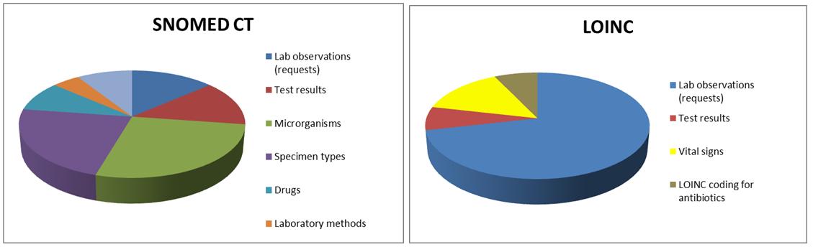

Figure 5. Current usage of SNOMED CT and LOINC

Using these scenarios, we have developed guidelines that describe the real-world usage of SNOMED CT and LOINC together.

To do so, use cases and also guidelines involved in terminology implementation in clinical lab environment have been scanned in order to consider current usage of LOINC and SNOMED CT.

## Practical guidance on uses of SNOMED CT and LOINC

1. Vital signs name (Observation name) / Vital signs result (Observation value)

|  |
| --- |
| Vital signs name (Observation name) **Recommendation**:  LOINC should be used as the standard coding system to identify the vital sign observation.  **Alternative 1:**  The SNOMED CT expression associated with a LOINC code for a vital sign may be used.  **Alternative 2:**  SNOMED CT concepts from the 46680005 |Observable entity| hierarchy may be used.  *Vital signs result (Observation value)*  **Recommendation**:  Most vital signs are physical quantities, but where a vital sign observation requires a coded value (e.g. the patient body position when a blood pressure measurement was obtained) SNOMED CT should be used as the standard coding system for such result values. |

***EXAMPLE 1:*** An .example value set for vital sign result type in PHIN-VADS (CDC)

|  |  |  |  |
| --- | --- | --- | --- |
| **Value Set Code PHVS_VitalSignResult_HITSP** | | |  |
| **Concept Code** | **Concept Name** | **Preferred Concept Name** | **Code System Name** |
| **8310-5** | Body Temperature | Body temperature:Temp:Pt:^Patient:Qn: | LOINC |
| **8462-4** | BP Diastolic | Intravascular diastolic:Pres:Pt:Arterial system:Qn: | LOINC |
| **8480-6** | BP Systolic | Intravascular systolic:Pres:Pt:Arterial system:Qn: | LOINC |
| **8287-5** | Head Circumference | Circumference.occipital-frontal:Len:Pt:Head:Qn:Tape measure | LOINC |
| **8867-4** | Heart Rate | Heart beat:NRat:Pt:XXX:Qn: | LOINC |
| **8302-2** | Height | Body height:Len:Pt:^Patient:Qn: | LOINC |
| **8306-3** | Height (Lying) | Body height^lying:Len:Pt:^Patient:Qn: | LOINC |
| **2710-2** | O2 % BldC Oximetry | Oxygen saturation:SFr:Pt:BldC:Qn:Oximetry | LOINC |
| **9279-1** | Respiratory Rate | Breaths:NRat:Pt:Respiratory system:Qn: | LOINC |
| **3141-9** | Weight Measured | Body weight:Mass:Pt:^Patient:Qn:Measured | LOINC |
| https://phinvads.cdc.gov/vads/ViewValueSet.action?id=7FFDBFB5-A277-DE11-9B52-0015173D1785# | | | |

1. Laboratory orders

|  |
| --- |
| **Recommendation**:  To identify the requested observation/test/battery LOINC should be used as the standard coding system.  **Alternative 1**:  The SNOMED CT expression associated with a LOINC code may be used.  **Alternative 2**:  SNOMED CT concepts from the 15220000 |Laboratory test| or 363787002 |Observable entity| hierarchy may be used. |

***EXAMPLE 1:*** Part of the Value set for Lab Test orderables that could be used for PHLP_Flu. PHIN-VADS

|  |  |  |
| --- | --- | --- |
| **Value Set Code PHVS_LabTestOrder_PHLIP_Flu** | |  |
| **Concept Code** | **Preferred Concept Name** | **Code System Name** |
| **68991-9** | Epidemiologically important information for public health reporting panel | LOINC |
| **29591-5** | Enterovirus RNA [Presence] in Unspecified specimen by Probe & target amplification method | LOINC |
| **60528-7** | Enterovirus subtype [Type] in Unspecified specimen by Probe & target amplification method | LOINC |
| **5843-8** | EV XXX cult | LOINC |
| **43364-9** | Enterovirus identified in Unspecified specimen by Immunofluorescence | LOINC |
| **5229-0** | Influenza Virus A (Ab) CF Titer | LOINC |
| **5230-8** | Influenza Virus B (Ab) CF Titer | LOINC |
| **6604-3** | Influenza Virus Culture for Isolation on XXX | LOINC |
| **6437-8** | Influenza Virus A+B EIA on XXX | LOINC |
| **5862-8** | Influenza Virus A EIA on XXX | LOINC |
| https://phinvads.cdc.gov/vads/ViewValueSet.action?id=2EFBC056-83A9-E311-8D07-0017A477041A# | |  |

***EXAMPLE 2:*** Laboratory Orders in National Animal Health Laboratory Network (NAHLN, see also appendix)

The NAHLN uses LOINC codes to defining the test or panel/battery ordered as the Universal Service Identifier (OBR-4). In the NAHLN, new tests or panels that do not have an assigned LOINC Code, are identified with an alternative or local identifier.

|  |  |  |
| --- | --- | --- |
| **Subset Test Codes NAHLN** | |  |
| **CODE** | **CODINGSYSTEM** | **TEXT** |
| 44273-1 | LN | CSFV RNA XXX PCR-aCnc |
| 10739-1 | LN | Virus XXX EM |
| 15444-3 | LN | FLUA Ab Ser Ql ID |
| 15448-4 | LN | APMV1 Ab Titr Ser HAI |
| 22822-1 | LN | FLUA Ab Ser Ql EIA |
| 22826-2 | LN | FLUA XXX Bioassay |
| 22832-0 | LN | APMV1 XXX Bioassay |
| 23002-9 | LN | CSFV Ab Ser Ql EIA |
| 23006-0 | LN | CSFV Ag XXX Ql IF |
| 23007-8 | LN | CSFV Ag Tiss Ql ImStn |
| 23108-4 | LN | FMDV Ab Ser Ql EIA |
| 23109-2 | LN | FMDV Ab Ser Ql ID |
| 23115-9 | LN | FMDV Sertyp XXX CF |
| 23120-9 | LN | FMDV Sertyp XXX EIA |
| 23121-7 | LN | FMDV Sertyp Tissue PCR |
| 23379-1 | LN | Abn Prion Prot Brain Ql IB |
| 23380-9 | LN | Abn Prion Prot Brain Ql ImStn |
| 23563-0 | LN | VSIV Ab Ser Ql EIA |
| http://vtsl.vetmed.vt.edu/nahln/main.cfm?page=subset&subset=observation_id | | |

1. Laboratory test results (Observation Name)/ Laboratory test results (Observation Value)

|  |
| --- |
| *Laboratory Test Name (Observation Name)*  **Recommendation:**  LOINC should be used as the standard coding system to identify the test (observation).  **Alternative 1:**  The SNOMED CT expression associated with a LOINC code may be used.  **Alternative 2:**  SNOMED CT concepts from the 15220000 |Laboratory test| or 363787002 |Observable entity| hierarchy may be used.  *Laboratory Result Value (Observation Value)*  **Recommendation:**  When a laboratory result observation requires a coded value, SNOMED CT should be used as the standard coding system for such result values.  **Explanation:**  Laboratory test results are reported different value types. For example, an LDL cholesterol level may be reported as a numeric value type, the results of a blood culture might identify an organism, and the results of a genetic mutation analysis may be reported as narrative text. In LOINC, these value types are distinguished in the Scale attribute.  For *coded laboratory test results*, SNOMED CT should be used as the standard coding system.  The majority of coded results for reportable laboratory results fall into three categories: **microorganism names**, **substances** and **presence or absence findings**. |

**Other Implications of using SNOMED CT for result values**

In laboratory test result reporting, the semantic relationship between the identification of the observation and its value is that the asserted value "refines" or "qualifies" the meaning of the laboratory test that is specified in the identification of the observation. In other words, how a particular result should be reported depends upon what is being used as an identification of the observation. This is true regardless of whether SNOMED CT is used.

When SNOMED CT is used for a coded result value, this understanding of the semantic relationship is consistent with the use of refinement as specified in the SNOMED CT Concept Model.

***EXAMPLE 1:*** Reportable Condition Mapping Table (RCMT)-Lab Test & Results. CDC Vocabulary Server

The Reportable Condition Mapping Table (RCMT) provides mappings between reportable conditions and their associated LOINC laboratory tests and SNOMED results.

The RCMTs use standards suggested for the meaningful use measure “reportable lab result reporting to public health”. They can be used to filter the output of clinical labs for test results that are of interest to public health.

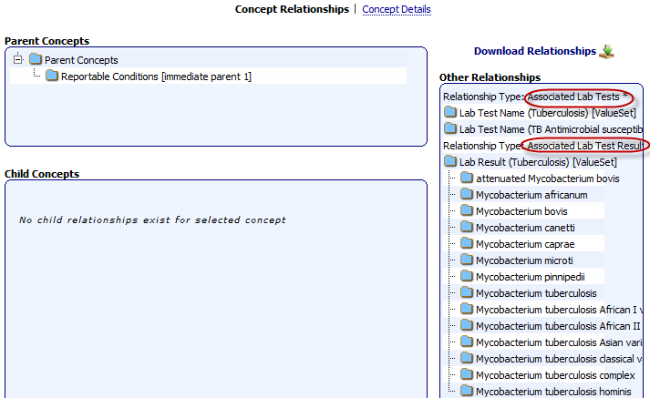

Figure 6. CDC Vocabulary Server (PHIN VADS). RCMT Tree (Navigator) e.g: Tuberculosis

Table 3. Relationships - Condition and Lab Tests/Results (RCMT excel format)

|  |  |  |  |  |  |
| --- | --- | --- | --- | --- | --- |
| **Notifiable Event (Disease/Condition) Code list: Tuberculosis** | | | |  |  |
| **Concept Code 1** | **Concept Name 1** | **Relationship Type** | **Concept Name 2** | **Concept Code 2** | **Code System Name 2** |
| 10220 | Tuberculosis | Associated Lab Test Results | Attenuated Mycobacterium bovis (organism) | 33610009 | SNOMED-CT |
| 10220 | Tuberculosis | Associated Lab Test Results | Mycobacterium africanum (organism) | 51320008 | SNOMED-CT |
| 10220 | Tuberculosis | Associated Lab Test Results | Mycobacterium bovis (organism) | 27142009 | SNOMED-CT |
| 10220 | Tuberculosis | Associated Lab Test Results | Mycobacterium canetti (organism) | 414789006 | SNOMED-CT |
| 10220 | Tuberculosis | Associated Lab Test Results | Mycobacterium caprae (organism) | 430579009 | SNOMED-CT |
| 10220 | Tuberculosis | Associated Lab Test Results | Mycobacterium microti (organism) | 70801007 | SNOMED-CT |
| 10220 | Tuberculosis | Associated Lab Test Results | Mycobacterium pinnipedii (organism) | 430914003 | SNOMED-CT |
| 10220 | Tuberculosis | Associated Lab Test Results | Mycobacterium tuberculosis (organism) | 113861009 | SNOMED-CT |
| 10220 | Tuberculosis | Associated Lab Test Results | Mycobacterium tuberculosis African I variant (organism) | 243372002 | SNOMED-CT |
| 10220 | Tuberculosis | Associated Lab Test Results | Mycobacterium tuberculosis African II variant (organism) | 243373007 | SNOMED-CT |
| 10220 | Tuberculosis | Associated Lab Test Results | Mycobacterium tuberculosis Asian variant (organism) | 243371009 | SNOMED-CT |
| 10220 | Tuberculosis | Associated Lab Test Results | Mycobacterium tuberculosis classical variant (organism) | 243370005 | SNOMED-CT |
| 10220 | Tuberculosis | Associated Lab Test Results | Mycobacterium tuberculosis complex (organism) | 113858008 | SNOMED-CT |
| 10220 | Tuberculosis | Associated Lab Test Results | Mycobacterium tuberculosis hominis (organism) | 36354002 | SNOMED-CT |
| 10220 | Tuberculosis | Associated Lab Tests | Gamma interferon background Bld EIA-aCnc | 71776-9 | LOINC |
| 10220 | Tuberculosis | Associated Lab Tests | IGNF neg cntrl Bld | 74279-1 | LOINC |
| 10220 | Tuberculosis | Associated Lab Tests | M bovis Ab Ser Ql | 23239-7 | LOINC |
| 10220 | Tuberculosis | Associated Lab Tests | M bovis Ab Ser Ql EIA | 23240-5 | LOINC |
| 10220 | Tuberculosis | Associated Lab Tests | M bovis Ag Bld Ql | 23242-1 | LOINC |
| 10220 | Tuberculosis | Associated Lab Tests | M bovis Ag Tiss Ql ImStn | 23241-3 | LOINC |
| 10220 | Tuberculosis | Associated Lab Tests | M bovis tuberc IGNF Pnl Bld | 53703-5 | LOINC |
| 10220 | Tuberculosis | Associated Lab Tests | M bovis tuberc-control IGNF Bld-aCnc | 53704-3 | LOINC |
| 10220 | Tuberculosis | Associated Lab Tests | M bovis-M avium tuberc IGNF Bld-aCnc | 53702-7 | LOINC |
| 10220 | Tuberculosis | Associated Lab Tests | M tb A60 Ab Ser Ql EIA | 55224-0 | LOINC |
| 10220 | Tuberculosis | Associated Lab Tests | M tb A60 IgM Ser Ql EIA | 55223-2 | LOINC |
| 10220 | Tuberculosis | Associated Lab Tests | M TB Cmplx DNA XXX Ql PCR | 38379-4 | LOINC |
| https://phinvads.cdc.gov/vads/ViewCodeSystemConcept.action?oid=2.16.840.1.114222.4.5.277&code=10220 | | | | |  |

***EXAMPLE 2:*** CIMI (see appendix)

The Clinical Information Modeling Initiative (CIMI) is an international collaboration dedicated to improving the interoperability of healthcare information systems through shared implementable clinical information models. CIMI’s goal is to provide a common format for detailed specifications for the representation of health information content so that semantically interoperable information may be created and shared in health records, messages, and documents.

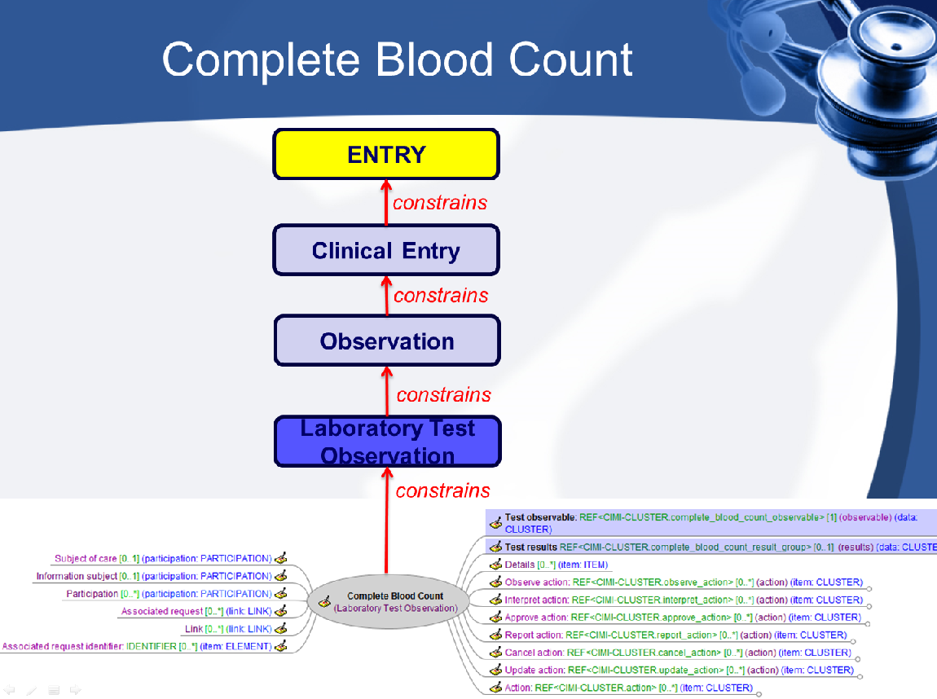

Figure 7. CIMI archetype map for laboratory results report

#### cid:image001.png@01CF8963.4A5BEDE0

Figure 8. CIMI Modelling Taskforce Report, Linda Bird

<http://www.semantichealthnet.eu/index.cfm/semantichealthnet-wp4-cimi-joint-meeting/>

***EXAMPLE 3:*** Microorganisms

Microbiology reporting is a common example of laboratory tests that are reported with coded result values (i.e. the microorganism identified). Use of SNOMED CT to code such results enables reporting and decision support capabilities.

The table below contains a portion of the Value set for Microorganisms/Infectious agents. PHIN-VADS (CDC)

|  |  |  |  |  |
| --- | --- | --- | --- | --- |
| **Value Set Code PHVS_Microorganism_CDC** | |  |  |  |
| **Concept Code** | **Preferred Concept Name** | **Code System Name** |  |  |
| **54857005** | 63U-11 virus | SNOMED-CT |  |  |
| **66177001** | 75V-2374 virus | SNOMED-CT |  |  |
| **77627007** | 75V-2621 virus | SNOMED-CT |  |  |
| **54454006** | 78V-2441 virus | SNOMED-CT |  |  |
| **11946001** | Abadina virus | SNOMED-CT |  |  |
| **113714003** | Abiotrophia defectiva | SNOMED-CT |  |  |
| **409815006** | Abiotrophia para-adiacens | SNOMED-CT |  |  |
| **372391001** | Abiotrophia species | SNOMED-CT |  |  |
| **17822001** | Abras virus | SNOMED-CT |  |  |
| https://phinvads.cdc.gov/vads/ViewValueSet.action?id=06B09CEF-0E37-E111-A720-0050568D00F8# | | | | |

1. Specimens:

|  |
| --- |
| **Recommendation:**  Were specimen source (type, source site and collection method) is conveyed in attributes other than the test name, these values should be coded using SNOMED CT.  In particular:   * specimen type terms should be drawn from the 123038009 |Specimen| hierarchy in SNOMED CT * specimen source site terms should be drawn from the 123037004 |Body structure| hierarchy * specimen collection method terms should be drawn from the 71388002 |Procedure| hierarchy   **Explanation:**  Laboratory test names typically include the specimen (e.g. the LOINC “System”) upon which the observation was made, but some attributes about the specimen can be carried in other parts of the information or messaging model. Where such other specimen attributes are reported as coded values, they should use SNOMED CT concepts. |

***EXAMPLE 1:*** Part of the Value set for Specimen Type. PHIN-VADS (CDC)

|  |  |  |  |  |  |
| --- | --- | --- | --- | --- | --- |
| **Value Set Code NHSNSpecimenTypeCode** | |  |  |  |  |
| **Concept Code** | **Preferred Concept Name** | **Code System Name** |  |  |  |
| **258414004** | Adipose tissue sample | SNOMED-CT |  |  |  |
| **309141004** | Adrenal gland specimen | SNOMED-CT |  |  |  |
| **119373006** | Amniotic fluid specimen | SNOMED-CT |  |  |  |
| **309479002** | Artery sample | SNOMED-CT |  |  |  |
| **309493009** | Bile duct biopsy sample | SNOMED-CT |  |  |  |
| **119341000** | Bile specimen | SNOMED-CT |  |  |  |
| **309491006** | Biliary tract tissue sample | SNOMED-CT |  |  |  |
| **119297000** | Blood specimen | SNOMED-CT |  |  |  |
| **119359002** | Bone marrow specimen | SNOMED-CT |  |  |  |
| https://phinvads.cdc.gov/vads/ViewValueSet.action?id=6F61F377-E515-43D2-BFEB-4BF135244033# | | | | | |

***EXAMPLE 2:*** Specimen type and specimen source site in NAHLN messaging

The Specimen Type (SPM.4) field describes the precise nature of the entity that will be the source material for the observation. While every effort will be made to provide coded values for specimen types being used in NAHLN agent testing, there may be cases where a coded value specific to a particular specimen type is not immediately available. In these instances, an alternative coded value and description of the specimen may be sent in components 4-6 of the CWE data type. In some cases the precise term is not available in the coded reference system. In these situations, it is allowable to send the original text of the specimen description in the CWE.9 component

An example of coded value for SPM.4 is shown below:

<SPM.4>

<CWE.1>**661000009100**</CWE.1>

<CWE.2>Oropharyngeal swab</CWE.2>

<CWE.3>**SCT**</CWE.3>

<CWE.9>**OP swabs**</CWE.9>

</SPM.4>

The Specimen Source Site (SPM.8) contains an identifier for the source of the specimen (i.e the anatomical location, organ or site from which the specimen originated). This field is needed when the SNOMED specimen hierarchy does not contain a precoordinated term that adequately describes the specimen. For example, in the case where tonsillar tissue is obtained from a pig by scraping, the source would be ‘Tonsillar structure (palatine)’ In general this field is only needed when additional information about the region from where the specimen was collected is needed. For environmental specimens this field may supply additional information on where the specimen originated. In cases where the specimen and specimen source are identical, this field need not be populated.

There is no one correct answer to precisely which detail should be provided by a pre-coordinated, more specific specimen type and which with a less specific type plus a specimen source. Many specimen/source combinations could be correctly expressed either way. The NAHLN will try to provide guidance on specific testing protocols.

An example of SPM.8, used in conjunction with SPM.4 is shown below:

<SPM.4>

<CWE.1>**128168004**</CWE.1>

<CWE.2>Tissue specimen from liver</CWE.2>

<CWE.3>**SCT**</CWE.3>

</SPM.4>

<SPM.8>

<CWE.1>**89255003**</CWE.1>

<CWE.2>right lateral lobe of liver</CWE.2>

<CWE.3>**SCT**</CWE.3>

</SPM.8>

1. Animal Species/Breeds:

|  |
| --- |
| **Recommendation:**  Where there is a requirement to identify an animal species, concepts from the SNOMED CT 387961004 |Animal| hierarchy should be used. |

***EXAMPLE 1:***

Part of Value set for Animal species for animal rabies. PHIN-VADS (CDC)

|  |  |  |  |  |  |
| --- | --- | --- | --- | --- | --- |
| **Value Set Code PHVS_AnimalSpecies_AnimalRabies** | | |  |  |  |
| **Concept Code** | **Preferred Concept Name** | **Code System Name** |  |  |  |
| **77108002** | Alopex lagopus | SNOMED-CT |  |  |  |
| **68014009** | Canis familiaris | SNOMED-CT |  |  |  |
| **8909006** | Canis latrans | SNOMED-CT |  |  |  |
| **68552000** | Caprine species | SNOMED-CT |  |  |  |
| **257529001** | Cow | SNOMED-CT |  |  |  |
| **26570006** | Equine species | SNOMED-CT |  |  |  |
| **125085001** | Equus asinus asinus | SNOMED-CT |  |  |  |
| **107003000** | Family cervidae | SNOMED-CT |  |  |  |
| https://phinvads.cdc.gov/vads/ViewValueSet.action?id=F9D34BBC-617F-DD11-B38D-00188B398520# | | | | | |

1. Procedures (laboratory methods):

|  |
| --- |
| **Recommendation:**  Where it is useful to code more specific information about testing method to a more granular level than what is contained in the test name, such details should be coded with SNOMED CT. |

***EXAMPLES:***

In Bio-surveillance, specific test methods can be populated with SNOMED (Anti-microbial susceptibility test methods or Varicella lab test method) in HL7 (specimen collection method) or CDC Code system for laboratory test method identifier.

Value set for anti-microbial Susceptibility test methods for invasive Pneumococcal disease. PHIN-VADS (CDC)

|  |  |  |  |
| --- | --- | --- | --- |
| **Value Set Code PHVS_AntimicrobialSuceptiblilityTestMethod_IPD** | |  |  |
| **Concept Code** | **Concept Name** | **Preferred Concept Name** | **Code System Name** |
| **104232004** | Antibiotic sensitivity, agar diffusion method (procedure) | AGAR | SNOMED-CT |
| **39334004** | Broth microdilution susceptibility test (procedure) | BROTH | SNOMED-CT |
| **359872008** | Disk diffusion susceptibility test (procedure) | DISK | SNOMED-CT |
| **104234003** | Gradient strip susceptibility test (procedure) | STRIP | SNOMED-CT |
| https://phinvads.cdc.gov/vads/ViewValueSet.action?id=515EF9FD-212B-DF11-B334-0015173D1785# | | |  |

Value set for Varicella lab testing. PHIN-VADS (CDC)

|  |  |  |  |  |  |
| --- | --- | --- | --- | --- | --- |
| **Value Set Code PHVS_LabTestMethod_VZ** | |  |  |  |  |
| **Concept Code** | **Preferred Concept Name** | **Code System Name** |  |  |  |
| **73512001** | Electron microscopic study | SNOMED-CT |  |  |  |
| **84095005** | Tzanck smear method | SNOMED-CT |  |  |  |
| https://phinvads.cdc.gov/vads/ViewValueSet.action?id=DB645D26-69A0-DD11-8A3F-00188B398520# | | | | | |

## Practical uses of Part Maps and Expression Associations

***Example 1***

#### Intro:

A GP needs to confirm a diagnosis of Pulmonary Tuberculosis. To do so, launches a query in order to obtain all the related lab tests.

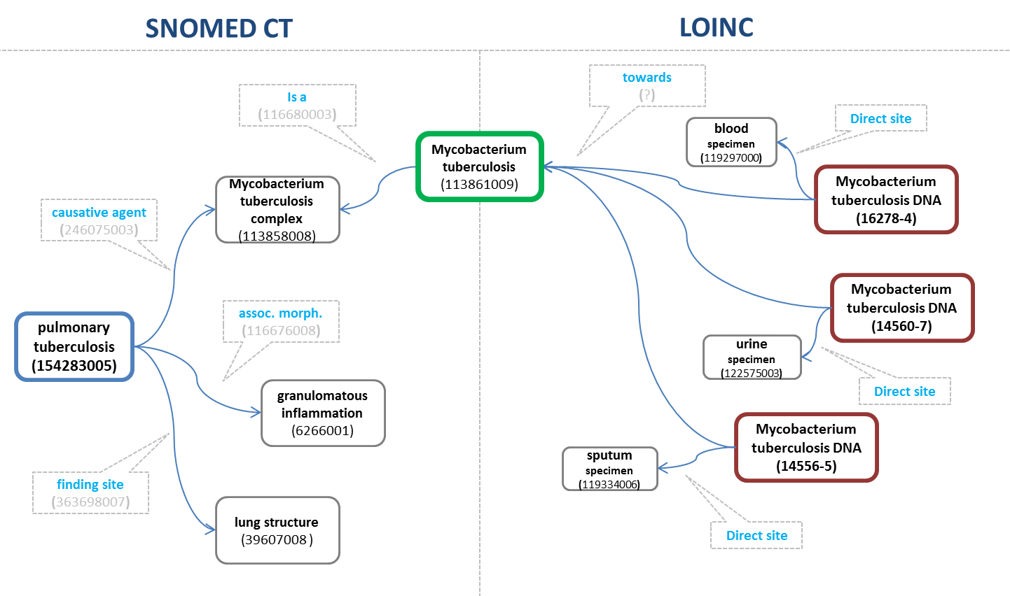

Figure 9. Link between causative agent organism and tests for organisms

#### Conclusions:

System retrieves all those clinical lab tests which component (towards) is related to the causative agent of the disease.

It is possible to refine the selection by considering the relationship between the disease finding site and the specimen source topography.

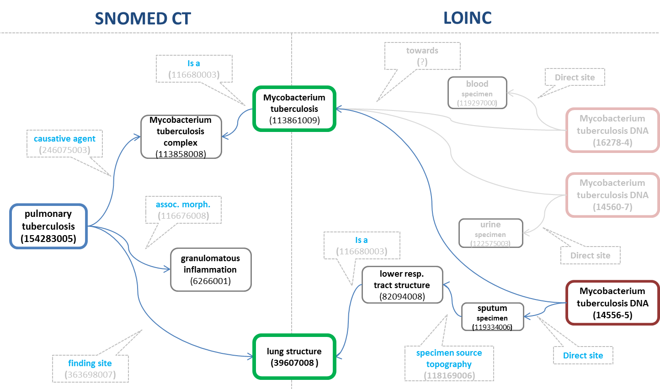

Figure 10. Link between finding site of disorder and specimen

### **Example 2**

#### Intro:

A GP needs to check vaccinations status level for rubella and queries the system for which lab tests are related.

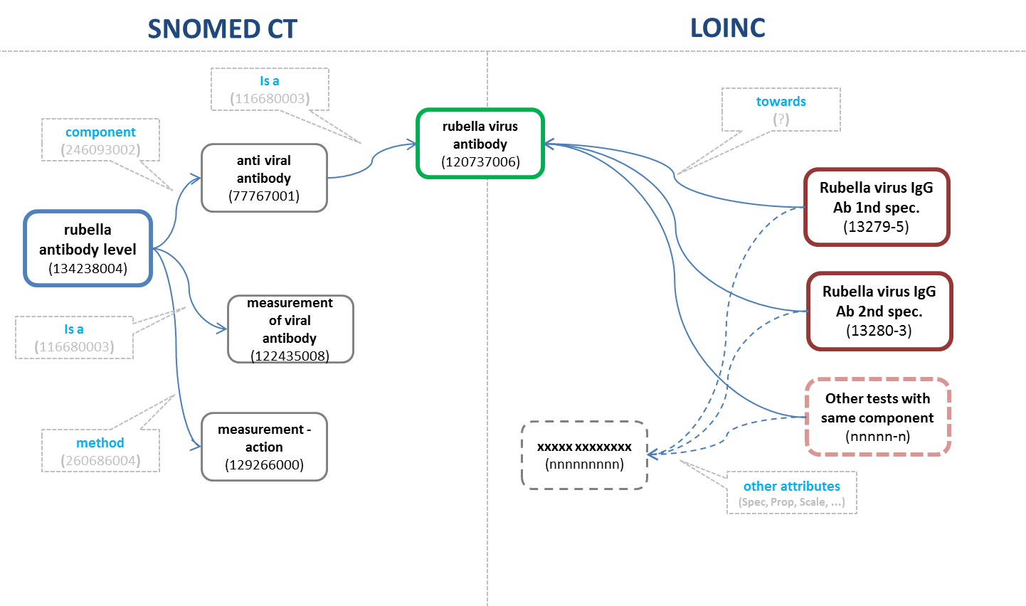

Figure 11. Link between antibody in SNOMED CT and LOINC

#### Conclusions:

System retrieves all those clinical lab tests which component (towards) is equivalent to the component of the evaluation procedure.

#### Example 3

#### Intro:

A GP needs to confirm a diagnosis of Hemochromatosis. To do so, launches a query in order to obtain related lab tests.

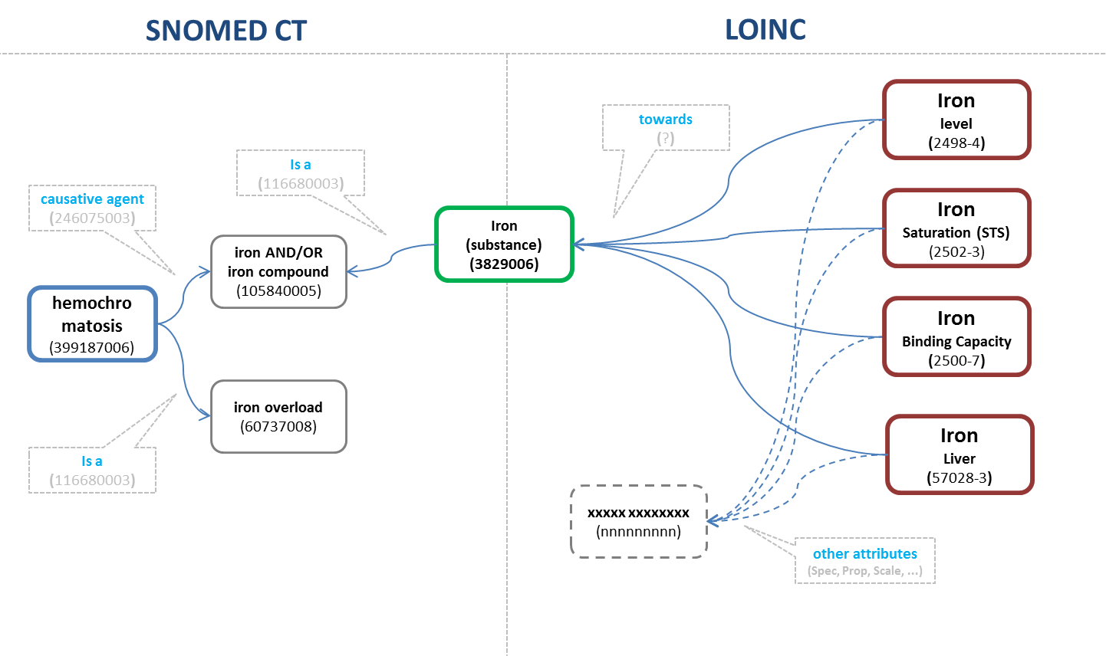

Figure 12. Link between substance in SNOMED CT and measurement in LOINC

#### Conclusions:

System retrieves all those clinical lab tests which component (towards) is related to the causative agent of the disease.

The semantic net shown in the previous graphics, could be used as a basis for decision algorithm optimization as shown in Figure 13

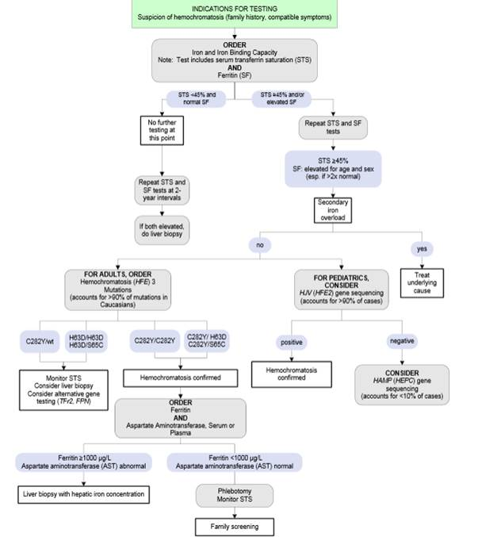Figure 13 ARUP HFE decision algorithm

### **Example 4** Illustrations of implementation of LOINC and SNOMED CT in the interface between laboratory data and EHR[1].

|  |  |
| --- | --- |
| This diagram illustrates a general case of a laboratory test on two specimens (coded with SNOMED CT) and test profiles containing four tests (coded using LOINC) two of which are applied to each of these specimens. |  |
| This diagram illustrates an anatomical pathology test for a specimen (e.g. a biopsy) taken from a particular site. Both the specimen type and site are coded using SNOMED CT. In this case the test is coded using LOINC and the diagnosis arising from the interpretation of the test result is coded using SNOMED CT.  Although not shown in this illustration, specific pathological findings leading to the diagnosis could also be coded using SNOMED CT. |  |
| This diagram outlines a recommended approach to representing a structured microbiology report using SNOMED CT and LOINC for different elements. |  |
| This diagram illustrates relationships between EHR entries coded using SNOMED CT and a microbiology report coded using the mixture of LOINC and SNOMED shown above.  In one case the link between organisms is simple, since both elements are coded using SNOMED CT. In the other the use of LOINC to represent a sensitivity test has an indirect link to a pharmaceutical product which contains that antibiotic. The latter in this case is represented using SNOMED CT. |  |

# REFERENCES

The following references identify sources of information related to the guidelines in this document. The materials provide examples of current use of SNOMED CT and LOINC together. Further detail about these and other examples were included in the report of the horizon scan which formed the first part of this study.

**REFERENCES**

## SOURCES USED FOR INFORMATION ON CDC

<https://www.cdc.gov/>

<https://phinvads.cdc.gov/vads/SearchVocab.action/>

PHIN VADS 3.3.4. Release Notes

<http://www.phconnect.org/group/rcmt>

## SOURCES USED FOR INFORMATION ON NAHLN

NAHLN Terminology services

<http://vtsl.vetmed.vt.edu/nahln/main.cfm>

<http://vtsl.vetmed.vt.edu/nahln/main.cfm?page=subset&subset=universal_service_id>

NAHLN HL7 Implementation Guide For Laboratory Results Messaging (Document version 3.0)

<http://vtsl.vetmed.vt.edu/nahln/main.cfm>

Clinical LOINC tutorial - Introductions. 2009.

<http://es.slideshare.net/dvreeman/2009-08-13-clinical-loinc-tutorial-introductions-and-foundations>

HL7 Version 2.5.1 Implementation Guide: Electronic Laboratory Reporting to Public Health, Release 2 - US Realm

<http://www.hl7.org/implement/standards/product_brief.cfm?product_id=329>

## SOURCES USED FOR INFORMATION ON CIMI

**CIMI History and Overview**

3/11/2014

Version 1.0

<http://www.semantichealthnet.eu/SemanticHealthNet/assets/File/CIMI%20Background%202014%2003%2010.pdf>

**SNOMED CT Binding Strategy for CIMI Models**

Cambridge, MA

September 21, 2013

Stanley M Huff, MD

Chief Medical Informatics Officer

**A Brief Review of CIMI Progress, Plans, and Goals**

Joint CIMI and SemanticHealthNet Meeting

Brussels, Belgium

March 13, 2014

Stanley M Huff, MD

Chief Medical Informatics Officer

<http://www.opencimi.org/node/96>

**CIMI Modelling Taskforce Report**

Joint CIMI and SemanticHealthNet Meeting

Brussels, Belgium

March 14, 2014

Linda Bird

<http://informatics.mayo.edu/CIMI/index.php/SHN_CIMI/Brussels_March_13-15,_2014>

## SOURCES USED FOR INFORMATION ON HEALTH LEVEL SEVEN

**Health Level Seven International**

<http://www.hl7.org/implement/standards/index.cfm?ref=nav>

**HL7 Version 2.5.1 Implementation Guide: Electronic Laboratory Reporting to Public Health, Release 1 (US Realm), 2010**

<http://www.hl7.org/implement/standards/product_brief.cfm?product_id=98>

**HL7 Version 2.5.1 Implementation Guide: Electronic Laboratory Reporting to Public Health, Release 2 (US Realm), 2014**

<http://www.hl7.org/implement/standards/product_brief.cfm?product_id=329>

**HL7 Version 2.5.1 Implementation Guide: Orders and Observations; Ambulatory Lab Result (ELINCS), Release 1, 2008**

<http://www.hl7.org/implement/standards/product_brief.cfm?product_id=31>

**HL7 Version 2.5.1 Implementation Guide: Orders and Observations; Interoperable Laboratory Result Reporting to EHR, Release 1, 2007**

<http://www.hl7.org/implement/standards/product_brief.cfm?product_id=94>

**HL7 Version 2.5.1 Implementation Guide: S&I Framework Lab Results Interface, Release 1- US Realm, 2012**

<http://www.hl7.org/implement/standards/product_brief.cfm?product_id=279>

**HL7 Version 2.5.1 Implementation Guide: S&I Framework Laboratory Orders from EHR, Release 1 - US Realm, 2013**

<http://www.hl7.org/implement/standards/product_brief.cfm?product_id=152>

1. The diagrams here are based on illustrations used in presentation by Hong Kong Hospital Authority (HKHA) as part of their work on matching their requirements to a combination of SNOMED CT and LOINC coding.