Chapter 3 Exercise 3.1

Group 3

6/3/2020

library(caret)

## Loading required package: lattice

## Loading required package: ggplot2

library(tidyverse)

## -- Attaching packages ----------------------------------------------- tidyverse 1.2.1 --

## v tibble 2.1.3 v purrr 0.3.2  
## v tidyr 0.8.3 v dplyr 0.8.3  
## v readr 1.3.1 v stringr 1.4.0  
## v tibble 2.1.3 v forcats 0.4.0

## -- Conflicts -------------------------------------------------- tidyverse_conflicts() --  
## x dplyr::filter() masks stats::filter()  
## x dplyr::lag() masks stats::lag()  
## x purrr::lift() masks caret::lift()

library(e1071)  
library(knitr)  
library(GGally)

## Warning: package 'GGally' was built under R version 3.6.3

## Registered S3 method overwritten by 'GGally':  
## method from   
## +.gg ggplot2

##   
## Attaching package: 'GGally'

## The following object is masked from 'package:dplyr':  
##   
## nasa

library(VIM)

## Warning: package 'VIM' was built under R version 3.6.3

## Loading required package: colorspace

## Loading required package: grid

## Loading required package: data.table

##   
## Attaching package: 'data.table'

## The following objects are masked from 'package:dplyr':  
##   
## between, first, last

## The following object is masked from 'package:purrr':  
##   
## transpose

## VIM is ready to use.   
## Since version 4.0.0 the GUI is in its own package VIMGUI.  
##   
## Please use the package to use the new (and old) GUI.

## Suggestions and bug-reports can be submitted at: https://github.com/alexkowa/VIM/issues

##   
## Attaching package: 'VIM'

## The following object is masked from 'package:datasets':  
##   
## sleep

## Exercise 3.1

3.1. The UC Irvine Machine Learning Repository6 contains a data set related to glass identification. The data consist of 214 glass samples labeled as one of seven class categories. There are nine predictors, including the refractive index and percentages of eight elements: Na, Mg, Al, Si, K, Ca, Ba, and Fe. The data can be accessed via:

library(mlbench)

## Warning: package 'mlbench' was built under R version 3.6.3

data(Glass)  
str(Glass)

## 'data.frame': 214 obs. of 10 variables:  
## $ RI : num 1.52 1.52 1.52 1.52 1.52 ...  
## $ Na : num 13.6 13.9 13.5 13.2 13.3 ...  
## $ Mg : num 4.49 3.6 3.55 3.69 3.62 3.61 3.6 3.61 3.58 3.6 ...  
## $ Al : num 1.1 1.36 1.54 1.29 1.24 1.62 1.14 1.05 1.37 1.36 ...  
## $ Si : num 71.8 72.7 73 72.6 73.1 ...  
## $ K : num 0.06 0.48 0.39 0.57 0.55 0.64 0.58 0.57 0.56 0.57 ...  
## $ Ca : num 8.75 7.83 7.78 8.22 8.07 8.07 8.17 8.24 8.3 8.4 ...  
## $ Ba : num 0 0 0 0 0 0 0 0 0 0 ...  
## $ Fe : num 0 0 0 0 0 0.26 0 0 0 0.11 ...  
## $ Type: Factor w/ 6 levels "1","2","3","5",..: 1 1 1 1 1 1 1 1 1 1 ...

The structure of the Glass data shows that all the predictors are numeric. The dependent variable is factor of 6 levels.

head(Glass)

## RI Na Mg Al Si K Ca Ba Fe Type  
## 1 1.52101 13.64 4.49 1.10 71.78 0.06 8.75 0 0.00 1  
## 2 1.51761 13.89 3.60 1.36 72.73 0.48 7.83 0 0.00 1  
## 3 1.51618 13.53 3.55 1.54 72.99 0.39 7.78 0 0.00 1  
## 4 1.51766 13.21 3.69 1.29 72.61 0.57 8.22 0 0.00 1  
## 5 1.51742 13.27 3.62 1.24 73.08 0.55 8.07 0 0.00 1  
## 6 1.51596 12.79 3.61 1.62 72.97 0.64 8.07 0 0.26 1

The head function displays the first values of each variables.

### (a) Using visualizations, explore the predictor variables to understand their

### distributions as well as the relationships between predictors.

We remove the target variable

glass.predictors <- Glass[,-10]

Since all variables are numerical, we can use the skewness function of e1071 to estimated the predictors to represent.

library(e1071)  
skewValues <- apply(glass.predictors, 2, skewness)  
skewValues

## RI Na Mg Al Si K   
## 1.6027151 0.4478343 -1.1364523 0.8946104 -0.7202392 6.4600889   
## Ca Ba Fe   
## 2.0184463 3.3686800 1.7298107

par(mfrow = c(3,3))  
hist(x = glass.predictors$RI)  
hist(x = glass.predictors$Na)  
hist(x = glass.predictors$Mg)  
hist(x = glass.predictors$Al)  
hist(x = glass.predictors$Si)  
hist(x = glass.predictors$K)  
hist(x = glass.predictors$Ca)  
hist(x = glass.predictors$Ba)  
hist(x = glass.predictors$Fe)

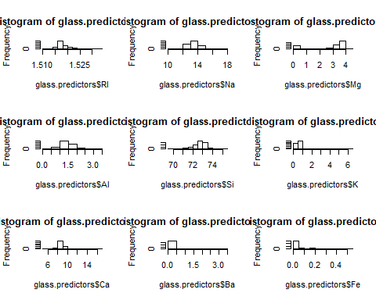

The predictors RI, Na, Al, Si and Ca are normal distributed The predictors K, Ba, and Fe are rigtht skewed. we can aplied the log function on those variable to normalise or Boxcox to centralise, scale and transform.

The Mg predictor need to be centralise and scale. It is neither normal, nor skewed.

### (b) Do there appear to be any outliers in the data? Are any predictors skewed?

Looking for outliers

par(mfrow = c(3,3))  
boxplot(x = glass.predictors$RI, main = "RI")  
boxplot(x = glass.predictors$Na, main = "Na")  
boxplot(x = glass.predictors$Mg, main = "Mg")  
boxplot(x = glass.predictors$Al, main = "Al")  
boxplot(x = glass.predictors$Si, main = "Si")  
boxplot(x = glass.predictors$K, main = "K")  
boxplot(x = glass.predictors$Ca, main = "Ca")  
boxplot(x = glass.predictors$Ba, main = "Ba")  
boxplot(x = glass.predictors$Fe, main = "Fe")

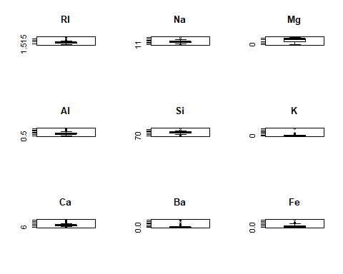

The boxplot graphs shows some outliers with the predictors RI, Na, Al, Si, K, Ca, Ba, and Fe. The outlier of Ba and K are extreme.

summary(glass.predictors)

## RI Na Mg Al   
## Min. :1.511 Min. :10.73 Min. :0.000 Min. :0.290   
## 1st Qu.:1.517 1st Qu.:12.91 1st Qu.:2.115 1st Qu.:1.190   
## Median :1.518 Median :13.30 Median :3.480 Median :1.360   
## Mean :1.518 Mean :13.41 Mean :2.685 Mean :1.445   
## 3rd Qu.:1.519 3rd Qu.:13.82 3rd Qu.:3.600 3rd Qu.:1.630   
## Max. :1.534 Max. :17.38 Max. :4.490 Max. :3.500   
## Si K Ca Ba   
## Min. :69.81 Min. :0.0000 Min. : 5.430 Min. :0.000   
## 1st Qu.:72.28 1st Qu.:0.1225 1st Qu.: 8.240 1st Qu.:0.000   
## Median :72.79 Median :0.5550 Median : 8.600 Median :0.000   
## Mean :72.65 Mean :0.4971 Mean : 8.957 Mean :0.175   
## 3rd Qu.:73.09 3rd Qu.:0.6100 3rd Qu.: 9.172 3rd Qu.:0.000   
## Max. :75.41 Max. :6.2100 Max. :16.190 Max. :3.150   
## Fe   
## Min. :0.00000   
## 1st Qu.:0.00000   
## Median :0.00000   
## Mean :0.05701   
## 3rd Qu.:0.10000   
## Max. :0.51000

To visualize the correlation between predictors, we use the corrplot function in the package of the same name.

correlations <- cor(glass.predictors)  
correlations

## RI Na Mg Al Si  
## RI 1.0000000000 -0.19188538 -0.122274039 -0.40732603 -0.54205220  
## Na -0.1918853790 1.00000000 -0.273731961 0.15679367 -0.06980881  
## Mg -0.1222740393 -0.27373196 1.000000000 -0.48179851 -0.16592672  
## Al -0.4073260341 0.15679367 -0.481798509 1.00000000 -0.00552372  
## Si -0.5420521997 -0.06980881 -0.165926723 -0.00552372 1.00000000  
## K -0.2898327111 -0.26608650 0.005395667 0.32595845 -0.19333085  
## Ca 0.8104026963 -0.27544249 -0.443750026 -0.25959201 -0.20873215  
## Ba -0.0003860189 0.32660288 -0.492262118 0.47940390 -0.10215131  
## Fe 0.1430096093 -0.24134641 0.083059529 -0.07440215 -0.09420073  
## K Ca Ba Fe  
## RI -0.289832711 0.8104027 -0.0003860189 0.143009609  
## Na -0.266086504 -0.2754425 0.3266028795 -0.241346411  
## Mg 0.005395667 -0.4437500 -0.4922621178 0.083059529  
## Al 0.325958446 -0.2595920 0.4794039017 -0.074402151  
## Si -0.193330854 -0.2087322 -0.1021513105 -0.094200731  
## K 1.000000000 -0.3178362 -0.0426180594 -0.007719049  
## Ca -0.317836155 1.0000000 -0.1128409671 0.124968219  
## Ba -0.042618059 -0.1128410 1.0000000000 -0.058691755  
## Fe -0.007719049 0.1249682 -0.0586917554 1.000000000

library(corrplot)

## Warning: package 'corrplot' was built under R version 3.6.3

## corrplot 0.84 loaded

corrplot(correlations, order = "hclust")

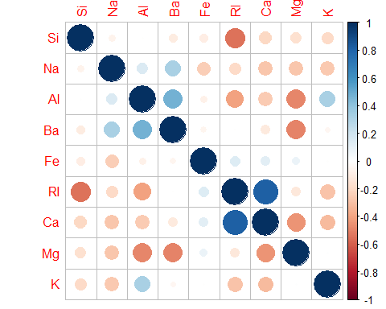

GGally::ggpairs(as.data.frame(glass.predictors))

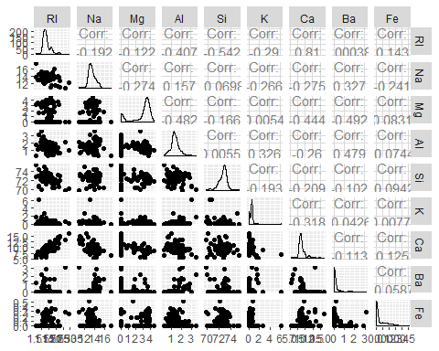

The only notable correlation is between RI and Ca.

### (c) Are there any relevant transformations of one or more predictors that

### might improve the classification model?

We use the powerTransform of the car package that calculates the Box-Cox transformation. The Box-Cox transformation uses the maximum likelihood approach and returns information on the estimated values along with convenient rounded values that are within 1.96 standard deviations of the maximum likelihood estimate.

library(car)

## Warning: package 'car' was built under R version 3.6.3

## Loading required package: carData

## Warning: package 'carData' was built under R version 3.6.3

##   
## Attaching package: 'car'

## The following object is masked from 'package:dplyr':  
##   
## recode

## The following object is masked from 'package:purrr':  
##   
## some

summary(powerTransform(Glass[,1:9], family="yjPower"))$result[,1:2]

## Est Power Rounded Pwr  
## RI -25.0853114 -25.09  
## Na 1.3755562 1.00  
## Mg 1.7699080 2.00  
## Al 0.9773267 1.00  
## Si 10.9452696 10.95  
## K -0.1441078 0.00  
## Ca 0.6774333 0.50  
## Ba -6.8620464 -6.86  
## Fe -14.9245600 -14.92

The suggested transformations are:

No transformation for RI, Na, Si, and K since λ=1. Log transformations for Mg, K, Ba, and Fe since λ≈0. Square root transformation for Ca since λ=0.5.

## Exercise 3.2.

3.2. The soybean data can also be found at the UC Irvine Machine Learning Repository. Data were collected to predict disease in 683 soybeans. The 35 predictors are mostly categorical and include information on the environmental conditions (e.g., temperature, precipitation) and plant conditions (e.g., left spots, mold growth). The outcome labels consist of 19 distinct classes.

The data can be loaded via:

library(mlbench)  
data(Soybean)  
## See ?Soybean for details  
str(Soybean)

## 'data.frame': 683 obs. of 36 variables:  
## $ Class : Factor w/ 19 levels "2-4-d-injury",..: 11 11 11 11 11 11 11 11 11 11 ...  
## $ date : Factor w/ 7 levels "0","1","2","3",..: 7 5 4 4 7 6 6 5 7 5 ...  
## $ plant.stand : Ord.factor w/ 2 levels "0"<"1": 1 1 1 1 1 1 1 1 1 1 ...  
## $ precip : Ord.factor w/ 3 levels "0"<"1"<"2": 3 3 3 3 3 3 3 3 3 3 ...  
## $ temp : Ord.factor w/ 3 levels "0"<"1"<"2": 2 2 2 2 2 2 2 2 2 2 ...  
## $ hail : Factor w/ 2 levels "0","1": 1 1 1 1 1 1 1 2 1 1 ...  
## $ crop.hist : Factor w/ 4 levels "0","1","2","3": 2 3 2 2 3 4 3 2 4 3 ...  
## $ area.dam : Factor w/ 4 levels "0","1","2","3": 2 1 1 1 1 1 1 1 1 1 ...  
## $ sever : Factor w/ 3 levels "0","1","2": 2 3 3 3 2 2 2 2 2 3 ...  
## $ seed.tmt : Factor w/ 3 levels "0","1","2": 1 2 2 1 1 1 2 1 2 1 ...  
## $ germ : Ord.factor w/ 3 levels "0"<"1"<"2": 1 2 3 2 3 2 1 3 2 3 ...  
## $ plant.growth : Factor w/ 2 levels "0","1": 2 2 2 2 2 2 2 2 2 2 ...  
## $ leaves : Factor w/ 2 levels "0","1": 2 2 2 2 2 2 2 2 2 2 ...  
## $ leaf.halo : Factor w/ 3 levels "0","1","2": 1 1 1 1 1 1 1 1 1 1 ...  
## $ leaf.marg : Factor w/ 3 levels "0","1","2": 3 3 3 3 3 3 3 3 3 3 ...  
## $ leaf.size : Ord.factor w/ 3 levels "0"<"1"<"2": 3 3 3 3 3 3 3 3 3 3 ...  
## $ leaf.shread : Factor w/ 2 levels "0","1": 1 1 1 1 1 1 1 1 1 1 ...  
## $ leaf.malf : Factor w/ 2 levels "0","1": 1 1 1 1 1 1 1 1 1 1 ...  
## $ leaf.mild : Factor w/ 3 levels "0","1","2": 1 1 1 1 1 1 1 1 1 1 ...  
## $ stem : Factor w/ 2 levels "0","1": 2 2 2 2 2 2 2 2 2 2 ...  
## $ lodging : Factor w/ 2 levels "0","1": 2 1 1 1 1 1 2 1 1 1 ...  
## $ stem.cankers : Factor w/ 4 levels "0","1","2","3": 4 4 4 4 4 4 4 4 4 4 ...  
## $ canker.lesion : Factor w/ 4 levels "0","1","2","3": 2 2 1 1 2 1 2 2 2 2 ...  
## $ fruiting.bodies: Factor w/ 2 levels "0","1": 2 2 2 2 2 2 2 2 2 2 ...  
## $ ext.decay : Factor w/ 3 levels "0","1","2": 2 2 2 2 2 2 2 2 2 2 ...  
## $ mycelium : Factor w/ 2 levels "0","1": 1 1 1 1 1 1 1 1 1 1 ...  
## $ int.discolor : Factor w/ 3 levels "0","1","2": 1 1 1 1 1 1 1 1 1 1 ...  
## $ sclerotia : Factor w/ 2 levels "0","1": 1 1 1 1 1 1 1 1 1 1 ...  
## $ fruit.pods : Factor w/ 4 levels "0","1","2","3": 1 1 1 1 1 1 1 1 1 1 ...  
## $ fruit.spots : Factor w/ 4 levels "0","1","2","4": 4 4 4 4 4 4 4 4 4 4 ...  
## $ seed : Factor w/ 2 levels "0","1": 1 1 1 1 1 1 1 1 1 1 ...  
## $ mold.growth : Factor w/ 2 levels "0","1": 1 1 1 1 1 1 1 1 1 1 ...  
## $ seed.discolor : Factor w/ 2 levels "0","1": 1 1 1 1 1 1 1 1 1 1 ...  
## $ seed.size : Factor w/ 2 levels "0","1": 1 1 1 1 1 1 1 1 1 1 ...  
## $ shriveling : Factor w/ 2 levels "0","1": 1 1 1 1 1 1 1 1 1 1 ...  
## $ roots : Factor w/ 3 levels "0","1","2": 1 1 1 1 1 1 1 1 1 1 ...

All variables are factors or ordered factors.

head(Soybean)

## Class date plant.stand precip temp hail crop.hist  
## 1 diaporthe-stem-canker 6 0 2 1 0 1  
## 2 diaporthe-stem-canker 4 0 2 1 0 2  
## 3 diaporthe-stem-canker 3 0 2 1 0 1  
## 4 diaporthe-stem-canker 3 0 2 1 0 1  
## 5 diaporthe-stem-canker 6 0 2 1 0 2  
## 6 diaporthe-stem-canker 5 0 2 1 0 3  
## area.dam sever seed.tmt germ plant.growth leaves leaf.halo leaf.marg  
## 1 1 1 0 0 1 1 0 2  
## 2 0 2 1 1 1 1 0 2  
## 3 0 2 1 2 1 1 0 2  
## 4 0 2 0 1 1 1 0 2  
## 5 0 1 0 2 1 1 0 2  
## 6 0 1 0 1 1 1 0 2  
## leaf.size leaf.shread leaf.malf leaf.mild stem lodging stem.cankers  
## 1 2 0 0 0 1 1 3  
## 2 2 0 0 0 1 0 3  
## 3 2 0 0 0 1 0 3  
## 4 2 0 0 0 1 0 3  
## 5 2 0 0 0 1 0 3  
## 6 2 0 0 0 1 0 3  
## canker.lesion fruiting.bodies ext.decay mycelium int.discolor sclerotia  
## 1 1 1 1 0 0 0  
## 2 1 1 1 0 0 0  
## 3 0 1 1 0 0 0  
## 4 0 1 1 0 0 0  
## 5 1 1 1 0 0 0  
## 6 0 1 1 0 0 0  
## fruit.pods fruit.spots seed mold.growth seed.discolor seed.size  
## 1 0 4 0 0 0 0  
## 2 0 4 0 0 0 0  
## 3 0 4 0 0 0 0  
## 4 0 4 0 0 0 0  
## 5 0 4 0 0 0 0  
## 6 0 4 0 0 0 0  
## shriveling roots  
## 1 0 0  
## 2 0 0  
## 3 0 0  
## 4 0 0  
## 5 0 0  
## 6 0 0

### (a) Investigate the frequency distributions for the categorical predictors. Are

### any of the distributions degenerate in the ways discussed earlier in this

### chapter?

nearZeroVar(Soybean)

## [1] 19 26 28

#### The predictors that correspond respectively to the position of variables 19, 26, 28 in the datafarme Soybean which are degenerate, are leaf.mild, mycelium and sclerotia.

summary(Soybean)

## Class date plant.stand precip temp   
## brown-spot : 92 5 :149 0 :354 0 : 74 0 : 80   
## alternarialeaf-spot: 91 4 :131 1 :293 1 :112 1 :374   
## frog-eye-leaf-spot : 91 3 :118 NA's: 36 2 :459 2 :199   
## phytophthora-rot : 88 2 : 93 NA's: 38 NA's: 30   
## anthracnose : 44 6 : 90   
## brown-stem-rot : 44 (Other):101   
## (Other) :233 NA's : 1   
## hail crop.hist area.dam sever seed.tmt germ   
## 0 :435 0 : 65 0 :123 0 :195 0 :305 0 :165   
## 1 :127 1 :165 1 :227 1 :322 1 :222 1 :213   
## NA's:121 2 :219 2 :145 2 : 45 2 : 35 2 :193   
## 3 :218 3 :187 NA's:121 NA's:121 NA's:112   
## NA's: 16 NA's: 1   
##   
##   
## plant.growth leaves leaf.halo leaf.marg leaf.size leaf.shread  
## 0 :441 0: 77 0 :221 0 :357 0 : 51 0 :487   
## 1 :226 1:606 1 : 36 1 : 21 1 :327 1 : 96   
## NA's: 16 2 :342 2 :221 2 :221 NA's:100   
## NA's: 84 NA's: 84 NA's: 84   
##   
##   
##   
## leaf.malf leaf.mild stem lodging stem.cankers canker.lesion  
## 0 :554 0 :535 0 :296 0 :520 0 :379 0 :320   
## 1 : 45 1 : 20 1 :371 1 : 42 1 : 39 1 : 83   
## NA's: 84 2 : 20 NA's: 16 NA's:121 2 : 36 2 :177   
## NA's:108 3 :191 3 : 65   
## NA's: 38 NA's: 38   
##   
##   
## fruiting.bodies ext.decay mycelium int.discolor sclerotia fruit.pods  
## 0 :473 0 :497 0 :639 0 :581 0 :625 0 :407   
## 1 :104 1 :135 1 : 6 1 : 44 1 : 20 1 :130   
## NA's:106 2 : 13 NA's: 38 2 : 20 NA's: 38 2 : 14   
## NA's: 38 NA's: 38 3 : 48   
## NA's: 84   
##   
##   
## fruit.spots seed mold.growth seed.discolor seed.size shriveling  
## 0 :345 0 :476 0 :524 0 :513 0 :532 0 :539   
## 1 : 75 1 :115 1 : 67 1 : 64 1 : 59 1 : 38   
## 2 : 57 NA's: 92 NA's: 92 NA's:106 NA's: 92 NA's:106   
## 4 :100   
## NA's:106   
##   
##   
## roots   
## 0 :551   
## 1 : 86   
## 2 : 15   
## NA's: 31   
##   
##   
##

Using the summary of Soybean, the fraction of unique values over the sample size of the predictors is low. There are 2, 3,0r 4 unique values over 683 observations.

The predictors leaf.mild, mycelium and sclerotia have the ratio of the frequency the most prevalent value to the frequency of the second most prevalent very large.

imbalance.leaf.mild = 535/20  
imbalance.leaf.mild

## [1] 26.75

imbalance.mycelium = 639/6  
imbalance.mycelium

## [1] 106.5

imbalance.sclerotia = 625/20  
imbalance.sclerotia

## [1] 31.25

##### The three predictors have a very strong imbalance. These are near-zero variance predictors

We can observe these large imbalance between uniques values in the plots below.

par(mfrow = c(3,3))  
plot(x = Soybean$leaves) + title(main = 'leaves')

## numeric(0)

plot(x = Soybean$leaf.malf) + title(main = 'leaf.malf')

## numeric(0)

plot(x = Soybean$leaf.mild) + title(main = 'leaf.mild')

## numeric(0)

plot(x = Soybean$lodging) + title(main = 'lodging')

## numeric(0)

plot(x = Soybean$mycelium) + title(main = 'mycelium')

## numeric(0)

plot(x = Soybean$int.discolor)+ title(main = 'int.discolor')

## numeric(0)

plot(x = Soybean$sclerotia) + title(main = 'sclerotia')

## numeric(0)

plot(x = Soybean$seed.size) + title(main = 'seed.size')

## numeric(0)

plot(x = Soybean$shriveling) + title(main = 'shriveling')

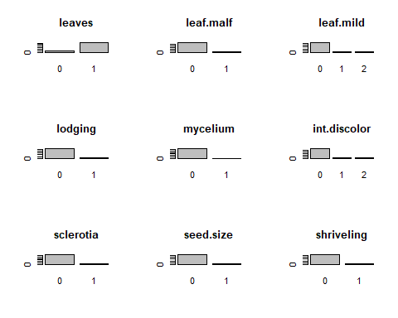

## numeric(0)

### (b) Roughly 18% of the data are missing. Are there particular predictors that

### are more likely to be missing? Is the pattern of missing data related to

### the classes?

Obsevation of missing values

colSums(is.na(Soybean))

## Class date plant.stand precip   
## 0 1 36 38   
## temp hail crop.hist area.dam   
## 30 121 16 1   
## sever seed.tmt germ plant.growth   
## 121 121 112 16   
## leaves leaf.halo leaf.marg leaf.size   
## 0 84 84 84   
## leaf.shread leaf.malf leaf.mild stem   
## 100 84 108 16   
## lodging stem.cankers canker.lesion fruiting.bodies   
## 121 38 38 106   
## ext.decay mycelium int.discolor sclerotia   
## 38 38 38 38   
## fruit.pods fruit.spots seed mold.growth   
## 84 106 92 92   
## seed.discolor seed.size shriveling roots   
## 106 92 106 31

The aggr function in the VIM package plots and calculates the amount of missing values in each variable. The dply function is useful for wrangling data into aggregate summaries and is used to find the pattern of missing data related to the classes.

aggr(Soybean, prop = c(TRUE, TRUE), bars=TRUE, numbers=TRUE, sortVars=TRUE)

## Warning in plot.aggr(res, ...): not enough horizontal space to display  
## frequencies

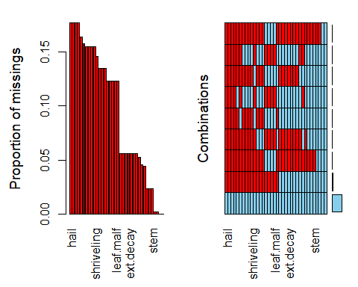

##   
## Variables sorted by number of missings:   
## Variable Count  
## hail 0.177159590  
## sever 0.177159590  
## seed.tmt 0.177159590  
## lodging 0.177159590  
## germ 0.163982430  
## leaf.mild 0.158125915  
## fruiting.bodies 0.155197657  
## fruit.spots 0.155197657  
## seed.discolor 0.155197657  
## shriveling 0.155197657  
## leaf.shread 0.146412884  
## seed 0.134699854  
## mold.growth 0.134699854  
## seed.size 0.134699854  
## leaf.halo 0.122986823  
## leaf.marg 0.122986823  
## leaf.size 0.122986823  
## leaf.malf 0.122986823  
## fruit.pods 0.122986823  
## precip 0.055636896  
## stem.cankers 0.055636896  
## canker.lesion 0.055636896  
## ext.decay 0.055636896  
## mycelium 0.055636896  
## int.discolor 0.055636896  
## sclerotia 0.055636896  
## plant.stand 0.052708638  
## roots 0.045387994  
## temp 0.043923865  
## crop.hist 0.023426061  
## plant.growth 0.023426061  
## stem 0.023426061  
## date 0.001464129  
## area.dam 0.001464129  
## Class 0.000000000  
## leaves 0.000000000

The table above and the histograms show that the predictors hail, sever, seed.tmt, and lodging have around 18% of missing data. Other variables that are more likely to be missing are germ(16% of missing values), leaf.mild(16%),fruiting.bodies(15%), fruits.spots(15%), seed.discolor(15%), and shriveling(15%). The grid shows the combination of all with 82% of data not missing in accordance with the problem description (18% missing). The remainder of the grid shows missing data for variable combinations with each row highlighting the missing values for the group of variables detailed in the x-axis. The non-graphical output of the function shows the exact proportion of missing values per variable.

### Looking for pattern in missing data by classes

Soybean %>%  
 mutate(Total = n()) %>%   
 filter(!complete.cases(.)) %>%  
 group_by(Class) %>%  
 mutate(Missing = n(), Proportion=Missing/Total) %>%  
 select(Class, Missing, Proportion) %>%  
 unique()

## # A tibble: 5 x 3  
## # Groups: Class [5]  
## Class Missing Proportion  
## <fct> <int> <dbl>  
## 1 phytophthora-rot 68 0.0996  
## 2 diaporthe-pod-&-stem-blight 15 0.0220  
## 3 cyst-nematode 14 0.0205  
## 4 2-4-d-injury 16 0.0234  
## 5 herbicide-injury 8 0.0117

Interpretation Checking if a pattern of missing data related to the classes exists is done by checking if some classes hold most of the incomplete cases. This is accomplished by filtering, grouping, and mutating the data with dplyr. The majority of the missing values are in the phytophthora-rot class which has nearly 10% incomplete cases. The are only four more, out of the eighteen other, variables with incomplete cases. The pattern of missing data is related to the classes. Mostly the phytophthora-rot class however since the other four variables only have between 1% and 2% incomplete cases.

1. Develop a strategy for handling missing data, either by eliminating predictors or imputation.

The strategy to handle missing data is by using the predictive mean matching method of the mice function to imput data. Next, we create a complete dataset with the function complete() We can previous the new dataset fro missing values with aggr from VIM package

library(mice)

## Warning: package 'mice' was built under R version 3.6.3

##   
## Attaching package: 'mice'

## The following objects are masked from 'package:base':  
##   
## cbind, rbind

MICE <- mice(Soybean, method="pmm", printFlag=FALSE, seed=6)

## Warning: Number of logged events: 1665

aggr(complete(MICE), prop = c(TRUE, TRUE), bars=TRUE, numbers=TRUE, sortVars=TRUE)

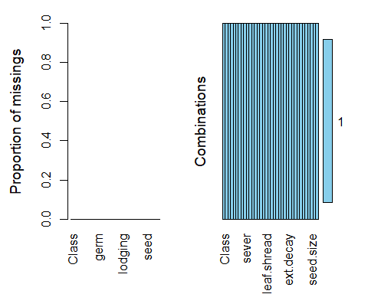

##   
## Variables sorted by number of missings:   
## Variable Count  
## Class 0  
## date 0  
## plant.stand 0  
## precip 0  
## temp 0  
## hail 0  
## crop.hist 0  
## area.dam 0  
## sever 0  
## seed.tmt 0  
## germ 0  
## plant.growth 0  
## leaves 0  
## leaf.halo 0  
## leaf.marg 0  
## leaf.size 0  
## leaf.shread 0  
## leaf.malf 0  
## leaf.mild 0  
## stem 0  
## lodging 0  
## stem.cankers 0  
## canker.lesion 0  
## fruiting.bodies 0  
## ext.decay 0  
## mycelium 0  
## int.discolor 0  
## sclerotia 0  
## fruit.pods 0  
## fruit.spots 0  
## seed 0  
## mold.growth 0  
## seed.discolor 0  
## seed.size 0  
## shriveling 0  
## roots 0

The strategy we use to deal with missing data is the simple imputation method that uses predictive mean matching (pmm) and “imputes missing values by means of the nearest-neighbor donor with distance based on the expected values of the missing variables conditional on the observed covariates.”

After applying the mice function, we realise that there are no missing values in any variable.

### References

<https://www.otexts.org/fpp/>

<https://rpubs.com/josezuniga/358605>

<https://rpubs.com/josezuniga/253955>

<https://rpubs.com/josezuniga/269297>

<http://appliedpredictivemodeling.com/>