Alain Nshimirimana

Color report

07/30/19

**Questions**

1. What’s the difference between “warm” and “cool” colors?

Warm colors tend to make you think of warm things such as sunlight and heat. They also heighten someone’s emotions, both positive and negative emotions. Warm colors appear to be more active and in the foreground of a picture.

Cool colors (blue, green, and purple) can calm and soothe. They create a sense of relaxation and feeling refreshed. Cool colors tend to be in the background.

1. How does a color’s effect can change depending on the other colors nearby?

When colors interact with one another, it creates an effect called simultaneous contrast. This effect is stronger when the colors interacting are complementary colors. The simultaneous contrast effects every pair of adjacent colors. For example, when red and blue interact, the red will make the blue seem green because it induces its complementary color. The blue will make the red seem yellow.

1. What are some examples of the cultural differences related to color and meaning?

In western countries, the color orange means affordable or inexpensive items. But in Netherlands it represents the color of the Dutch royal family. In eastern countries, it represents happiness and spirituality.

The color purple in western countries, it means royalty, wealth, and fame. But in Brazil, it stands for death and mourning.

**Sources**

1. [thespruce.com](https://www.thespruce.com/understanding-warm-and-cool-colors-1976480)
2. [empower-yourself-with-color-psychology.com](https://www.empower-yourself-with-color-psychology.com/cultural-color.html)
3. [webexhibits.org/colorart/contrast.html](http://www.webexhibits.org/colorart/contrast.html)

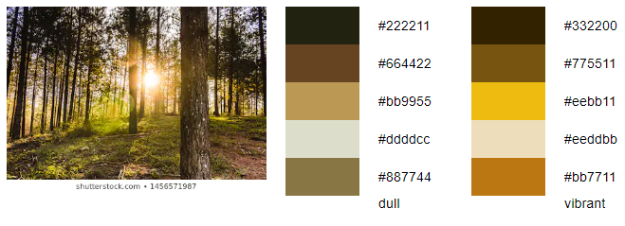

Name: Nature

Mood: happiness

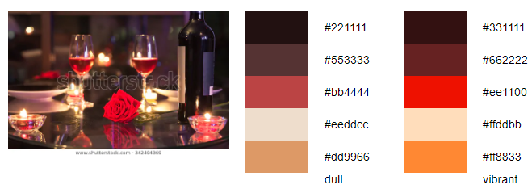

Name: date night

Mood: romance and passion

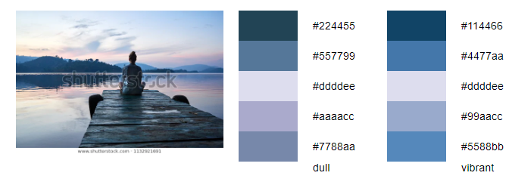

Name: meditation

Mood: peaceful and calm