Alain Nshimirimana

Personal Website Design

8/07/19

**Development Guide**

**Site Directory Structure**

**Folders**:

images – will contain photos (jpg, png, and gif) files.

styles – contains all of the style sheets that will be used.

**Files**:

index.html – home page for site, site purpose and overview

about.html – about the photographer.

faqs.html – frequently asked questions and answers.

portfolio.html – a page that show cases the photographer’s work.

contact.html – ways to contact the photographer.

**Main Navigation:**

Home – a homepage that’s linked to all other pages.

About – an About that’s linked to all other pages.

Portfolio – a Portfolio that’s linked to all other pages.

FAQs – a FAQs that’s linked to all other pages.

Contact – a contact us page that’s linked to all other pages.

**HTML Template:**

[Template.html](http://studentfolders.student.cascadia.edu/bit112/Alain_Nshimirimana/pwp/oswaldo_photograpy/template.html)

[Wire Frame](http://studentfolders.student.cascadia.edu/bit112/Alain_Nshimirimana/pwp/oswaldo_photograpy/index.html)

**Design Guide**

**Layout sample**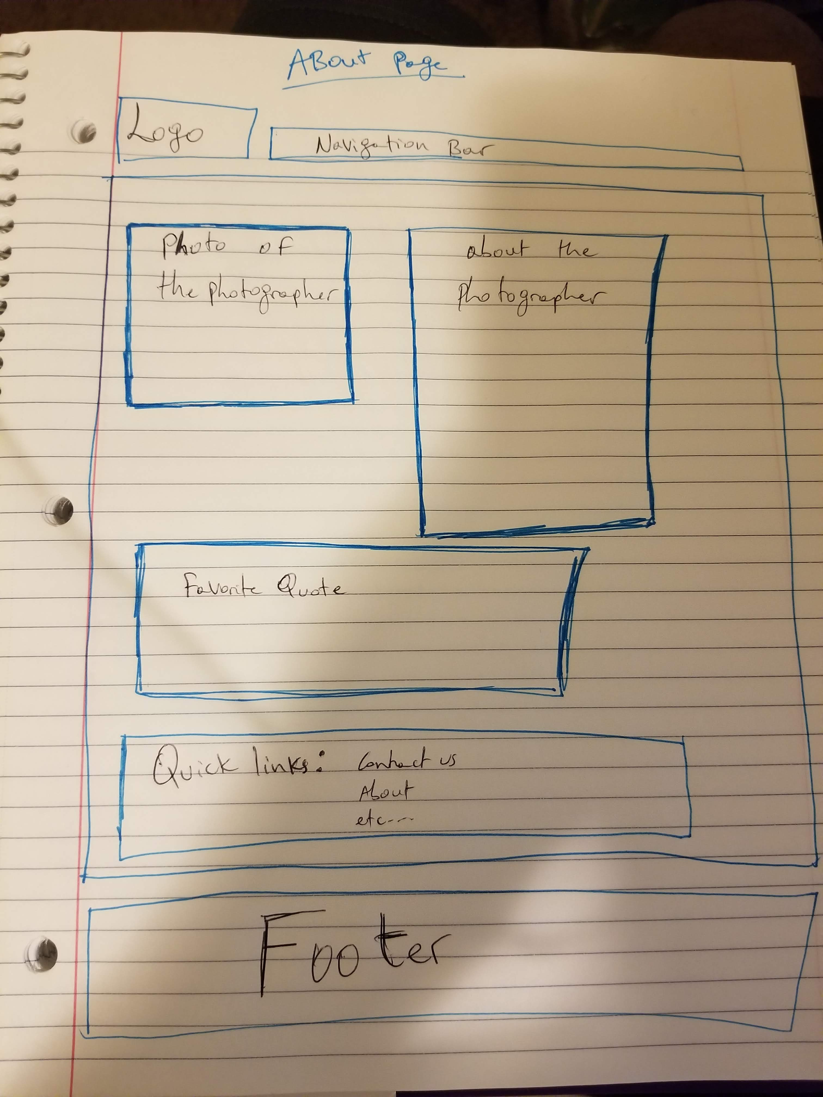

**Color Palette**

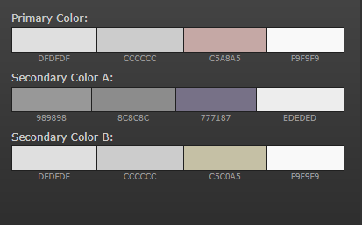

**Style Guide:**

li:hover

float:

clear:

margin

border

color

background color

etc…

**Media Assets:**

The types of media this website will feature are photos. So files like jpg, png, and maybe gif.