MARMITES–MODFLOW 6

Guide to the scripts and the workflow
What each script does, how they link and where to start, with the PEST++ calibration suite in detail
Branch MM-MF6_SFR_LAK_CRR · 2026-11-11 · generated by docs/make_scripts_guide.py (edit the script, not this file)

1 Start here
2 Where things live
3 The scripts, by role
4 Inside one model run
5 The PEST++ calibration suite
6 After the calibration: checks against satellites
7 Commands, in one place
8 Where to read more

1 Start here
MARMITES computes the water balance of the soil, cell by cell and day by day, and MODFLOW 6 the unsaturated zone, the groundwater, the streams and the ponds; the two run coupled. You drive everything from the front end, an app in the browser: it edits one configuration file per model, launches the runs and the calibration, and shows the results. Every script behind it can also be started from a command line (section 7).
The order of the work is the order of the app's pages:
- Start the app: python code/tools/launch_app.py, in the model's Python environment. It opens in the browser.
- Home: say once where things are on this machine (the data, the run workspace, MODFLOW, the PEST workspace).
- 1 Grid: name the GIS layers (catchment, streams, ponds, DEM), convert them into the dataset, choose and build the mesh.
- 2 to 6: the surface and the driving forces, the soil, the unsaturated zone and the groundwater, the state variables (the observations), the plots. Validate & save in the sidebar writes the configuration, code/configs/<model>.toml.
- 7 Run: the validation tab says what is wrong or missing; the Run tab launches the model and shows its log.
- 10 Results: the figures of each run, maps of any single day, the comparisons with satellite products.
- 8 PEST++ set-up: define the calibration, set it up, launch it. 9 PEST++ progress: follow it.
- 8 PEST++ set-up, Export: write the calibrated model as <model>_PEST.toml, then run it on page 7.
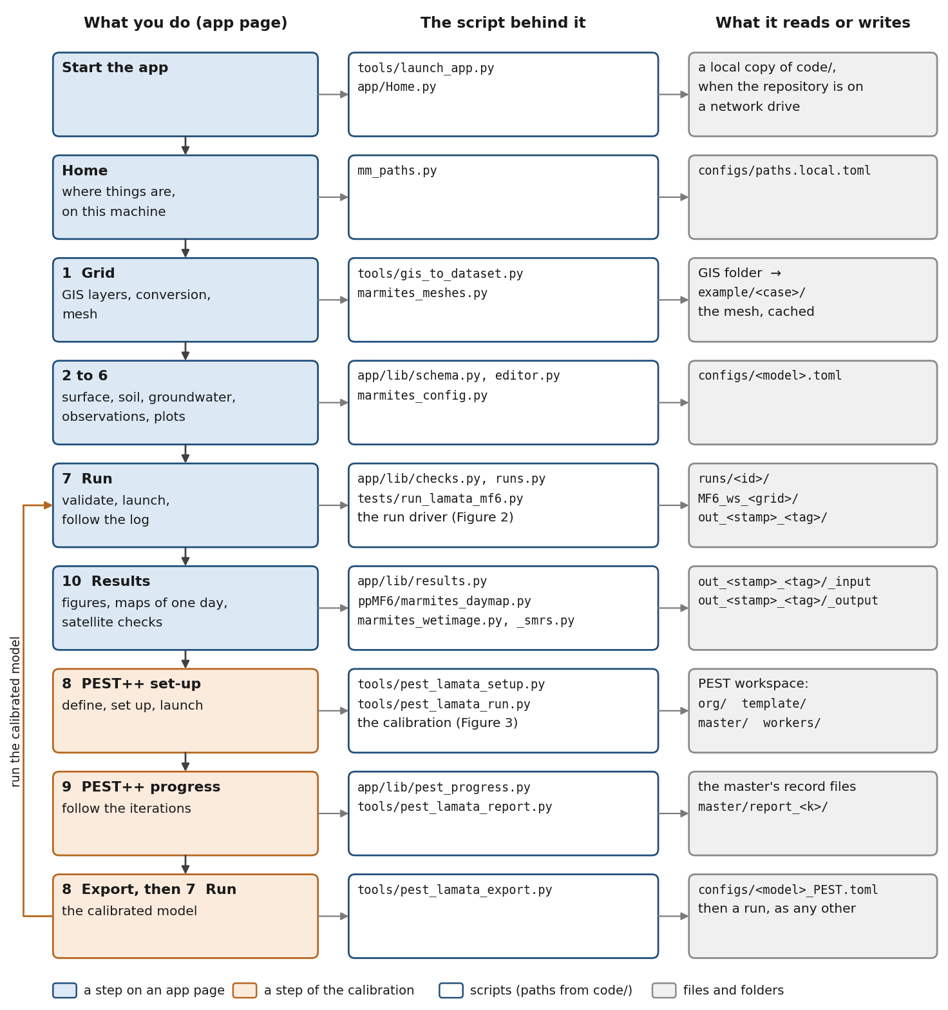
Figure 1. From the data to a calibrated model: each step on an app page, the script behind it, and what it reads or writes.
About the names. The run driver is code/tests/run_lamata_mf6.py and the calibration tools are code/tools/pest_lamata_*.py: they carry La Mata's name because they were built on that case. The driver runs any case (it reads paths.case from the configuration). The calibration tools read their choices from the configuration too, but still hold a few La Mata file names (pest_lamata.toml, lamata.pst): check them before calibrating a second case.

2 Where things live
Four places, three of them set on the Home page. The repository never receives a run's output, and a run never opens a shapefile.
Place | Set on | What it holds
The repository | – | code/: every script (section 3)  code/configs/: one .toml per model, and paths.local.toml (this machine's folders, not tracked)  example/<case>/: the dataset, the inputs the model reads directly  docs/: the documents
Data root | Home | GIS/: shapefiles and the DEM, read by the converter only  RS/: satellite products (MODIS ET, NDVI scenes, soil moisture)
Run workspace (WS_ROOT) | Home | MF6_ws_<grid>/: the MODFLOW 6 model, its outputs, the saved states, the observation exports  <case>_MMsurf/: the daily forcing, when the run computes it  out_<stamp>_<tag>/: one run's figures and tables (_input, _output)  runs/<run id>/: one run's log, status and record
PEST workspace | Home | org/, template/, master/, workers/, jobs/, results/, code/ (section 5.6). Tens of GB; never inside the run workspace or the repository

3 The scripts, by role
Paths are from code/. The tables go from what you start, to the app, to the model, to what comes after a run.

3.1 What you start
Script | What it does | Started from
tools/launch_app.py | Starts the front end. On a network drive it first copies the code to a local disk (a mirror, refreshed at each start) and runs the app from there; the configurations and the dataset stay in the repository. | command line
tests/run_lamata_mf6.py | The run driver. Builds the MODFLOW 6 model from the configuration and the dataset, runs the coupled model, saves the state, draws the figures (section 4). Options: --config, --set section.key=value (a one-off override), --run-tag, --probe. | page 7, a PEST agent, command line
tools/gis_to_dataset.py | The converter: the GIS layers the configuration names (catchment, streams, ponds, soil zones, vegetation, irrigation fields, observation points, DEM) into the dataset's tables. --dry-run previews. | page 1, command line
tools/pest_lamata_setup.py, pest_lamata_run.py, pest_lamata_report.py, pest_lamata_export.py | The calibration: set-up, launch, report, export (section 5). | page 8, command line
tools/pest_modis_et.py | MODIS MOD16A2GF tiles into the catchment's ET per 8-day composite; with --obs also into the dataset, as the catchment's observed ET. | the set-up, command line
tools/validate_grid.py | Does a run on a mesh mean the same as the run on the structured grid? Compares their water balances. | command line
tools/flags_to_toml.py | Translates an old command line of the driver into a configuration file. | command line (legacy)

3.2 The front end, app/
A viewer, an editor and a launcher: it may import the model, the model never imports it. Runs and calibration jobs are separate processes, so closing the browser stops nothing.
File | What it does
Home.py | The first page: the case, and where things are on this machine (written to configs/paths.local.toml).
pages/1_1_-_Grid.py | The GIS layers and their conversion; the grid (structured, Voronoi mesh or quadtree) and the DEM.
pages/2_2_-_Surface_and_driving_forces.py | Meteo stations, vegetation types, crops, surface soils; the daily forcing.
pages/3_3_-_Soil.py | Soil zones, thickness, horizons; the vegetation cover of each cell.
pages/4_4_-_Unsaturated_zone_and_groundwater.py | Layers and their properties, the unsaturated zone, drains, groundwater ET, streams, ponds, the runoff cascade, the start state.
pages/5_5_-_State_variables.py | What the run is compared with: heads, soil moisture, streamflow, actual ET, and the points.
pages/6_6_-_Plots.py | Which figures a run draws.
pages/7_7_-_Run.py | Validation of the configuration, then the launch and the live log.
pages/8_8_-_PEST_setup.py | The calibration's definition (the [pest] section) and its jobs: set up, launch, export.
pages/9_9_-_PEST_progress.py | A calibration's progress. Read-only.
pages/10_10_-_Results.py | The figures of a run by tab; maps of one day; wetness against a satellite NDVI; satellite soil moisture.
lib/schema.py | Every field of the panels: label, units, help.
lib/panelui.py | The widgets the pages share.
lib/editor.py | Applies the edits to the configuration, validates, saves.
lib/checks.py | Everything that can be said about a configuration before it runs; the Run page lists it and refuses on it.
lib/runs.py | The run registry: launches a run as a detached process, its status, its log.
lib/dataset_state.py | Is the dataset still what the GIS layers say? Starts the converter.
lib/loaders.py, lib/results.py | Readers for the pages; which tab and title each figure gets.
lib/pest_jobs.py, lib/pest_progress.py | The calibration's jobs and its progress (section 5).

3.3 Configuration and paths
Script | What it does
marmites_config.py | The configuration's schema: every section and field of the .toml, their defaults and their validation. The app and the driver both read it.
mm_paths.py | The only machine-specific paths: an MM_* environment variable, else configs/paths.local.toml (the Home page), else a default.
marmites_runinfo.py | What a finished run leaves to build on: the configuration as it ran and the state it saved. A calibration starts from both.
mmsurf_config.py | Reads the surface model's parameter file as named records (used by the app and the tests).
marmites_indices.py | The names of the columns of the soil model's result arrays.

3.4 The grid, and the inputs onto it
Script | What it does
marmites_meshes.py | The mesh producers, chosen by [grid] kind: the structured grid, a quadtree, a Voronoi mesh refined along the streams and at the ponds.
marmites_gridgen.py | The quadtree, through USGS GRIDGEN.
marmites_mesh.py | Projects the model's inputs onto a mesh.
marmites_grid.py | Cell geometry for any grid: area, width.
marmites_dem.py | The land surface from the DEM at its own resolution, onto the model cells.
marmites_raster.py, marmites_vector.py | Rasters sampled at the cells; points, lines and polygons wrapped onto the cells.
ppMF6/marmites_overlay.py | Polygon layers into cell values: the majority class, the area mean, the area share (soil zones, vegetation cover).
ppMF6/marmites_topology.py | Which cells are neighbours on a mesh.
ppMF6/marmites_channel.py | The stream cells, from the mapped stream lines.
ppMF6/marmites_props.py | The layers and their properties (K, Sy, Ss, thickness) from the configuration.

3.5 The model
Script | What it does
marmites_surface.py | Runs the surface model from the configuration (when run.surface is on) and checks the forcing files.
MARMITESsurf/startMARMITESsurface.py, PET_P_INTER.py | The surface model: the hourly meteo record into daily rainfall, interception and throughfall, potential transpiration per vegetation type, potential evaporation per soil, open-water evaporation, LAI.
MARMITESsurf/rain_seasons.py | Vegetation seasons started by the rain: green-up after the first autumn rain, wilting after a dry spell.
MARMITESsoil/MARMITESsoil_v3.py | The soil model: for a cell and a day, infiltration, soil evaporation and transpiration, percolation, runoff, and the groundwater's share of ET.
MARMITESsoil/marmites_soil_nb.py | The same soil step, compiled (numba): what a coupled run uses. A change to the soil step must be made in both files; a test holds them equal.
ppMF6/marmites_mf6.py | Builds the MODFLOW 6 simulation: grid, layers, unsaturated zone (UZF), drains, boundaries, solver, adaptive time steps.
ppMF6/marmites_sfr.py, marmites_lak.py | The streams (SFR) and the ponds (LAK) and their connection.
ppMF6/marmites_evt.py | Groundwater evaporation and transpiration, as MODFLOW 6 EVT curves.
ppMF6/marmites_crr.py | The runoff cascade: runoff routed to the downslope cells, where it can re-infiltrate.
marmites_coupler.py | The coupling: for each day, the soil step, then MODFLOW 6 solved through its API, then the heads and the exfiltration back to the soil.
marmites_pest.py | The model's side of a calibration run: applies the parameter multipliers on the run's own grid.

3.6 After a run
Script | What it does
ppMF6/marmites_postprocess.py | The figures and tables of a run: maps, time series at the observation points, water budgets, Sankey diagrams; and the observation exports the calibration reads.
ppMF6/marmites_cdl_figs.py, marmites_cdl_out.py | Input figures (parameters, layers, sections through the ponds); pond recharge, steady-state heads, run time per day.
ppMF6/marmites_rasterise.py, marmites_plot.py | A mesh result as a raster for the map figures; maps for any grid.
MARMITESutilities/MARMITESplot/MARMITESplot_v3.py | The older figure suite, still drawing the maps and the point time series.
tests/plot_water_budget.py | Water-budget figures, and the comparison with the older MODFLOW-NWT reference run.
ppMF6/marmites_daymap.py | Maps of one day of a finished run, for any flux, and the wetness W (Results page).
ppMF6/marmites_rs.py, marmites_wetimage.py | Finds and fetches a Landsat or Sentinel-2 scene; the model's wetness against its NDVI.
ppMF6/marmites_smrs.py | Satellite soil moisture (Copernicus SWI, SSM) against the model's soil saturation.

3.7 Not on the run path
Scripts | What they are
startMARMITES_v3.py, ppMF_FloPy/ | The former driver, for MODFLOW-NWT. Kept as the reference; ppMF_FloPy still supplies the object that holds the model description.
MARMITESutilities/ (the other scripts) | Small older helpers (conversions, plots).
SFR_LAK_CRR/ | The Casa de Lobos MODFLOW 6 scripts, kept as the reference for what was merged into MARMITES.
tests/test_*.py | The test suite (about 1570 tests, half an hour). tests/lamata_model.py builds La Mata for the tests.
tests/diag_*.py, tests/diagnose_coupling.py | Diagnostics of past problems (small MODFLOW 6 models).
docs/make_cookbook.py, docs/make_scripts_guide.py | Generate the cookbook and this guide.

4 Inside one model run
Page 7 starts the run driver as a separate process (app/lib/runs.py), with the saved configuration. The driver goes through eight stages (Figure 2). On La Mata (4524 cells, 1949 days) a run takes about an hour.
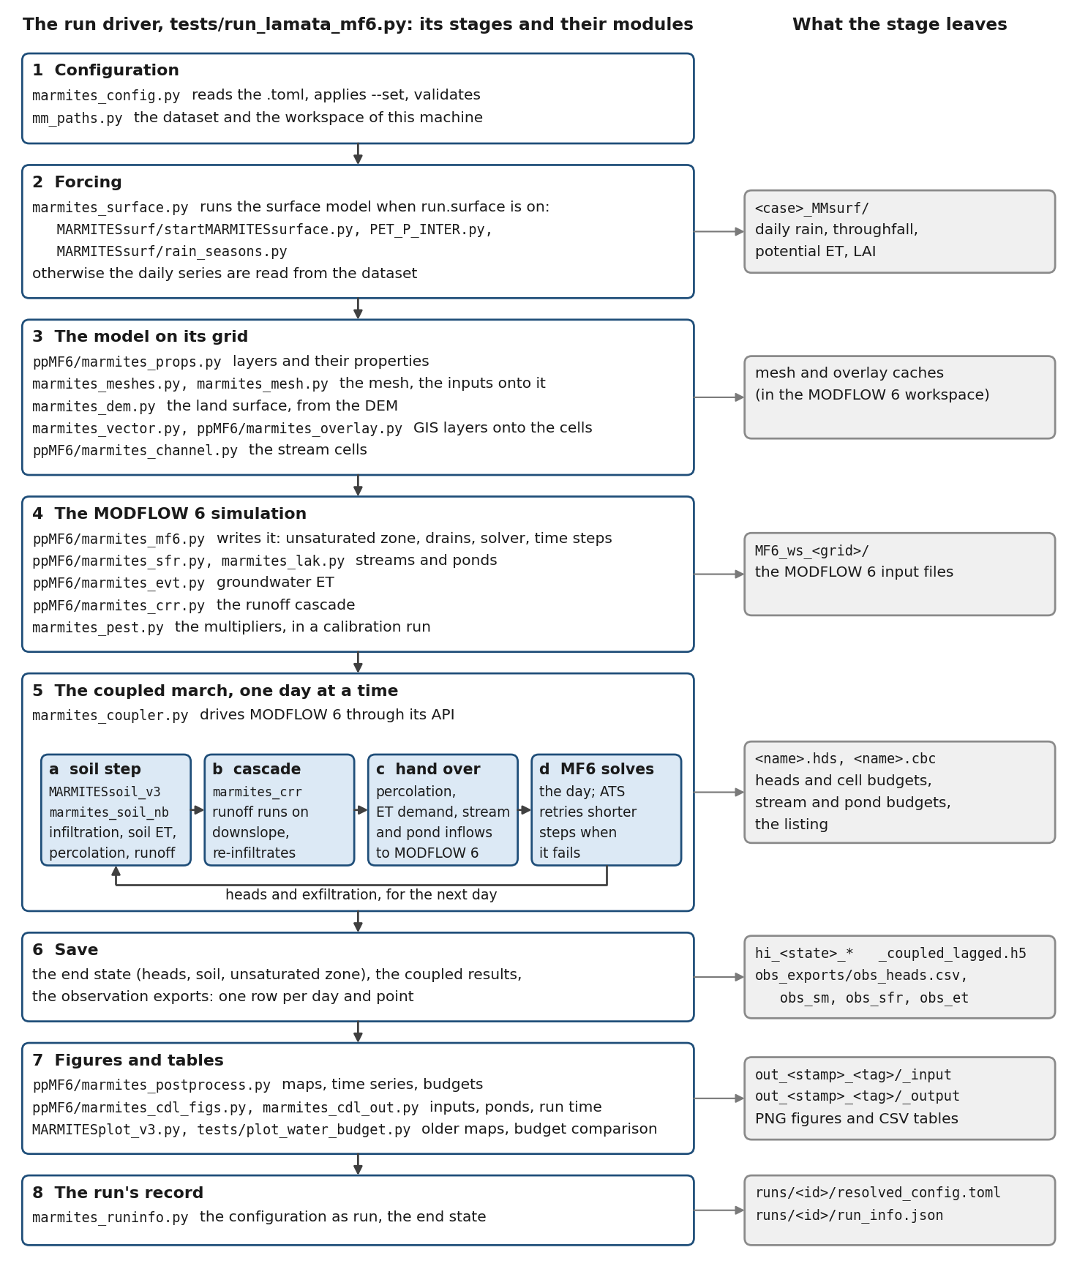
Figure 2. One model run: the stages of the driver, the modules each uses, and what each leaves in the run workspace.
Three things are worth knowing:
- The outputs in MF6_ws_<grid>/ are overwritten by the next run there. The figures and tables of each run are kept in its own out_<stamp>_<tag>/ folder, and its log and record in runs/<run id>/.
- The saved state has a name, and a run asked to save under the same name replaces it. A calibration starts from a saved state, so the PEST tools refuse a state that changed after the run they were told to start from.
- The forcing is recomputed only when run.surface is on. Off, the daily series are read from the dataset, whatever the surface page says.

5 The PEST++ calibration suite

5.1 What it does
The calibration uses PEST++ IES (pestpp-ies), an iterative ensemble smoother. It runs the model with many parameter sets at once (an ensemble of realisations: 100 on La Mata), compares each run with the observations through one number, the objective function phi, and corrects all the sets together, iteration after iteration. pyemu (Python) writes the PEST files. The runs are shared among agents, each in its own folder, by a master. On La Mata the last calibration had 313 parameters, 8955 observations (7987 fitted), 100 realisations, 3 iterations and 20 agents, and took about two days.
Figure 3 shows the whole suite. The sections after it take the steps one by one.
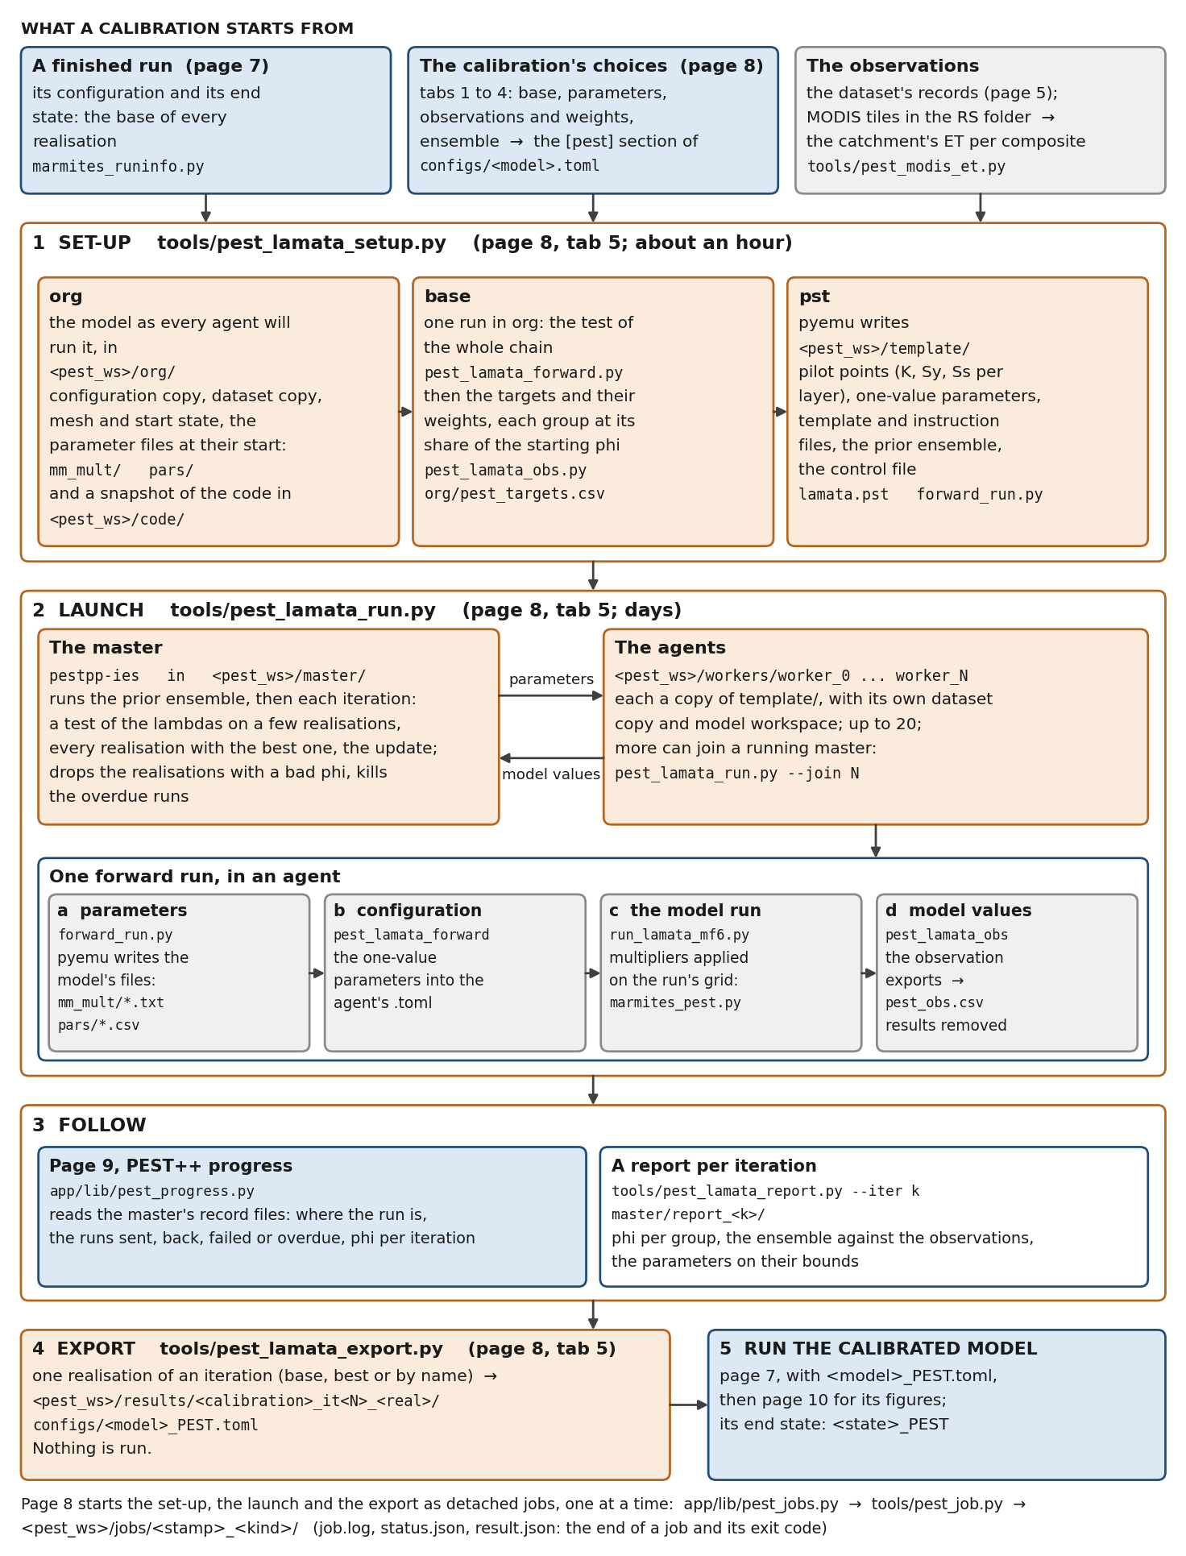
Figure 3. The PEST++ suite: what a calibration starts from, the set-up, the launch with its master and agents, one forward run, the follow-up, the export and the calibrated run.

5.2 Before you start
- Home: the PEST workspace (its own folder, with tens of GB free), the MODFLOW folder (it must hold pestpp-ies), and the Python executable the agents run the model with.
- A finished run to start from (page 7): the calibration takes its configuration as the model to calibrate and its end state as the start of every realisation.
- The observations in the dataset (page 5). For the satellite ET, the MODIS MOD16A2GF tiles in the RS folder, in MODIS4<case>/.

5.3 The scripts of the suite
Script | Role | Reads | Writes
app/pages/8_8_-_PEST_setup.py | The calibration's choices, and the buttons that start its jobs. | the configuration | its [pest] section
app/lib/pest_jobs.py, tools/pest_job.py | Start the set-up, the launch and the export as detached jobs, one at a time, and record how each ended. | – | jobs/<stamp>_<kind>/: job.log, status.json, result.json
tools/pest_lamata_setup.py | The set-up, in three steps: org, base, pst. | the configuration, the base run, the dataset | org/, template/, code/
tools/pest_lamata_obs.py | The observations: the targets and their weights at set-up; the model's value of each target after a run. | the observed records; a run's observation exports | pest_targets.csv; pest_obs.csv
tools/pest_modis_et.py | The catchment's ET per MODIS composite. | the MODIS tiles | org/modis_et_catchment.csv
tools/pest_lamata_run.py | The launch: the master and its agents. --join N adds agents to a running master. | [pest] (at launch), template/ | master/, workers/worker_<k>/
tools/pest_lamata_forward.py | One forward run, in an agent: parameters in, model run, model values out. | the parameter files pyemu wrote | pest_obs.csv
marmites_pest.py | In the model: the multipliers applied on the run's grid. | mm_mult/*.txt | –
app/pages/9_9_-_PEST_progress.py, app/lib/pest_progress.py | The progress of a calibration. | the master's record files | nothing
tools/pest_lamata_report.py | Figures and a summary of the prior runs or of an iteration. | master/ | master/report_<k>/
tools/pest_lamata_export.py | One realisation as a configuration of its own: the calibrated model. | master/, template/ | results/<calibration>_it<N>_<real>/, configs/<model>_PEST.toml

5.4 The steps

Step 0. Define the calibration (page 8, tabs 1 to 4)
- Base and workspace: the finished run every realisation starts from, and the first day that is fitted (the days before it are a warm-up: reported, not fitted).
- Parameters: one row per family and layer or soil horizon: on or off, starting value, bounds; the spacing of the pilot points.
- Observations and weights: each group's share of the starting phi and its measurement noise.
- Ensemble and PEST++: the number of realisations, of iterations and of agents, and where the ensemble starts (prior, warm, restart).
Validate & save in the sidebar writes them into the [pest] section of the configuration. The tools read that section; nothing about a calibration is set anywhere else.

Step 1. Set up (tab 5, or pest_lamata_setup.py)
Three steps, run in a row (--step all) or one at a time:
Step | What it does | Result
org | Prepares the model as every agent will run it: a copy of the configuration (forcing not recomputed, no figures, one cycle from the base state, multipliers on), a copy of the dataset, the mesh and the start state, the parameter files at their starting values, the MODIS series. Takes a snapshot of the code, so that a calibration of days does not change under a later edit. | <pest_ws>/org/, <pest_ws>/code/
base | Runs the model once in org: the test of the whole chain. Then builds the targets (one row per observation) and balances the weights, so that each group carries its share of the starting phi. | org/pest_targets.csv
pst | pyemu writes the PEST files: the pilot points for K, Sy and Ss per layer, the one-value parameters, the template and instruction files, the prior ensemble, the control file and the forward-run script. | <pest_ws>/template/

It takes about an hour, most of it the base run. The launch is offered only after a set-up that succeeded.

Step 2. Launch (tab 5, or pest_lamata_run.py)
The launch copies the template into one folder per agent, moves a previous master/ aside (as master_<stamp>) and starts pestpp-ies. It reads [pest] at that moment, so the ensemble settings can still change after the set-up:
- noptmax: -1 runs the prior ensemble only; 0 makes one run at the starting values, the check that the whole chain works (it should give the set-up's phi); n runs n iterations.
- start: prior is the ensemble drawn at set-up; warm starts from a parameter ensemble of an earlier calibration, after the model changed; restart continues an interrupted calibration of the same model from its master folder.
- agents: up to 20. More can be added while it runs: pest_lamata_run.py --join N.
pestpp-ies then runs the prior ensemble and, in each iteration, tests its lambda values on a few realisations, runs every realisation with the best one and updates the parameters. It drops a realisation whose phi is far above the others and kills a run that takes much longer than the average.

Step 3. Follow (page 9, and pest_lamata_report.py)
Page 9 reads what the master writes: where the calibration is, the runs sent, returned, failed or overdue, phi per iteration and per group, and the end of a failed run's log. It changes nothing. After the prior runs and after each iteration, pest_lamata_report.py --iter k draws a report into master/report_<k>/: phi of each group, the ensemble against the observations through time, and the parameters that sit on their bounds.

Step 4. Export, then run (tab 5, or pest_lamata_export.py)
Once an iteration has run, the export writes one of its realisations as the calibrated model. By default it takes the base realisation of the last iteration; best or a name are the alternatives. It writes the multipliers and the one-value parameters into results/<calibration>_it<N>_<real>/ and the configuration <model>_PEST.toml beside the input one. Nothing is run: choose <model>_PEST.toml on page 7 and run it. That run saves its end state as <state>_PEST, never over the base state.

5.5 One forward run, inside an agent
- pestpp-ies hands the agent a parameter set. forward_run.py (written by the set-up) lets pyemu turn it into the model's files: the multipliers per cell, interpolated from the pilot points (mm_mult/k_l<L>.txt, sy_l<L>.txt, ss_l<L>.txt), and the one-value parameters (pars/<name>.csv).
- pest_lamata_forward.py writes the one-value parameters into the agent's copy of the configuration: the soil horizons' field capacity and Ks, the streambed and pond-bed conductances, the unsaturated zone's parameters, the cascade's.
- It runs the driver in the agent's own workspace. While the model is built, marmites_pest.py applies the multipliers on the grid the model runs on.
- pest_lamata_obs.py reads the run's observation exports (obs_heads.csv, obs_sm.csv, obs_sfr.csv, obs_et.csv) and writes the model's value of every target into pest_obs.csv.
- The run's results folder is removed, so that an agent does not fill the disk.
A run that fails still writes pest_obs.csv, with a large sentinel value everywhere, so that PEST++ counts a failed realisation and goes on. A run that stops converging is ended by the model's own guard ([run] stall_iterations, stall_periods).

5.6 The PEST workspace
Folder | Written by | What it holds
code/ | set-up (org) | The snapshot of the repository's code the agents run.
org/ | set-up (org, base) | The model as an agent runs it (pest_lamata.toml, example/<case>/, ws/, mm_mult/, pars/), the base run's exports, pest_targets.csv, setup.json.
template/ | set-up (pst) | What every agent is a copy of: org plus the PEST files (lamata.pst, the .tpl and .ins files, the pilot points, the prior ensemble, forward_run.py).
master/ | launch | The run of pestpp-ies: its record (lamata.rec, lamata.rmr), phi per iteration (lamata.phi.actual.csv, lamata.phi.group.csv), the parameter and observation ensembles of each iteration (lamata.<k>.par.jcb, lamata.<k>.obs.jcb), the reports (report_<k>/).
master_<stamp>/ | launch | An earlier calibration, moved aside by the next launch.
workers/worker_<k>/ | launch | One agent each: a copy of the template, its own dataset copy and model workspace, its model.log.
jobs/<stamp>_<kind>/ | page 8 | One job each (setup, launch, export): job.log, status.json, result.json.
results/<calibration>_it<N>_<real>/ | export | An exported realisation: its multipliers and parameters, export.json.

5.7 What is calibrated, against what
The parameter families (page 8, Parameters), each on or off, with its bounds:
Family | What | How
k, sy, ss | Hydraulic conductivity, specific yield, specific storage of each layer | pilot points: a value every few hundred metres, interpolated to the cells
k33, sr, drn | Kh/Kv, specific retention, drain conductance of each layer | one value per layer
sfc, ks | Field capacity and saturated conductivity of each soil horizon | one value per horizon
sfr_rhk, lak_bedleak | Streambed conductivity, pond-bed leakance | one value
uzf_eps, uzf_vks | The unsaturated zone's exponent and vertical conductivity | one value
crr_beta | The share of runoff the cascade passes downslope | one value

The observation groups, with La Mata's shares of the starting phi:
Group | What is compared | Share
hds_p0 | Measured heads at the main piezometer, near-daily | 35 %
hds_c | Heads at the other points: soft data, each weighing a quarter of a measured head | (soft)
sm_p0, sm_sm | Soil moisture at two probes, two horizons each | 17.5 % each
q_log | Outlet flow, as its logarithm, daily | 10 %
q_dry | The model's flow on the gauge's dry days, against zero | 5 %
q_year | Outlet volume per hydrological year | 5 %
et_rs | MODIS ET over the catchment, per 8-day composite | 10 %
et_pt | Measured ET at the points (eddy-covariance tower) | 0: reported only

5.8 Rules and traps
- One PEST job at a time. A set-up rewrites the template every agent copies; page 8 refuses a second job while one runs.
- A calibration runs the code as it was at set-up (the snapshot in <pest_ws>/code/). A later change to the code reaches it only through a new set-up.
- After a change to the model (code or configuration): a new base run on page 7, a new set-up, then a launch. An earlier ensemble can be reused with start = warm.
- Check the chain first: a launch with noptmax = 0 makes one run and should give the set-up's phi.
- The PEST workspace is its own folder: never the run workspace, never the repository. It grows to tens of GB.
- A job has ended when its result.json exists; status.json only says that it started.
- The export refuses when the base state or the template changed after the calibration: the exported model would not be the one that was calibrated.
- At most 20 agents in all.

6 After the calibration: checks against satellites
These are on the Results page and use the outputs of a finished run. They compare; they are not part of the calibration.
Check | Script | What it gives
Maps of one day | ppMF6/marmites_daymap.py | Any flux on any day, and the wetness W (soil saturation and open water). Only while the run's outputs are still in its workspace.
Wetness against NDVI | ppMF6/marmites_rs.py, marmites_wetimage.py | Finds and fetches a Landsat or Sentinel-2 scene; a regression of NDVI on W per cell and vegetation class; a map of the residuals.
Satellite soil moisture | ppMF6/marmites_smrs.py | The Copernicus Soil Water Index or surface soil moisture against the catchment's soil saturation: correlation, bias, by T-value. Reads product files or the Copernicus Browser's CSV exports.

7 Commands, in one place
From the repository's folder, in the model's Python environment. The app does the same through its pages.
# the app
python code/tools/launch_app.py

# GIS layers -> dataset (--dry-run to preview)
python code/tools/gis_to_dataset.py --case LaMata

# a model run; --set overrides one key for this run
python code/tests/run_lamata_mf6.py --config code/configs/lamata.toml
python code/tests/run_lamata_mf6.py --config code/configs/lamata.toml --set run.nsp=60 --run-tag try

# calibration: set-up (all steps, or --step org|base|pst)
python code/tools/pest_lamata_setup.py --config code/configs/lamata.toml
# launch (settings from [pest]); add agents to a running master
python code/tools/pest_lamata_run.py --config code/configs/lamata.toml
python code/tools/pest_lamata_run.py --join 4
# report of the prior runs (0) or of iteration k
python code/tools/pest_lamata_report.py --iter 0
# the calibrated model: lamata_PEST.toml, then run it
python code/tools/pest_lamata_export.py --real base
python code/tests/run_lamata_mf6.py --config code/configs/lamata_PEST.toml

# MODIS ET over the catchment, also as an observation file
python code/tools/pest_modis_et.py --product MODIS4LaMata --config code/configs/lamata.toml --obs

# the tests (all, or one file)
python -m pytest code/tests -q

# this guide
python docs/make_scripts_guide.py

8 Where to read more
Document | What it covers
CLAUDE.md | The working rules of the project, the environments, the design decisions in force, the traps already met.
docs/MM-MF6/CdL_kickoff.md | The state at the end of the La Mata work and the plan for Casa de Lobos.
docs/MM-MF6/WP7_PESTpp_LaMata_draft.md | The design of the calibration: parameters, observations, weights.
docs/MM-MF6/WP7_PEST_frontend_plan.md | The PEST pages of the app, phase by phase.
docs/MM-MF6/MARMITES_SFR_LAK_CRR_analysis.md | The running notes of the analyses: streams, ponds, cascade, convergence.
docs/MARMITES_x_CdL_merge_cookbook.docx | The plan of the merge of the Casa de Lobos approach into MARMITES, by work package.
code/app/README.md | The front end: how to start it, its layout and its two rules.
Each script's own first lines | Every script opens with a text that says what it does and why; the tables above are their summary.

