Practical 3

We initialize the problem as follows. We choose 100 initial samples on each level, and impose that the levels used by the MLMC routine are between 2 and 10. For the convergence tests, we used the first 7 levels, with 20’000 paths for each coupling between level l and level l-1.

We first look at the convergence results when we use a refinement factor of M = 3 and an initial number of step at layer 0 of n0 = 9.
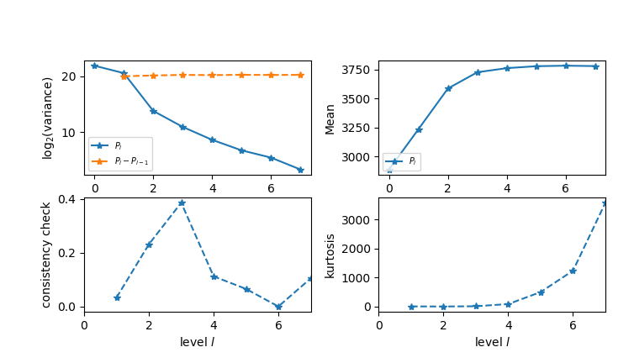

***************************************************************************
*** Convergence tests, kurtosis, telescoping sum check ***
******* using N = 20000 samples *******
***************************************************************************

l ave(Pf-Pc) ave(Pf) var(Pf-Pc) var(Pf) kurtosis check cost
-----------------------------------------------------------------------------------------------------------------
0 2.8874e+03 2.8874e+03 3.8290e+06 3.8290e+06 5.7218e+00 0.0000e+00 1.0000e+00
1 3.5166e+02 3.2361e+03 1.5255e+06 1.0361e+06 7.1935e+00 3.3235e-02 3.0000e+00
2 3.6206e+02 3.5874e+03 1.4275e+04 1.1418e+06 3.7094e+00 2.3148e-01 9.0000e+00
3 1.2215e+02 3.7277e+03 1.9826e+03 1.2250e+06 1.2290e+01 3.8606e-01 2.7000e+01
4 4.0745e+01 3.7631e+03 3.9989e+02 1.1957e+06 8.8003e+01 1.1255e-01 8.1000e+01
5 1.3628e+01 3.7799e+03 1.0887e+02 1.2382e+06 5.0056e+02 6.5891e-02 2.4300e+02
6 4.4656e+00 3.7843e+03 4.4435e+01 1.2180e+06 1.2370e+03 5.0735e-04 7.2900e+02
7 1.5137e+00 3.7809e+03 1.0228e+01 1.2296e+06 3.5736e+03 1.0518e-01 2.1870e+03

We observe that the mean and the variance of the estimators are of the right order. However, we failed to achieve the same value as in Anderson & Higham (2011), which was around 3713. We believe that this small bias is introduced in the way we deal with the initial steps of the algorithm. Indeed, at first, only G is present in the mix. Hence, the first reaction of the simulation has to be the reaction G → G + M. But the reaction M → M + P happens 40 times more often, so we must discard this reaction if it is triggered first. But even correcting this bias is not sufficient to get to their value.

We now run the main MLMC code to see the number of samples needed in each level, and the associated saving for a fixed error.

******************************************************
*** Linear regression estimates of MLMC parameters ***
******************************************************

alpha = 1.408080 (exponent for MLMC weak convergence)
beta = 2.585748 (exponent for MLMC variance)
gamma = 1.584962 (exponent for MLMC cost)

*****************************
*** MLMC complexity tests ***
*****************************

eps value mlmc_cost std_cost savings l=2 l=3 l=4 l=5 l=6 l=7 l=8 l=9 l=10
---------------------------------------------------------------------------------------------------------------------------------------------------------------
1.0000 3.7837e+03 1.685e+08 3.227e+10 191.54 16436148 5989478 997975 218057 37273 6290 1356 318 100
2.0000 3.7861e+03 4.087e+07 8.964e+08 21.93 4038204 1468972 244762 54359 9299 1570 341 57
5.0000 3.7827e+03 6.849e+06 1.434e+08 20.94 660806 241253 40198 8761 1499 387 77 13
10.000 3.7745e+03 1.626e+06 1.184e+07 7.28 160426 59861 9975 2173 372 63 11
20.000 3.7755e+03 3.972e+05 1.003e+06 2.53 39946 14645 2441 554 95 16
50.000 3.8010e+03 6.064e+04 1.605e+05 2.65 6343 2163 361 84 14 3

We see that the savings for eps=1 are huge: a factor 190. Standard Monte Carlo would have been impractical in this case.
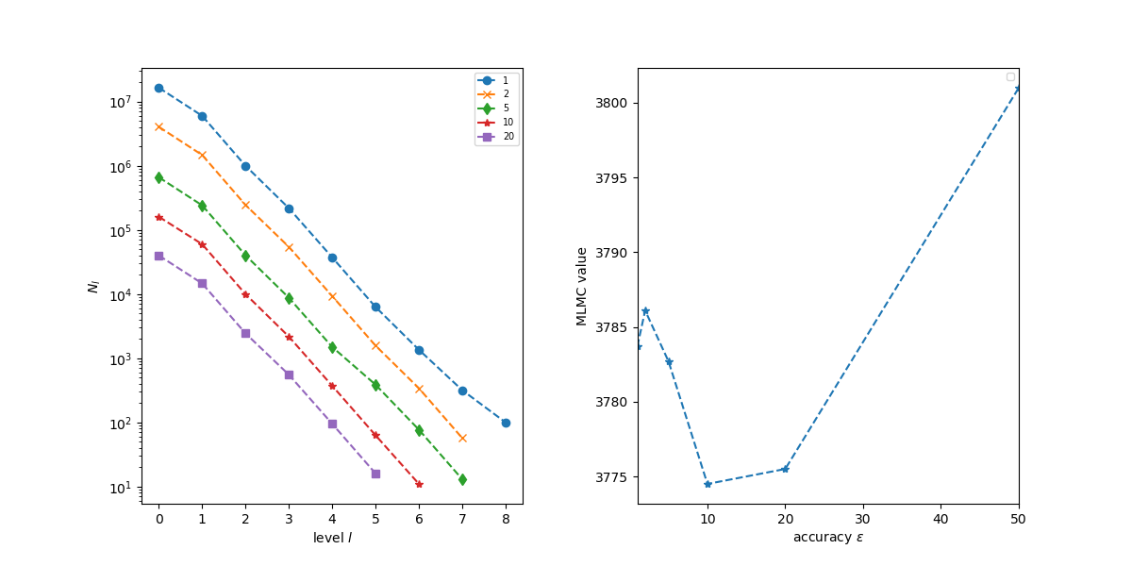

We redo the same experiments with a refinement factor of M = 2 and an initial number of step at layer 0 of n0 = 4. For the convergence tests, we used the first 7 levels, with 20’000 paths for each coupling between level l and level l-1. The results we got are fairly similar to the case M = 3 above.
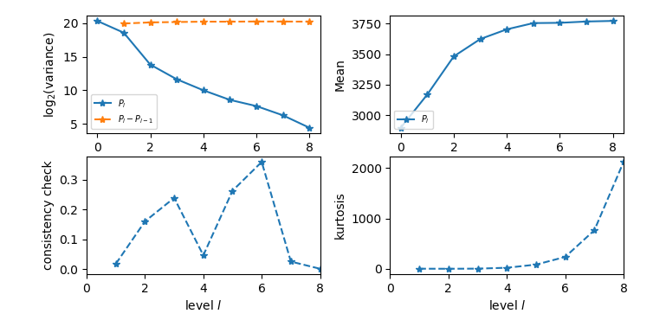

For the number of samples per level for a fixed error, we observe the same trend as in the case M=3.

******************************************************
*** Linear regression estimates of MLMC parameters ***
******************************************************

alpha = 0.899725 (exponent for MLMC weak convergence)
beta = 1.788249 (exponent for MLMC variance)
gamma = 1.000000 (exponent for MLMC cost)

*****************************
*** MLMC complexity tests ***
*****************************

eps value mlmc_cost std_cost savings l = 2 l = 3 l = 4 l = 5 l = 6 l = 7 l = 8 l = 9 l = 10 l = 11 l = 12 l =13 l = 14
----------------------------------------------------------------------------------------------------------------------------------------------------------------------------------------------------
1.0000 3.7844e+03 6.326e+07 2.674e+10 422.73 5179697 1985111 534068 170576 47318 15471 6906 3177 1176 332 174 98 52
2.0000 3.7839e+03 1.541e+07 3.343e+09 216.87 1273420 488970 131551 42773 11867 4638 1960 710 195 72 52 19
5.0000 3.7913e+03 2.247e+06 2.674e+08 118.99 193260 73735 19838 6788 1875 513 147 59 28 19 7
10.000 3.7713e+03 5.693e+05 4.178e+06 7.34 48650 18554 4992 1698 473 205 69 19 8
20.000 3.7713e+03 1.335e+05 1.045e+06 7.82 11643 4523 1217 429 120 33 10 4 1
50.000 3.7272e+03 1.984e+04 4.249e+04 2.14 1779 666 180 67 19 5 2
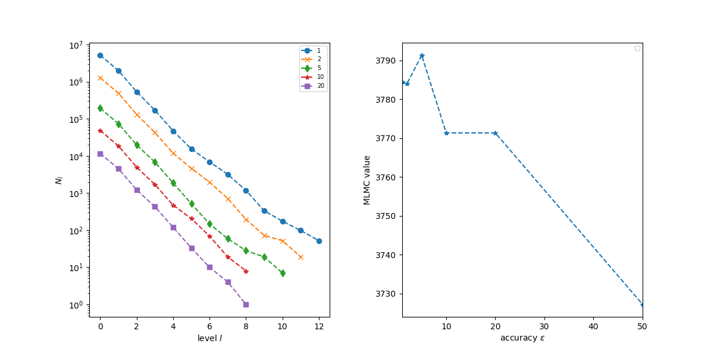

We observe that the value for eps=1 is 3784.4, comparable to the 3783.7 we got in the case M=3. Hence, the bias we get compared to the value in the paper is an implementation issue, it is not coming from a discretization error in the MLMC.

The rate of weak convergence is slower : 0.89 for M = 2, and 1.40 for M = 3. We run the experiments with M = 4 as well, obtaining an even bigger rate : 1.86.

We tested as well different generators for Poisson random variables. The random number generator from the standard C++11 library is quite slow. For performance, we used the C++ CPU software at
http://people.maths.ox.ac.uk/gilesm/codes/poissinv/ to transform samples from the uniform distribution to a Poisson distribution with specified lambda.

