Practical 2

2.a. Weak convergence of SDE
Analysis of the weak convergence of GBM SDE with N = 10000000 paths and 6 levels.

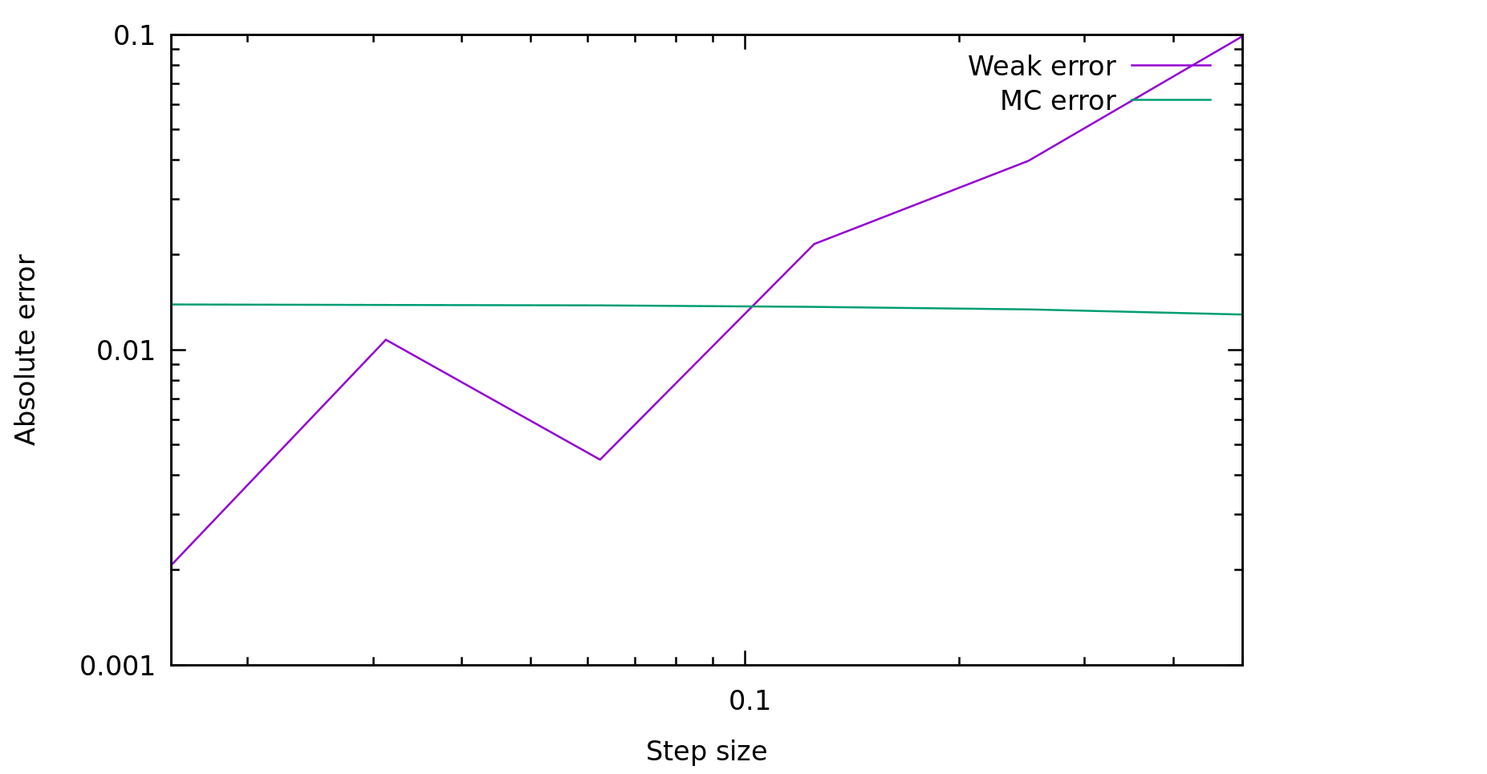
With a linear interpolation on the log-log plot above, we infer that the convergence of the weak error is of order O(h). The Monte-Carlo error stays roughly constant as expected.

2.b. Weak convergence of SDE with steps 2h
Analysis of the weak convergence of GBM SDE with N = 10000000 paths and 6 levels, with the 2h trick.

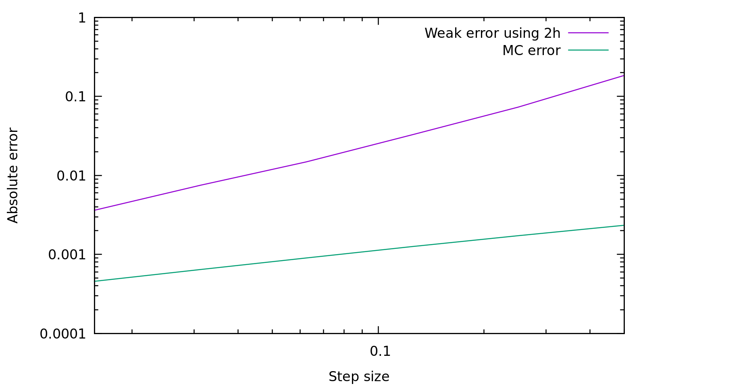

With a linear interpolation on the log-log plot above, we infer that the convergence of the weak error using the 2h trick is of order O(h). The Monte-Carlo error is now an order of magnitude lower, as the path with step size h and step size 2h are heavily correlated.

2.c. Strong convergence of SDE with steps 2h
Analysis of the strong convergence of GBM SDE with N = 10000000 paths and 6 levels, with the 2h trick.

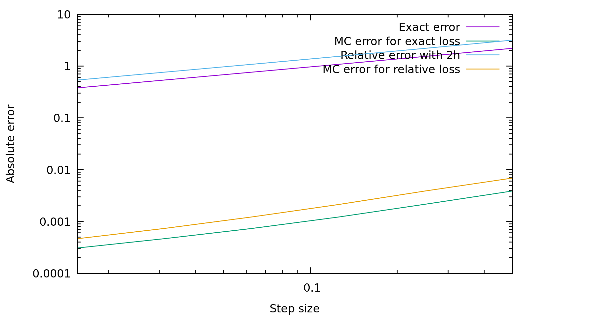
With a linear interpolation on the log-log plot above, we infer that the convergence of the strong error using the 2h trick and the exact error is of order O(h^0.5). The Monte-Carlo error are both several orders of magnitude lower.

3. Strong convergence of the Ornstein-Uhlenbeck process with steps 2h.
Analysis of the strong convergence of Ornstein-Uhlenbeck SDE with N = 10000000 paths and 6 levels, with the 2h trick.

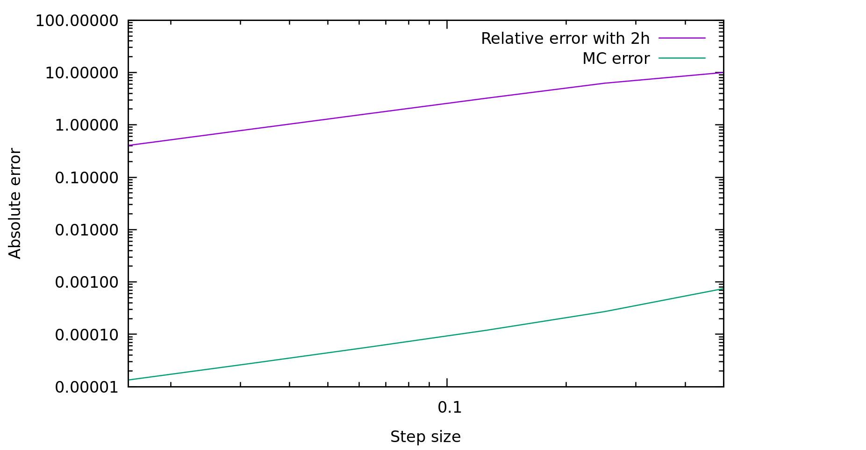

With a linear interpolation on the log-log plot above, we infer that the convergence of the strong error using the 2h trick is of order O(h). My best guess for this faster convergence is that the Ornstein-Uhlenbeck process is mean-reverting, so that paths don’t drift away like the geometric Brownian paths do.

4. Strong convergence of the Heston stochastic volatility model with steps 2h.
Analysis of the strong convergence of GBM SDE with N = 10000000 paths and 6 levels, with the 2h trick.

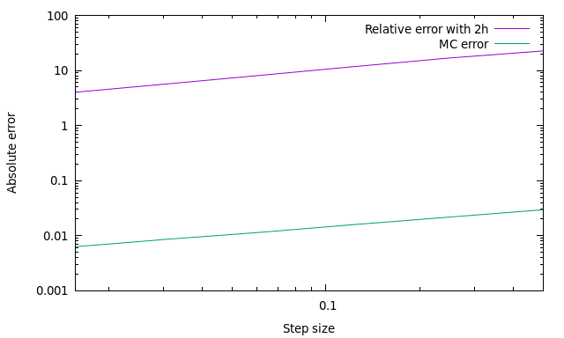
With a linear interpolation on the log-log plot above, we infer that the convergence of the strong error using the 2h trick is of order O(h^0.5). The strong error is still very large compared to the Monte-Carlo error, so decreasing the time step is needed here. The fact that the order is still O(h^0.5) by adding a “nested“ SDE is a bit surprising to me, as it adds an additional cumulated discretization error to the scheme.

5. Analysis of pricing financial options using a Milstein discretisation

---- option 1: European call ----

**********************************************************
*** MLMC file version 0.9 produced by ***
*** C++ mlmc_test on Mon Nov 18 19:31:53 2019 ***
**********************************************************

**********************************************************
*** Convergence tests, kurtosis, telescoping sum check ***
*** using N = 20000 samples ***
**********************************************************

l ave(Pf-Pc) ave(Pf) var(Pf-Pc) var(Pf) kurtosis check cost
---------------------------------------------------------------------------------------
0 1.0064e+01 1.0064e+01 1.9757e+02 1.9757e+02 5.9784e+00 0.0000e+00 1.0000e+00
1 1.8461e-01 1.0278e+01 1.5478e-01 2.0682e+02 5.8921e+01 4.7871e-02 2.0000e+00
2 1.0313e-01 1.0384e+01 4.1604e-02 2.1064e+02 4.1238e+01 5.6546e-03 4.0000e+00
3 5.4703e-02 1.0405e+01 1.1833e-02 2.1402e+02 1.8193e+01 5.5490e-02 8.0000e+00
4 2.8138e-02 1.0478e+01 3.3422e-03 2.2091e+02 1.7814e+01 7.1988e-02 1.6000e+01
5 1.3890e-02 1.0432e+01 8.1471e-04 2.1711e+02 1.1223e+01 9.5699e-02 3.2000e+01
6 7.0644e-03 1.0572e+01 2.0848e-04 2.1891e+02 1.0084e+01 2.1211e-01 6.4000e+01
7 3.5145e-03 1.0345e+01 5.4824e-05 2.1954e+02 9.9735e+00 3.6660e-01 1.2800e+02
8 1.7623e-03 1.0516e+01 1.3085e-05 2.1534e+02 8.9373e+00 2.7110e-01 2.5600e+02

******************************************************
*** Linear regression estimates of MLMC parameters ***
******************************************************

alpha = 0.967004 (exponent for MLMC weak convergence)
beta = 1.929346 (exponent for MLMC variance)
gamma = 1.000000 (exponent for MLMC cost)

*****************************
*** MLMC complexity tests ***
*****************************

eps value mlmc_cost std_cost savings N_l
---------------------------------------------------------
0.0050 1.0450e+01 1.353e+07 2.940e+09 217.24 11891386 232787 86464 32889 12275 4385 1558 563 233
0.0100 1.0447e+01 3.777e+06 3.747e+08 99.19 3368897 60380 21431 8155 3342 1200 385 159
0.0200 1.0433e+01 8.266e+05 4.670e+07 56.49 735020 13970 5419 1919 786 276 82
0.0500 1.0474e+01 1.403e+05 3.705e+06 26.42 125277 2391 955 365 125 46
0.1000 1.0401e+01 3.457e+04 2.283e+05 6.60 31687 670 223 81

The weak convergence is of order O(h), as in the Euler-Maruyama scheme. But we achieve a reasonable error with only 20000 samples here.

---- option 2: Asian call ----

**********************************************************
*** MLMC file version 0.9 produced by ***
*** C++ mlmc_test on Mon Nov 18 19:32:04 2019 ***
**********************************************************

**********************************************************
*** Convergence tests, kurtosis, telescoping sum check ***
*** using N = 20000 samples ***
**********************************************************

l ave(Pf-Pc) ave(Pf) var(Pf-Pc) var(Pf) kurtosis check cost
---------------------------------------------------------------------------------------
0 5.6236e+00 5.6236e+00 6.0357e+01 6.0357e+01 5.6679e+00 0.0000e+00 1.0000e+00
1 3.8958e-02 5.6751e+00 2.4225e-01 6.1737e+01 1.7728e+01 3.6483e-02 2.0000e+00
2 4.2510e-02 5.7075e+00 3.7573e-02 6.2121e+01 1.2834e+01 2.9712e-02 4.0000e+00
3 2.6405e-02 5.8037e+00 6.1997e-03 6.3959e+01 8.6445e+00 2.0598e-01 8.0000e+00
4 1.4836e-02 5.7887e+00 1.2580e-03 6.4783e+01 8.2411e+00 8.7289e-02 1.6000e+01
5 7.6109e-03 5.7747e+00 2.8261e-04 6.4769e+01 8.3631e+00 6.3308e-02 3.2000e+01
6 3.9159e-03 5.8086e+00 6.3417e-05 6.3240e+01 7.0431e+00 8.8195e-02 6.4000e+01
7 1.9410e-03 5.6982e+00 1.5320e-05 6.3330e+01 7.2586e+00 3.3278e-01 1.2800e+02
8 9.8726e-04 5.8041e+00 3.7443e-06 6.3731e+01 7.0457e+00 3.1022e-01 2.5600e+02

******************************************************
*** Linear regression estimates of MLMC parameters ***
******************************************************

alpha = 0.816718 (exponent for MLMC weak convergence)
beta = 2.263786 (exponent for MLMC variance)
gamma = 1.000000 (exponent for MLMC cost)

*****************************
*** MLMC complexity tests ***
*****************************

eps value mlmc_cost std_cost savings N_l
---------------------------------------------------------
0.0050 5.7660e+00 4.811e+06 8.701e+08 180.87 3872483 207540 53889 15086 4477 1425 530 171 55
0.0100 5.7573e+00 1.173e+06 1.081e+08 92.16 963166 44548 12024 3745 1102 357 128 41
0.0200 5.7511e+00 2.902e+05 1.349e+07 46.49 238673 10968 3061 953 264 102 35
0.0500 5.7334e+00 4.517e+04 5.528e+05 12.24 37907 1677 486 152 47
0.1000 5.8321e+00 1.191e+04 6.822e+04 5.73 9905 431 200 43

Path-dependent option, the variance of the MLMC estimator is converging quite fast here. The order of convergence is better than the strong error in the Euler-Maruyama scheme (0.81 > 0.5), the MLMC method is quite powerful.

---- option 3: lookback call ----

**********************************************************
*** MLMC file version 0.9 produced by ***
*** C++ mlmc_test on Mon Nov 18 19:32:10 2019 ***
**********************************************************

**********************************************************
*** Convergence tests, kurtosis, telescoping sum check ***
*** using N = 20000 samples ***
**********************************************************

l ave(Pf-Pc) ave(Pf) var(Pf-Pc) var(Pf) kurtosis check cost
---------------------------------------------------------------------------------------
0 2.0492e+01 2.0492e+01 2.0466e+02 2.0466e+02 4.5965e+00 0.0000e+00 1.0000e+00
1 -1.0042e-01 1.9989e+01 2.0793e+00 2.1332e+02 1.3111e+01 6.2498e-01 2.0000e+00
2 -1.4702e-01 1.9416e+01 7.3927e-01 2.1272e+02 1.1482e+01 6.6953e-01 4.0000e+00
3 -1.0367e-01 1.8766e+01 2.2793e-01 2.1307e+02 1.1575e+01 8.6789e-01 8.0000e+00
4 -6.1888e-02 1.8503e+01 6.6431e-02 2.1850e+02 1.2493e+01 3.2030e-01 1.6000e+01
5 -3.4587e-02 1.8087e+01 1.7425e-02 2.1400e+02 1.0537e+01 6.0852e-01 3.2000e+01
6 -1.7557e-02 1.7997e+01 4.3729e-03 2.1480e+02 1.0159e+01 1.1648e-01 6.4000e+01
7 -8.8618e-03 1.7600e+01 1.1472e-03 2.1635e+02 1.0021e+01 6.2186e-01 1.2800e+02
8 -4.5789e-03 1.7621e+01 2.9928e-04 2.1070e+02 1.1564e+01 4.0609e-02 2.5600e+02
9 -2.2201e-03 1.7422e+01 7.1190e-05 2.1361e+02 1.0043e+01 3.1774e-01 5.1200e+02
10 -1.1070e-03 1.7376e+01 1.8453e-05 2.1240e+02 1.0689e+01 7.2423e-02 1.0240e+03

******************************************************
*** Linear regression estimates of MLMC parameters ***
******************************************************

alpha = 0.804660 (exponent for MLMC weak convergence)
beta = 1.890051 (exponent for MLMC variance)
gamma = 1.000000 (exponent for MLMC cost)

*****************************
*** MLMC complexity tests ***
*****************************

eps value mlmc_cost std_cost savings N_l
---------------------------------------------------------
0.0050 1.9979e+01 2.727e+07 5.833e+09 213.90 17203052 1237100 520434 206011 77203 28345 10410 3760 1318 460
0.0100 2.0004e+01 6.686e+06 7.192e+08 107.56 4263627 304823 128305 50604 18870 7095 2536 921 335
0.0200 1.9985e+01 1.688e+06 3.646e+08 215.98 1070056 76980 33007 12250 4592 1725 615 221 85 31
0.0500 2.0025e+01 2.593e+05 7.332e+06 28.27 172706 12515 4851 1902 757 275 95
0.1000 2.0028e+01 5.570e+04 4.661e+05 8.37 39861 2800 1121 398 161

Same as the Asian option.

---- option 4: digital call ----

**********************************************************
*** MLMC file version 0.9 produced by ***
*** C++ mlmc_test on Mon Nov 18 19:32:38 2019 ***
**********************************************************

**********************************************************
*** Convergence tests, kurtosis, telescoping sum check ***
*** using N = 200000 samples ***
**********************************************************

l ave(Pf-Pc) ave(Pf) var(Pf-Pc) var(Pf) kurtosis check cost
---------------------------------------------------------------------------------------
0 5.6951e+01 5.6951e+01 1.0000e-10 1.0000e-10 -9.3731e+19 0.0000e+00 1.0000e+00
1 -2.7025e+00 5.4314e+01 2.0321e-01 7.2260e+02 1.1225e+01 3.6092e-01 2.0000e+00
2 -7.1986e-01 5.3488e+01 1.9119e+00 1.1918e+03 1.8826e+01 2.5182e-01 4.0000e+00
3 -1.9782e-01 5.3482e+01 1.2835e+00 1.5065e+03 2.4435e+01 3.8405e-01 8.0000e+00
4 -5.9823e-02 5.3140e+01 5.6668e-01 1.7230e+03 3.7001e+01 5.2037e-01 1.6000e+01
5 -2.3277e-02 5.3420e+01 2.0433e-01 1.8722e+03 3.9073e+01 5.3113e-01 3.2000e+01
6 -8.5493e-03 5.3184e+01 7.8465e-02 1.9776e+03 6.3606e+01 3.8521e-01 6.4000e+01
7 -4.1095e-03 5.3198e+01 2.7400e-02 2.0529e+03 7.4843e+01 3.0158e-02 1.2800e+02
8 -1.3468e-03 5.3197e+01 1.0663e-02 2.1032e+03 1.2577e+02 9.4702e-04 2.5600e+02

WARNING: kurtosis on finest level = 125.765526
indicates MLMC correction dominated by a few rare paths;
for information on the connection to variance of sample variances,
see http://mathworld.wolfram.com/SampleVarianceDistribution.html

******************************************************
*** Linear regression estimates of MLMC parameters ***
******************************************************

alpha = 1.535899 (exponent for MLMC weak convergence)
beta = 0.880433 (exponent for MLMC variance)
gamma = 1.000000 (exponent for MLMC cost)

*****************************
*** MLMC complexity tests ***
*****************************

eps value mlmc_cost std_cost savings N_l
---------------------------------------------------------
0.0100 5.3236e+01 3.776e+06 3.504e+09 927.80 200 70780 153687 89550 41747 18347 8635 3872
0.0200 5.3236e+01 7.851e+05 4.219e+08 537.37 200 16281 35108 20233 9580 4540 2367
0.0500 5.3271e+01 5.684e+04 1.470e+07 258.68 200 1815 4116 2122 1223
0.1000 5.3280e+01 1.193e+04 3.676e+06 308.06 200 352 843 493 232
0.2000 5.3417e+01 2.200e+03 4.017e+05 182.60 200 200 200 100

Discontinuous payoff, the variance of the difference between the coarse and the fine level is not decreasing fast (0.88), but its average is shrinking fast, which is surprising to me. Maybe it’s because of the discontinuity : decreasing the time step won’t affect much the final probability of being in-the-money, but the variance can remain quite high if you finish nearly at-the-money.

---- option 5: barrier call ----

**********************************************************
*** MLMC file version 0.9 produced by ***
*** C++ mlmc_test on Mon Nov 18 19:33:18 2019 ***
**********************************************************

**********************************************************
*** Convergence tests, kurtosis, telescoping sum check ***
*** using N = 200000 samples ***
**********************************************************

l ave(Pf-Pc) ave(Pf) var(Pf-Pc) var(Pf) kurtosis check cost
---------------------------------------------------------------------------------------
0 9.4249e+00 9.4249e+00 1.8948e+02 1.8948e+02 6.7485e+00 0.0000e+00 1.0000e+00
1 1.6052e-01 9.6448e+00 1.6798e-01 2.0048e+02 5.0294e+01 3.1269e-01 2.0000e+00
2 1.4501e-01 9.7560e+00 1.5470e-01 2.0639e+02 9.5410e+01 1.7472e-01 4.0000e+00
3 9.7639e-02 9.9464e+00 1.3865e-01 2.1488e+02 3.5931e+02 4.7038e-01 8.0000e+00
4 4.5567e-02 9.8334e+00 5.0557e-02 2.1210e+02 2.7356e+03 8.0227e-01 1.6000e+01
5 2.0725e-02 9.9590e+00 1.1591e-02 2.1500e+02 1.2428e+03 5.3251e-01 3.2000e+01
6 9.9106e-03 9.9413e+00 3.6583e-03 2.1697e+02 3.0275e+03 1.3966e-01 6.4000e+01
7 4.6982e-03 9.9590e+00 9.8927e-04 2.1801e+02 5.4389e+03 6.5588e-02 1.2800e+02
8 2.2779e-03 9.8992e+00 2.6170e-04 2.1676e+02 1.9218e+03 3.1370e-01 2.5600e+02

WARNING: kurtosis on finest level = 1921.844116
indicates MLMC correction dominated by a few rare paths;
for information on the connection to variance of sample variances,
see http://mathworld.wolfram.com/SampleVarianceDistribution.html

******************************************************
*** Linear regression estimates of MLMC parameters ***
******************************************************

alpha = 0.937498 (exponent for MLMC weak convergence)
beta = 1.423632 (exponent for MLMC variance)
gamma = 1.000000 (exponent for MLMC cost)

*****************************
*** MLMC complexity tests ***
*****************************

eps value mlmc_cost std_cost savings N_l
---------------------------------------------------------
0.0050 9.9568e+00 2.096e+07 5.919e+09 282.44 14450772 307386 213755 139517 66932 26937 11103 4173 1798 550
0.0100 9.9621e+00 4.710e+06 3.721e+08 79.00 3413829 72123 50950 32204 15986 6816 2095 644
0.0200 9.9550e+00 1.202e+06 9.302e+07 77.41 865512 20341 12790 9003 3853 1589 503 215
0.0500 9.9739e+00 1.878e+05 7.406e+06 39.44 135057 3248 2299 944 375 501 116
0.1000 9.8828e+00 3.668e+04 4.525e+05 12.34 30037 531 611 242 75

Path dependent option with discontinuous payoff, it is impressive to see a weak convergence of order O(h) hear, even though the kurtosis is very high.

