“Databases Programming Project”

Date: 14/05/2024

Group Members:

Alaitz Shan Ye Pardavila, University of the Basque Country, Spain
Tommaso Chinello, Università di Padova, Italy

aye003@ikasle.ehu.es
tchinello001@ikasle.ehu.es

Subject: Databases
Degree: Informatics Engineering
Academic Year: 2023/2024
School: Facultad de Informática

Table of contents
Abstract 3
1. Introduction 3
1.0.0 About the structure of the Java Project in Eclipse 3
1.0.1. Structure of the code source packages 4
1.0.3. Location of the documentation 6
2. Structure of the Software 6
2.1. Classes design 6
2.2 TRANSACTIONS designed by each member of the group. 6
2.2.1 Tommaso Chinello’s transactions: 7
2.2.2 Alaitz’s transactions 8
2.3 Other additional work done by each member of the group 11
3. Notes of the Meetings 11
4. Conclusions 11
5. Bibliography and references 12

Abstract

This project focuses on the development of a little database management that involves the manipulation of some transactions like insert, update and remove of data used during this curse.

We have combined java and SQL to give to the user versatility and robustness of the power of those tools in database world.

1. Introduction

This document provides an overview of our project. Over the course of this project, we have performed several tasks.
We loaded the JDBC Drivers, connected to the DB and each component of the team has then issued several transactions to it.
The team has used GitHub to ensure effective collaboration and documentation.
https://github.com/Alaitz19/DB

1.0.0 About the structure of the Java Project in Eclipse

In order to have a clear and uniform structure of your Java project across different systems and users, the structure of the code in the Eclipse IDE is the next:
Our main Project Java Folder have the following format: “DBChinelloYe”, where DB is the code for this course and the surnames correspond to the members of our project.

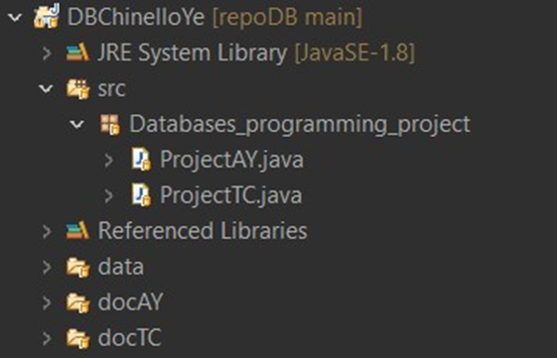

1.0.1. Structure of the code source packages

Our source code is placed inside packages located under src.
Test classes are placed inside the folder src, package Databases_programming_project.
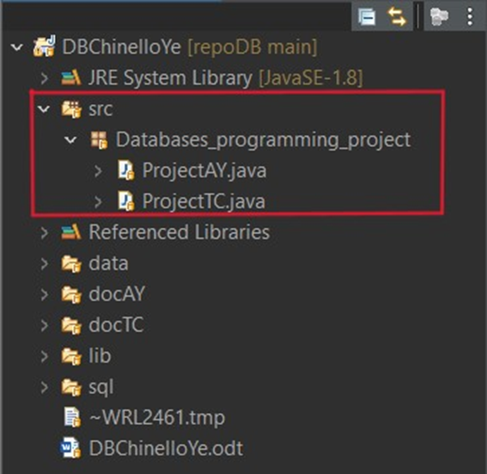

1.0.2. Structure of the data files and datasets

Input changed is placed at the Project folder level or in a specific folder named “data”.
Library we used to connect to sql database and use classes of it is in the folder named “lib”.
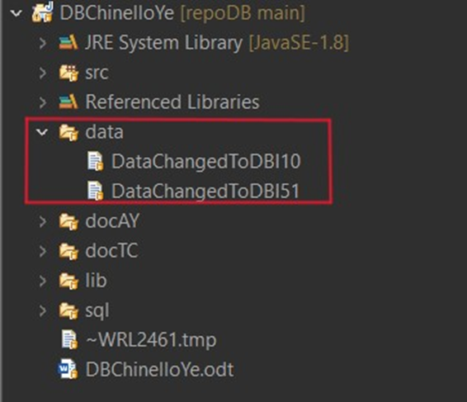

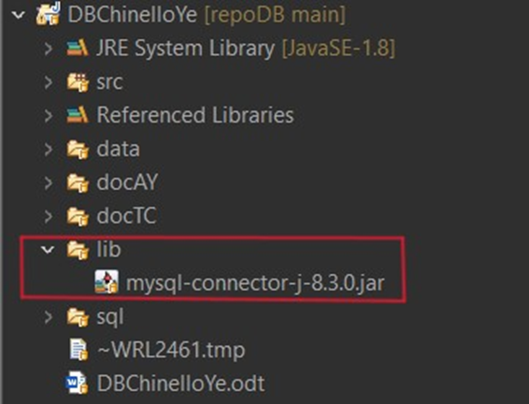
1.0.3. Location of the documentation
The main document that describes our project is named: DBChinelloYe.odt and it is located in the main Project Folder. Then we have generated one Javadoc for each ProjectXX.java, each one is located in the corresponding folder docXX:
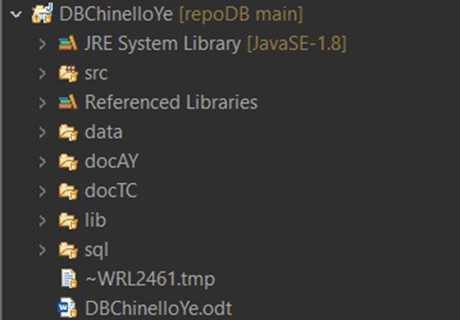

2. Structure of the Software
The project content and the alternative solutions to the requirements will evolve as the course progresses, so recording the activities performed will allow the stakeholders to assess the status of the project.
The scheme for this section can be organized with the following subsections.

2.1. Classes design
Both have a method of getconnection() to keep it easier the call to each database.

Tommaso’s classes to perform transactions:

insertDependent(Connection conn, String Essn, String Dependent_name, String Sex, String Bdate, String Relationship): Inserts a dependent record into the database.
insertProject(Connection conn, String Pname, int Pnumber, String Plocation, int Dnum ): Inserts a project record into the database.
insertWorker(Connection conn, String Essn, int Pno, String Hours): Inserts a worker into the database.
deleteDependent(Connection conn, String Essn,String Dependent_name): Deletes a dependent from the database.
deleteProject(Connection conn, int Pnumber): Deletes a project from the database, including related records, like employees in the table works_on.
updateWorkson(Connection conn): Update the project of an employee in the works_on table.

Alaitz’s classes to perform transactions:

insertDepartment(Connection conn, String name, int number, String mgrSsn, String mgrStartDate): Inserts a department record into the database.
deletePerson(Connection conn, String nameId): Deletes a person record from the database, including related records from associated tables (eats, frequents).
updateOptionalExcursion(Connection conn): Updates an optional excursion in the database by modifying the Price column in the optional_excursion table.
insertPerson(Connection conn, String nameId, int age, String gender, String id): Inserts a person record into the database.
deleteDepartment(Connection conn, int dnumber): Deletes a department record from the database based on the department number (Dnumber).

2.2 TRANSACTIONS designed by each member of the group.
The first part of the ProjectXX.java file, for both members of the group is dedicated to the connection to the database and setting the auto-commit mode to false, this allows for transaction management where multiple operations can be treated as a single unit of work.
To interact with the user we have utilized the `javax.swing.JOptionPane` package. This package provides a set of standard dialog boxes that prompt users for a value or inform them of something. In our specific case, we have used it to present three options to the user. The first one to do some transactions that will modify the databases, the second one to revert all changes from the first one, and the last one to execute one of five queries. The choice of the query is offered using always the JOptionPane package.
The user can choose between the 5 queries until he decides to close the connection with the database by choosing the number 0 to exit.
The transactions for each member are described in the following lines:

2.2.1 Tommaso Chinello’s part:
Before and after each transaction, it is shown in output what changes in the database. (using the function getTable() for each table)
Insertion in Dependent Table
Two records are inserted into the dependent table without using a savepoint. The commit operation is then executed to save these changes to the database.
Insertion in Project Table Using Savepoint
Three records are inserted into the project table using a savepoint. If an error occurs after the savepoint, the transaction can be rolled back to the savepoint instead of discarding all changes in the transaction. Three new projects are added to the table.

Update Works_On Table
The works_on table is updated by changing the number of the project to a worker. The changes are then committed to the database.

Deletion from Tables
A project and some dependents are deleted from their respective tables. The deletion of the project caused the deletion of some workers in the Works_on table. The changes are then committed to the database.

To revert all changes
It was done a transaction that inserted Dependents, Projects, Workers in the correspondent tables, and deleted some of them to revert all changes caused by the previous transactions.

5 Queries
1. Using the Travel database: the user can choose a city; the query retrieves the trips whose price per day is greater than the price per day of all trips with destination that city. The query uses a subquery and the keyword ALL to confront the Ppday of all trips.
2. Using the Company database: the user can choose a salary; the query retrieves employees that are making more than that salary in the department with more than 2 employees. It is divided in main query and subquery: the subquery is helping to filter departments in the main query based on the count of employees.
3. Using the Restaurant database: The structure of the query is such that it’s using the results of the subqueries to filter the data in the main query. In this case, the subqueries are helping to filter restaurants in the main query based on the dishes they serve. The query is designed to return the names of restaurants that serve all the dishes listed in the dishes table. This is a typical example of a relational division query.
4. Using Company database: The structure of the query is such that it’s using the results of the two main queries to create a unified list of project names and numbers associated with a specific employee, based on the last name provided. The UNION operator ensures that the final result-set contains only distinct values.
5. The query is retrieving the customer names, customer IDs, and customer phone numbers for customers who have booked trips at hotels in a specific city. The results are sorted by customer name using ORDER BY.

2.2.2 Alaitz’s transactions
In the realm of database configuration, the configureDatabase method orchestrates several crucial tasks. It inserts data into the department table, showcasing both standard insertion techniques and insertion employing savepoints for transaction management. Additionally, it updates records within the optional_excursion table and performs deletion operations on the person table, exemplifying diverse database manipulation scenarios as it has foreign key with other table, have to create the deletion there too (there were many options to solve this, but to program more it has been done like that).

INSERT transaction before:

INSERT transaction after:
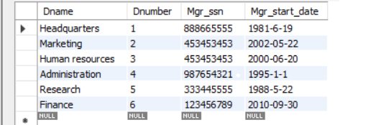

UPDATE transaction before:
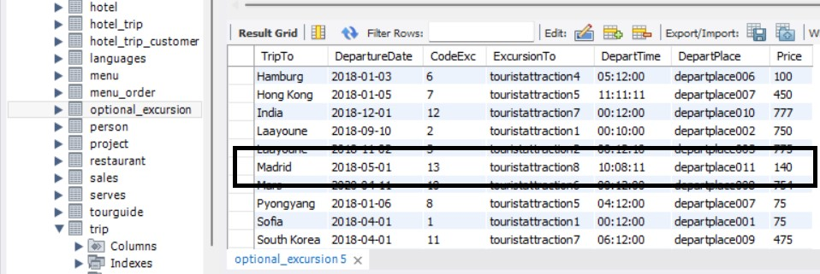
UPDATE transaction after:
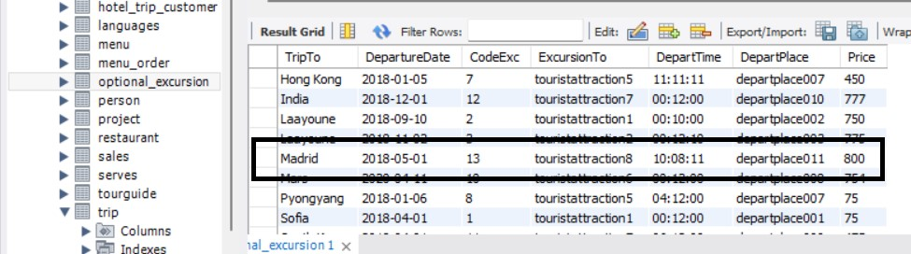
DELETE transaction before:
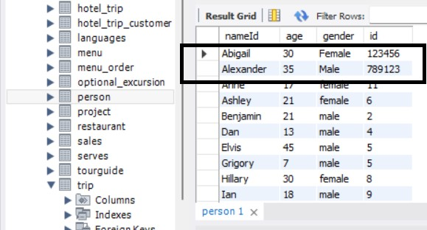
DELETE transaction after: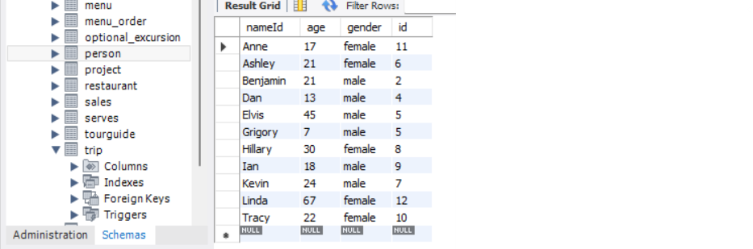

The executeQueries method enriches the program's functionality by enabling users to execute predefined SQL queries interactively. This dynamic feature prompts users to input a query number (ranging from 1 to 5) or 0 to exit. Based on the provided query number, the program executes the corresponding SQL query and displays the results.

5 queries:
- Tour Guide Matching Customers Query:
This query aims to find tour guides whose names partially match those of customers they guide. It selects the guidename from the tourguide table where the GuideId matches with the CustomerId from the customer table, based on a partial match of the customer’s name with the tour guide name. The subquery correlates the tour guide's GuideId with the customer's CustomerId, filtering results based on this relationship.

- Person Exclusion Query:
This query retrieves distinct nameId values from the person table. It ensures that the selected individuals do not meet certain criteria by using the NOT EXISTS predicate with subqueries. Specifically, it excludes persons who have made purchases exceeding a certain amount from a restaurant named 'KingMeal', those who frequent a restaurant named 'GoodFood', those who eat a dish named 'eggsbenedicte', and those who are served by a restaurant named 'LittleFat' with a price greater than $10.00.

- Unmatched Tour Guides Query:
This query identifies tour guides who have no corresponding entry in the customer table. It selects the guidename from the tourguide table where the guidename is not found in the custname column of the customer table. Essentially, it retrieves tour guides who have not been assigned any customers based on a lack of matching entries in the customer table.

- Customer Trips by Language Query:
This query retrieves distinct customer names from the trip, tourguide, languages, hotel_trip_customer, and customer tables based on a specified language. It selects customers who have booked trips guided in the specified language by joining multiple tables on common fields such as guideId and customerId, and filtering results based on the provided language.

- Trip Details by City Query:
This query retrieves trip destinations (TripTo) and departure dates (DepartureDate) from the trip table for trips departing from a specified city. It selects trip details where the CityDeparture matches the provided city name, displaying the destination and departure date for each matching trip.

2.3 Other additional work done by each member of the group.
In the code of Alaitz, for ensuring error handling and unmake changed done before, the program incorporates a method named revertChanges. This method employs savepoints to manage transactions, allowing for the rollback of changes in case of errors during database manipulation. It conducts operations similar to the configuration method but with the intent of reverting these changes if an error arises.

In Tommaso’s code, before and after each transaction, it is shown the tables that are affected by the transactions. It is also used the method revertChanges to unmake changes done in the configuration of the database.

3. Notes of the Meetings
Our team primarily communicated through text messages. Our communication was seamless and effective. We were able to understand each other’s perspectives and ideas clearly, which contributed to the smooth progression of the project.
The collaboration between us was highly efficient. We discussed potential solutions, evaluated their pros and cons, and decided on the best course of action together.

4. Conclusions
Throughout the project, we achieved several milestones and implemented a range of functionalities, including transaction management, database manipulation, and interactive querying.
Both team members have contributed significantly to the project, with Alaitz focusing on transaction implementation and error handling, while Tommaso concentrated on database manipulation and interactive querying. The distribution of work was balanced.
In conclusion, our project demonstrates a high level of technical proficiency, effective teamwork, and commitment to delivering a robust and functional database management system. We are proud of our achievements and confident in the value that our software provides to users in managing database transactions effectively.

5. Bibliography and references
Esat Erkec, “Transaction in sql server for beginners”, SQLShack, 2021
https://www.sqlshack.com/transactions-in-sql-server-for-beginners/
pildorasinformaticas, github and eclipse, Youtube, 2021
https://www.youtube.com/watch?v=TpB6rk7fKvQ

