“DataBases
Programming Project”

Date: 13/05/2024

Group Members:

Alaitz Shan Ye Pardavila, University of the Basque Country, Spain
YourNameSurname, YourUniversityofOrigin
Ex: J. Dolado, UPV/EHU, Univ. of the Basque Country, Spain
--- F. Ibáñez, UPV/EHU, Univ. of the Basque Country, Spain
--- A. Arruarte, UPV/EHU, Univ. of the Basque Country, Spain

aye003@ikasle.ehu.es
xxxxx@ehu.es

Subject: Databases
Degree: Informatics Engineering
Academic Year: 2023/2024
School: Facultad de Informática

Table of Contents
Abstract 3
1. Introduction 3
2. Structure of the Software 3
2.1. Classes design 3
2.2 TRANSACTIONS designed by each member of the group 3
Transactions of Group member 1 3
Transactions of Group member 2 3
2.3 Other additional work done by each member of the group 3
3. Notes of the Meetings 3
4. Conclusions 4
5. Bibliography and references 4
Annexes 4
Annex 0. Any interesting documentation 4
Annex 1. More documents of interest 4

Abstract

This project focuses on the development of a little database management that involves the manipulation of some transactions like insert, update and remove of data used during this curse.
We have combined java and SQL to give to the user versatility and robustness of the power of those tools in database world.

1. Introduction
The introduction describes the project and the tasks that have been performed. The full description of the requirements of the project can be attached as an annex.
It is recommended that the group uses some collaborative system for the documentation, or even for the project (git, docs, etc.).

1.0.0 About the structure of the Java Project in Eclipse
In order to have a clear and uniform structure of your Java project across different systems and users, the structure of the code in the Eclipse IDE, or other, should conform to the following conventions and diagrams.
Your main Project Java Folder must have the following format for its name: “DBSurname1Surname2Surname3”, where DB is the code for this course and the surnames correspond to the members of your project.

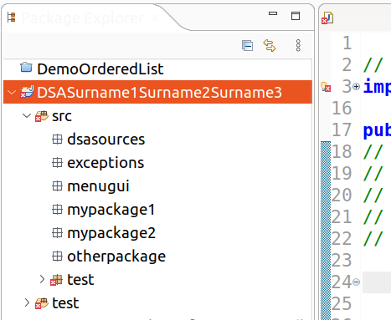
DB

1.0.1. Structure of the code source packages

Source code must be placed inside packages located under src or test.
Test classes may be placed inside the folder test or inside the folder src, package test.

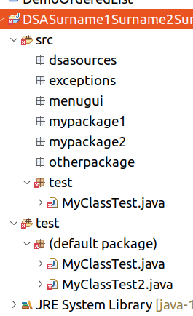
DB

1.0.2. Structure of the data files and datasets

Input files can be placed at the Project folder level or in a specific folder named “data”.
Output files can be place at the Project folder level or in a specific folder named “output”.
The data files that you create must have the code of your project somewhere in the filename. Example: if the code of your group is G00000 and you create a text file of people, the filename for the file will be peopleG00000.txt. The same idea applies to the output files that you generate.
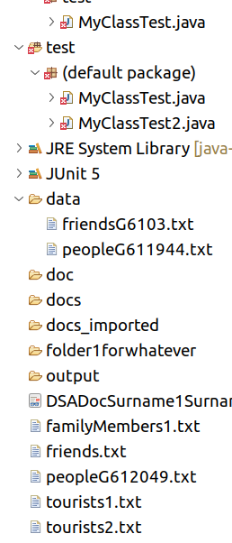

1.0.3. Location of the documentation
The main document that describes your project must be named with this format: DBSurname1Surname2Surname3.pdf (and/or other formats), where DB is the code for this course and the surnames correspond to the members of your project.
The document must be located in the main Project Folder, not in any of the subfolders.
Other documentation may be placed in doc, docs, or other ..

2. Structure of the Software
The project content and the alternative solutions to the requirements will evolve as the course progresses, so recording the activities performed will allow the stakeholders to assess the status of the project.
The scheme for this section can be organized with the following subsections.

2.1. Classes design
As the title says, the description of the Java classes designed

2.2 TRANSACTIONS designed by each member of the group
Here you may explain the transactions designed and the datasets used, if any.
    - Transactions of Group member 1

2.3 Other additional work done by each member of the group

3. Notes of the Meetings
Write down here whatever was worth of remark of the group meetings.

4. Conclusions
In this section you may describe the main merits of your project.
You may also state here the percentage of the work performed by each member of the group. The marks will be adjusted accordingly.
If you have done other additional work in the project you must describe here its main characteristics and the Section in which it is fully described.

5. Bibliography and references
Author 1, “An interesting book”, International press, 2010
http://an.internet.web.com

Annexes

Annex 0. Any interesting documentation
Annex 1. More documents of interest

