“DataBases
Programming Project”

Date: 13/05/2024

Group Members:

Alaitz Shan Ye Pardavila, University of the Basque Country, Spain
Tommaso Chinello, Università di Padova, Italy

aye003@ikasle.ehu.es
tchinello001@ikasle.ehu.es

Subject: Databases
Degree: Informatics Engineering
Academic Year: 2023/2024
School: Facultad de Informática

Table of Contents
Abstract 3
1. Introduction 3
2. Structure of the Software 3
2.1. Classes design 3
2.2 TRANSACTIONS designed by each member of the group 3
Transactions of Group member 1 3
Transactions of Group member 2 3
2.3 Other additional work done by each member of the group 3
3. Notes of the Meetings 3
4. Conclusions 4
5. Bibliography and references 4
Annexes 4
Annex 0. Any interesting documentation 4
Annex 1. More documents of interest 4

Abstract

This project focuses on the development of a little database management that involves the manipulation of some transactions like insert, update and remove of data used during this curse.
We have combined java and SQL to give to the user versatility and robustness of the power of those tools in database world.

1. Introduction

This document provides an overview of our project. Over the course of this project, we have performed several tasks.
We loaded the JDBC Drivers, connected to the DB and each component of the team has then issued several transactions to it.
The team has used GitHub to ensure effective collaboration and documentation.

1.0.0 About the structure of the Java Project in Eclipse

In order to have a clear and uniform structure of your Java project across different systems and users, the structure of the code in the Eclipse IDE, or other, should conform to the following conventions and diagrams.
Your main Project Java Folder must have the following format for its name: “DBSurname1Surname2Surname3”, where DB is the code for this course and the surnames correspond to the members of your project.

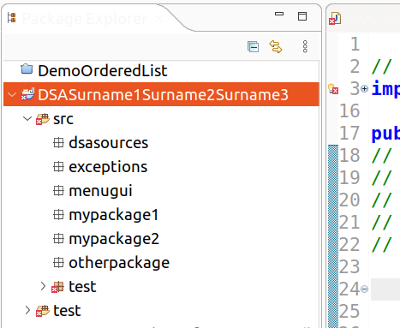
DB

1.0.1. Structure of the code source packages

Source code must be placed inside packages located under src or test.
Test classes may be placed inside the folder test or inside the folder src, package test.
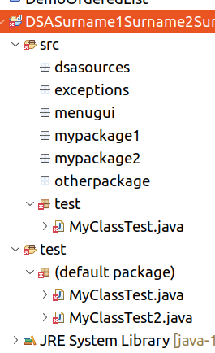
DB
1.0.2. Structure of the data files and datasets

Input files can be placed at the Project folder level or in a specific folder named “data”.
Output files can be place at the Project folder level or in a specific folder named “output”.
The data files that you create must have the code of your project somewhere in the filename. Example: if the code of your group is G00000 and you create a text file of people, the filename for the file will be peopleG00000.txt. The same idea applies to the output files that you generate.
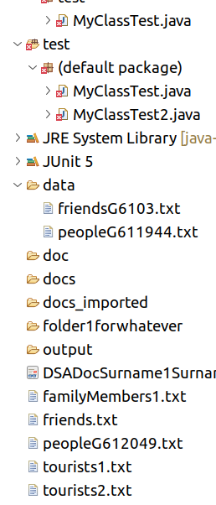

1.0.3. Location of the documentation
The main document that describes your project must be named with this format: DBSurname1Surname2Surname3.pdf (and/or other formats), where DB is the code for this course and the surnames correspond to the members of your project.
The document must be located in the main Project Folder, not in any of the subfolders.
Other documentation may be placed in doc, docs, or other ..

2. Structure of the Software
The project content and the alternative solutions to the requirements will evolve as the course progresses, so recording the activities performed will allow the stakeholders to assess the status of the project.
The scheme for this section can be organized with the following subsections.

2.1. Classes design
As the title says, the description of the Java classes designed.

2.2 TRANSACTIONS designed by each member of the group.
The first part of the ProjectXX.java file, for both members of the group is dedicated to the connection to the database and setting the auto-commit mode to false, this allows for transaction management where multiple operations can be treated as a single unit of work.
To interact with the user we have utilized the `javax.swing.JOptionPane` package. This package provides a set of standard dialog boxes that prompt users for a value or inform them of something. In our specific case, we have used it to present three options to the user. The first one to do some transactions that will modify the databases, the second one to revert all changes from the first one, and the last one to execute one of five queries. The choice of the query is offered using always the JOptionPane package.
The user can choose between the 5 queries until he decides to close the connection with the database by choosing the number 0 to exit.
The transactions for each member are described in the following lines:

2.2.1 Tommaso Chinello’s part:
Insertion in Dependent Table
Two records are inserted into the dependent table without using a savepoint. The commit operation is then executed to save these changes to the database.
Insertion in Project Table Using Savepoint
Three records are inserted into the project table using a savepoint. If an error occurs after the savepoint, the transaction can be rolled back to the savepoint instead of discarding all changes in the transaction. Three new projects are added to the table.

Update Works_On Table
The works_on table is updated by changing the number of the project to a worker. The changes are then committed to the database.

Deletion from Tables
A project and some dependents are deleted from their respective tables. The deletion of the project caused the deletion of some workers in the Works_on table. The changes are then committed to the database.

To revert all changes
It was done a transaction that inserted Dependents, Projects, Workers in the correspondent tables, and deleted some of them to revert all changes caused by the previous transactions.

5 Queries
1. Using the Travel database: the user can choose a city; the query retrieves the trips whose price per day is greater than the price per day of all trips with destination that city. The query uses a subquery and the keyword ALL to confront the Ppday of all trips.
2. Using the Company database: the user can choose a salary; the query retrieves employees that are making more than that salary in the department with more than 2 employees. It is divided in main query and subquery: the subquery is helping to filter departments in the main query based on the count of employees.
3. Using the Restaurant database: The structure of the query is such that it’s using the results of the subqueries to filter the data in the main query. In this case, the subqueries are helping to filter restaurants in the main query based on the dishes they serve. The query is designed to return the names of restaurants that serve all the dishes listed in the dishes table. This is a typical example of a relational division query.
4. Using Company database: The structure of the query is such that it’s using the results of the two main queries to create a unified list of project names and numbers associated with a specific employee, based on the last name provided. The UNION operator ensures that the final result-set contains only distinct values.
5. The query is retrieving the customer names, customer IDs, and customer phone numbers for customers who have booked trips at hotels in a specific city. The results are sorted by customer name using ORDER BY.

2.2.2

2.3 Other additional work done by each member of the group.

3. Notes of the Meetings
Our team primarily communicated through text messages. Our communication was seamless and effective. We were able to understand each other’s perspectives and ideas clearly, which contributed to the smooth progression of the project.
The collaboration between us was highly efficient. We discussed potential solutions, evaluated their pros and cons, and decided on the best course of action together.

4. Conclusions
In this section you may describe the main merits of your project.
You may also state here the percentage of the work performed by each member of the group. The marks will be adjusted accordingly.
If you have done other additional work in the project, you must describe here its main characteristics and the Section in which it is fully described.

5. Bibliography and references
Author 1, “An interesting book”, International press, 2010
http://an.internet.web.com

Annexes

Annex 0. Any interesting documentation
Annex 1. More documents of interest

