**MINOR-2 PROJECT**

**Software Requirement Systems**

For

**A Deep Learning Approach for Ship Detection & Localization using Satellite Imagery**

Submitted By

| **Specialization** | **SAP ID** | **Name** |
| --- | --- | --- |
| B.Tech CSE(AIML) Hons. | 500082346 | Sparsh Patial |
| B.Tech CSE(AIML) Hons. | 500083042 | Akshat Mittal |
| B.Tech CSE(AIML) Hons. | 500084027 | Aditya Aryan |
| B.Tech CSE(AIML) | 500083578 | Alakh Niranjan |



Department of Informatics

School Of Computer Science

UNIVERSITY OF PETROLEUM & ENERGY STUDIES,

DEHRADUN- 248007. Uttarakhand

Dr. Tanupriya

Choudhury Dr. Thipendra P Singh  **Project Guide Cluster Head**

# Table of Contents

| **Topic** | | **Page No** |
| --- | --- | --- |
| Table of Content | | 1 |
| 1 | Introduction | 2 |
|  | 1.1 Purpose of the Project | 2 |
|  | 1.2 Target Beneficiary | 2-3 |
|  | 1.3 Project Scope | 3 |
|  | 1.4 References | 3-4 |
| 2 | Project Description | 5 |
|  | 2.1 Reference Algorithm | 5-6 |
|  | 2.2 Data/ Data structure | 6 |
|  | 2.3 SWOT Analysis | 6-7 |
|  | 2.4 Project Features | 7 |
|  | 2.5 User Classes and Characteristics | 7 |
|  | 2.6 Assumption and Dependencies | 7 |
|  | 2.7 Design Diagrams | 8-10 |
|  | 2.8 Assumption and Dependencies | 10 |
| 3 | System Requirements | 10 |
|  | 3.1 User Interface | 10 |
|  | 3.2 Software Interface | 10 |
|  | 3.3 Database Interface | 10 |
|  | 3.4 Protocols | 10 |
| 4 | Non-functional Requirements | 11 |
|  | 4.1 Performance requirements | 11 |
|  | 4.2 Security requirements | 11 |
|  | 4.3 Software Quality Attributes | 11 |
| Appendix A: Glossary, B: ANALYSIS MODEL, C:ISSUES | | 12 |

## **1. INTRODUCTION**

Ship detection and localization is a crucial task for various maritime applications, including vessel traffic management, maritime security, and environmental monitoring. In recent years, there has been a growing interest in using satellite imagery for ship detection and localization due to its wide coverage, high resolution, and ability to capture information in different spectral bands. However, manual analysis of large volumes of satellite imagery is time-consuming and requires significant human effort, making it impractical for real-time applications.

To address this challenge, deep learning techniques have been applied to satellite imagery for ship detection and localization. Deep learning is a subfield of machine learning that uses artificial neural networks with multiple layers to extract high-level features from data. Deep learning has shown remarkable success in various computer vision tasks, including object detection, classification, and segmentation. By using deep learning techniques, researchers have been able to develop automated ship detection and localization systems that can process large volumes of satellite imagery in real-time, making it feasible for applications that require quick response times.

This approach typically involves training a deep neural network on a large dataset of annotated satellite images to learn the features that are indicative of ships. The trained network can then be used to detect and localize ships in new satellite images. This approach has shown promising results in several studies and has the potential to revolutionize the way ship detection and localization are performed.

In this context, this paper proposes a deep learning approach for ship detection and localization using satellite imagery. The paper presents a detailed analysis of the methodology, including the dataset used, network architecture, and training process. Additionally, the paper evaluates the performance of the proposed approach using various metrics and compares it to other state-of-the-art techniques. The results demonstrate the effectiveness of the proposed approach in detecting and localizing ships in satellite imagery, highlighting its potential for various maritime applications.

**1.1 Purpose of the Project**

* The purpose of our project is to develop a system that can automatically detect and localize ships in satellite imagery using deep learning techniques. The primary goal of the project is to provide an accurate and efficient solution for ship detection, which can be used for a variety of applications, including maritime surveillance, border control, and search and rescue operations.
* The project aims to overcome the limitations of traditional methods of ship detection, which are often time-consuming and require human intervention. By leveraging the power of deep learning algorithms, the project seeks to provide a more reliable and automated solution that can detect and locate ships in real-time. The system will be designed to handle large amounts of data and provide accurate results even in challenging environmental conditions.
* Ultimately, the project aims to contribute to the development of advanced technologies that can improve maritime safety and security, as well as facilitate the management of maritime activities. The system developed as part of this project has the potential to be used by various stakeholders, including maritime authorities, defence organizations, and commercial entities operating in the maritime industry.

**1.2 Target Beneficiaries**

* With the growing world population, particularly in developing nations, low cost and efficient maritime transport has a vital role to play in the growth and sustainable development of the world. Ships travel the world’s oceans and other sufficiently deep waterways, carrying cargo or passengers, or are used for specialized missions, such as defense, research and fishing. Therefore, maritime tracking and ship detection is really essential and an ideal way to manoeuvre and stabilize a ship’s route and course enabling marine and naval vessels to track, identify and monitor a ship’s position, location thus helping in preventing collision of ships and port management. It’s also a crucial application for maritime security which includes among others traffic surveillance, protection against illegal fisheries, oil discharge control and sea pollution monitoring. Therefore, the target beneficiaries of this project are not only mariners but also the people in the defense sector.

**1.3 Project Scope**

* The scope of the project is to be able to detect and segment ships in an image, as it would be of great help to the logistics and transportation departments of the country. It could bring a whole new dimension of transport for container ships and vessels by tracking ships from satellite images in real time.
* This project will also be of crucial importance to maritime surveillance as it will be able to assist in monitoring and controlling illegal fishing, marine traffic, and similar activities along the sea boundaries.

**1.4 References**

[1] Chong, J.; Zhu, M. Survey of the Study on Ship and Wake Detection in SAR Imagery. Acta Electron. Sin. 2003, 31, 1356–1360.

[2] Xi, Y.; Zhang, X.; Lai, Q.; Li, W.; Lang, H. A New PolSAR Ship Detection Metric Fused by Polarimetric Similarity and the Third Eigenvalue of the Coherency Matrix. In Proceedings of the IEEE International Geoscience and Remote Sensing Symposium, Beijing, China, 10–15 July 2016; pp. 112–115

[3] Yu, W.; Wang, Y.; Liu, H.; He, J. Superpixel-Based CFAR Target Detection for High-Resolution SAR Images. IEEE Geosci. Remote Sens. Lett. 2016, 13, 730–734.

[4] Fan, Q.; Chen, F.; Cheng, M.; Wang, C.; Li, J. A Modified Framework for Ship Detection from Compact Polarization SAR Image. In Proceedings of the IEEE International Geoscience and Remote Sensing Symposium, Valencia, Spain, 22–27 July 2018; pp. 3539–3542.

[5] Markopoulos, P.; Dhanaraj, M.; Savakis, A. Adaptive L1-Norm Principal-Component Analysis with Online Outlier Rejection. IEEE J. Sel. Top. Signal Process. 2018, 12, 1131–1143.

[6] Javed, S.; Mahmood, A.; Al-Maadeed, S.; Bouwmans, T.; Ki Jung, S. Moving Object Detection in Complex Scene Using Spatiotemporal Structured-Sparse RPCA. IEEE Trans. Image Process. 2018, 28, 1007–1022.

[7] Biondi, F. Low-Rank Plus Sparse Decomposition and Localized Radon Transform for Ship-Wake Detection in Synthetic Aperture Radar Images. IEEE Geosci. Remote Sens. Lett. 2018, 15, 117–121.

[8] Li, C.; Yu, Z.; Chen, J. Overview of Techniques for Improving High-resolution Spaceborne SAR Imaging and Image Quality. J. Radars 2019, 8, 717–731.

[9] Liu, T.; Yang, Z.; Yang, J.; Gao, G. CFAR Ship Detection Methods Using Compact Polarimetric SAR in a K-Wishart Distribution. IEEE J. Sel. Top. Appl. Earth Obs. Remote Sens. 2019, 12, 3737–3745.

[10] Li, J.; Tian, J.; Gao, P.; Li, L. Ship Detection and Fine-Grained Recognition in Large-Format Remote Sensing Images Based on Convolutional Neural Network. In Proceedings of the IEEE International Symposium on Geoscience and Remote Sensing (IGARSS), Waikoloa, HI, USA, 26 September–2 October 2020; pp. 2859–2862.

[11] Ai, J.; Cao, Z.; Xing, M. An Adaptive-trimming-depth Based CFAR Detector of Heterogeneous Environment in SAR Imagery. Remote Sens. Lett. 2020, 11, 730–738.

[12] Ai, J.; Cao, Z.; Mao, Y.; Wang, H.; Wang, F.; Jin, J. An Improved Bilateral CFAR Ship Detection Algorithm for SAR Image in Complex Environment. J. Radars 2021, 10, 499–515.

[13] Liu, T.; Yang, Z.; Jiang, Y.; Gao, G. Review of Ship Detection in Polarimetric Synthetic Aperture Imagery. J. Radars 2021, 10, 1–19.

[14] Zou, B.; Qiu, Y.; Zhang, L. Ship Detection Using PolSAR Images Based on Simulated Annealing by Fuzzy Matching. IEEE Geosci. Remote Sens. Lett. 2022, 19, 1–5

## **2. PROJECT DESCRIPTION**

The overall design algorithm of the project consists of four components:

The figure describes the overall steps involved in this project.

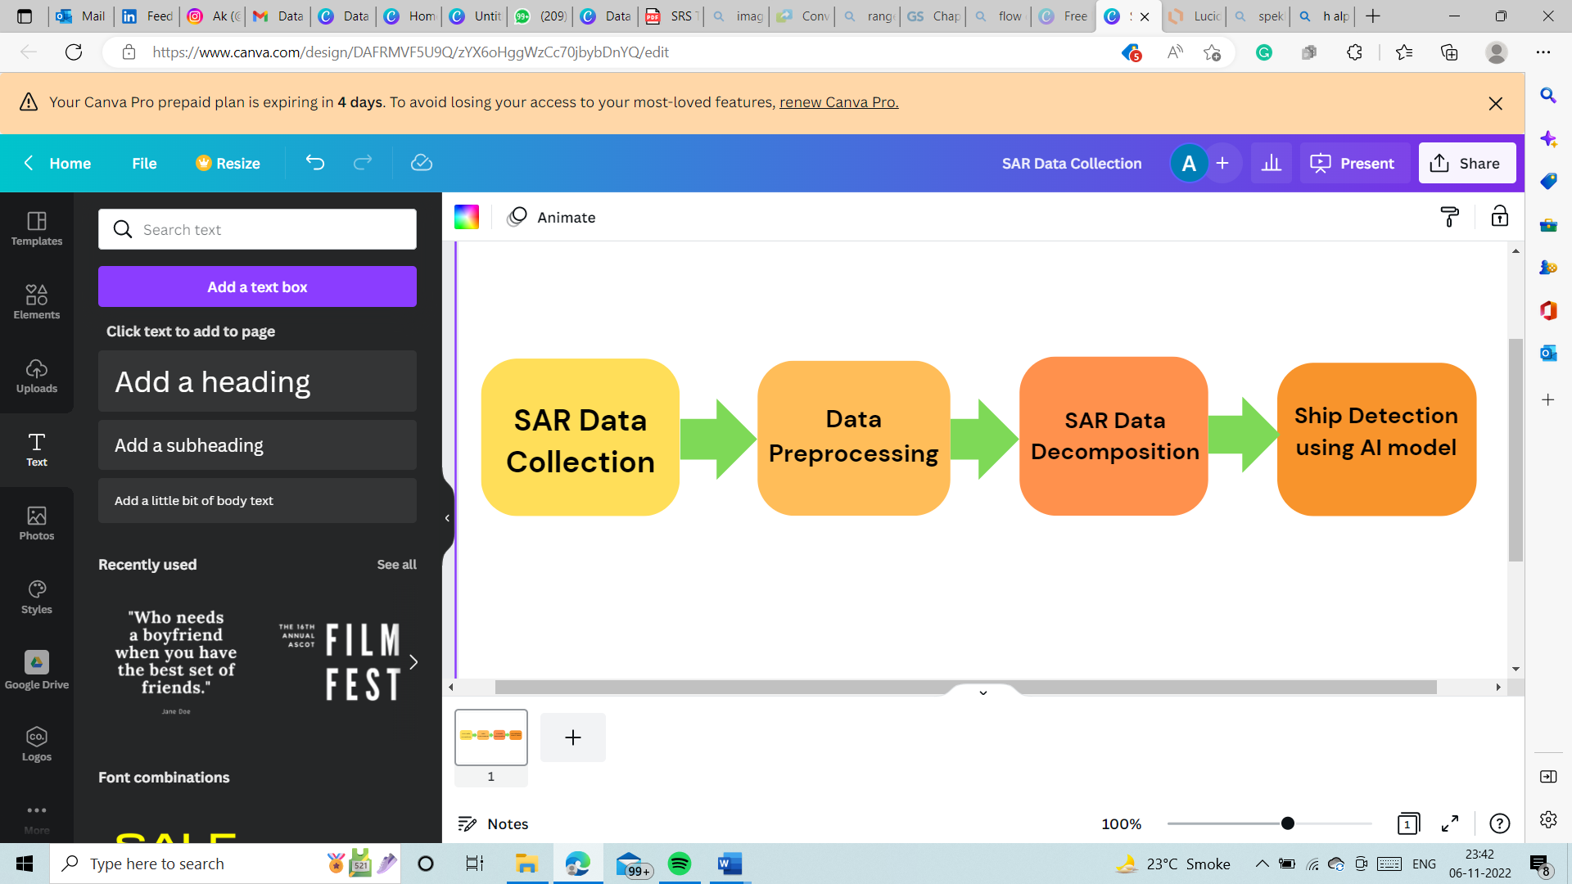

Fig.1 Project model workflow

**2.1 Reference Algorithm**

**U-Net:**

The U-Net is a deep convolutional neural network architecture that is widely used for image segmentation tasks, including ship detection in satellite images. To detect ships in satellite images using U-Net, the network is trained on a large dataset of annotated satellite images, where the ships are labeled as the foreground and the background is labeled as the sea or sky. During training, the network learns to identify the unique features of ships, such as their shapes, colors, and textures, and to distinguish them from the surrounding background.

Once the U-Net is trained, it can be used to detect ships in new satellite images by segmenting the image into foreground (ship) and background (sea/sky) regions. This segmentation process involves passing the input image through the U-Net and obtaining a segmentation map, which indicates the probability of each pixel belonging to the foreground or background. The segmentation map is then thresholded to obtain a binary mask, where the foreground pixels correspond to the ship and the background pixels correspond to the sea/sky.

Overall, U-Net provides an efficient and accurate way to detect ships in satellite images, which can have many applications in fields such as maritime surveillance, environmental monitoring, and navigation. The U-Net model is a popular neural network architecture for semantic segmentation tasks, including ship detection. Here's a general overview of how the U-Net algorithm works for ship detection:

* **Input:** The U-Net model takes as input an image that contains one or more ships.
* **Encoding Path:** The image is first passed through a series of convolutional layers that extract features from the image. The size of the feature maps is reduced at each layer, while the number of feature maps is increased.
* **Decoding Path:** The feature maps obtained from the encoding path are then passed through a series of transposed convolutional layers that upsample the feature maps back to the size of the input image. At each layer, the feature maps are concatenated with the corresponding feature maps from the encoding path, allowing the decoder to combine information from different scales.
* **Output:** The final layer of the U-Net model produces a segmentation mask that indicates which pixels in the input image belong to a ship and which do not. The output mask has the same size as the input image.
* **Training:** The U-Net model is trained using a loss function that measures the difference between the predicted segmentation mask and the ground truth mask. The most common loss function used for semantic segmentation is the cross-entropy loss.

By training the U-Net model on a large dataset of ship images with their corresponding ground truth masks, the model can learn to accurately detect ships in new images.

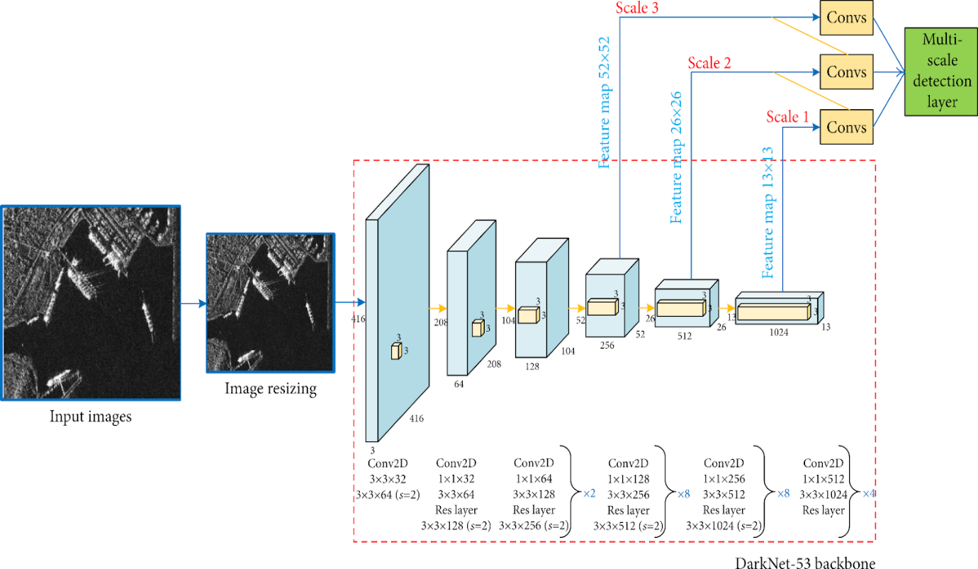

**Fig No.2 U-net backbone structure for the model**

**2.2 Characteristic of Data**

The Sentinels are the satellites of European Space Agency (ESA), designed to deliver a vast amount of data and imagery for Europe’s Copernicus program. The Sentinel-1 is equipped with twin polar orbiting satellites designed to provide a spatial data for environment and security warranting, global economic and business growth. As Sentinel-1 provides data with high spatial and temporal resolution it is useful for ship detection. In this project, we’ll be using Synthetic Aperture Radar (SAR) data for ship detection as it has its advantages over optical data.[1] It uses radio waves typically ranging from approximately 3 cm up to a few meters in wavelength, which is much longer than the wavelength of visible light, used in creating optical images. SAR images are very different from optical images as it does not utilize the light from the sun to generate a picture rather it actively illuminates the region to be captured. Thus, making it more efficient for capturing images at night or when clouds or smoke are present as the waves used in [2] SAR can penetrate through clouds making it a 24-hour, all-weather technology.

The Dataset is extracted from a secondary source that is <https://scihub.copernicus.eu>.

**2.3 SWOT Analysis**

* ​STRENGTH:​

The model will have an ability to learn and analyze the images accurately.

* WEAKNESS: ​

It works as a black box and takes time in computations.​

The complexities that are taking place in hidden layers remains unknown to us.​

* OPPORTUNITIES: ​

The model can be used to solve real world problems accurately.​

* THREAT: ​

If the system corrupts it can affect our cache memory.​

It can drastically affect our GPU and CPU.

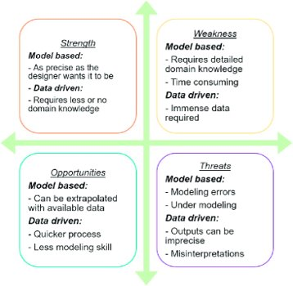

**Fig No.3 SWOT-Analysis**

**2.4 Project Features**

* Our project uses computers to identify and locate ships in pictures taken from space. The project uses advanced techniques like deep learning and computer vision to train the computer to recognize ships in images. It uses a large set of pictures of ships and other things to teach the computer what ships look like. The computer is also taught to adjust the images to make them easier to recognize, and to ignore things that aren't ships. Once trained, the computer can quickly and accurately identify and locate ships in new images. This technology has practical applications in real-world scenarios like maritime surveillance and monitoring, marine traffic control, and search and rescue operations.

**2.5 User classes and characteristic**

* User classes of the project are mariners and also people from the defense sector. The project focusses on accurately detecting the ships along the sea boundaries to look for visual evidence of ‘dark’ vessels and for maritime security which includes among other applications such as traffic surveillance, protection against illegal fisheries, oil discharge control and sea pollution monitoring.

**2.6 Design and Implementation Constraints**

* DESIGN: The user interface of our project basically takes input by the user and processes it to give output.
* CONSTRAINTS: The constraints of this can be that if the user tries to process a lot of data the system might take a lot of time and memory space to render the raw data.

**2.7 Design Diagrams**

* **Data Flow Diagram:**

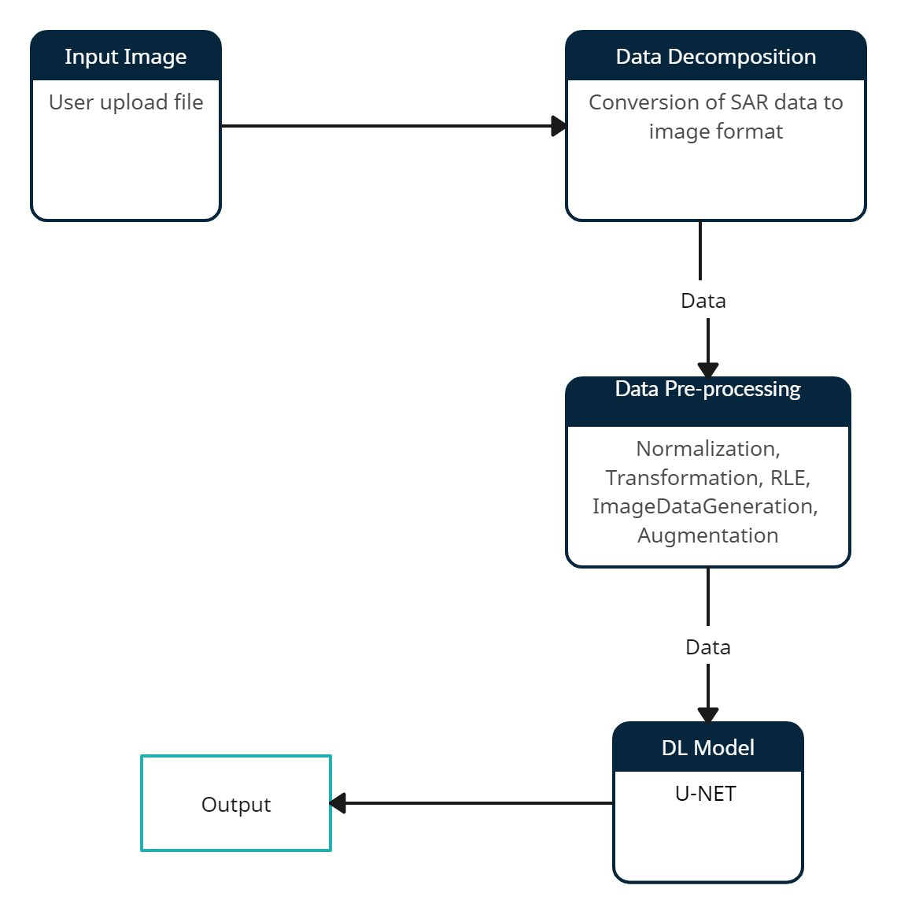

**Fig No.4 Data Flow Diagram**

* **Use Case Diagram:**

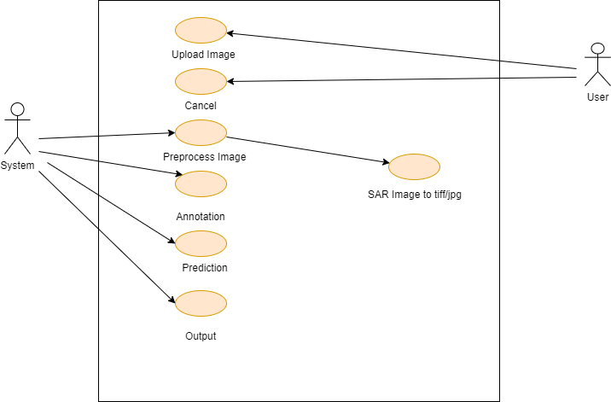

**Fig No.5 Use-Case Diagram for the model**

* **UML Diagram:**

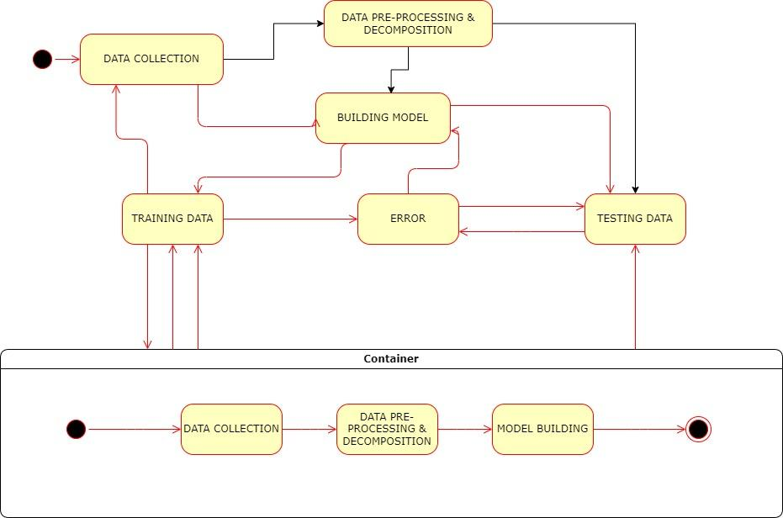

**Fig No.6 UML Diagram**

* **PERT Chart:**

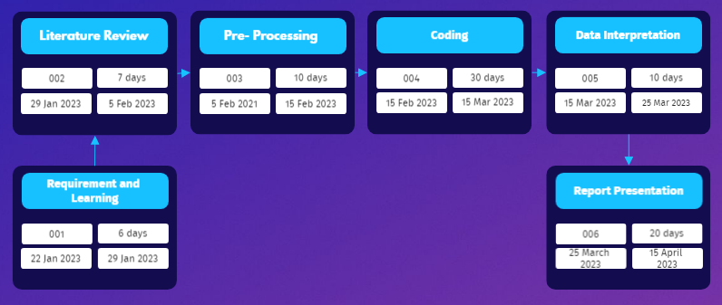

**Fig No.7 Pert Chart**

**2.8 Assumption and Dependencies**

* No assumption and dependencies

## **3. SYSTEM REQUIREMENTS**

**3.1 User Interface**

* + - Sentinel- 1 dataset is used to train the model.
    - Libraries used-
* Numpy
* Matplotlib
* OS
* SnapPy
* Tensorflow
* Keras
* GC
* Sklearn

**3.2 Software Interface**

* The software used is SNAP, ARCMap and VS code to implement the code.

**3.3 Database Interface**

* No use of database.

**3.4 Protocols**

* No protocols have been used in our proposed model.

## **4. NON- FUNCTIONAL REQUIREMENTS**

**4.1 Performance Requirements**

* + - The project should be able to detect and segment each and every kind of image, the dataset is containing.
    - The project should have high accuracy.
    - The proposed technique should be better than the existing models

**4.2 Security requirements**

* There is no specific security requirement for our project.

**4.3 Software Quality Attributes**

* The output of the project should not be misleading, as it can cause a drawback in the detection of ships and can therefore lead to various severe circumstances like ship collision etc.

## **APPENDIX A: GLOSSARY**

* Pre-processing of SAR data- Preprocessing data is a common first step in any project to prepare raw data in a format that the AI model can accept. For example, we’ll be converting the SAR data to image format that is in tiff/jpg. You can also preprocess data to enhance desired features or reduce artifacts that can bias the AI model.
* DEM: Digital Elevation Model (DEM) is a representation of the bare ground (bare earth) topographic surface of the Earth excluding trees, buildings, and any other surface objects. DEMs are created from a variety of sources.
* Test and analysis- The following step will handle the accuracy of the AI model and give the overall analysis of the project and its working.

## **APPENDIX B: ANALYSIS MODEL**

* The waterfall model has helped us derive a systematic approach towards our motto.

## **APPENDIX C: ISSUES**

## Not-Applicable