**MINOR-2 PROJECT**

**SYNOPSIS**

For

**A Deep Learning Approach for Ship Detection & Localization using Satellite Imagery**

Submitted By

| **Specialization** | **SAP ID** | **Name** |
| --- | --- | --- |
| B.Tech CSE(AIML) Hons. | 500082346 | Sparsh Patial |
| B.Tech CSE(AIML) Hons. | 500083042 | Akshat Mittal |
| B.Tech CSE(AIML) Hons. | 500084027 | Aditya Aryan |
| B.Tech CSE(AIML) | 500083578 | Alakh Niranjan |



Department of Informatics

School Of Computer Science

UNIVERSITY OF PETROLEUM & ENERGY STUDIES,

DEHRADUN- 248007. Uttarakhand

Dr. Tanupriya

Choudhury Dr. Thipendra P Singh  **Project Guide Cluster Head**



**School of Computer Science**

University of Petroleum & Energy Studies, Dehradun

**Synopsis Report**

**Project Title:**

**A Deep Learning Approach for Ship Detection & Localization using Satellite Imagery**

**Abstract**

Ships are one of the most important means of transport in the world. It has been used since ages to meet our traveling and business requirements. Despite the invention and development of new modes of transportation, maritime transport still remains to be one of the fastest and best modes of transport till date. A prominent area of research in remote sensing and computer vision is the identification and location of ships using satellite data. There are numerous uses for the capacity to precisely identify and locate ships in satellite photos, including fisheries management, maritime surveillance, and marine environmental monitoring. The creation of automatic ship recognition and localisation algorithms utilising satellite data has gained popularity in recent years. In order to evaluate satellite photos and identify ships, these systems often use machine learning and deep learning techniques.

As most of the earth is covered by water, it is very difficult and expensive to monitor those vast areas by human analysis or earth-based sensors.

Ship detection is usually done by using Automatic Identification System (AIS), which involves the use of VHF radio frequencies to wirelessly broadcast the ship’s location, destination and identity to nearby receiver devices on other ships and land-based systems. Monitoring ships using AIS is very effective but the ships are required to legally install a VHF transponder. But the issue arises when particular ships often referred to as ‘Dark Ships’ which are commonly engaged in illegal activities disconnect their transponder and hence don’t use Automatic Identification System (AIS). In such scenarios, satellite imagery can be used to detect the ships.This project proposes a ship detection method using satellite imagery by performing a polarimetric analysis technique called H/A/Alpha decomposition after orthorectification. Due to its ability to capture images regardless of atmospheric conditions, Synthetic Aperture Radar (SAR) has gained traction in the Earth Observation market above all. Unlike optical imagery, SAR uses instruments which use radio waves to image the Earth’s surface which are not affected by the time of day or meteorological conditions, enabling imagery to be obtained during the day or night, with cloudy, or clear skies. As the SAR data is available for free due to the open data policy of the EU’s Copernicus program, in this project we’ll be using Sentinel-2 data of the coastal regions of India for marine object detection.

**Keywords:**

Satellite imagery, Synthetic Aperture Radar (), H/A/Alpha Decomposition, Orthorectification, Ship detection

**Abbreviations:**

**ANN:** Artificial neural networks **DBN:** Deep belief networks

**CNN:** Convolutional neural networks **SAR :** Synthetic Aperture Radar

**AIS:** Automatic Identification System **GPS:** Global Positioning System

**1.1 Introduction**

Ship detection and localization is a crucial task for various maritime applications, including vessel traffic management, maritime security, and environmental monitoring. In recent years, there has been a growing interest in using satellite imagery for ship detection and localization due to its wide coverage, high resolution, and ability to capture information in different spectral bands. However, manual analysis of large volumes of satellite imagery is time-consuming and requires significant human effort, making it impractical for real-time applications.

To address this challenge, deep learning techniques have been applied to satellite imagery for ship detection and localization. Deep learning is a subfield of machine learning that uses artificial neural networks with multiple layers to extract high-level features from data. Deep learning has shown remarkable success in various computer vision tasks, including object detection, classification, and segmentation. By using deep learning techniques, researchers have been able to develop automated ship detection and localization systems that can process large volumes of satellite imagery in real-time, making it feasible for applications that require quick response times.

This approach typically involves training a deep neural network on a large dataset of annotated satellite images to learn the features that are indicative of ships. The trained network can then be used to detect and localize ships in new satellite images. This approach has shown promising results in several studies and has the potential to revolutionize the way ship detection and localization are performed.

In this context, this paper proposes a deep learning approach for ship detection and localization using satellite imagery. The paper presents a detailed analysis of the methodology, including the dataset used, network architecture, and training process. Additionally, the paper evaluates the performance of the proposed approach using various metrics and compares it to other state-of-the-art techniques. The results demonstrate the effectiveness of the proposed approach in detecting and localizing ships in satellite imagery, highlighting its potential for various maritime applications.

**1.2 Background**

Ship detection and localization using satellite imagery is a crucial task in many applications, including maritime surveillance, environmental monitoring, and maritime transportation. Traditional methods for detecting ships involve manually searching through satellite images or using simple image processing techniques. However, with the rapid advancements in deep learning, new techniques are emerging that offer greater accuracy and efficiency.

Deep learning approaches for ship detection and localization involve the use of convolutional neural networks (CNNs), a type of artificial neural network that is designed to process image data. CNNs consist of multiple layers of neurons that are trained to detect and classify specific features in the input images.

To train a CNN for ship detection and localization, a large dataset of satellite images is required. This dataset must be annotated with labels indicating the location of ships within the images. Annotated datasets can be generated using manual labeling by human annotators or using automated labeling techniques, such as object detection algorithms.

Once a CNN is trained on a ship detection and localization dataset, it can be used to automatically detect and locate ships within new satellite images. The CNN analyzes each image, looking for features that indicate the presence of a ship. When a ship is detected, the CNN outputs its location within the image.

Several challenges exist in developing deep learning approaches for ship detection and localization using satellite imagery. One of the main challenges is the large size of the images. Satellite images can be several gigabytes in size, which makes them difficult to process quickly. Additionally, ships can be small and difficult to distinguish from other objects in the image, such as waves or clouds.

Despite these challenges, deep learning approaches for ship detection and localization using satellite imagery have shown promising results. These techniques have the potential to improve maritime surveillance and enable more efficient and effective monitoring of shipping activity.

**1.3 Deep Learning Methods**

The task of ship detection and localization using satellite imagery has long been a challenge for computer vision researchers due to the complexity of the problem and the inherent variability of the data. In recent years, deep learning techniques have shown promising results in this area.

A deep learning approach for ship detection and localization in satellite imagery typically involves training a neural network model to learn from a large dataset of labeled images. The model typically consists of multiple layers of neurons, each of which processes the input data in a non-linear way to extract increasingly abstract features. The final layers of the model output a probability map, indicating the likelihood of a ship being present at each pixel in the input image.

There are several key components to a deep learning approach for ship detection and localization using satellite imagery. The first is the dataset, which must be large and diverse enough to capture the range of variability in real-world data. The dataset may be preprocessed to remove noise or artifacts, and may include additional annotations such as bounding boxes or masks to aid in training.

The second component is the choice of neural network architecture. Convolutional neural networks (CNNs) are commonly used in this area due to their ability to process spatial data and learn hierarchical representations of features. Other architectures, such as fully connected networks or recurrent networks, may also be used depending on the specific requirements of the task.

The third component is the training process itself, which typically involves minimizing a loss function that measures the difference between the predicted probability map and the ground truth labels. The training process may also include techniques such as data augmentation, regularization, or transfer learning to improve generalization and prevent overfitting.

Once a deep learning model has been trained, it can be used to detect and localize ships in new satellite images. This typically involves applying the model to a sliding window or patch-based approach to generate a probability map, which is then thresholded to identify candidate ship locations. These candidates may be further refined using techniques such as non-maximum suppression or clustering.

Overall, a deep learning approach for ship detection and localization using satellite imagery has shown promising results in recent years, and is likely to continue to improve as new techniques and datasets are developed. However, challenges such as data variability, computational complexity, and model interpretability remain areas of active research.

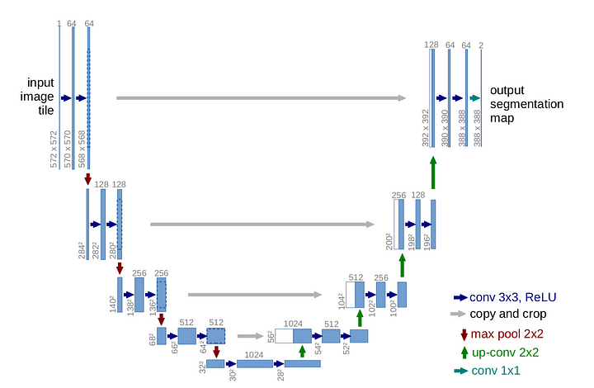

**Fig No.1: U-NET Architecture**

* The name U-NET itself is due to the shape of its architecture.
* Each blue box corresponds to a multi-channel feature map.
* The number of channels are denoted on top of the box.
* The x-y size is provided at the lower left edge of the box.
* The arrows show the respective operations as mentioned on the bottom right of the image.
* This architecture consists of three sections: The contraction, The bottleneck, and the expansion section.
* This action would ensure that the features that are learned while contracting the image will be used to reconstruct it.

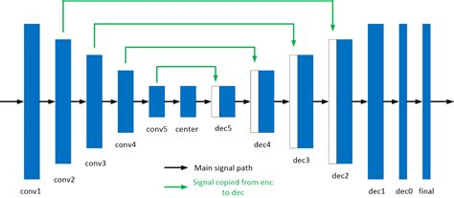

**Fig No.2: U-NET Encoding - Decoding layers**

**1.4 OOPs concept used:**

Object-oriented programming (OOP) and its concepts can be used in the development of a deep learning approach for ship detection and localization using satellite imagery. Here are some ways in which OOP concepts can be applied:

* **Abstraction:** The complexity of the deep learning model can be hidden behind simple interfaces, making it easier to use and understand.
* **Encapsulation:** Data and behavior can be encapsulated within classes, ensuring that they are kept private and not accessible from other parts of the program.
* **Inheritance:** Deep learning models can be built using existing libraries and frameworks, which can be extended through inheritance to add custom functionality.
* **Polymorphism:** Polymorphism can be used to define a common interface for different types of deep learning models, making it easier to swap between them without affecting the rest of the program.

By applying these OOP concepts, developers can create a robust and scalable deep learning approach for ship detection and localization using satellite imagery.

**2. Literature Review**

**[1] Chong, J.; Zhu, M. Survey of the Study on Ship and Wake Detection in SAR Imagery. Acta Electron. Sin. 2003, 31, 1356–1360.**

In recent years,researches of ship detection using synthetic aperture radar (SAR) images have received considerable attentions in the area of marine remote sensing.The origin and development of ship detection in SAR imagery is reviewed.The physical factors that would affect ship and wake are analyzed.

**[2] Xi, Y.; Zhang, X.; Lai, Q.; Li, W.; Lang, H. A New PolSAR Ship Detection Metric Fused by Polarimetric Similarity and the Third Eigenvalue of the Coherency Matrix. In Proceedings of the IEEE International Geoscience and Remote Sensing Symposium, Beijing, China, 10–15 July 2016; pp. 112–115**

SAR image used for ship detection, the sea surface echo is weak and changes randomly, which means that the sea surface has an approximate low-rank attribute. The ship echo is strong and the ship is sparsely distributed on the sea surface, which means that the ship has an approximate sparse attribute.

**[3] Yu, W.; Wang, Y.; Liu, H.; He, J. Superpixel-Based CFAR Target Detection for High-Resolution SAR Images. IEEE Geosci. Remote Sens. Lett. 2016, 13, 730–734.**

In dealing with the problem of target detection in high-resolution Synthetic Aperture Radar (SAR) images, segmenting before detecting is the most commonly used approach. After the image is segmented by the superpixel method, the segmented area is usually a mixture of target and background, but the existing regional feature model does not take this into account, and cannot accurately reflect the features of the SAR image.

**[4] Fan, Q.; Chen, F.; Cheng, M.; Wang, C.; Li, J. A Modified Framework for Ship Detection from Compact Polarization SAR Image. In Proceedings of the IEEE International Geoscience and Remote Sensing Symposium, Valencia, Spain, 22–27 July 2018; pp. 3539–3542.**

Although AIS information was used to verify the labeled dataset over several sub-areas, it is unfortunate that not all labeled ships in this study were supported by AIS data. It is a fact that not all ships on the ocean carry AIS transponders,likewise, especially for archived earth observations.

**[5] Markopoulos, P.; Dhanaraj, M.; Savakis, A. Adaptive L1-Norm Principal-Component Analysis with Online Outlier Rejection. IEEE J. Sel. Top. Signal Process. 2018, 12, 1131–1143.**

Both these extreme approaches exhibit an unfavorable performance/cost trade-off. In contrast, a preferred method would leverage each new measurement, together with previous ones, to efficiently update the existing bases. The development of such a method is the main contribution of this paper,

**[6] Javed, S.; Mahmood, A.; Al-Maadeed, S.; Bouwmans, T.; Ki Jung, S. Moving Object Detection in Complex Scene Using Spatiotemporal Structured-Sparse RPCA. IEEE Trans. Image Process. 2018, 28, 1007–1022.**

To address this issue, we propose a spatiotemporal structured sparse RPCA algorithm for moving objects detection, where we impose spatial and temporal regularization on the sparse component in the form of graph Laplacians. Each Laplacian corresponds to a multi-feature graph constructed over superpixels in the input matrix

**[7] Biondi, F. Low-Rank Plus Sparse Decomposition and Localized Radon Transform for Ship-Wake Detection in Synthetic Aperture Radar Images. IEEE Geosci. Remote Sens. Lett. 2018, 15, 117–121.**

The problem in obtaining stable motion estimation of maritime targets is that sea clutter makes wake

Structure detection and reconnaissance are difﬁcult. This research presents a complete procedure for automatic estimation of maritime target motion parameters by evaluating the generated Kelvin waves detected in synthetic aperture radar (SAR) images.

**[8] Li, C.; Yu, Z.; Chen, J. Overview of Techniques for Improving High-resolution Spaceborne SAR Imaging and Image Quality. J. Radars 2019, 8, 717–731.**

The start-stop hypothesis considers that the radar does not move in the time between sending and receiving the signal of spaceborne SAR, but this assumption is not accurate. For this purpose, the literatureestablished a two-way slant range model and proposed a strict single-base configuration with an equivalent center time, but it still did not have an explicit expression, which was not conducive to the research of specific imaging methods.

**[9] Liu, T.; Yang, Z.; Yang, J.; Gao, G. CFAR Ship Detection Methods Using Compact Polarimetric SAR in a K-Wishart Distribution. IEEE J. Sel. Top. Appl. Earth Obs. Remote Sens. 2019, 12, 3737–3745.**

Synthetic aperture radar (SAR) is a microwave imaging sensor capable of all-day, all-weather observations of the ground. Therefore, SAR is widely used in disaster investigation, environmental monitoring, target detection and other fields. At present, SAR ship detection has important research value in both the military field

**[10] Li, J.; Tian, J.; Gao, P.; Li, L. Ship Detection and Fine-Grained Recognition in Large-Format Remote Sensing Images Based on Convolutional Neural Network. In Proceedings of the IEEE International Symposium on Geoscience and Remote Sensing (IGARSS), Waikoloa, HI, USA, 26 September–2 October 2020; pp. 2859–2862.**

Ship detection and fine-grained recognition in large-format remote sensing image are an important research direction in the field of remote sensing image detection. But less research has been done in this area. Aiming at this problem, this paper constructs a large-format remote sensing image ship target dataset with ship category information, and proposes a background filtering network and a ship fine-grained classification network.

**[11] Ai, J.; Cao, Z.; Xing, M. An Adaptive-trimming-depth Based CFAR Detector of Heterogeneous Environment in SAR Imagery. Remote Sens. Lett. 2020, 11, 730–738.**

Traditional CFAR detectors generally use all samples in the background window for parameter estimation. However, in the heterogeneous regions, these detectors will overestimate the parameters used for statistical modelling due to the interference of high-intensity interference pixels such as adjacent ships, ghosts, breakwaters and azimuth ambiguity

**[12] Ai, J.; Cao, Z.; Mao, Y.; Wang, H.; Wang, F.; Jin, J. An Improved Bilateral CFAR Ship Detection Algorithm for SAR Image in Complex Environment. J. Radars 2021, 10, 499–515.**

The intensity level division based on the nonuniform quantization method can improve the similarity and contrast information of weak targets, leading to improved ship detection rate. The information fusion of strength spatial domain is to fuse the spatial similarity, distance direction and strength information, which can further improve the detection rate and describe the ship structure information.

**[13] Liu, T.; Yang, Z.; Jiang, Y.; Gao, G. Review of Ship Detection in Polarimetric Synthetic Aperture Imagery. J. Radars 2021, 10, 1–19.**

Various sensing and imaging techniques are developed to record different information from four primary physical quantities related to the optical field: intensity, wavelength, phase, and polarization. For example, traditional monochromatic sensors measure intensity information of optical radiation in a single wavelength. Spectral sensors, such as color cameras and multispectral devices, measure intensity information in multiple wavelengths simultaneously

**[14] Zou, B.; Qiu, Y.; Zhang, L. Ship Detection Using PolSAR Images Based on Simulated Annealing by Fuzzy Matching. IEEE Geosci. Remote Sens. Lett. 2022, 19, 1–5.**

The detection statistics are binarized according to the local threshold set by the detection statistic value of the keypoint to complete the ship detection. Experiments on three data sets obtained from the RADARSAT-2 and AIRSAR quad-polarization data demonstrate that the proposed detector is effective for ship detection.

**3. Problem Statement**

The problem statement for the topic "A Deep Learning Approach for Ship Detection & Localization using Satellite Imagery" is to develop an accurate and efficient system for detecting and localizing ships in satellite images. The objective is to use deep learning techniques to extract relevant features from the images and classify them as either containing a ship or not, and to determine the precise location of the ship within the image. This technology can be used for various applications such as maritime surveillance, monitoring of fishing activities, and detecting illegal activities in marine protected areas.

The challenge is to develop a robust and scalable system that can handle large datasets and perform accurately in different environmental conditions, such as varying weather and lighting conditions, and different ship sizes and orientations. The proposed deep learning model will need to use advanced techniques such as convolutional neural networks (CNNs), recurrent neural networks (RNNs), and attention mechanisms to effectively capture the complex features and spatial relationships present in satellite images.Once the model has been trained and optimized, it will be evaluated on a test set of satellite images to assess its performance in detecting and localizing ships. The evaluation metrics used may include precision, recall, F1 score, and mean average precision (mAP).Overall, the successful development of a deep learning model for ship detection and localization in satellite imagery could have important applications in maritime surveillance, ship tracking, and search and rescue operations.

**4. Objectives**

* To design and develop a deep learning model that can accurately detect and localize ships in satellite imagery.
* To collect and preprocess a large dataset of satellite imagery with labeled ship locations, to be used for training and testing the deep learning model.
* To investigate and compare different deep learning architectures and techniques, such as convolutional neural networks (CNNs), recurrent neural networks (RNNs), and transfer learning, to identify the most effective approach for ship detection and localization.
* To evaluate the performance of the deep learning model on a variety of real-world satellite imagery datasets, including images taken in different weather and lighting conditions, and from different satellite platforms.
* To explore the potential applications of ship detection and localization using satellite imagery, such as in maritime surveillance, environmental monitoring, and commercial shipping operations.
* To identify and address any ethical or privacy concerns related to the use of satellite imagery for ship detection and localization, such as the risk of surveillance or violation of international law.
* To publish the research findings in relevant academic journals or conferences, and to share the code and data publicly to facilitate further research in this area

**5. Methodology**

The methodology for developing a deep learning approach for ship detection and localization using satellite imagery typically involves the following steps:

* **Data Collection:** Collecting and organizing a dataset of satellite images that contain ships as well as images without ships to train and validate the deep learning model. The data should be annotated with the location of ships in the images.Dataset is collected from <https://scihub.copernicus.eu/>
* **Data Preprocessing:** Preprocessing the data by performing tasks such as data augmentation through ImageDataGeneration,run length encoding and decoding, segmented masking,normalization, and resizing to ensure the data is in a suitable format for training the model.
* **Model Selection:** U-NET is a type of convolutional neural networks (CNNs) which is capable of detecting and localizing ships in satellite imagery.
* **Training the Model:** Training the selected model using the preprocessed dataset, typically using a training and validation set. The model is trained to minimize a loss function that measures the error between the predicted locations of ships and the true locations.Random undersampling is performed to generate a better balanced data to train the model.
* **Model Evaluation:** Evaluating the performance of the trained model on a separate test set to determine its accuracy in detecting and localizing ships in satellite imagery. Common evaluation metrics include precision, recall, and F1-score.
* **Optimization and Tuning:** Optimizing and tuning the model hyperparameters, such as the learning rate and batch size,edge cropping,gaussian noise,number of epochs to improve the model's performance.
* **Deployment:** Deploying the model for use on new satellite imagery data to detect and localize ships. This may involve integrating the model into a larger system or developing a user interface for interacting with the model.

It is important to note that the specific details of each step may vary depending on the specific deep learning approach and dataset used.

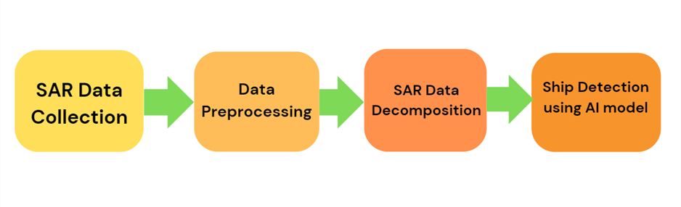

**Fig No.3 Methodology flow diagram**

**5.1 Algorithms used**

**U-Net:**

The U-Net is a deep convolutional neural network architecture that is widely used for image segmentation tasks, including ship detection in satellite images.

To detect ships in satellite images using U-Net, the network is trained on a large dataset of annotated satellite images, where the ships are labeled as the foreground and the background is labeled as the sea or sky. During training, the network learns to identify the unique features of ships, such as their shapes, colors, and textures, and to distinguish them from the surrounding background.

Once the U-Net is trained, it can be used to detect ships in new satellite images by segmenting the image into foreground (ship) and background (sea/sky) regions. This segmentation process involves passing the input image through the U-Net and obtaining a segmentation map, which indicates the probability of each pixel belonging to the foreground or background. The segmentation map is then thresholded to obtain a binary mask, where the foreground pixels correspond to the ship and the background pixels correspond to the sea/sky.

Overall, U-Net provides an efficient and accurate way to detect ships in satellite images, which can have many applications in fields such as maritime surveillance, environmental monitoring, and navigation.

The U-Net model is a popular neural network architecture for semantic segmentation tasks, including ship detection. Here's a general overview of how the U-Net algorithm works for ship detection:

* **Input:** The U-Net model takes as input an image that contains one or more ships.
* **Encoding Path:** The image is first passed through a series of convolutional layers that extract features from the image. The size of the feature maps is reduced at each layer, while the number of feature maps is increased.
* **Decoding Path:** The feature maps obtained from the encoding path are then passed through a series of transposed convolutional layers that upsample the feature maps back to the size of the input image. At each layer, the feature maps are concatenated with the corresponding feature maps from the encoding path, allowing the decoder to combine information from different scales.
* **Output:** The final layer of the U-Net model produces a segmentation mask that indicates which pixels in the input image belong to a ship and which do not. The output mask has the same size as the input image.
* **Training:** The U-Net model is trained using a loss function that measures the difference between the predicted segmentation mask and the ground truth mask. The most common loss function used for semantic segmentation is the cross-entropy loss.

By training the U-Net model on a large dataset of ship images with their corresponding ground truth masks, the model can learn to accurately detect ships in new images.

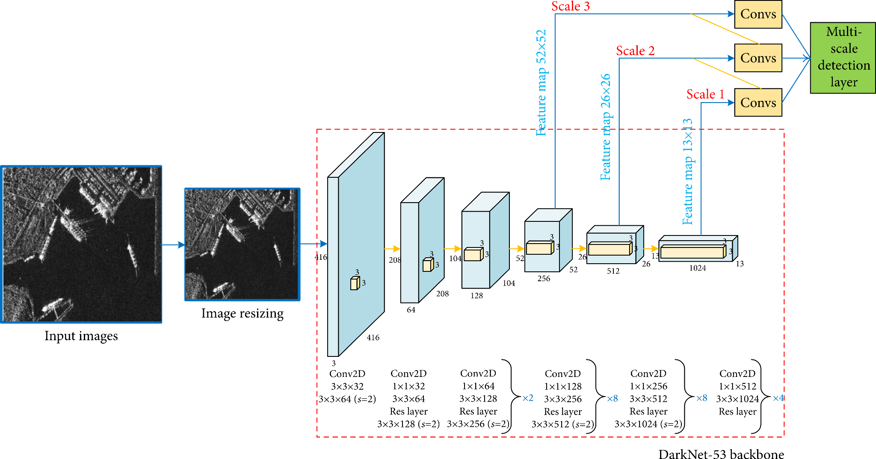

**Fig No.4 U-net backbone structure for the model**

**6. PERT Chart**

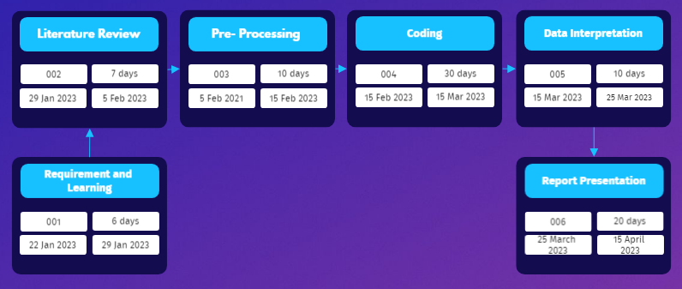

**Fig No.5 Pert Chart**

**7. References**

[1] Chong, J.; Zhu, M. Survey of the Study on Ship and Wake Detection in SAR Imagery. Acta Electron. Sin. 2003, 31, 1356–1360.

[2] Xi, Y.; Zhang, X.; Lai, Q.; Li, W.; Lang, H. A New PolSAR Ship Detection Metric Fused by Polarimetric Similarity and the Third Eigenvalue of the Coherency Matrix. In Proceedings of the IEEE International Geoscience and Remote Sensing Symposium, Beijing, China, 10–15 July 2016; pp. 112–115

[3] Yu, W.; Wang, Y.; Liu, H.; He, J. Superpixel-Based CFAR Target Detection for High-Resolution SAR Images. IEEE Geosci. Remote Sens. Lett. 2016, 13, 730–734.

[4] Fan, Q.; Chen, F.; Cheng, M.; Wang, C.; Li, J. A Modified Framework for Ship Detection from Compact Polarization SAR Image. In Proceedings of the IEEE International Geoscience and Remote Sensing Symposium, Valencia, Spain, 22–27 July 2018; pp. 3539–3542.

[5] Markopoulos, P.; Dhanaraj, M.; Savakis, A. Adaptive L1-Norm Principal-Component Analysis with Online Outlier Rejection. IEEE J. Sel. Top. Signal Process. 2018, 12, 1131–1143.

[6] Javed, S.; Mahmood, A.; Al-Maadeed, S.; Bouwmans, T.; Ki Jung, S. Moving Object Detection in Complex Scene Using Spatiotemporal Structured-Sparse RPCA. IEEE Trans. Image Process. 2018, 28, 1007–1022.

[7] Biondi, F. Low-Rank Plus Sparse Decomposition and Localized Radon Transform for Ship-Wake Detection in Synthetic Aperture Radar Images. IEEE Geosci. Remote Sens. Lett. 2018, 15, 117–121.

[8] Li, C.; Yu, Z.; Chen, J. Overview of Techniques for Improving High-resolution Spaceborne SAR Imaging and Image Quality. J. Radars 2019, 8, 717–731.

[9] Liu, T.; Yang, Z.; Yang, J.; Gao, G. CFAR Ship Detection Methods Using Compact Polarimetric SAR in a K-Wishart Distribution. IEEE J. Sel. Top. Appl. Earth Obs. Remote Sens. 2019, 12, 3737–3745.

[10] Li, J.; Tian, J.; Gao, P.; Li, L. Ship Detection and Fine-Grained Recognition in Large-Format Remote Sensing Images Based on Convolutional Neural Network. In Proceedings of the IEEE International Symposium on Geoscience and Remote Sensing (IGARSS), Waikoloa, HI, USA, 26 September–2 October 2020; pp. 2859–2862.

[11] Ai, J.; Cao, Z.; Xing, M. An Adaptive-trimming-depth Based CFAR Detector of Heterogeneous Environment in SAR Imagery. Remote Sens. Lett. 2020, 11, 730–738.

[12] Ai, J.; Cao, Z.; Mao, Y.; Wang, H.; Wang, F.; Jin, J. An Improved Bilateral CFAR Ship Detection Algorithm for SAR Image in Complex Environment. J. Radars 2021, 10, 499–515.

[13] Liu, T.; Yang, Z.; Jiang, Y.; Gao, G. Review of Ship Detection in Polarimetric Synthetic Aperture Imagery. J. Radars 2021, 10, 1–19.

[14] Zou, B.; Qiu, Y.; Zhang, L. Ship Detection Using PolSAR Images Based on Simulated Annealing by Fuzzy Matching. IEEE Geosci. Remote Sens. Lett. 2022, 19, 1–5.