Deliverable 1:

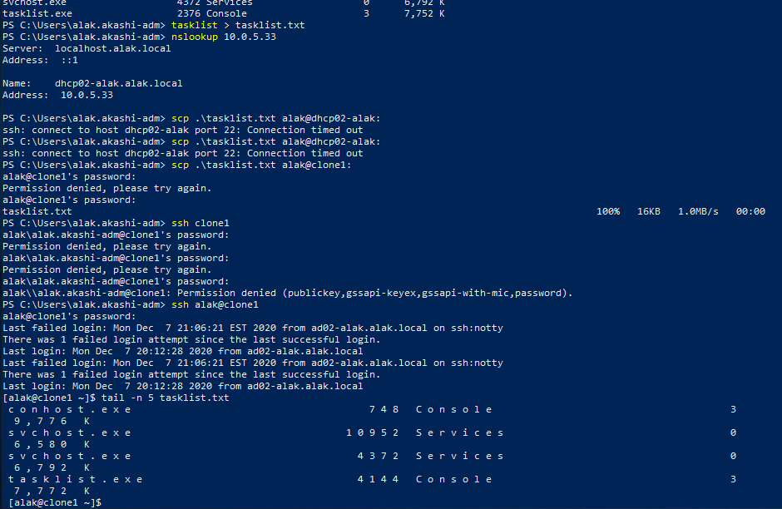

Deliverable 2:

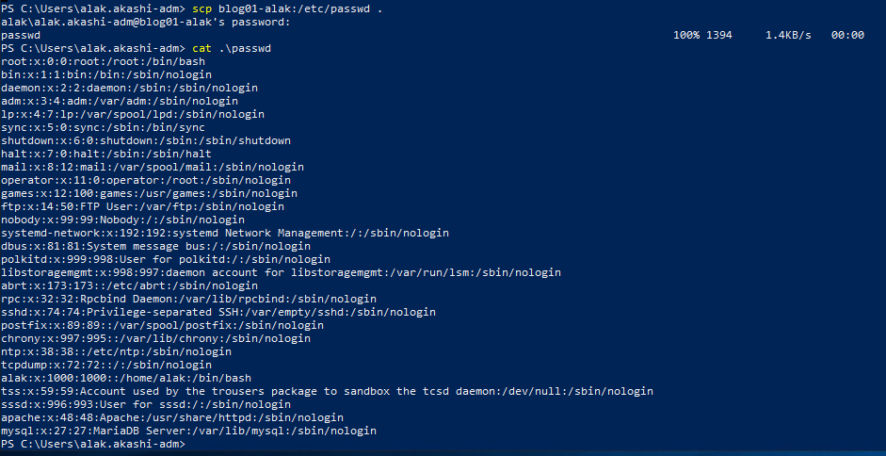

Deliverable 3:

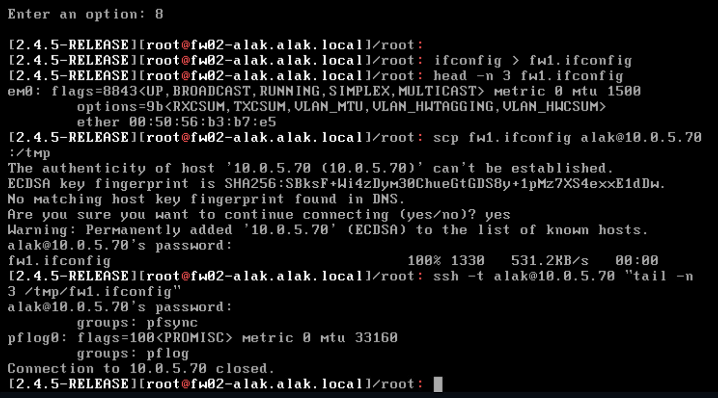

Deliverable 4:

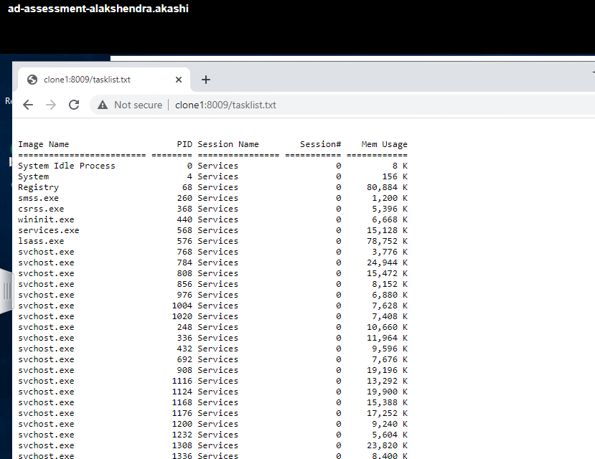

Deliverable 5:

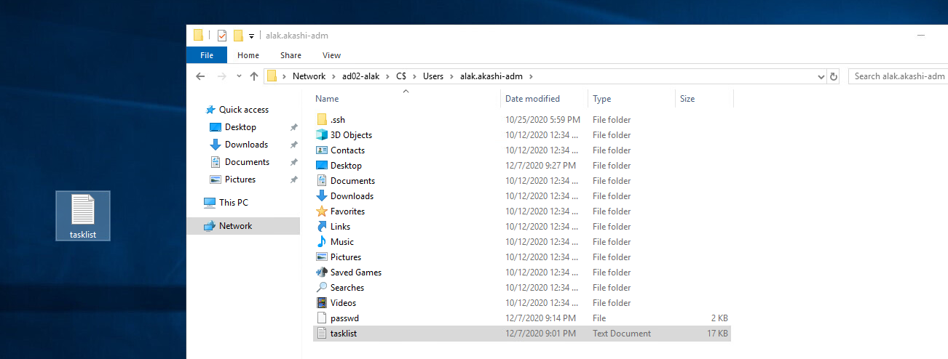

Deliverable 6: used fs01 but could not see it when I scrolled up. It started with some random numbers.

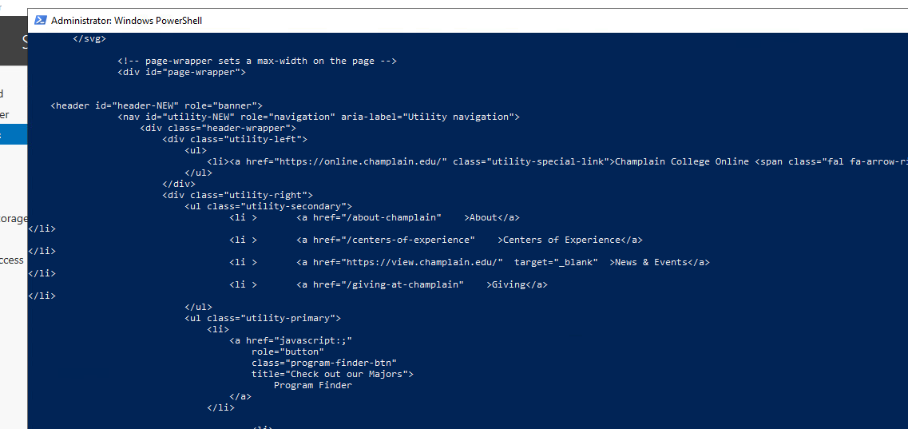

Deliverable 7:

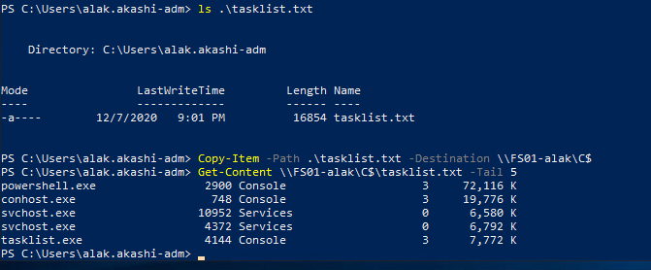

Deliverable 8:

Link to Github: