University of Stirling MATPMD0

Computing Science & Mathematics 2022

**MATPMD0 INTRODUCTORY STATISTICS FOR DATA SCIENCE**

**PROJECT : AUTUMN SEMESTER 2022**

**Submission due 19th December 17:00**

**Student Number: <Student id>**

**Declaration: In submitting this project I declare that this is all my own work and I did not seek help to complete it.**

**For each project question, insert answers below.**

1. Perform an exploratory data analysis, taking care to describe the type of variables in the data set.

**Ans**: In given data set variables are quantitative, numeric, and continuous.

**Code in R language:**

#loading Libraries

library(stats)

library(dplyr)

#1 Data summarizaiton

a= r$BodyFat

b=r$Abdomen

# Calculation  mean of the given data

mean(a)

mean(b)

# Calculation  median of the given data

median(r$BodyFat)

median(r$Abdomen)

# Calculation  mode of the given data

Mode(a)

Mode(b)

#calculate standard deviation

sd(a)

sd(b)

#calculate Variance

var(a)

var(b)

#calculate IQR

quantile(a)

quantile(b)

#Data visualization

str(a)

str(b)

#Numeric Data -Histogram

hist(a)

hist(b)

#Catagorical Data -Barplot

barplot(a)

barplot(b)

**Mode Function in R language:**# Calculation  mode of the given data

Mode=function(x){

  ta=table(x)

  tam=max(ta)

  if(all(ta==tam))

    mod=NA

  else

    if(is.numeric(x))

      mod=as.numeric(names(ta)[ta==tam])

  else

    mod=names(ta)[ta==tam]

  return(mod)

}

**Outputs:**

**a=Bodyfat**

**b=Abdomen**

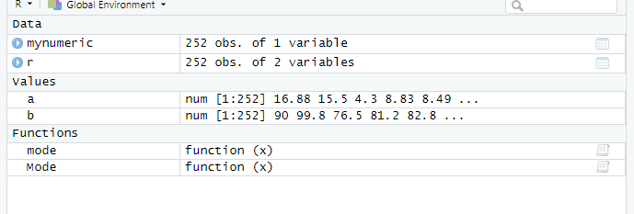

**Histogram of a(BodyFat)& Histogram of b(Abdomen)**

**Bar plot of a(Bodyfat)& Barplot of b(Abdomen)**

1. Calculate the correlation coefficient for the two variables given and comment on the relationship between body fat and abdomen size.

**Code:**

#corelation between Bodyfat and Abdomen

cor(r$BodyFat,r$Abdomen)

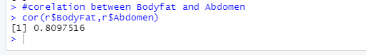

3. Investigate a model to test the relationship between body fat and abdomen size. You must include output from R to support your findings. Details you should include are:

* **a description of the model.**

Alternative hypothesis :True difference in means is equal to 0

* **a summary of the fitted model with interpretation of test statistics and parameter estimates;**

**T-test**

**t.test(r$BodyFat,r$Abdomen)**

* **evidence as to whether assumptions of the model have been met;**

T-Test

* **conduct a formal test to question whether there is a significant linear relationship between body fat and abdomen size.**

**Corelation**

#corelation between Bodyfat and Abdomen

cor(r$BodyFat,r$Abdomen)

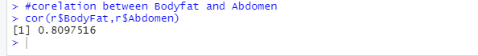

4. Use the equation to predict the percentage of body fat for a male whose abdomen measures 100cm.

5. Assess the predictive performance of the model.

**Prediction:**

v=lm(r$BodyFat~r$Abdomen,data = r)

base_model <- lm(a ~ b + a, data = r)

base_model_output <- predict(base_model, newdata = r)

base_model_output

#Prediction

cbind(base_model_output)

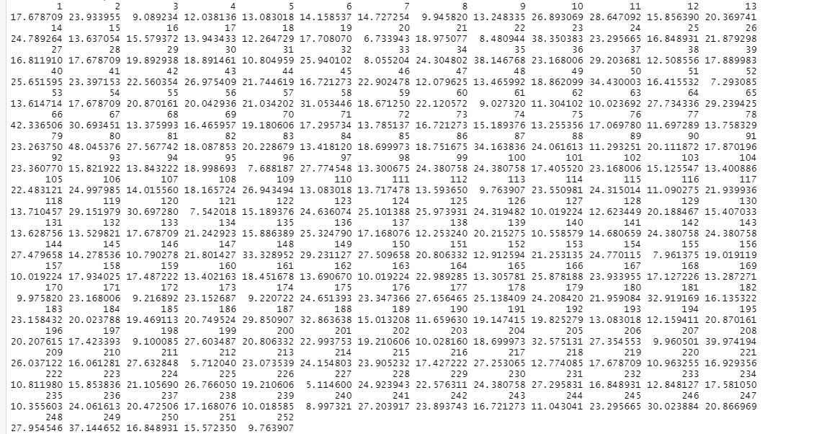

6. In this final section include all R code that you have used for this project verbatim. Ensure that:

* the code for each question can be easily found;
* all code is adequately commented;
* variable names are sensible.

#loading Libraries

library(stats)

library(dplyr)

#1 Data summarizaiton

a= r$BodyFat

b=r$Abdomen

# Calculation  mean of the given data

mean(a)

mean(b)

# Calculation  median of the given data

median(r$BodyFat)

median(r$Abdomen)

# Calculation  mode of the given data

Mode(a)

Mode(b)

#calculate standard deviation

sd(a)

sd(b)

#calculate Variance

var(a)

var(b)

#calculate IQR

quantile(a)

quantile(b)

#Data visualization

str(a)

str(b)

#Numeric Data -Histogram

hist(a)

hist(b)

#Catagorical Data -Barplot

barplot(a)

barplot(b)

cor(a,b)

#T test

t.test(r$BodyFat,r$Abdomen)

#linear Regression Model

v=lm(r$BodyFat~r$Abdomen,data = r)

base_model <- lm(a ~ b + a, data = r)

base_model_output <- predict(base_model, newdata = r)

base_model_output

#Prediction

cbind(base_model_output)

**Code of Mode:**

# Calculation  mode of the given data

Mode=function(x){

  ta=table(x)

  tam=max(ta)

  if(all(ta==tam))

    mod=NA

  else

    if(is.numeric(x))

      mod=as.numeric(names(ta)[ta==tam])

  else

    mod=names(ta)[ta==tam]

  return(mod)

}