Name: Alam Khalid

Class: BSCS-8A

CMS: 260652

# Task 1:

**Query:**

CREATE VIEW v1 AS

SELECT fname

FROM faculty

WHERE fid NOT IN (SELECT fid FROM class);

**Screenshot:**

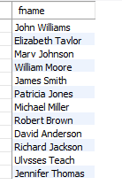

# Task 2:

**Query:**

CREATE VIEW v2 AS

SELECT sname

FROM student

WHERE snum IN (SELECT snum

FROM enrolled

WHERE cname = (SELECT cname FROM class WHERE fid =

(SELECT fid

FROM faculty

WHERE fname = 'Alen Bob')));

**Screenshot:**

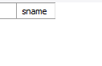

# Task 3:

**Query:**

CREATE VIEW stdVu AS

SELECT sname

FROM student JOIN enrolled USING(snum)

**Screenshot:**

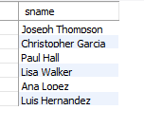

# Task 4:

**Query:**

ALTER TABLE student

ADD COLUMN course VARCHAR(20) NOT NULL;

**Screenshot:**

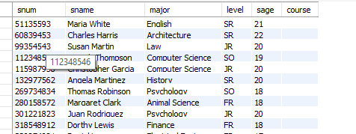

# Task 5:

There is no change in the student table because the view we created in task 3 depends upon the ‘snum’ not on any other relating attribute. The ‘stdVu’ after inserting the course column is as follows:

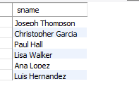

# Task 6:

**Query:**

ALTER VIEW v2 AS

SELECT sname

FROM student

WHERE snum IN

( SELECT snum

FROM enrolled

WHERE cname = (SELECT cname

FROM class WHERE fid = (

SELECT fid

FROM faculty

WHERE fname = 'Ivana Teach')))

AND level = 'JR';

**Screenshot:**



# Task 7:

(a)

**Query:**

CREATE VIEW csmajor AS

SELECT sname

FROM student

WHERE major = 'Computer Science';

**Screenshot:**

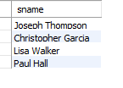

(b)

**Query:**

CREATE VIEW classbyjohn AS

SELECT cname

FROM class JOIN faculty USING(fid) WHERE fname = 'John Williams' AND dept_id = 68;

**Screenshot:**



(c)

**Query:**

CREATE VIEW stdAge AS

SELECT DISTINCT sage

FROM student S NATURAL JOIN enrolled WHERE cname = 'Database Systems'

ORDER BY sage DESC;

**Screenshot:**

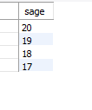

(d)

**Query:**

CREATE VIEW garciaVu AS

SELECT DISTINCT fname

FROM faculty NATURAL JOIN class NATURAL JOIN enrolled NATRUAL JOIN student

WHERE sname = 'Christopher Garcia';

**Screenshot:**



(e)

**Query:**

CREATE VIEW stds AS

SELECT snum, sname

FROM student S NATURAL JOIN enrolled E NATURAL JOIN class C NATURAL JOIN faculty F

WHERE F.fname = 'Christopher Davis' AND F.fname = 'Linda Davis';

**Screenshot:**

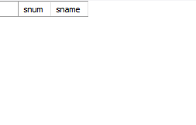

# Task 8:

**Query:**

DROP VIEW IF EXISTS

university.v1,

university.v2;

# Task 9:

You can insert, update, and delete rows in a view, subject to the following limitations:

* If the view contains joins between multiple tables, you can only insert and update one table in the view, and you can't delete rows.
* You can't directly modify data in views based on union queries. You can't modify data in views that use GROUP BY or DISTINCT statements.
* All columns being modified are subject to the same restrictions as if the statements were being executed directly against the base table.
* Text and image columns can't be modified through views.
* There is no checking of view criteria. For example, if the view selects all customers who live in Paris, and data is modified to either add or edit a row that does not have City = 'Paris', the data will be modified in the base table but not shown in the view, unless WITH CHECK OPTION is used when defining the view.

#### **Using WITH CHECK OPTION**

The WITH CHECK OPTION clause forces all data-modification statements executed against the view to adhere to the criteria set within the WHERE clause of the SELECT statement defining the view. Rows cannot be modified in a way that causes them to vanish from the view.