NAME: ALAM KHALID

CLASS: BSCS-8A

CMS ID: 260652

DATE: 6/9/2019

COURSE: CS-220 DATABASE SYSTEMS

1. Write a query to Select columns “city_id” and “country_id” from the table “city” which already exists in the “Sakila” database. (Observe the output when you execute the queries.)

**QUERY:**

SELECT city_id, country_id FROM city;

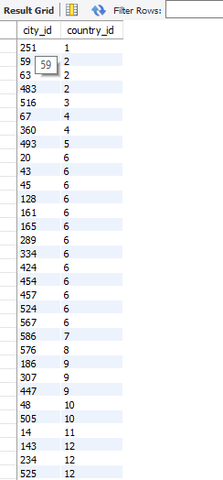

2. Write a query to Select column “actor_id” from the table “actor” which already exists in the “Sakila” database where the “actor_id=58”. (Observe the output when you execute the queries.)

**QUERY:**

SELECT actor_id FROM actor WHERE actor_id=58;

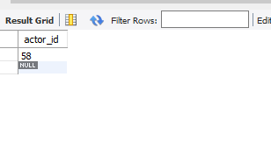

3. Write a query to retrieve names of movies starting with P.

**QUERY:**

SELECT title FROM film WHERE title LIKE 'p%';

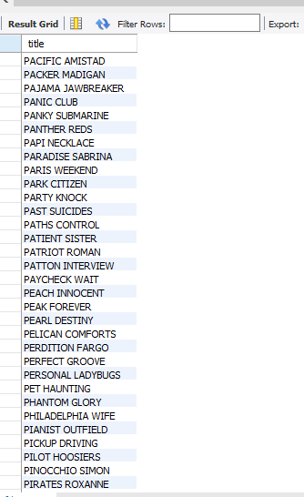

4. Write a query to retrieve movies which were released in year 2006?

**QUERY:**

SELECT title, release_year FROM film WHERE release_year = 2006;

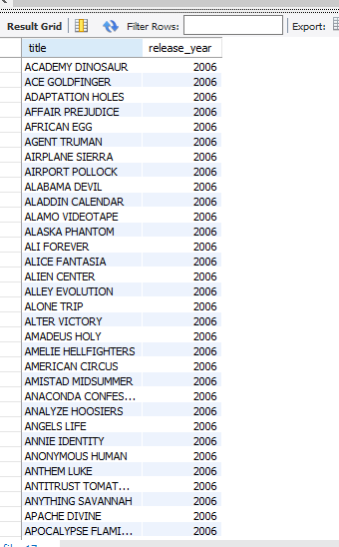

5. What password did the DBA assign to the user „MIKE‟?

**QUERY:**

SELECT username, password FROM staff WHERE username = 'MIKE';

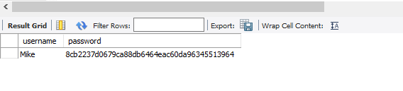

6. Write a query to retrieve data of all actors whose names are not ending on T.

**QUERY:**

SELECT first_name FROM actor WHERE first_name NOT LIKE '%t';

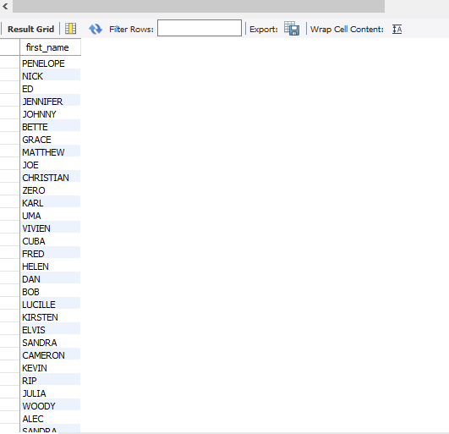

7. Write a query to retrieve first and last name of actors.

**QUERY:**

SELECT first_name, last_name FROM actor;

