Name: Alam Khalid

Class: BSCS-8A

CMS ID: 260652

Course: CS-220 Database Systems

Date: 13/09/2019

1. Select the names of actors whose IDs are between 50 and 150, or those whose last name starts with A.

**Answer:**

SELECT first_name, last_name, actor_id FROM actor WHERE last_name LIKE 'A%' OR actor_id BETWEEN 50 AND 150;

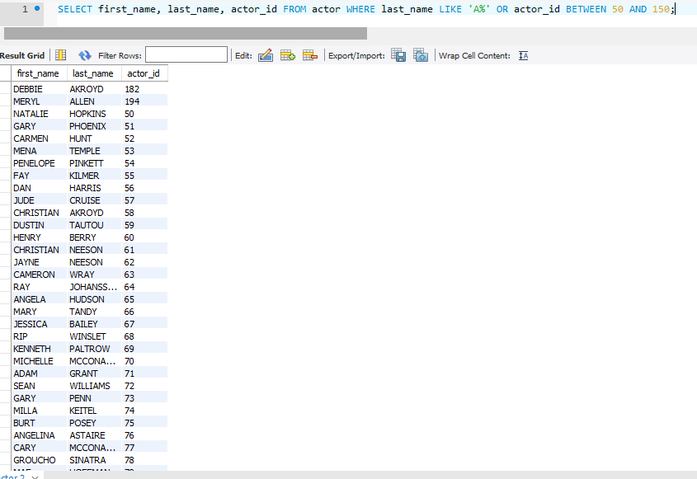

1. Write an SQL query to display list of languages which neither is English nor French.

**Answer:**

SELECT name FROM language WHERE NOT name='English' AND NOT name='French';

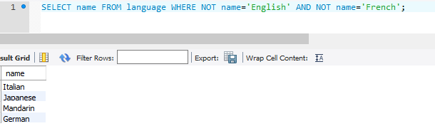

1. Display the usernames and address_ids of customers in the Sakila database.

**Answer:**

SELECT first_name, address_id FROM customer;

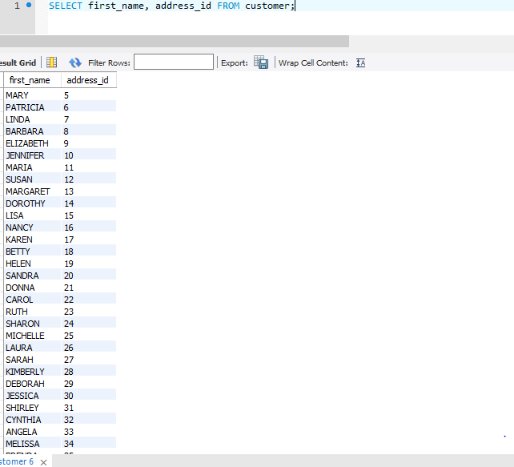

1. Find and display the Income (payments) generated during August 2005. Sort them in the descending order.

**Answer:**

SELECT amount, payment_date FROM payment WHERE payment_date LIKE '2005-08-%' ORDER BY amount DESC;

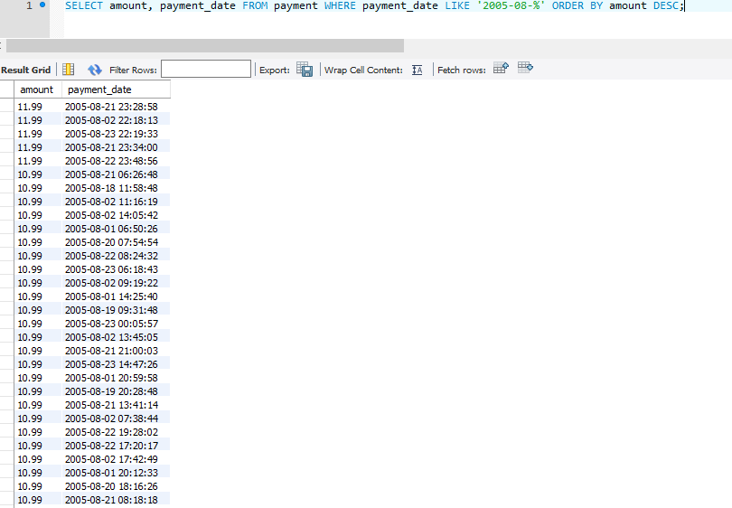

1. Retrieve the total number of films related to which some data is stored in the database.

**Answer:**

SELECT COUNT(film_id)

FROM film;

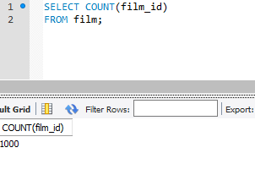

1. Display the actor names which start with A and end on letter A.

**Answer:**

SELECT first_name FROM actor WHERE first_name LIKE 'A%A';

