**Name: Alam Khalid**

**Class: BSCS-8A**

**Course: Database Systems**

**Lab #04**

**CMS ID: 260652**

**Date: 27/09/2019**

1. Create COMPANY database and the corresponding tables/relations in the COMPANY schema using the DDL commands. Ensure only the following constraints are specified during the table creation time for Q.1:
   1. Primary Key
   2. Not Null
   3. Unique

**PK values are given in the figure. Bdate attribute should not be null while Dname should always be unique. Assign valid names to all the constraints.**

***Answer:***

CREATE DATABASE company;

USE company;

**FOR WORKER TABLE:**

create table worker (

fname varchar(20),

minit int,

lname varchar(20),

ssn int PRIMARY KEY,

bdate date NOT NULL,

address varchar(50),

sex varchar(1),

salary int,

super_ssn int,

dno int

);

**FOR DEPT TABLE:**

CREATE TABLE dept (

dname varchar(50) UNIQUE,

dnumber int PRIMARY KEY,

mgr_ssn int,

mgr_start_date date

);

**FOR LOCATION TABLE:**

CREATE TABLE location (

dnumber int,

dlocation varchar(50) PRIMARY KEY

);

**FOR DEPT_PROJECT TABLE:**

CREATE TABLE dept_project (

pname varchar(50),

pnumber int PRIMARY KEY,

plocation varchar(50),

dnumber int

);

**FOR WORK TABLE:**

CREATE TABLE work (

essn int,

pno int,

hours int

);

**FOR WORKER_DEPENDENT TABLE:**

CREATE TABLE worker_dependent (

essn int,

dependment_name varchar(50) PRIMARY KEY,

sex varchar(1),

bdate date,

relationship varchar(10)

);

1. After creating the table structures and applying constraints to it, verify if the constraints applied are working as desired (hint: apply constraint violations while inserting updating deleting data).
   1. Insert atleast 3 rows of valid data into the tables. Follow the violations which occur while you insert data.

***Answer:***

**FOR WORKER TABLE:**

INSERT INTO worker

VALUES ('Alam', 62, 'Khalid', 223, '2000-03-08', 'Islamabad', 'M', 260000, 35, 1),

('Haseeb', 76, 'Asim', 224, '1999-07-06', 'Lahore', 'M', 129000, 36, 2),

('Umar', 60, 'Javed', 225, '2000-12-22', 'Karachi', 'M', 34550, 37, 3);

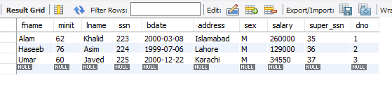

**FOR DEPT TABLE:**

INSERT INTO dept

VALUES ('Alam', 4, 89, '2016-08-20'),

('Ali', 5, 90, '2015-09-23'),

('Umar', 6, 91, '2008-01-01');

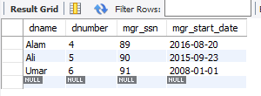

**FOR LOCATION TABLE:**

INSERT INTO location

VALUES (1, 'Islamabad'),

(2, 'Karachi'),

(3, 'Chiniot');

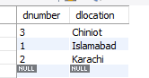

**FOR DEPT_PROJECT TBALE:**

INSERT INTO dept_project

VALUES ('EE', 1, 'Isb', 70),

('CS', 2, 'Khi', 71),

('SE', 3, 'Lhr', 72);

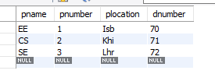

**FOR WORK TABLE:**

INSERT INTO work

VALUES (1,10,20),

(2,11,21),

(3,12,22);

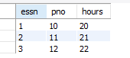

**FOR WORKER_DEPENDENT TABLE:**

INSERT INTO worker_dependent

VALUES (1, 'Asad', 'M', '2000-07-07', 'Son'),

(2, 'Umar', 'M', '1999-09-09', 'Manager'),

(3, 'Ali', 'M', '1900-07-09', 'Son');

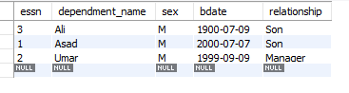

* 1. Try inserting some invalid data values and check how the DBMS responds. Record the error messages.

***Answer:***

INSERT INTO location

Values (3,null);



INSERT INTO dept

VALUES(‘Alam’, 1232,78,’2019-02-20’);



* 1. Update three of the rows using any column values; Observe whether a value is changed or not. Give your justifications.

***Answer:***

UPDATE dept

SET mgr_start_date = '2017-08-09'

WHERE dnumber = 4;

**BEFORE:**



**AFTER:**

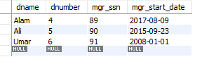

UPDATE worker_dependent

SET relationship = 'Son'

WHERE dependment_name = 'Umar'

**BEFORE:**



**AFTER:**

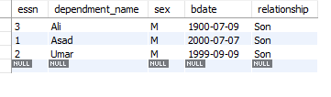

UPDATE dept_project

SET pnumber = 5

WHERE pnumber = 2

**BEFORE:**



**AFTER:**

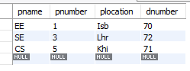

* We can only update values using where clause and by using only the PRIMARY KEY value in the where clause. Otherwise SQL gives safe update error is we use any column other than PRIMARY KEY column name.



* 1. Delete a record from the Dept_Locations table. Can we delete a row from the table using the PK column? If yes how, if not why?

***Answer:***

DELETE FROM location

WHERE dlocation = 'Islamabad';

**BEFORE:**



**AFTER:**

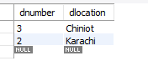

Yes we can delete a row using a PK column as shown above.

1. Save your previous queries and then drop the Company Schema.

***Answer:***

DROP DATABASE company;

1. Again create COMPANY database and the corresponding tables/relations in the Company schema using the DDL commands. For this time ensure all of the following constraints are specified during the table creation time:
   1. Primary Key
   2. Foreign Key
   3. Not Null
   4. Unique

Create FK, PK as shown in the figure. Bdate attribute should not be null while Dname should always be unique. Assign valid names to your constraints.

**In order to specify an action in case of constraint violation, you will propagate the changes.**

***Answer:***

**CREATING TABLES:**

create table worker (

fname varchar(20),

minit int,

lname varchar(20),

ssn int,

bdate date NOT NULL,

address varchar(50),

sex varchar(1),

salary int,

super_ssn int,

dno int,

CONSTRAINT ssn_id PRIMARY KEY (ssn)

);

CREATE TABLE dept (

dname varchar(50) UNIQUE,

dnumber int,

mgr_ssn int,

mgr_start_date date,

CONSTRAINT dno PRIMARY KEY(dnumber)

);

CREATE TABLE location (

dnumber int,

dlocation varchar(50),

CONSTRAINT dlocation PRIMARY KEY(dlocation)

);

CREATE TABLE dept_project (

pname varchar(50),

pnumber int,

plocation varchar(50),

dnumber int,

CONSTRAINT project_number PRIMARY KEY(pnumber)

);

CREATE TABLE work (

essn int,

pno int,

hours int

);

CREATE TABLE worker_dependent (

essn int,

dependment_name varchar(50) ,

sex varchar(1),

bdate date,

relationship varchar(10),

CONSTRAINT dependment_name PRIMARY KEY(dependment_name)

);

**ALTERING TABLE TO ADD FOREIGN KEYS:**

ALTER TABLE worker

ADD CONSTRAINT dnumber FOREIGN KEY(dno) REFERENCES dept(dnumber);

ALTER TABLE dept

ADD CONSTRAINT mgr_ssn_key FOREIGN KEY(mgr_ssn) REFERENCES worker(ssn);

ALTER TABLE location

ADD CONSTRAINT location_number FOREIGN KEY(dnumber) REFERENCES dept(dnumber);

ALTER TABLE dept_project

ADD CONSTRAINT dnum FOREIGN KEY(dnumber) REFERENCES dept(dnumber);

ALTER TABLE work

ADD CONSTRAINT eno foreign key(essn) REFERENCES worker(ssn),

ADD CONSTRAINT pno foreign key(pno) REFERENCES dept_project(pnumber),

ADD CONSTRAINT eno_pno PRIMARY KEY(essn,pno);

ALTER TABLE worker_dependent

ADD CONSTRAINT essn foreign key(essn) references worker(ssn);

1. Attempt question no. 2 again and answer the questions on the basis of new constraints added and their corresponding violations.

***Answer:***

**(a)**

INSERT INTO worker

VALUES ('Alam', 62, 'Khalid', 223, '2000-03-08', 'Islamabad', 'M', 260000, 35, 1),

('Haseeb', 76, 'Asim', 224, '1999-07-06', 'Lahore', 'M', 129000, 36, 2),

('Umar', 60, 'Javed', 225, '2000-12-22', 'Karachi', 'M', 34550, 37, 3);

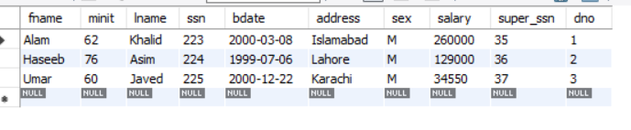

INSERT INTO dept

VALUES ('EE', 1, 223, '2016-08-20'),

('CS', 2, 224, '2015-09-23'),

('SE', 3, 225, '2008-01-01');

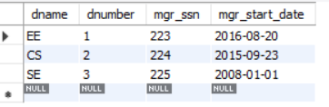

INSERT INTO location

VALUES (1, 'Islamabad'),

(2, 'Karachi'),

(3, 'Chiniot');

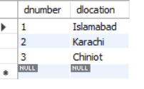

INSERT INTO dept_project

VALUES ('Android', 11, 'Isb', 1),

('Web', 22, 'Khi', 2),

('Java', 33, 'Lhr', 3);

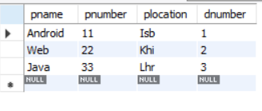

INSERT INTO work

VALUES (223,11,2),

(224,22,3),

(225,33,3);

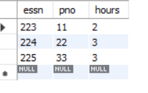

INSERT INTO worker_dependent

VALUES (225, 'Asad', 'M', '2000-07-07', 'Son'),

(225, 'Umar', 'M', '1999-09-09', 'Son'),

(223, 'Ali', 'M', '1900-07-09', 'Son');

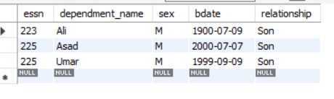

**(b)**

INSERT INTO location

VALUES(3, null)



INSERT INTO dept

VALUES ('CS', 3, 225, '2017-09-09');



INSERT INTO dept_project

VALUES ('Web',66,'Khi',4);



**(c)**

UPDATE worker

SET dno = 4

WHERE ssn = 225;



We cannot update a value for a foreign key if it does not exist in the referenced table.

UPDATE dept

SET dname = 'CS'

WHERE dnumber = 3;We cannot update the dname because we applied the constraint of UNIQUE to it.

UPDATE location

SET dnumber = 2

WHERE dlocation = 'Chiniot';



**BEFORE:**

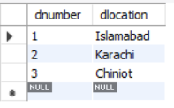

**AFTER:**

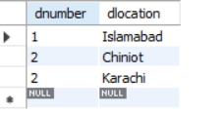

This was valid because we already had a dnumber 2 in the dept table.

**(d)**

DELETE FROM location

WHERE dlocation = 'Islamabad';

**BEFORE:**



**AFTER:**



Yes we can delete a row using a PK column as shown above.