**Name: Alam Khalid**

**Class: BSCS-8A**

**CMS: 260652**

**Date: 4/10/2019**

* Find the highest, lowest, sum and average salary of all employees. Label the columns as Maximum, Minimum, Sum and Average respectively. Save your query.

**Answer:**

SELECT MAX(sal) as Maximum,

MIN(sal) as Minimum,

SUM(sal) as Sum,

AVG(sal) as Average

FROM emp;

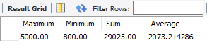

* Find the highest, lowest, sum and average salary for each job type. Label the columns as Maximum, Minimum, Sum and Average respectively. Save your query.

**Answer:**

SELECT job,

MAX(sal) as Maximum,

MIN(sal) as Minimum,

SUM(sal) as Sum,

AVG(sal) as Average

FROM emp

GROUP BY job;

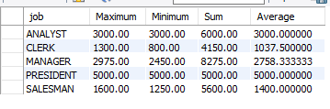

* Lists the number of employees in each job, sorted high to low.

**Answer:**

SELECT job,

COUNT(job) AS 'Number of Emp'

FROM emp

GROUP BY job

ORDER BY 'Number of Emp' DESC;

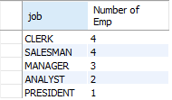

* Display the number of distinct department values in the EMPLOYEES table.

**Answer:**

SELECT count(distinct deptno) as ‘Number of Deparment’

FROM emp;



* Determine the number of managers without listing them. Label the column as Number of Mangers.

**Answer:**

SELECT COUNT(job) AS 'Number of Managers'

FROM emp

WHERE job = 'Manager';



* Find the difference between highest and lowest salaries.

**Answer:**

SELECT MAX(sal)-MIN(sal) AS 'Difference between highest and lowest salaries'

FROM emp;



* Formulate a query to display the manager number and the salary of the lowest-paid employee for that manager. Exclude any groups where the minimum salary is 6000 or less. Sort the output in descending order of salary.

**Answer:**

SELECT mgr,

MIN(sal) As 'Minimum'

FROM emp

GROUP BY mgr

HAVING MIN(sal) <= 3000;

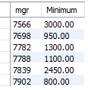

* Give the department names and their locations.

**Answer:**

SELECT dname AS 'Deparment Name',

loc AS Location

FROM dept;

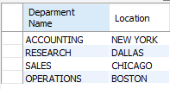

* Retrieve total no. of employees in the Company.

**Answer:**

SELECT COUNT(empno) AS 'Total Number of Employee'

FROM emp;



* Practice retrieving data from multiple tables.

**Answer:**

SELECT dname, ename

FROM emp, dept

WHERE emp.deptno = dept.deptno;

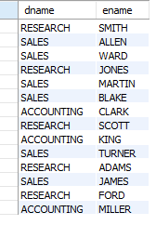

SELECT dname, count(ename)

FROM emp, dept

WHERE emp.deptno = dept.deptno

GROUP BY dname;

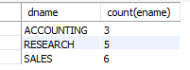

SELECT dname, count(ename), loc

FROM emp, dept

WHERE emp.deptno = dept.deptno

GROUP BY dname;

