# Name: Alam Khalid

**CMS ID: 260652**

**Class: BSCS-8A**

**Date: 18/10/2019**

**Course: CS-220 Database Systems**

# Department of Computer Science

**CS220: Database Systems**

**Class: BSCS-8AB**

# Lab 06: Data Modeling Using the Entity-Relationship (ER) Model

# Date: 18 October, 2019

# Time: 09:00-12:00 & 02:00-05:00 (BSCS-8AB)

# Instructor: Dr. Shams Uddin Qazi

# Lab Engineer: Ayesha Asif

# CLO-3: . Design a relational schema using the entity relationship model.

**SCENARIO 1:**

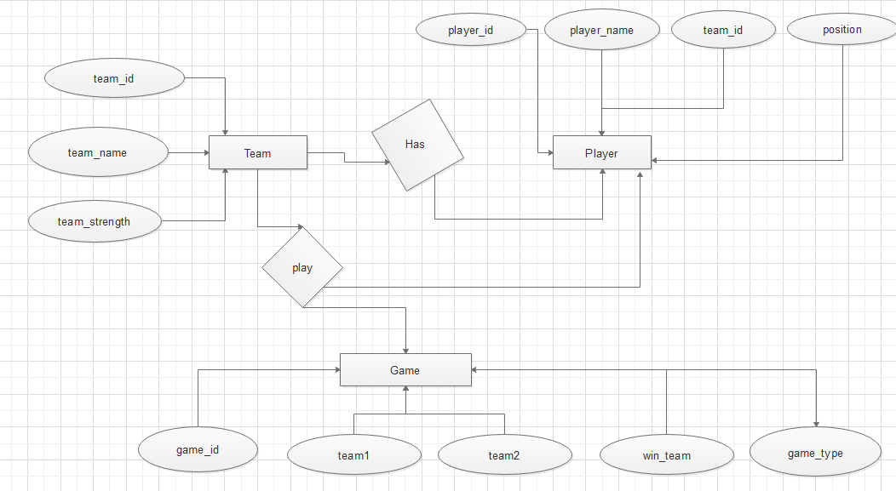

**SCENARIO 2:**

