**Name: Alam Khalid**

**Class: BSCS-8A**

**CMS: 260652**

**Date: 25/10/2019**

**Task (a):**

**Query:**

SELECT name as 'Category', f.title

FROM category c

JOIN film_category fc

USING (category_id)

JOIN film f

USING (film_id)

WHERE f.title = 'Chocolate Duck';

**Screenshot:**



**Task (b):**

**Query:**

SELECT city, country, first_name

FROM country

JOIN city

USING (country_id)

JOIN address

USING (city_id)

JOIN staff

USING (address_id)

WHERE first_name = 'Jon'

**Screenshot:**



**Task (c):**

**Query:**

SELECT first_name, last_name

FROM actor

JOIN film_actor

USING (actor_id)

JOIN film f

USING (film_id)

WHERE f.title = 'Alone Trip';

**Screenshot:**

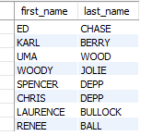

**Task (d):**

**Query:**

SELECT title

FROM film f

JOIN film_category

USING (film_id)

JOIN category

USING (category_id)

WHERE name = 'Games' AND f.rental_rate > 4

ORDER BY f.title;

**Screenshot:**



**Task (e):**

**Query:**

SELECT email, f.title

FROM customer

JOIN payment p

USING (customer_id)

JOIN rental

USING (rental_id)

JOIN inventory

USING (inventory_id)

JOIN film f

USING (film_id)

WHERE p.amount = 0;

**Screenshot:**

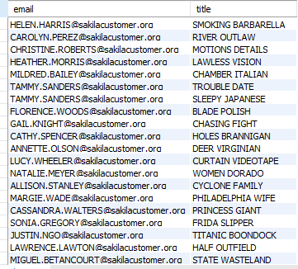

**Task (f):**

**Query:**

SELECT f.title, rental_id, rental_date, rental_duration

FROM film f

JOIN inventory

USING (film_id)

JOIN rental

USING (inventory_id)

JOIN payment

USING (rental_id)

WHERE amount = 0

ORDER BY f.title, rental_date;

**Screenshot:**

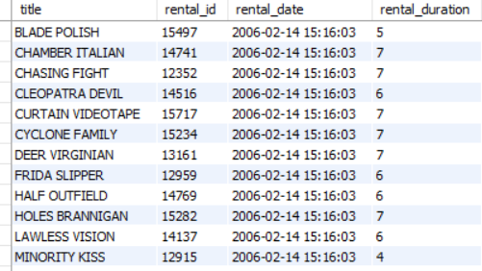

**Task (g):**

**Query:**

SELECT COUNT(*)

FROM film f

WHERE f.title

LIKE '%crocodile%'

OR f.title LIKE '%shark%';

**Screenshot:**



**Task (h):**

**Query:**

SELECT language_id

FROM language

WHERE name IN ('English','French');

**Screenshot:**

