Name: Alam Khalid

Class: BSCS-8A

CMS: 260652

Date: 8/11/2019

1. Number of customers who never rented BREAKING HOME.

**QUERY:**

SELECT COUNT(*) AS 'Number of customers'

FROM customer

WHERE customer_id NOT IN (SELECT customer_id

FROM rental

WHERE inventory_id IN (SELECT inventory_id

FROM inventory

WHERE film_id = (SELECT film_id

FROM film

WHERE title = 'BREAKING HOME')))

**SCREENSHOT:**

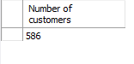

1. List accumulative replacement cost of the movies that were never rented.

**QUERY:**

SELECT SUM(replacement_cost)

FROM film

WHERE film_id NOT IN (SELECT film_id

FROM inventory)

**SCREENSHOT:**

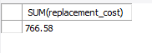

1. Find customers who are associated to City Abu Dhabi or Aden.

**QUERY:**

SELECT first_name, last_name

FROM customer

WHERE address_id IN (SELECT address_id

FROM address

WHERE city_id IN (SELECT city_id

FROM city

WHERE city IN ('Abu Dhabi','Aden')))

**SCREENSHOT:**

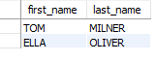

1. What category does the movie COMA HEAD belong to?

**QUERY:**

SELECT name

FROM category

WHERE category_id = (SELECT category_id

FROM film_category

WHERE film_id = (SELECT film_id

FROM film

WHERE title = 'COMA HEAD'))

**SCREENSHOT:**



e) Find the movies whose rental duration is less than the rental duration of movie ‘AFRICAN EGG’.

**QUERY:**

SELECT title

FROM film

WHERE rental_duration < (SELECT rental_duration

FROM film

WHERE title = 'AFRICAN EGG')

**SCREENSHOT:**

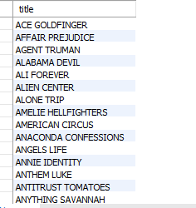

f) Find those films whose category id is greater than every category id of available films.

**QUERY:**

SELECT title

FROM film

WHERE film_id IN (SELECT film_id

FROM film_category

WHERE category_id = (SELECT MAX(category_id)

FROM film_category

WHERE film_id IN (SELECT film_id

FROM inventory)))

**SCREENSHOT:**

