NAME : ALAM KHALID

CMS ID: 260652

CLASS: BSCS-8A

DATE: 15/11/2019

1. Find the name of faculty members who do not teach any course.

**QUERY:**

SELECT fname

FROM faculty F

WHERE NOT EXISTS (SELECT * FROM class c WHERE f.fid = c.fid);

**SCREENSHOT:**

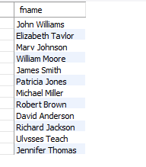

1. Find the names of faculty members that have taught classes only in room R128.

**QUERY:**

SELECT fname

FROM faculty F

WHERE EXISTS (SELECT * FROM class c WHERE f.fid = c.fid AND room = 'R128');

**SCREENSHOT:**

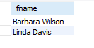

1. Retrieve the snum and sname of students who have taken classes from both ‘Ivana Teach’ and ‘Linda Davis’.

**QUERY:**

SELECT snum, sname

FROM student S

WHERE EXISTS (SELECT snum FROM enrolled E WHERE EXISTS (

SELECT cname

FROM class C

WHERE EXISTS (SELECT fid FROM faculty F WHERE fname IN ('Ivana Teach','Linda Davis') AND s.snum = E.snum)));

**SCREENSHOT:**

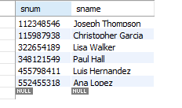

1. Find the age of the oldest student(s) who is enrolled in a course taught by Ivana. Teach.

**QUERY:**

SELECT MAX(age)

FROM student S

WHERE EXISTS (SELECT snum FROM enrolled E WHERE EXISTS (

SELECT cname

FROM class C

WHERE EXISTS (SELECT fid FROM faculty F WHERE fname = 'Ivana Teach' AND s.snum = E.snum)));

**SCREENSHOT:**



1. Find the name of faculty members that do not teach to class ‘database systems’.

**QUERY:**

SELECT fname

FROM faculty F

WHERE NOT EXISTS (SELECT fid

FROM class C

WHERE C.cname = 'Database Systems' AND f.fid = C.fid);

**SCREENSHOT:**

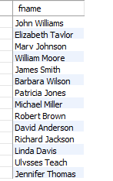

1. Find the name of faculty member, department who has taught the maximum number of distinct classes.

**QUERY:**

SELECT fname, dept_id

FROM faculty F

WHERE EXISTS (SELECT fid

FROM (SELECT fid,COUNT(fid) as 'count'

FROM class C

WHERE EXISTS (SELECT distinct cname

FROM class C)

GROUP BY C.fid) M

HAVING MAX(count) AND M.fid = F.fid);

**SCREENSHOT:**



1. Find the names of all classes and their enrollment strength that have enrollment greater than 5.

**QUERY:**

SELECT cname

FROM class

WHERE EXISTS (SELECT cname

FROM enrolled E

GROUP BY E.cname

HAVING COUNT(*) > 5);

**SCREENSHOT:**



1. Find the names of all students who are enrolled in two classes that meet at the same time.

**QUERY:**

SELECT sname

FROM student s

WHERE EXISTS (SELECT snum

FROm enrolled E

WHERE EXISTS (SELECT cname FROM class C

WHERE EXISTS (SELECT meets_at

FROM CLASS WHERE s.snum = e.snum)));

**SCREENSHOT:**

