E-Learning Platform Analysis – Summary Report
Overview:
- Analysis of purchasing behavior using MySQL across learners, courses, and purchases.
- Focus areas include learner spending, popular courses, and category performance.
- Techniques used: JOINs, aggregations, formatting, and filtering,concatination,grouping.
Key Insights:
- Technology and Analytics generate the highest revenue.
- Python, SQL, and Power BI are the most purchased courses.
- Technology leads revenue; Analytics has strong repeat learners.
- Four learners purchased from multiple categories, showing high engagement.
- Cloud Computing course has zero purchases, indicating low visibility.
Recommendations:
- Strengthen marketing for Technology and Analytics categories.
- Review Non_Purchased Courses.
- Offer bundles and personalization for multi-category learners.
- Refresh Business category content to increase adoption.
- Repackage or promote non-purchased courses effectively.
- Create advanced-level versions of high-demand courses.
Learner-Level Metrics:
- High spenders belong mostly to Technology and Analytics.
- Multi-category learners show strong long-term potential.
- Revenue per learner varies by purchase count and course price.
Course-Level Metrics
- Top 3 courses drive most platform sales.
- Technology dominates overall revenue contribution.
- Courses with no purchases need redesign or better positioning.

Course Sales Trends and Price Structure Analysis:
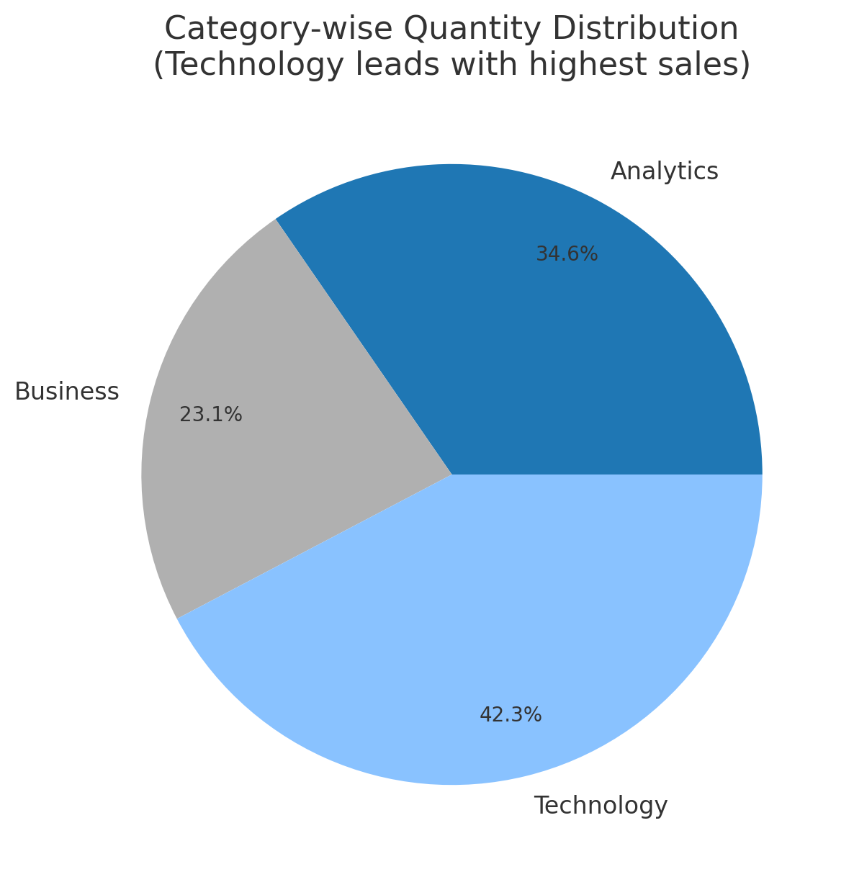
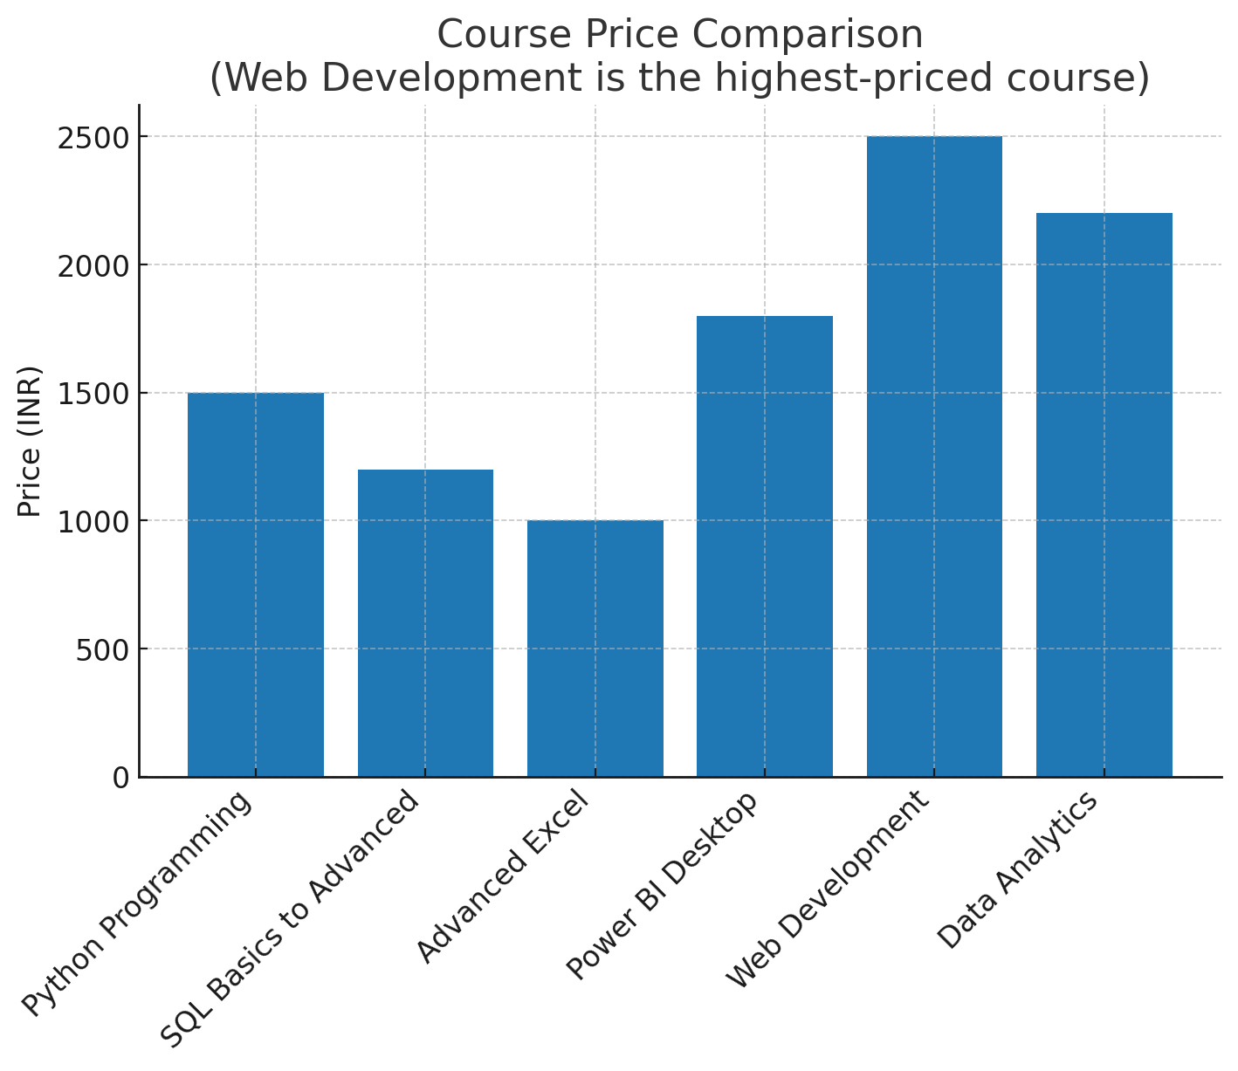

Conclusion:
- Analysis shows strong demand for technology-focused learning.
- Opportunities exist to improve weaker categories and enhance engagement.

