Meflex

# Meta:

1. (+) New Screen.
2. (+mobile) Mobile responsive.

# Home Page:

1. (+) Artist Section after Featured On. (+mobile)
2. Header Section Changes.
3. Categories Section Design
4. (+) Create Contest in on going contest.
5. Discover Fashion UI (+mobile)
6. Footer changes (+mobile)

# Login (+):

1. (+) Login Screen for desktop. (+mobile)
2. (+) Login Failed Pop up Modal

# Forgot password (+):

1. (+) Reset password screen. (+mobile).
2. (+) Code sent popup modal (+mobile).
3. (+) Enter Verification Code (+mobile).
4. (+) Password reset (+mobile).
5. (+) Reset success popup modal (+mobile).

# Signup screens (+):

1. (+) Signup screen (+mobile)
2. (+) Validation Popup modal(+mobile)

# Import Wallet (+):

1. (+) Import Wallet (+mobile).
2. (+) Import success Modal
3. (+) Import Failed Modal.

# Explore NFT:

1. Add trending option in Sort option.
2. Redesign Product Card
3. Change color of Category accordion.
4. Show 2 product in one row on mobile. (+mobile)
5. (+) Share Popup design. (+mobile)

# NFT Details:

1. Show likes button with counter. (right side)
2. Change share Icon (right side)
3. Show Badge on the top (right side).
4. Buy now and place a bid button (right side).
5. (+) Comment section (+mobile).
6. (+) Personal Info on Buy now (+mobile).
7. (+) Make a Bid (+mobile).

# Create NFT:

1. Change Price Currency selection (MEF/BNB)
2. (+) Collect User address input.

# Explore Contest:

1. Create Contest Modification.

# ***Questioners***

1. Which search is it?

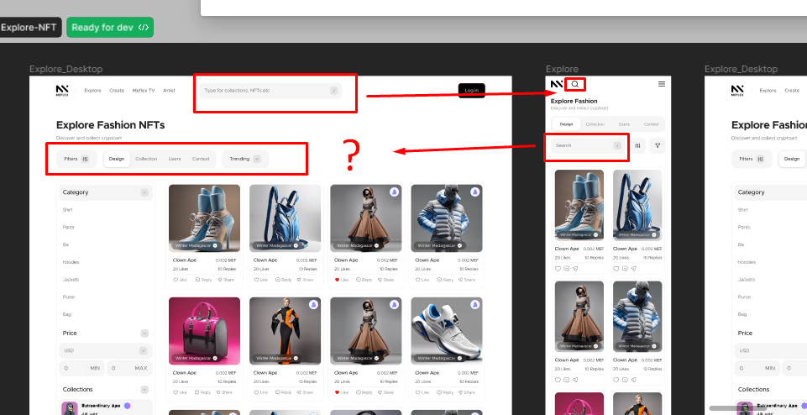

1. Icons?  
   