**Start your day with a coffee!**

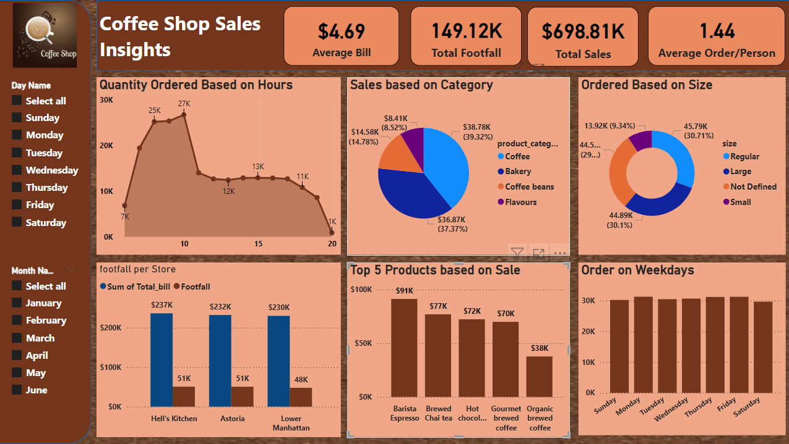

**Summery**

This is one of my Portfolio projects where I have analysed the data of a Coffee Shop name Maven Roasters in New York to uncover the trends and insights of the sales. It covers every aspect of the lifecycle from requirements gathering, analysis, visualization, and recommending action taken for the Coffee Shop.

**Objectives**

the main objective of this project is to analyse the retail sales data to gain actionable insights that will enhance the performance of the Coffee Shop.

**Recommended Analysis**

There are some key questions that must be answered by analysis through this study.

1. How do sales vary by day of the week and hour of the day?
2. Are there any peak times for sales activity?
3. What is the total revenue for each month?
4. How do sales vary across different store locations?
5. What is the average price per person?
6. Which products are the best selling in terms of quantity and revenue?
7. How do sales vary by product category and type?

**Data:**

Transaction records for Maven Roasters, a fictitious coffee shop operating out of three NYC locations. Dataset includes the transaction date, timestamp, and location, along with product-level details. I have downloaded this dataset from the Kaggle to local storage and imported into MySQL Workbench through the Table Data Import Wizard.

**Tools used in this project:**

**MySQL**

**Power Query**

**Power BI**

**Processing of Data**

I have cleaned the raw data and transformed into suitable format to do analysis. During clean up I must remove blank space, change data format, and add new columns such as total bill, month name, day name, hour, day of the week, and month. I also added conditional columns and transform month name into month number and weekday into weekday number for sorting.

Removing date and time to a separate column

**Analysis based on the Project Requirements**

**Sales vary by day and hours.**

From the visual diagram it clearly shows that sales are high in weekdays rather than weekends. The peak time of sale is between 7am to 11am.

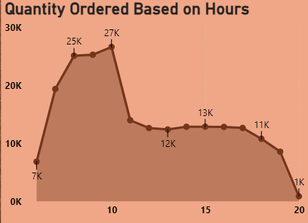

**Total Revenue for each month**

Diagram shows significant monthly increase of sales and trends are positive which may have for climate reason or monthly promotions.

**Sales according to Store location**

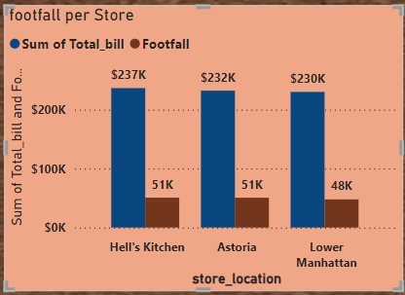

The diagram shows that out of the three stores, Hell’s Kitchen is generating more revenue at $237k. The other two stores are doing good, and they are almost close.

**Average price per person**

The average bill per person calculated $4.69, and the average order value per person is $1.44.

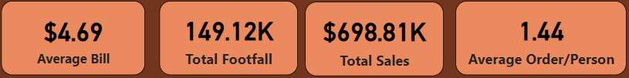

**Best selling product by Category**

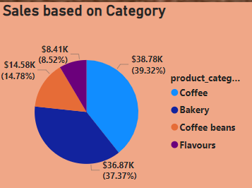 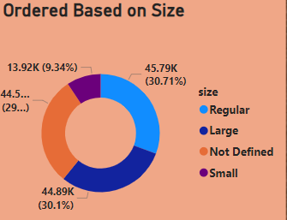

From the pie diagram it shows that Coffee sales are at the top of about $38.78k (39.32%) then Bakery $36.87(37.37%)

**Best Selling product**

Barista Espresso, Brewed Chai Tea, Hot Chocolate Gourmet Brewed Coffee and emerged as favorites, indicating a strong preference for these beverages.

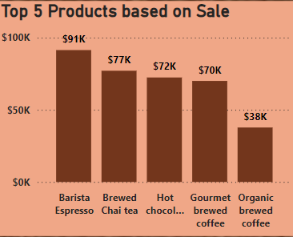

Analyzed sales by product category and type, find that Premium brewed coffee and Scone products lead in sales, making up 77% of total revenue.

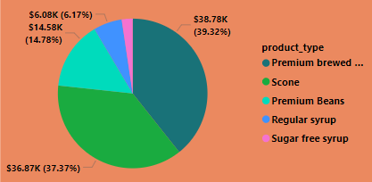

**Recommendation**

The trends of the graphs show that Sales are growing, and people are likely to buy branded products more than other flavours. The peak hour of sale is between 6am to 10am for morning people who are going to work. So, management should hire more people at that time to serve quicky and generate more revenue. Weekend sales look slower than weekday, so they should offer promotion to attack more customer during weekend. Management can also take customer feedback about their concern and opinion for better customer service.