**HR Attrition Analysis dashboard**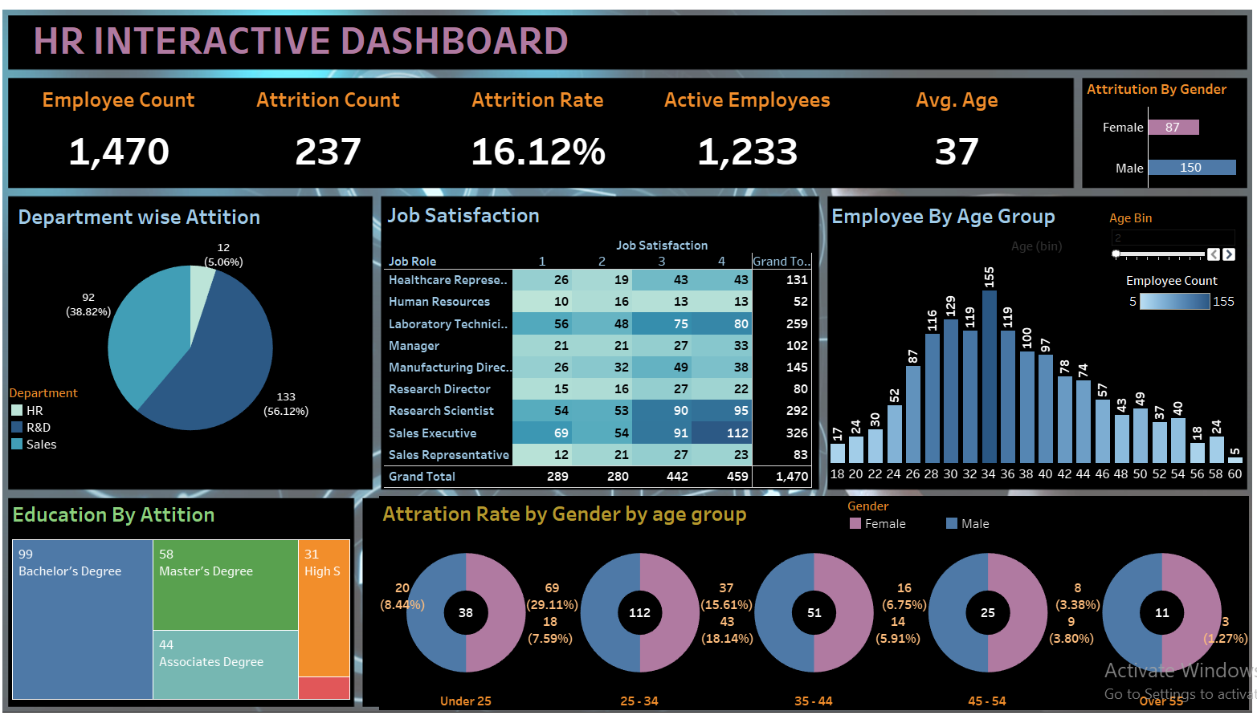

**Business Issue**

HR Department of the ABC Company are having a hard time finding the attrition rate among employees and want to get insights through an automated visual dashboard which will help them to take necessary action if required.

**Requirements:**

I have used below the Key Performance Indicator (KPI) in this dashboard:

* Total Headcount
* Total Attrition of the Company
* Percentage of Attrition
* Active Employees
* Age group or range
* Attrition based on whether they are male or female
* Department based Attrition
* Job satisfaction based on job role
* Total employees by age group
* Education wise attrition
* Attrition rate by gender and age group

**Tools used in this project**

* **Excel**
* **MySQL**
* **Tablue**

**About Data**

Data downloaded from the internet in an excel format <HR Data.xlsx>

**Data Cleaning**

The data I downloaded is already cleaned by uploader.

**Formatting and Transformation of data**

Converting yes to 1 and no to 0 for calculation.

Creating API for the Dashboard

**Success Criteria**

Dashboard uncovers Attritions based on male, female, age group, education, and department. Attrition rate is 16.12% among employees where most of them from R&D Department (56.12%), and Sales Department (38.82%). Attrition interims of degree found bachelor’s degrees are among the top with ninety-nine in total. Highest attrition rate of the mail and female is in the age group between 24 to 35.