
Child Mind Institute
Problematic Internet Use
────────────────────────────────────────
Data Mining 2 — Advanced Topics and Applications

SAGOR HOWLADER (685068)
MD AL AMIN (701533)

Academic Year 2025/2026

Table of Contents
Module 0 — Data Understanding and Preparation 3
0.1 Dataset Overview 3
0.2 Target Variable Distribution 3
0.3 Feature Engineering and Pre-processing 4
0.3.1 Target leakage removal 4
0.3.2 Train/test split 4
0.3.3 Missing values 4
0.3.4 Correlation structure 5
Module 1 — Outlier Detection and Imbalanced Learning 6
1.1 Outlier Detection 6
1.2 Imbalanced Learning 7
Module 2 — Advanced Classification, Regression, and Explainability 9
2.1 Classification Approach: Ordinal Cumulative Binary Models 9
2.2 Classifiers and Hyperparameter Tuning 9
2.2.1 Logistic Regression (baseline) 9
2.2.2 Support Vector Machine 9
2.2.3 Neural Network (MLP) 9
2.2.4 Ensemble Methods: Bagging and Random Forest 9
2.2.5 AdaBoost 10
2.2.6 XGBoost (Gradient Boosting, ordinal) 10
2.3 Classification Results 10
2.4 Advanced Regression 12
2.5 Explainability: SHAP Analysis 14
Module 3 — Time Series Analysis 16
3.1 Dataset Description and Preprocessing 16
3.2 Exploratory Analysis 16
3.3 Motifs and Discords 17
3.4 Time Series Clustering 18
3.5 Relation Between Shapelets and Motifs 19
3.6 Time Series Classification 20
3.6.1 k-NN with Euclidean distance 20
3.6.2 k-NN with DTW (Sakoe-Chiba constrained) 20
3.6.3 ROCKET 20
3.6.4 Shapelet Transform 20

Module 0 — Data Understanding and Preparation

0.1 Dataset Overview
The tabular dataset is a modified version of the Child Mind Institute (CMI) Problematic Internet Use Kaggle competition dataset, containing 8,460 rows (participants) and 82 columns. Each row corresponds to one child or adolescent whose level of problematic internet use has been assessed via the Severity Impairment Index (sii), derived from the Parent-Child Internet Addiction Test (PCIAT). The dataset includes measurements from several assessment instruments: demographic information, physical measurements, fitness tests, body composition (BIA), sleep questionnaires, and a pre-internet behaviour questionnaire.
Dataset dimension | Value
Total records | 8,460
Original features | 82
Target variable | sii (ordinal, 0–3)
Train set (75%) | 6,345 rows
Test set (25%) | 2,115 rows
Split strategy | Stratified by sii, before cleaning

0.2 Target Variable Distribution
The sii target (Severity Impairment Index) is an ordinal four-level variable: 0 = None, 1 = Mild, 2 = Moderate, 3 = Severe. It is derived by binning PCIAT_Total scores. The distribution is heavily imbalanced, dominated by class 0.
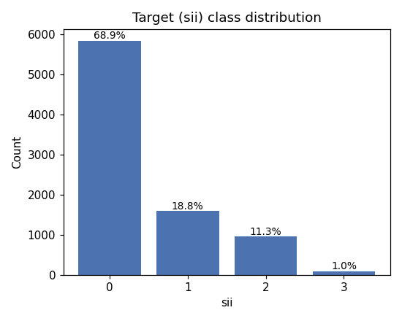
Figure 0.1: Distribution of sii (Severity Impairment Index) in the full dataset.
sii class | Label | Count | % of dataset
0 | None | 5,842 | 69.1%
1 | Mild | 1,585 | 18.7%
2 | Moderate | 952 | 11.2%
3 | Severe | 81 | 1.0%

0.3 Feature Engineering and Pre-processing

0.3.1 Target leakage removal
The 22 PCIAT_* columns (raw PCIAT item scores) and the id column were dropped before any modelling, as sii is arithmetically derived from PCIAT_Total. Retaining them would constitute target leakage.

0.3.2 Train/test split
A stratified 75/25 split was applied to the full dataset before any cleaning or imputation, to ensure that no test-set information influences the preprocessing pipeline. This yielded 6,345 training rows and 2,115 test rows, with matching class proportions.

0.3.3 Missing values
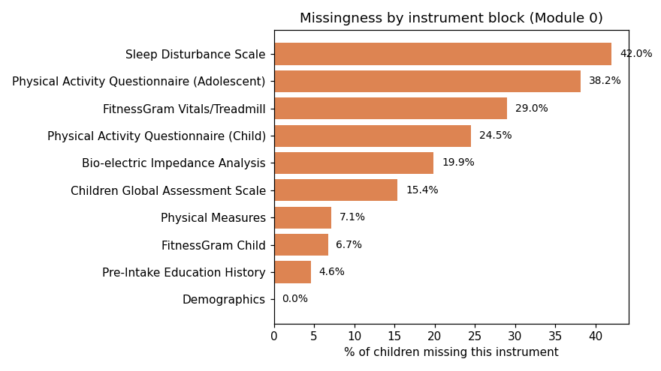
Figure 0.2: Missingness rate (%) per feature, grouped by instrument block.
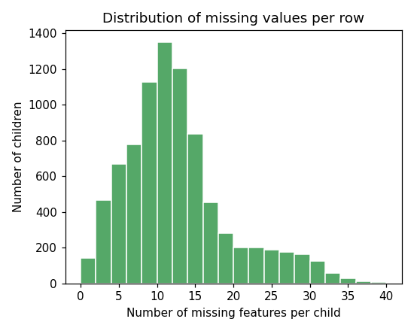
Figure 0.3: Distribution of the number of missing values per row.
Missing values were handled as follows: for each instrument block, a binary missingness flag was added (1 = all features in the block missing for this participant). Numeric features were then imputed with the training-set median; the Season columns were treated as categorical and imputed with the mode. This resulted in 107 features after one-hot encoding of seasonal columns.

0.3.4 Correlation structure
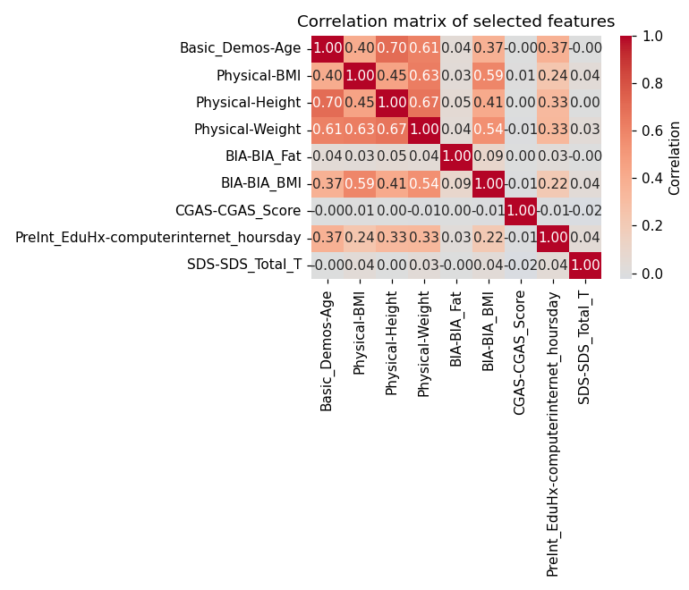
Figure 0.4: Pearson correlation matrix of the 107 processed features (numeric features only).
The correlation heatmap reveals several tight groups corresponding to the original assessment instruments (e.g., SDS sleep subscores, BIA body-composition indices), confirming that feature groups within each block convey partially redundant information.

Module 1 — Outlier Detection and Imbalanced Learning

1.1 Outlier Detection
Three complementary outlier detection methods were applied to the standardised training set, each from a different family:
- Local Outlier Factor (LOF, n_neighbors=50): detects points in low-density regions relative to their neighbours.
- Angle-Based Outlier Detection (ABOD, fast variant, n_neighbors=50): detects geometrically unusual points based on angle variance, well-suited to high-dimensional data.
- Isolation Forest (n_estimators=200, max_samples=0.6): detects points easily isolated by random splits.
The three methods were combined via majority voting: a point flagged by at least 2 of 3 methods was labelled an outlier. Thresholds were set at the 10th percentile of LOF scores, 90th percentile of ABOD scores, and 5th percentile of Isolation Forest scores.
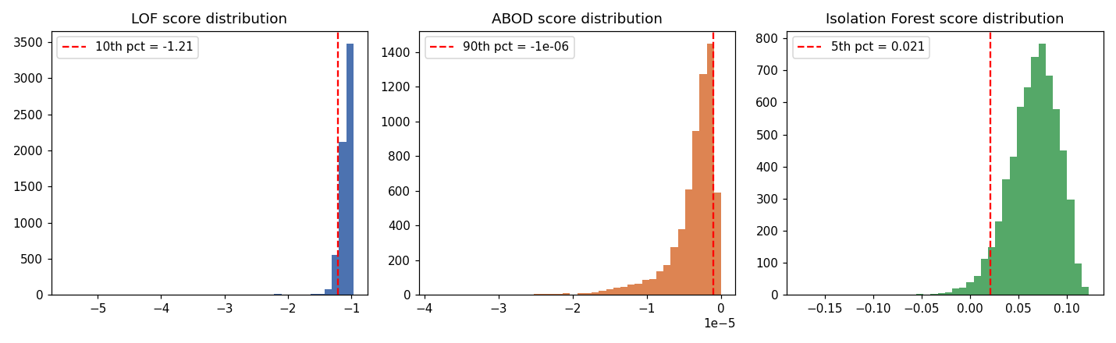
Figure 1.1: Score distributions for LOF (left), ABOD (centre), and Isolation Forest (right) with chosen thresholds.
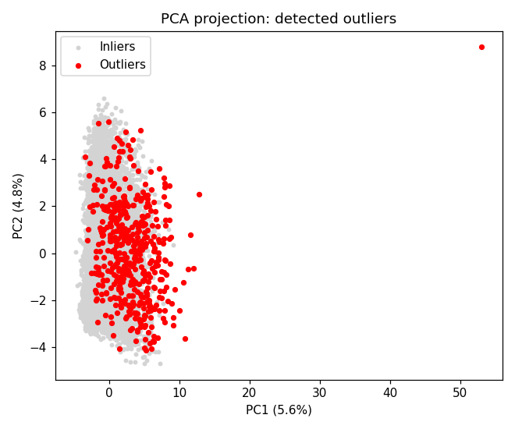
Figure 1.2: PCA projection of the training set (2D), with ensemble-detected outliers highlighted in red.
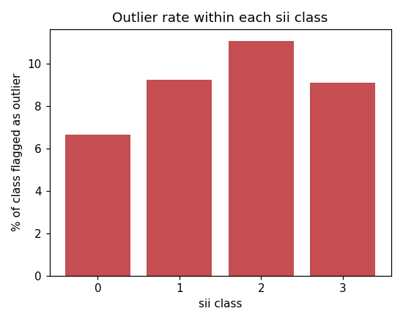
Figure 1.3: Percentage of each sii class flagged as an outlier by the ensemble.
Method | Individual outliers | % Of train | Contribution to ensemble
LOF | 635 | 10.0% | 79.6%
ABOD | 635 | 10.0% | 98.6%
Isolation Forest | 318 | 5.0% | 50.6%
Ensemble (>=2/3) | 486 | 7.66% | —

ABOD drives 98.6% of the ensemble decisions, consistent with its effectiveness in high-dimensional, sparse settings such as this one-hot-encoded feature set. The outlier rate is similar across sii classes (6.7%–11.1%), so no class is disproportionately depleted. The 486 flagged observations were removed, reducing the training set from 6,345 to 5,859 rows.

1.2 Imbalanced Learning
With sii = 3 (Severe) representing only ~1% of the training set, a binary one-vs-rest classification task was defined (sii=3 vs rest) to study the impact of resampling. A Decision Tree (max_depth=6) was used as the base classifier, evaluated on an internal 70/30 stratified split. Three resampling families were tested with sensitivity analysis on the neighbourhood parameter k:
- SMOTE (oversampling): k ∈ {3, 5, 7}
- ENN (undersampling): k ∈ {3, 5, 7}
- SMOTEENN (combined): (k_SMOTE, k_ENN) ∈ {(3,3), (5,5), (3,5), (5,3)}
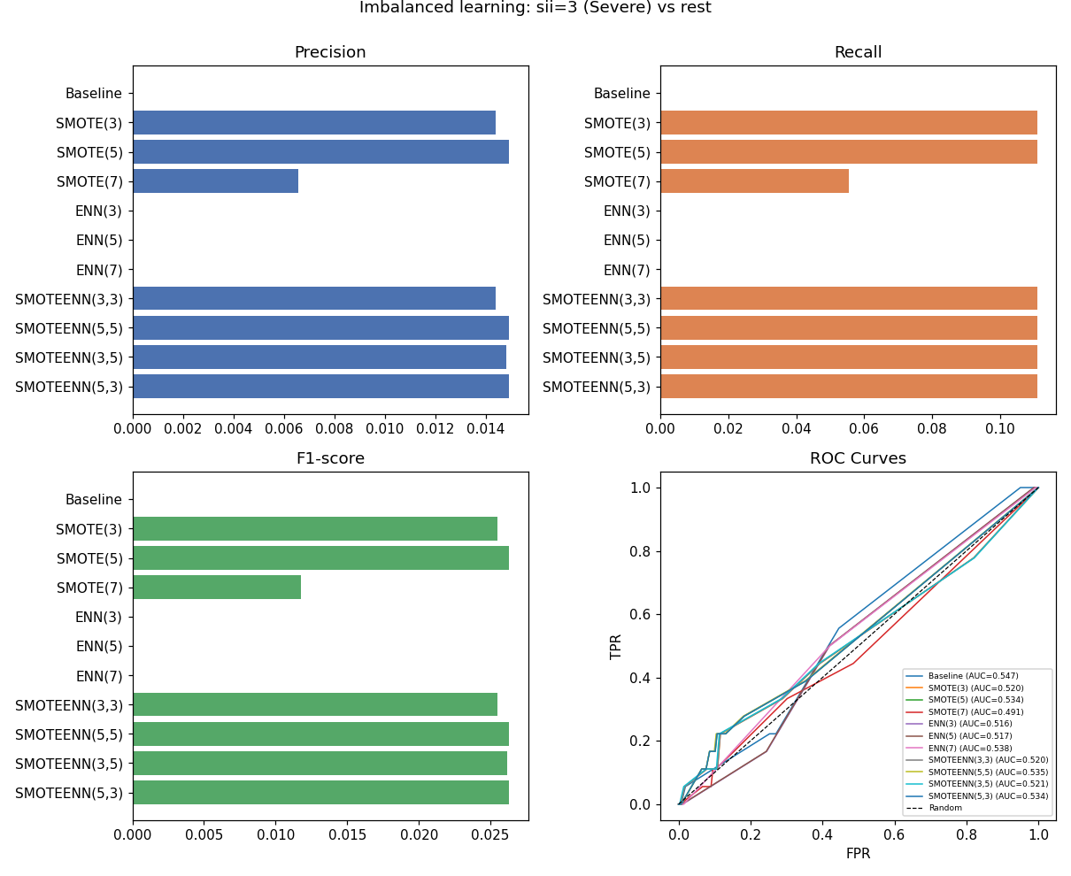
Figure 1.4: Precision, Recall, F1, and ROC curves for all resampling configurations (sii=3 vs rest).
The baseline Decision Tree achieves precision=recall=0 for the Severe class — it never predicts sii=3. SMOTE and SMOTEENN raise recall to ~0.11 at the cost of very low precision (~0.015), and all AUC values remain near random (0.49–0.54). ENN has no effect. This finding is consistent with the extreme scarcity of sii=3 cases (~60 in the training set) and motivates the class-weighting strategy used in Module 2 rather than data-level resampling.

Module 2 — Advanced Classification, Regression, and Explainability

2.1 Classification Approach: Ordinal Cumulative Binary Models
Because sii is an ordinal variable (0 < 1 < 2 < 3) and standard 4-class approaches would treat the classes as unordered, this module adopts an ordinal classification strategy. The multi-class problem is decomposed into three nested binary sub-problems:
- M1: P(sii ≥ 1) — any impairment vs. none [30.3% positive in train]
- M2: P(sii ≥ 2) — moderate-or-severe vs. mild/none [11.9% positive]
- M3: P(sii ≥ 3) — severe vs. rest [1.0% positive, scale_pos_weight=96.7]
Each binary model is independently fitted with class weighting (class_weight='balanced' for Logistic Regression and SVM; scale_pos_weight = neg/pos for XGBoost). The three predicted probabilities are recombined into a final class prediction: P(sii=k) = P(sii≥k) − P(sii≥k+1), values clipped to [0,1], renormalised, argmax taken.
In addition, all classifiers were also benchmarked in a direct 4-class setting (predicting sii ∈ {0,1,2,3}) with class_weight='balanced', to compare the ordinal vs. direct approaches.

2.2 Classifiers and Hyperparameter Tuning

2.2.1 Logistic Regression (baseline)
Logistic Regression with L2 regularisation was trained both in ordinal mode (three binary models) and direct 4-class mode. Hyperparameter: C ∈ {0.01, 0.1, 1, 10} tuned via 3-fold cross-validation. Best: C=1 (ordinal mode). Features were standardised (zero mean, unit variance).

2.2.2 Support Vector Machine
A linear-kernel SVM was selected after cross-validating kernel ∈ {linear, rbf} and C ∈ {0.1, 1, 10}. Linear kernel with C=1 gave the best macro-F1 in 3-fold CV (0.316), while rbf required prohibitively long training times on the full feature set. class_weight='balanced' was applied.

2.2.3 Neural Network (MLP)
A Multi-Layer Perceptron was evaluated for hidden_layer_sizes ∈ {(64,), (128,), (64,32)}, alpha ∈ {0.0001, 0.01}, and learning_rate_init ∈ {0.001, 0.01}. Best configuration: hidden_layer_sizes=(64,), alpha=0.0001, lr=0.01. Early stopping with validation_fraction=0.1 was used to prevent overfitting.
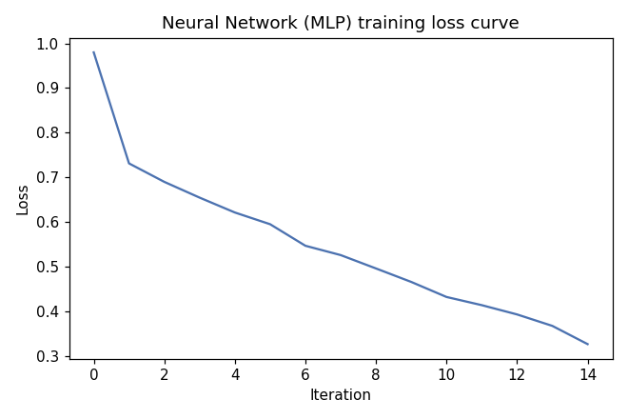
Figure 2.1: MLP training and validation loss curves (best configuration).

2.2.4 Ensemble Methods: Bagging and Random Forest
Bagging with Decision Tree base learners was evaluated for n_estimators ∈ {50, 100}, max_samples ∈ {0.5, 0.7, 1.0}. Best: 50 estimators, max_samples=0.7.
Random Forest was evaluated for n_estimators ∈ {100, 200}, max_depth ∈ {None, 20, 40}, max_features ∈ {sqrt, 0.5, 0.7}, min_samples_leaf ∈ {1, 5}. Best: 200 estimators, max_depth=40, max_features=0.7, min_samples_leaf=5. Random Forest is the best-performing model overall (macro-F1=0.341).
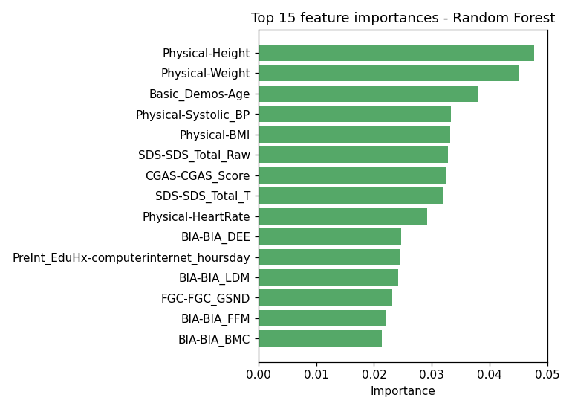
Figure 2.2: Top 15 features by Random Forest feature importance (mean decrease in impurity).

2.2.5 AdaBoost
AdaBoost with Decision Tree stumps was evaluated for n_estimators ∈ {50, 100}, learning_rate ∈ {0.5, 1.0}, max_depth of base estimator ∈ {1, 3}. Best: 50 estimators, lr=1.0, max_depth=3.

2.2.6 XGBoost (Gradient Boosting, ordinal)
XGBoost was applied in the cumulative binary ordinal mode. Fixed hyperparameters: n_estimators=300, max_depth=4, learning_rate=0.05, subsample=0.8, colsample_bytree=0.8, reg_lambda=1.5, reg_alpha=0.1. scale_pos_weight was set per threshold (2.3 / 7.4 / 96.7 for M1/M2/M3).

2.3 Classification Results
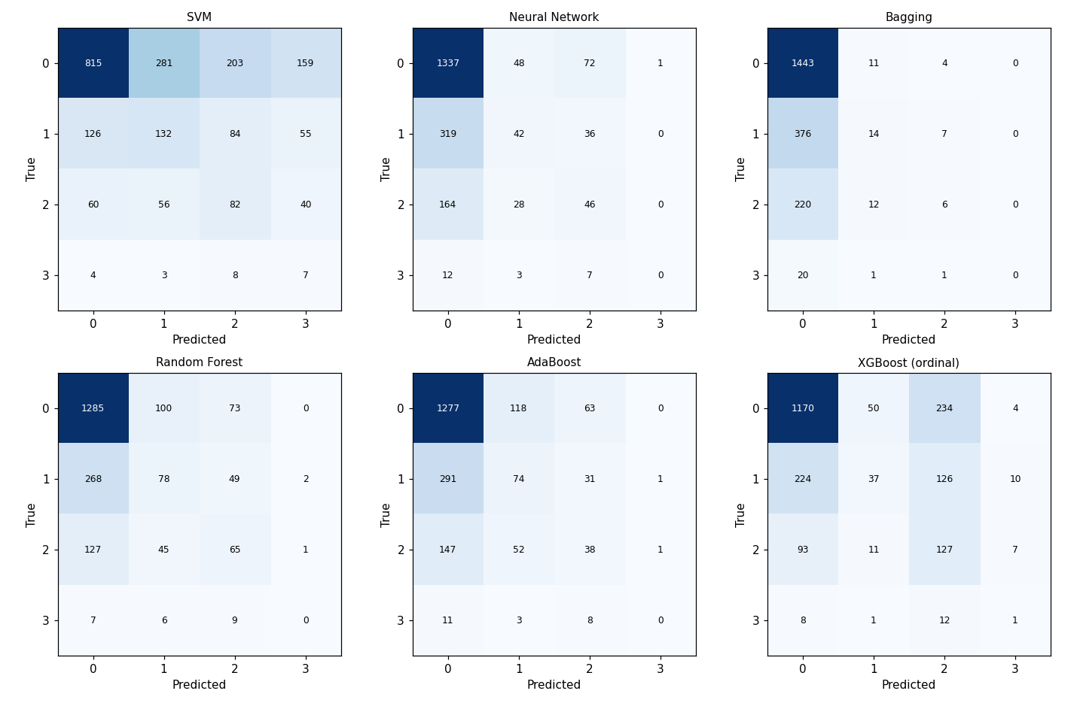
Figure 2.3: Confusion matrices for all classifiers on the test set (sii ∈ {0,1,2,3}).
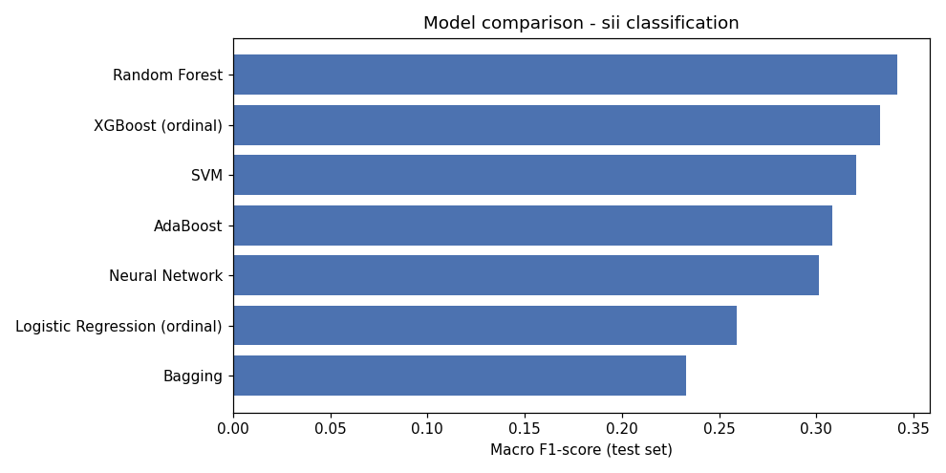
Figure 2.4: Macro-F1 comparison across all classifiers.
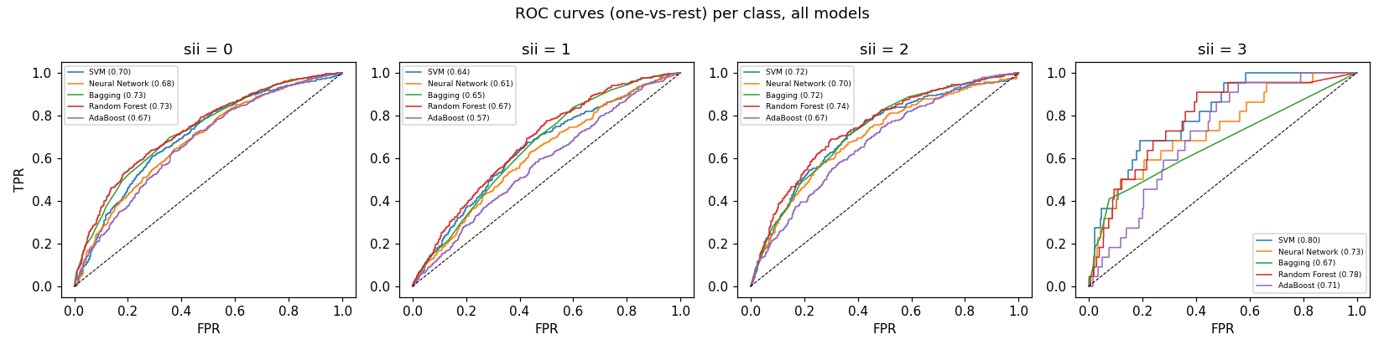
Figure 2.5: ROC curves per sii class (one-vs-rest) for all models.
Model | Acc | Macro F1 | Wtd F1 | F1(sii=0) | F1(sii=1) | F1(sii=2) | F1(sii=3)
SVM (linear, C=1) | 0.490 | 0.320 | 0.544 | 0.662 | 0.304 | 0.267 | 0.049
Neural Net (64,) | 0.674 | 0.301 | 0.617 | 0.813 | 0.162 | 0.231 | 0.000
Bagging (50 est) | 0.692 | 0.233 | 0.583 | 0.821 | 0.064 | 0.047 | 0.000
Random Forest (BEST) | 0.675 | 0.341 | 0.644 | 0.817 | 0.249 | 0.300 | 0.000
AdaBoost (50 est) | 0.657 | 0.308 | 0.619 | 0.802 | 0.230 | 0.201 | 0.000
LogReg (ordinal) | 0.521 | 0.259 | 0.538 | 0.738 | 0.005 | 0.250 | 0.043
XGBoost (ordinal) | 0.631 | 0.333 | 0.614 | 0.792 | 0.149 | 0.345 | 0.045

Random Forest achieves the highest macro-F1 (0.341), followed closely by XGBoost-ordinal (0.333) and SVM (0.320). The ordinal XGBoost and LogReg models are the only ones that assign non-zero F1 to sii=3 (Severe), because the cumulative binary formulation forces them to learn a ranking for this class; all direct 4-class models predict sii=3 with F1=0, consistent with the extreme scarcity (~1%) of this class.
The SVM's higher macro-F1 compared to Neural Network and Bagging is due to better recall on the minority classes (sii=1, 2, 3), aided by the balanced class weighting. The Neural Network achieves the highest accuracy overall (0.674) but is dominated by class 0, achieving F1=0 for sii=3. The Bagging classifier likewise collapses to a near-majority-class predictor (F1=0.064 for sii=1, 0.047 for sii=2). This shows that ensemble diversity alone is not sufficient when class imbalance is as severe as in this dataset; explicit class weighting (SVM, XGBoost) or the ordinal framing (LogReg/XGBoost) are required to recognise minority classes.

2.4 Advanced Regression
A multiple regression task was defined to predict CGAS-CGAS_Score (Children's Global Assessment Scale), a continuous measure of overall psychological functioning scored from 0 to 100. CGAS was identified as one of the top SHAP predictors of sii in the classification analysis (Section 2.5). Rows with CGAS > 100 (data entry errors, including one value of 999) were excluded, leaving 5,847 training rows and 2,111 test rows. All 106 remaining features were used as inputs.
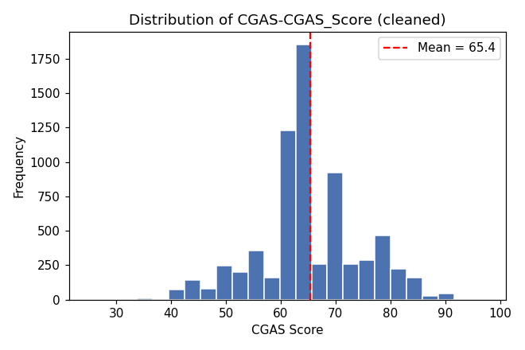
Figure 2.6: Distribution of the CGAS score (regression target) in the training set.
Two non-linear regression approaches were compared:
- XGBoost Regressor: n_estimators=200, max_depth=5, learning_rate=0.02, subsample=1.0, colsample_bytree=0.7, reg_lambda=2.
- Random Forest Regressor: n_estimators=200, max_depth=None, max_features=sqrt, min_samples_leaf=10.
Model | MSE (test) | MAE (test) | R² (test) | CV R² (5-fold)
XGBoost Regressor | 90.15 | 7.00 | 0.026 | 0.039
Random Forest Regressor | 89.81 | 6.98 | 0.030 | 0.041

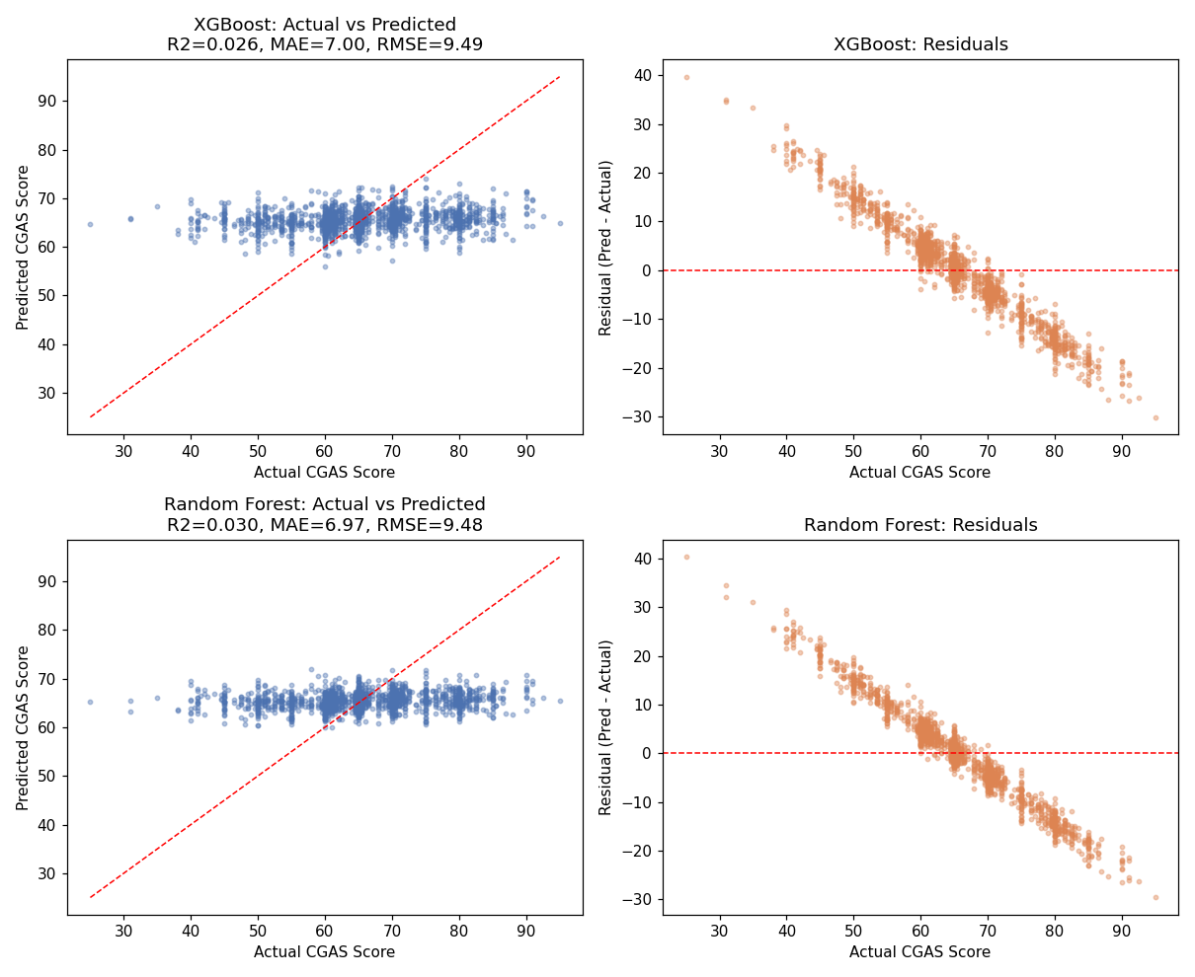
Figure 2.7: Actual vs. predicted CGAS scores (left panels) and residual plots (right panels) for XGBoost and Random Forest.
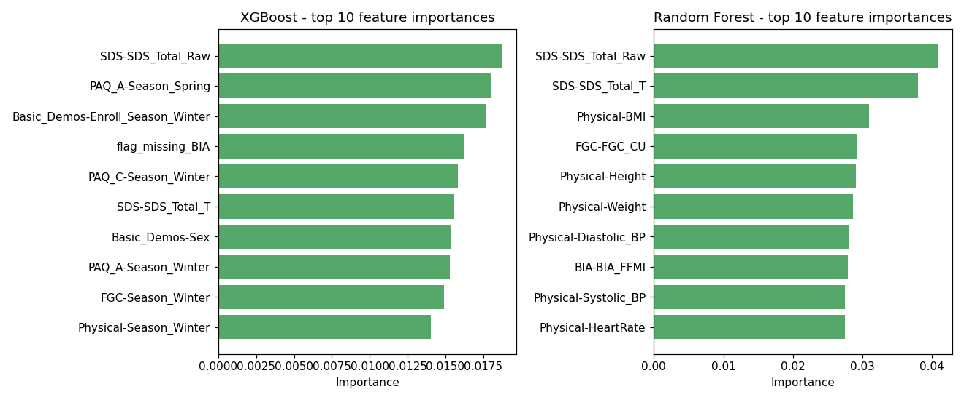
Figure 2.8: Top 15 features by importance for the XGBoost (left) and Random Forest (right) regression models.
Both models achieve a low but positive R² (0.03–0.04 on test and cross-validation), which is characteristic of regression on subjective psychological scales from physical and lifestyle features alone. The residual plots show a clear regression-to-the-mean pattern (predictions cluster near the mean CGAS ≈ 65.4, std ≈ 9.4), with both models struggling to predict extreme values. This is expected: CGAS is a clinician-rated summary score influenced by many factors beyond what is captured in this dataset.
The Random Forest marginally outperforms XGBoost on test MSE (89.81 vs 90.15) and R² (0.030 vs 0.026), though the difference is not meaningful at this level of performance. Both models agree on the most predictive features: physical measurements (height, weight, BMI), age, and the SDS sleep score are the top predictors of CGAS, consistent with the known relationship between physical development, sleep quality, and overall psychological functioning in adolescents.

2.5 Explainability: SHAP Analysis
SHAP (SHapley Additive exPlanations) was applied to the XGBoost binary model for P(sii ≥ 1) — the most balanced of the three ordinal thresholds (AUC = 0.745). TreeExplainer was used on a random sample of 500 test instances.
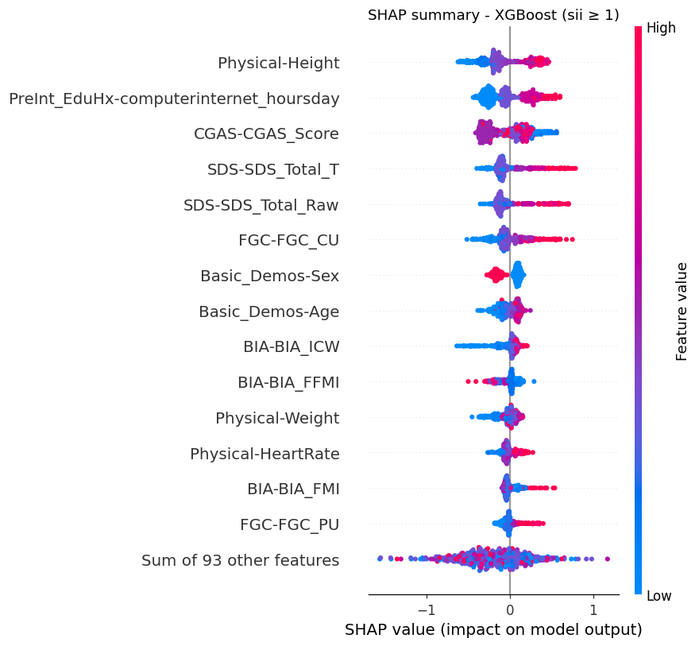
Figure 2.9: SHAP beeswarm plot — distribution of feature contributions to P(sii ≥ 1).
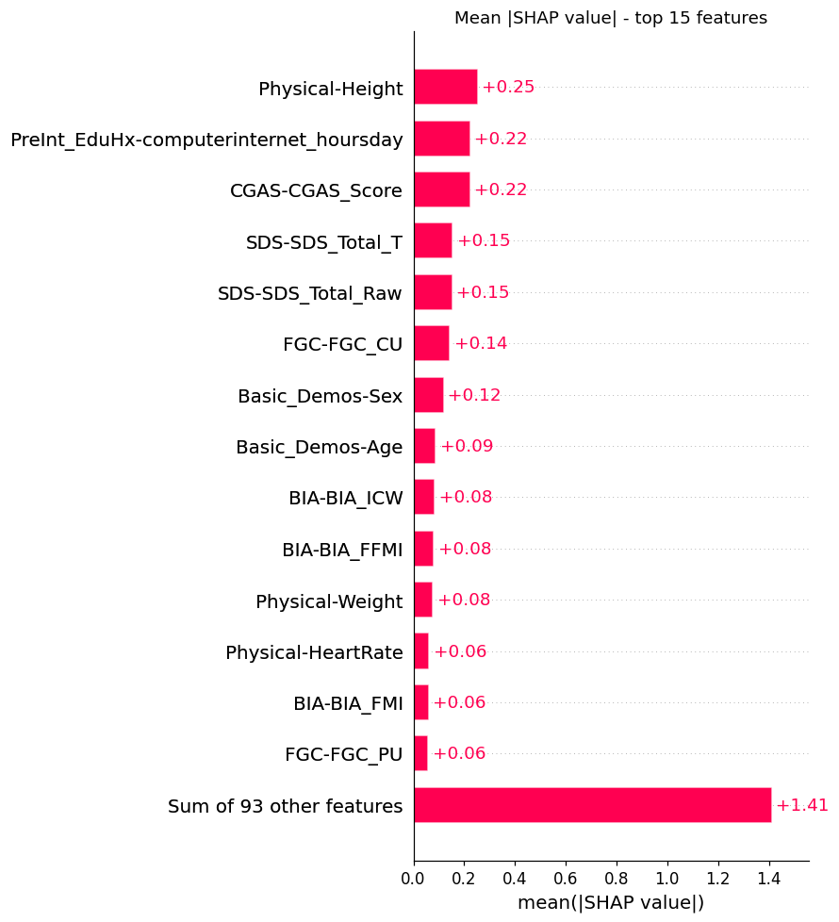
Figure 2.10: Mean |SHAP value| ranking — global feature importance.
Rank | Feature | Mean |SHAP| | Interpretation
1 | Physical-Height | 0.252 | Developmental proxy for age/maturity
2 | PreInt_EduHx-computerinternet_hoursday | 0.224 | Direct measure of daily internet exposure
3 | CGAS-CGAS_Score | 0.223 | Overall psychological functioning (lower → higher risk)
4 | SDS-SDS_Total_T | 0.154 | Sleep disturbance (T-score)
5 | SDS-SDS_Total_Raw | 0.153 | Sleep disturbance (raw score)
6 | FGC-FGC_CU | 0.143 | Curl-up fitness test (physical fitness)
7 | Basic_Demos-Sex | 0.120 | Gender
8 | Basic_Demos-Age | 0.088 | Age
9 | BIA-BIA_ICW | 0.084 | Intracellular water (body composition)
10 | BIA-BIA_FFMI | 0.080 | Fat-free mass index

The SHAP analysis reveals a clinically meaningful feature hierarchy. Daily internet usage hours (rank 2) is the most directly relevant feature, confirming that self-reported internet exposure is predictive even when the classifier is predicting a formal clinical assessment (sii). CGAS score (rank 3) highlights the link between overall psychological wellbeing and internet-use severity. Sleep disturbance features (ranks 4–5) capture the well-established connection between screen time and sleep disruption in adolescents. Physical/developmental features (height, age, body composition) likely capture the role of developmental stage and lifestyle patterns in problematic internet use.

Module 3 — Time Series Analysis

3.1 Dataset Description and Preprocessing
The time series dataset contains wrist-worn accelerometer recordings for 494 children from the CMI study. Each record is a DataFrame of 200 timesteps (30-minute intervals, covering approximately 4.2 consecutive days) with 13 columns: X, Y, Z acceleration; enmo (Euclidean Norm Minus One — a standard measure of overall movement intensity); anglez (wrist tilt angle); non-wear flag; ambient light; battery voltage; weekday; quarter; and the child's id and binarised sii_binary target (0 = non-problematic, 1 = problematic internet use).
The analysis focuses on enmo, the standard univariate summary of tri-axial acceleration: it is directly interpretable (higher enmo = more movement), eliminates directional ambiguity, and keeps all subsequent techniques tractable as univariate time series.
- Non-wear series removal: 179 of 4,437 series (4.0%) had the non-wear flag active throughout, indicating the device was not worn. These were excluded, retaining 4,258 series from 326 unique children.
- No missing values were present in any retained series.
- Train/test split: performed at the child level (by id) to prevent leakage — a child's series never appear in both sets. This yielded 3,094 train series (244 children) and 1,164 test series (82 children), with class proportions preserved (sii_binary ≈ 33% positive in both splits).
Statistic | Value
Total series (raw) | 4,437
Non-wear series removed | 179 (4.0%)
Retained series | 4,258
Unique children | 326
Series length | 200 timesteps (30-min intervals, ≈4.2 days)
Channels | 13 (focus: enmo)
sii_binary balance | 67% negative / 33% positive
Train series / children | 3,094 / 244
Test series / children | 1,164 / 82

3.2 Exploratory Analysis
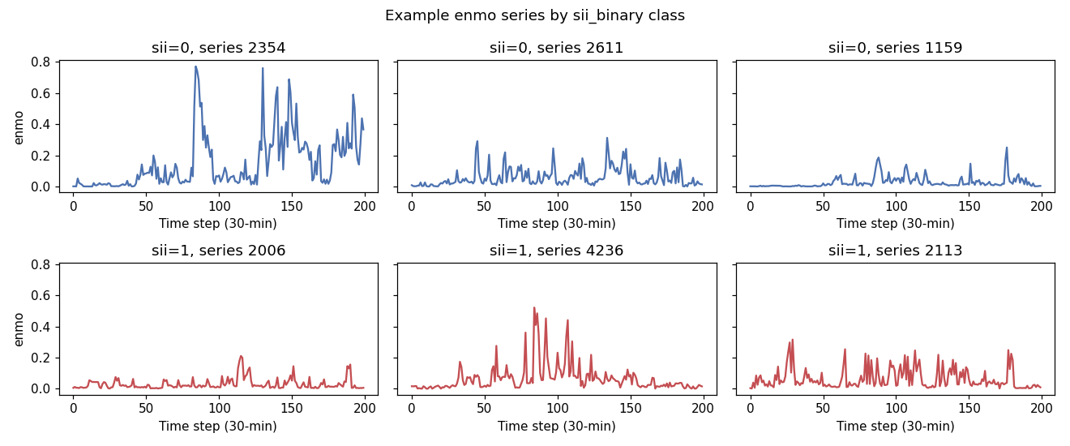
Figure 3.1: Example enmo series for sii_binary=0 (top row) and sii_binary=1 (bottom row).
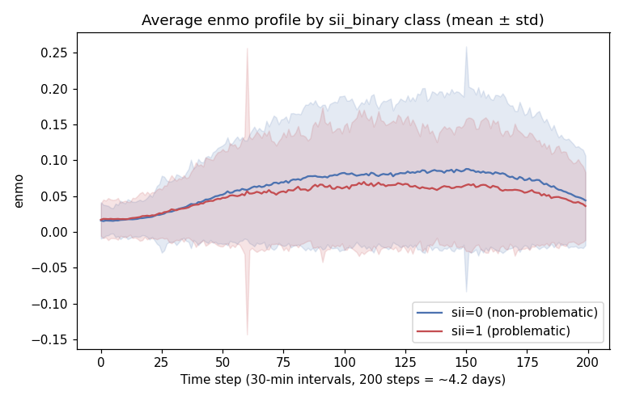
Figure 3.2: Average enmo profile (± std) for each sii_binary class over 200 timesteps.
Individual series display the expected alternation between active (daytime) and rest (sleep) periods. The average profiles for the two sii_binary classes largely overlap, indicating that class differences are subtle at the level of the average signal shape — motivating the use of shape-sensitive clustering and discriminative classification methods below.
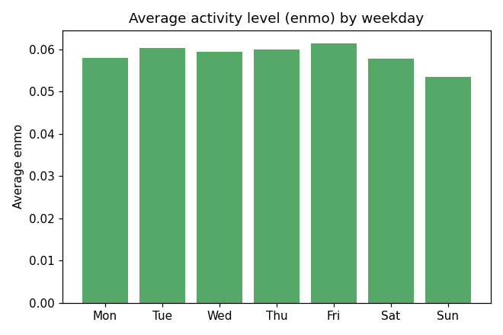
Figure 3.3: Average enmo by day of week (1=Monday, 7=Sunday) across all retained series.
A mild weekday pattern is visible (activity slightly lower on weekends), consistent with the biological expectation of reduced structured activity on non-school days, though the effect is modest.

3.3 Motifs and Discords
Motifs (most frequently recurring subsequences) and discords (most anomalous subsequences) were identified using the Matrix Profile (STUMP algorithm from the stumpy library), computed on individual series with a window of 10 timesteps (5 hours). One representative series from each class was analysed.
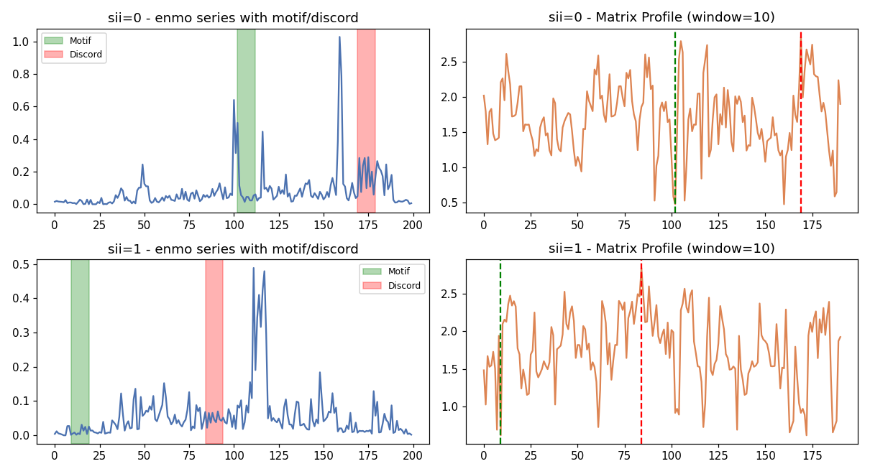
Figure 3.4: enmo series (left) with identified motif (green) and discord (red), and Matrix Profile (right), for sii_binary=0 (top) and sii_binary=1 (bottom).
In both examples, motifs correspond to recurring low-amplitude rest periods (consistent with regular sleep episodes), while discords correspond to isolated bursts of unusually high or irregular activity with no close match elsewhere in the series. This pattern is consistent across classes and relates directly to shapelets (Section 3.5): motifs capture common, class-non-discriminative patterns; discriminative shapelets tend to correspond to less common activity patterns, closer in nature to discords.

3.4 Time Series Clustering
Clustering was performed at the child level (326 per-child average enmo profiles, each of length 200). Each profile was z-score normalised before clustering, so that cluster assignment reflects differences in activity pattern shape rather than overall amplitude level. Two algorithms were compared, both producing k=3 clusters:
- A) SAX + KMeans: each normalised profile was transformed via Symbolic Aggregate approXimation (20 segments, alphabet size 5), then clustered with KMeans (10 random initialisations).
- B) Agglomerative clustering (Ward linkage): applied directly to the normalised profiles, using Euclidean distance with Ward’s minimum-variance criterion.
Method | Cluster | n (children) | % sii_binary=1
SAX + KMeans | 0 | 133 | 29.3%
SAX + KMeans | 1 | 84 | 51.2%
SAX + KMeans | 2 | 109 | 34.9%
Ward (normalised profiles) | 0 | 127 | 33.9%
Ward (normalised profiles) | 1 | 147 | 33.3%
Ward (normalised profiles) | 2 | 52 | 53.8%

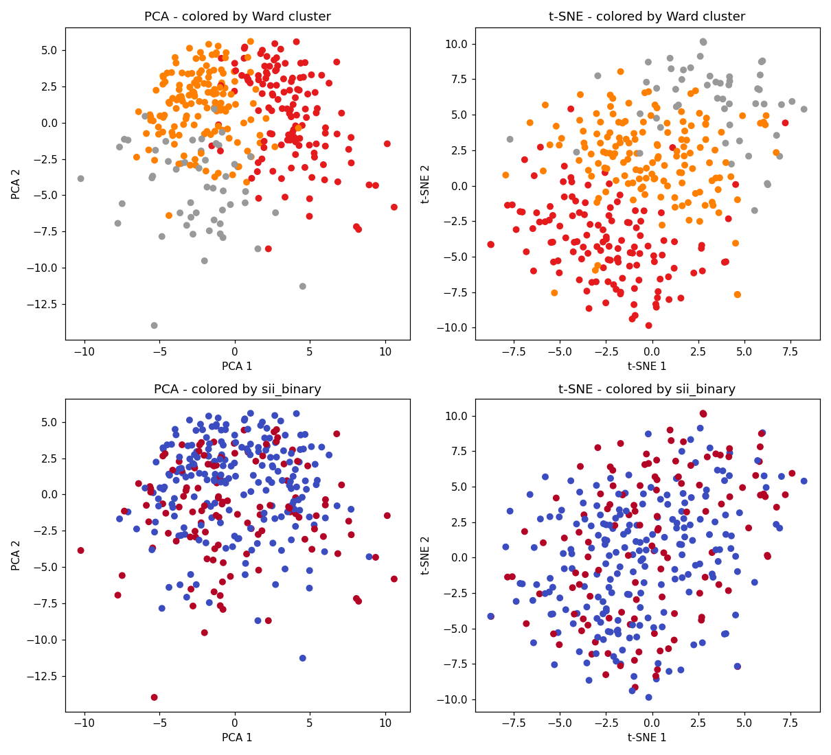
Figure 3.5: PCA (left) and t-SNE (right) projections of normalised per-child enmo profiles, coloured by Ward cluster (top) and sii_binary (bottom).
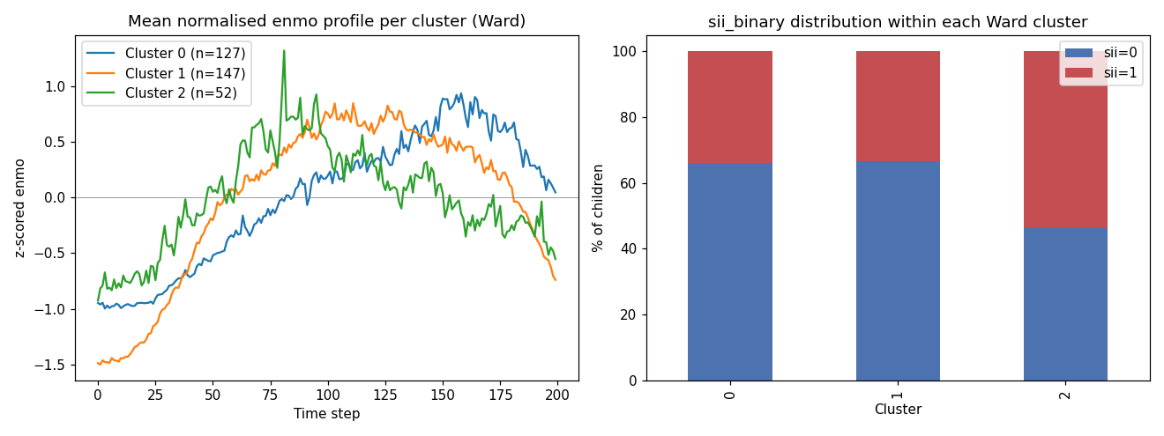
Figure 3.6: Mean normalised enmo profile per Ward cluster (left) and sii_binary distribution within each cluster (right).
Both clustering methods identify a subgroup with a markedly higher sii_binary=1 rate than the overall 33% base rate: SAX+KMeans cluster 1 (51.2%, n=84) and Ward cluster 2 (53.8%, n=52). This small subgroup of ~16% of children exhibits an activity pattern shape that is moderately associated with problematic internet use.
The PCA and t-SNE projections show that the three Ward clusters occupy partially separated regions of the reduced space, while the sii_binary colouring reveals no sharp boundary — consistent with the modest classification performance in Section 3.5. The mean cluster profiles (Figure 3.6, left) differ mainly in the amplitude and timing of activity peaks, with the high-sii cluster (cluster 2) showing a more irregular pattern relative to the child's baseline.

3.5 Relation Between Shapelets and Motifs
The Matrix Profile motifs identified in Section 3.3 correspond to common, class-non-discriminative patterns (recurring rest periods shared by both classes), while the shapelets extracted in Section 3.6 capture localised subsequences that maximally separate the two sii_binary classes. This mirrors the general relationship between motifs (what is typical) and shapelets (what is discriminative), and parallels the relationship between low-Matrix-Profile regions (frequent, expected patterns) and discords (rare, anomalous patterns that are more likely to carry class-specific information).

3.6 Time Series Classification
The task is to predict sii_binary for each individual 200-step series. Four methods were compared, all applied to z-score-normalised enmo series:

3.6.1 k-NN with Euclidean distance
Evaluated for k ∈ {3, 5, 7, 9, 11} on the full test set (1,164 series). Best: k=5, macro-F1=0.507.

3.6.2 k-NN with DTW (Sakoe-Chiba constrained)
Dynamic Time Warping with Sakoe-Chiba band constraint was evaluated for radius ∈ {1, 3, 5} and k ∈ {3, 5, 7}. Due to the O(n²) cost of pairwise DTW, this was run on a subsample of 400 train / 200 test series. Best: radius=3, k=5, macro-F1=0.505. DTW performs on par with Euclidean k-NN, suggesting that the discriminative signal is not primarily in local temporal misalignment but in the overall shape and amplitude pattern.

3.6.3 ROCKET
ROCKET (RandOm Convolutional KErnel Transform, 500 kernels) transforms each series into a fixed-length feature vector via random convolutional kernels, then uses a ridge classifier. Trained on the full training set. Macro-F1=0.504, accuracy=0.639.

3.6.4 Shapelet Transform
Shapelet Transform Classifier (10 shapelets, extracted from a 500-series training subsample with an 8-minute time budget) achieved macro-F1=0.522, the highest of the four methods, at the cost of lower overall accuracy (0.591). Its superior macro-F1 reflects better recall on the minority class (sii_binary=1, recall=0.33 vs 0.18 for Euclidean k-NN), confirming that localised discriminative subsequences carry more class-relevant information than global shape features at these training-set sizes.
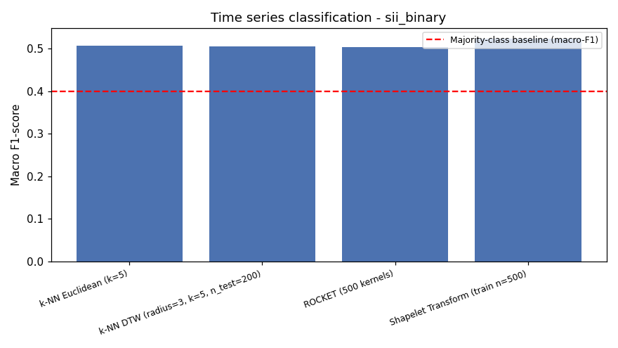
Figure 3.7: Macro-F1 comparison across all-time series classification methods (dashed = majority-class baseline).
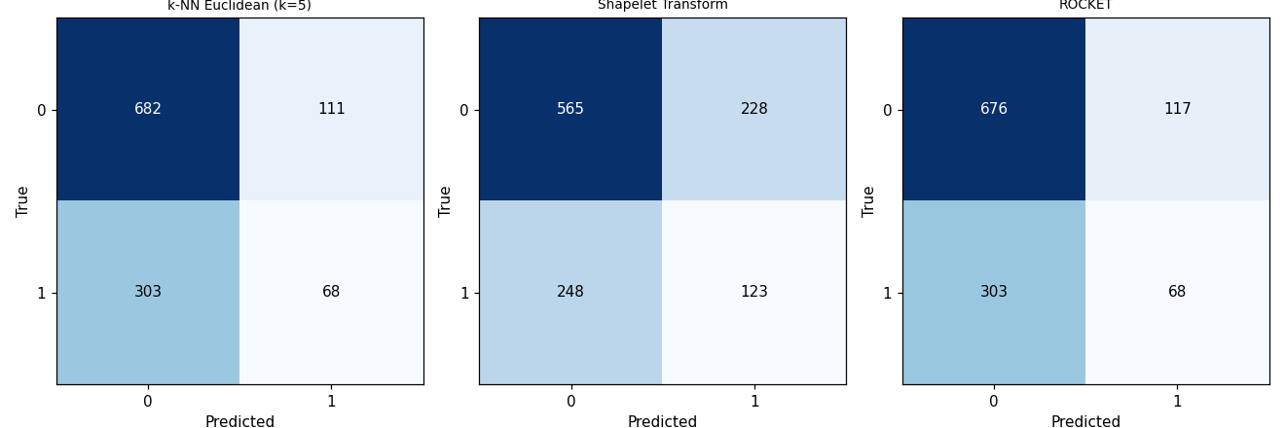
Figure 3.8: Confusion matrices for k-NN Euclidean, Shapelet Transform, and ROCKET on the full test set.
Method | Accuracy | Macro Prec. | Macro Rec. | Macro F1
k-NN Euclidean (k=5) | 0.644 | 0.536 | 0.522 | 0.507
k-NN DTW (radius=3, k=5, n=200) | 0.660 | 0.543 | 0.523 | 0.505
ROCKET (500 kernels) | 0.639 | 0.529 | 0.518 | 0.504
Shapelet Transform (train n=500) | 0.591 | 0.523 | 0.522 | 0.522
Majority-class baseline | 0.671 | 0.400 | 0.500 | 0.401

All four methods improve over the majority-class baseline (macro-F1≈0.40), reaching 0.50–0.52. The pattern across methods is consistent: the majority class (sii_binary=0) is well-identified (recall 0.71–0.86), while the minority class (sii_binary=1) is only partially recovered (recall 0.18–0.33). This is consistent with the exploratory finding that average enmo profiles for the two classes overlap substantially; a single 30-minute-resolution accelerometer channel over ~4.2 days carries weak but non-negligible information about problematic internet use, a multi-factorial construct also influenced by psychological and lifestyle factors identified in the tabular analysis (Module 2, SHAP).

