NON-FUNCTIONAL REQUIREMENT
GUIDELINES

Version 1.0.0

Revision History

Date | Version | Description/Reason For Changes | Author
04.11.2010 | 1.0.0 | Initial document | Md. Abu Taher
09.11.2010 | 1.0.1 | - Name of documents has been updated  - Description from each section has been removed.  - Several example have been included in the different parts of the document where applicable  - Guidelines for font, font size and font style have been included both for Bangla and English | Md. Abu Taher

Pop up message

Message window
For successfully save record | 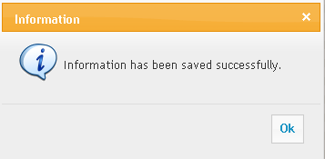
For successfully delete record | 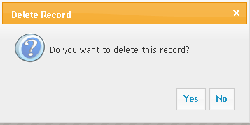
For mandatory fields | 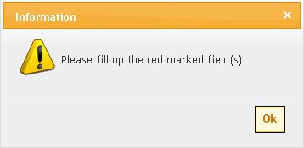

Message Title
The Title of all the message windows should be as per instructions | For mandatory fields, data validation, add record, edit record:  Message title : Information  For delete record:  Message title : Delete Record

Message Icon
Information | To add or edit the record, icon should display “Information icon".  
Interrogation | To delete the record, icon should display “interrogation icon". 
Information | For validation alert, icon should display "Exclamation icon".  

Message Dialog
While performing Save operation | - “Are you sure you want to save?" [Optional]  - “Information has been saved successfully”
While performing Delete Operation | - “Are you sure you want to delete?"  - “Information has been deleted successfully.”
While Exit from the application | - “Do you want to exit?"
For Mandatory Blank Field | - Case 1: when the blank fields are not highlighted:  - “[Field’s name(s)] cannot be blank.”  Example: Employee Name cannot be blank  OR  - [Field’s name] is mandatory field,  Please enter a valid [Field name] information  Example: Employee Name is mandatory,  Please enter a valid employee name.  - Case 2: when the blank fields are highlighted:  - “Required field cannot be blank.”  - Case 3: when the blank fields are highlighted:  - Please fill up the red marked fields or  - Please fill up the * marked fields and so on
Signing confirmation in login page | - Case 1: “You have signed up successfully”
Incase of invalid or blank User ID and/or Password | - “Invalid user ID or password. Please try again.” Or  - User id / Password you have entered are invalid. Or  - Please enter a valid user id / password again
While saving duplicate information | - “Information already exists.”
For Duplicate ID | - This ID already exists.
Date related validation like Date of Joining, Confirmation, Increment, Evaluation etc. | - “Date of joining must be greater than date of birth. Date of birth of selected [employee] is 24/06/1985.” [2nd part is Optional]
Parent / Child relationship | - This record cannot be deleted as it has been used in other process(es)
When related data are not found in report | - Your search criteria do not match any data.
Date Period Error | - Invalid Period
Data Initialization Error | - Error in data initialization.  In some cases system is not showing any data as per user expectation. In that case system is throwing an error message like “Error in data initialization” and it should the more user friendly like “Problem in data loading”
List box or combo box | While entering text in the drop down boxes, instead of selecting data from drop down boxes by mouse key  - Please select a valid item which is available in the list
Message window | - Some message window contain two command buttons such as (Yes, No). Default focus should be in “No” button  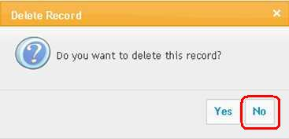

Login Screen
Login Captions | Login Window/Screen should contain only two Text Boxes [User ID and Password] and one Command Button [“Sign In” or “Log In”

Others
Parent-Child relationship | In relational data base concept parent data cannot be deleted if child data is available in other line information
Tab sequence | - Tab sequence should be followed I format or Z format.  - Tab sequence should be performed either tab key or enter key or both way
Cursor position during form loading | - After loading the pages cursor should be in its right places. For example: Suppose there are three text boxes in a page (Branch ID, Branch Name and Address). Branch ID is auto ID and user has to enter branch name and address accordingly. In this case cursor should be placed in branch name control during form loading.
Cursor position after throwing validation message | - After throwing the message, the position of cursor must be its right place. For example: Branch name is a mandatory field and user press save button without putting any data in branch name field. In that case normally system will through a message and cursor position will be placed in branch name box.
Date type format | - System should maintain unique format for date type data both in pages and reports. For example: 25/05/2010 or 25/05/10 or 25-05-2010 or 25-05-10 or client specific
Size of controls (text box, combo box, list box, date control and so on) | - Size of controls should depend on the size of data. But this is not mandatory for all cases. This should consider during design of page
Font (For English) | - Font name, size, type should be similar across the project. For example:  Font Name: Verdana, Arial Helvetica, Sans –serif, Tahoma  Font Size : 12  Font Style : Regular (For data), Bold (For caption of menu and grid column)
Font (For Bangla) | - Font name, size, type should be similar across the project. For example:  Font Name: Sutonny bangla OMJ, Tonni bangla MJ, SolaimanLipi  Font Size : 14  Font Style : Regular (For data), Bold (For caption of menu and grid column)
Data loading | - It is not wise to load all data during loading of form. For example: Suppose there are 50,000 data in the database. During form load, it should not load all data.
Paging | - For data loading purposes application should follow paging and paging should be configurable. So that user can set the number of records that he wants to display per page.
Current active page identification | - Current active page should be different comparing with other pages  For example: Suppose there are huge records and the records are shown in 25 pages. For such scenario use different color or different font or both for the current page numbers. So that user can understand the current active page like 1, 2, 3, 4, 5, 6, 7, 8, 9, …….. In this example it means that the user’s current active page is 5 as it is different from others.
Numeric data alignment | - Numeric data should be right alignment
Comma separator | - System should maintain comma separator for numeric data like 15,120.
Textual data alignment | - Textual data should be left alignment
Use of dot (.) sign | - Use dot (.) sign where applicable like No., Tk. And so on
Button sequence | - For different action buttons (add, edit, delete, view) sequence of buttons should be unique and caption of buttons must be similar for whole application.
Spelling & Grammar | - Text of screen, Labels, message should be spelled correctly with tense and grammar
Unaccepted data | - System should not receive any unaccepted data. For example: for numeric data system should not accept alpha-numeric data. In this case when user try to enter alpha-numeric data instead of numeric data, he cannot enter the data.
Star (*) sign for mandatory data | - Use star (*) mark with different color at the right position of level for mandatory entry
Non-editable field | - Background color of non-editable field should be ash color and text should be black color
Data sorting | - In drop down list data should sort according to text instead of id. For example in employee drop down list, data should be sorted employee name instead of employee id.

Reports
Report header | - Company name, report title should be middle alignment
Report margin | - Some times it depends on number of columns but most of the cases left margin should 1 inch and right margin should 0.5 inch and lower margin should not more than 1 inch.
Page No : | - Most below-right corner of the page like “Page x of y”
Gap between caption and data | - The gap between caption and data should not more than 0.5 cm
Colon | - Use colon sign at the right side of the caption like Employee name:
Caption of label or column | Use either sentence case or word case for the caption of label and column header of the report  - Sentence case:  Employee name:  - Word Case:  Employee Name:
Column header | - Should be available in each and every pages of the report
Wrap text | - When the length of text is larger than size of column width, in that case data should be shown in multiple rows in the same column.

