## test_void_Envelope_and_Verify_notification

# Passed Tests

Test Script - 1 : test_change_sign_tag_size

Test Script - 1 : test_create_new_user

Test Script - 1 : test_Envelope_Complete_WorkFlow

Test Script - 1 : test_send_envelope_With_NoSign_tags

Test Script - 1 : test_verify_date_time_format

Test Script - 1 : test_ReceiverReceivesEnvelopeCopy

Test Script - 1 : test_void_Envelope_and_Verify_notification

# Failed Tests

Test Script - 1 : test_declineEnvelope

Test Script - 1 : test_NoDeletionOrReplacement_on_SignedDoc

Test Script - 1 : test_send_envelope_approve

Test Script - 1 : test_sendTemplate_approve

Test Script - 1 : test_validate_user_action

Test Script - 1 : test_verify_access_code

Test Script - 1 : test_verify_comment_field

Test Script - 1 : testReceiverReceivesEnvelope

Test Script - 1 : test_void_envelope

# Skipped Tests

Test Script - 1 : test_verify_decline_notification

Test Script - 1 : test_envelope_completion_notification

Test Script - 1 : test_download_allDocuments

Test Script - 1 : test_verify_receiver_receives_copy

Test Script - 1 : test_verify_void_notification

# Summary

Total Passed: 7

Total Failed: 9

Total Skipped: 5

## test_change_sign_tag_size

Before_changing_Signature_Tag_size_100%_resolution

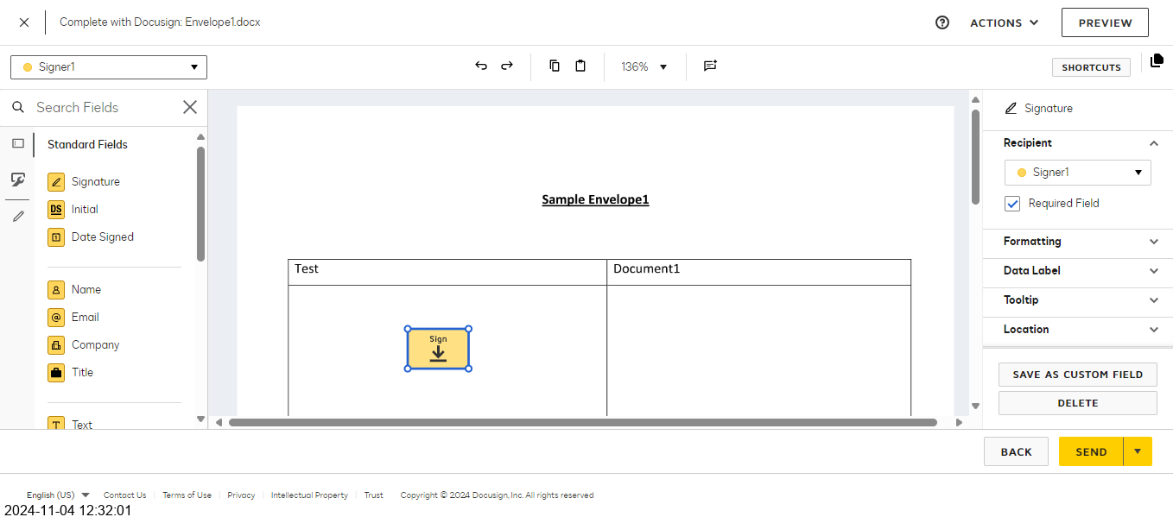

After_Changing_signature_Tag_size_200%_resolution

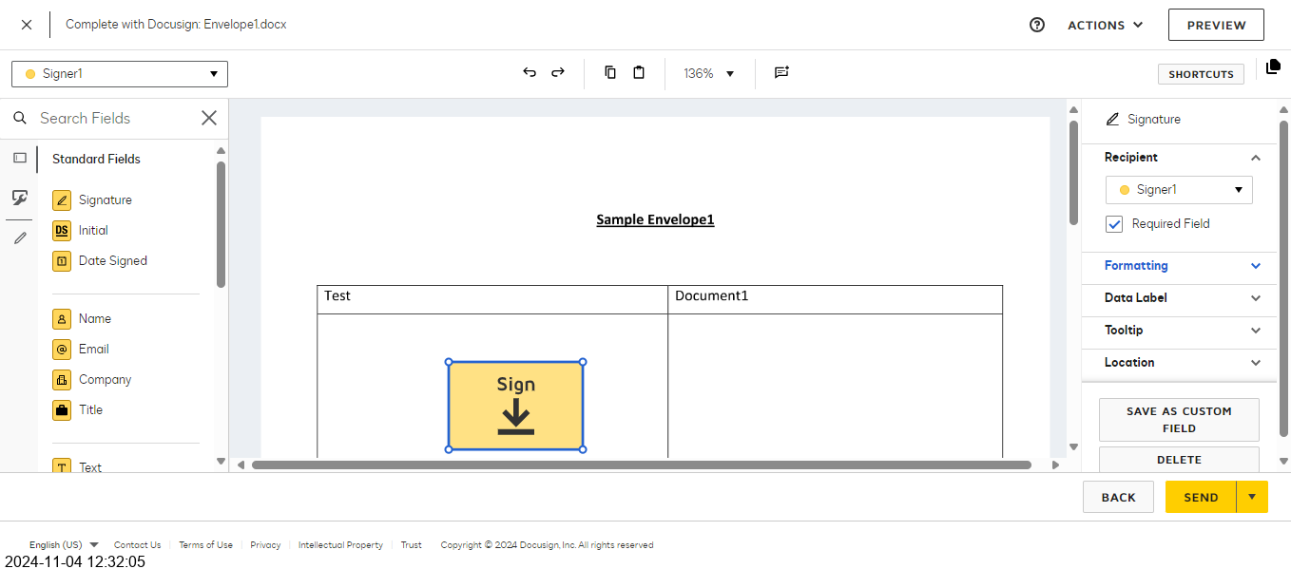

# Passed Tests

Test Script - 1 : test_change_sign_tag_size

# Summary

Total Passed: 1

Total Failed: 0

Total Skipped: 0