**Assignment 1 – Change the Default SHELL.**

**Question:**

There are many ways to change the shell in linux OS from the default to another type. Search in the web resources about how to change the default shell in both Ubuntu and Centos. Take screenshot for the code and show it succeed.

**Ubuntu:**

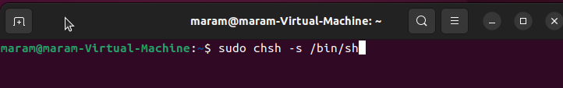

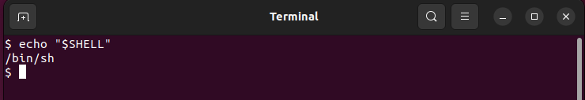

**Centose**

