Paddock plan

Website:
The website has to be world-class, it must have a chatbot that contains requirements when it is used by the requirements like the client, such as when the client wants to book or reserve a paddock.
The website must have an automated blog post. This blog must have the contents of nightlife in Kigali and daily life in Kigali, (having something called: WHY PADDOCK,….)

UI DESIGN OF WEBSITE:
WE are going to analyze the websites of the best bars all around the world. This means the analysis is based on considering the best features the websites contain, and we try to build the same thing, but in our own website and our own way. Here is the list of the bars I have and the features we need to get from them after analysing them:
- The dead rabbit( Bar in New York):
- The fact in the background, the way the video is playing, motion, slowly moving
- Another feature that contains a way of looking at patterns they work with
- Another section of “what’s on the dead rabbit”= what’s on the paddock: it makes good sense,

- Paradiso Bar (Barcelona, Spain):
- The feature showing specialities of the bar and the way it's clicking when you put the mouse or cursor on them, it changes, displaying words just by pointing the mouse. It looks GENIOUS.
- Attaching the picture of the section we want to analyze: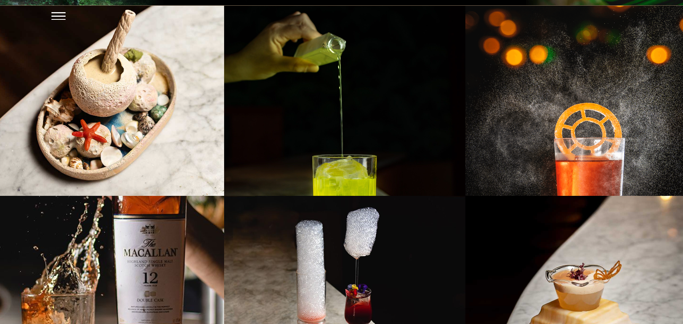

- Havana Bar (Auckland, New Zealand):
- It has a picture of the front desk where they sell bottles. The way it's designed, it’s looking blurry, but not that much. It was designed professionally and looks good
- Using the blur, looking where people are in the picture, but at the same time, you can’t recognize who they are. (We can use this, but the bottles are looking normal without blur)
- The section attached is the one with the pictures to analyze on the website: 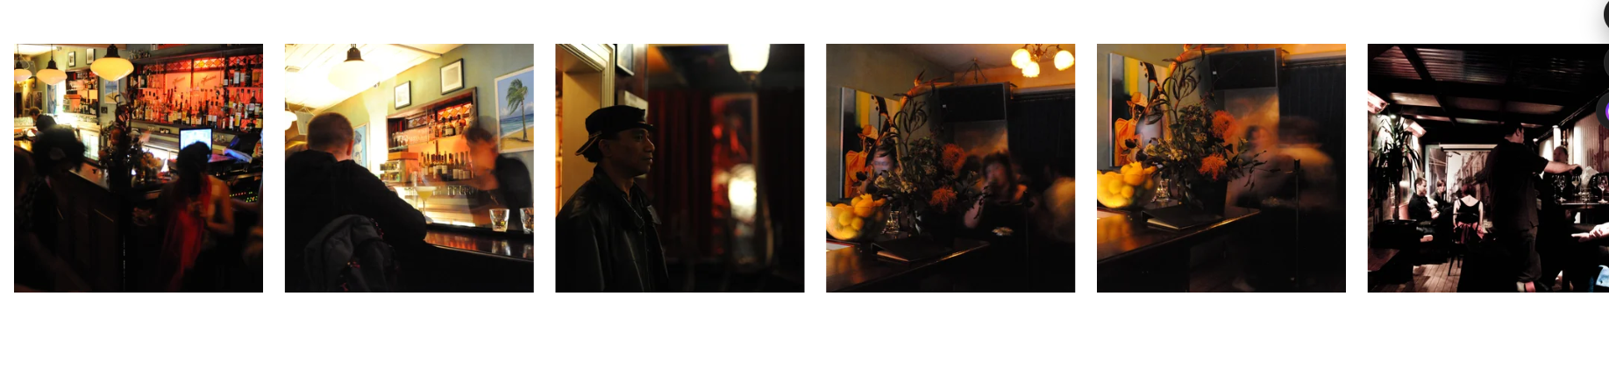
- Sunset (Bar in Auckland, New Zealand):
- Under the view full DJ lineup, there is a picture showing a sunset. The picture looks great, especially the people looking at the sunset, the drinks they are holding, and the people in the background. (We can use the same feature that the section is designed for.)
- Attached is the picture of the section we want to analyze: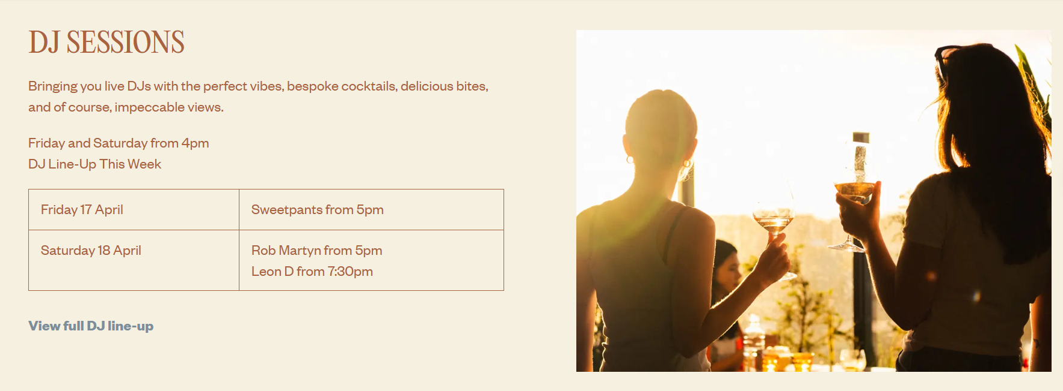

- Adding another feature which can say, for example: Want to experience Kigali night in Rwanda, Paddock got u,…… This is an Idea to modify and work on to make it attractive and professional.
- Special features the website must have, if it cocktail, some movement in the background of pouring a cocktail designed in a way its professional, and until it brings a cocktail feature, some bubbles in the section or the picture.

The cocktails section must have the most attractive-looking:
Thirsty Attractive Design Elements
Hero Drink Slider: Use high-resolution, close-up images of your signature cocktails. Ensure the lighting highlights textures like ice cubes, mint leaves, or fruit slices.
Parallax "Pouring" Effect: As users scroll, have a high-speed video or GIF of a cocktail being poured or a bottle being opened to create a sense of action.
Condensation Backgrounds: Subtle, high-quality textures of chilled glass or frosted metal can make the user "feel" the coldness of the drinks.
Interactive Menu Hover: When users hover over a drink name, a vibrant image of that specific cocktail should pop up or fill the background to entice them.

MENU PART (Design inside when the navigation bar is clicked on):
We will consider the design of RUTZ Ltd This is a restaurant in Rwanda, their menu is designed such that the way each food, drink, or anything served is rated with a star for rating, a picture of the thing to be served, price, button to add so the selected item can be added in the system to be served.
After analyzing their menu, we designed our own menu more than any other menu we searched and analyzed, and we designed our best top rated meu on the world.
Pictures attached are the ones to analyze on based on the section: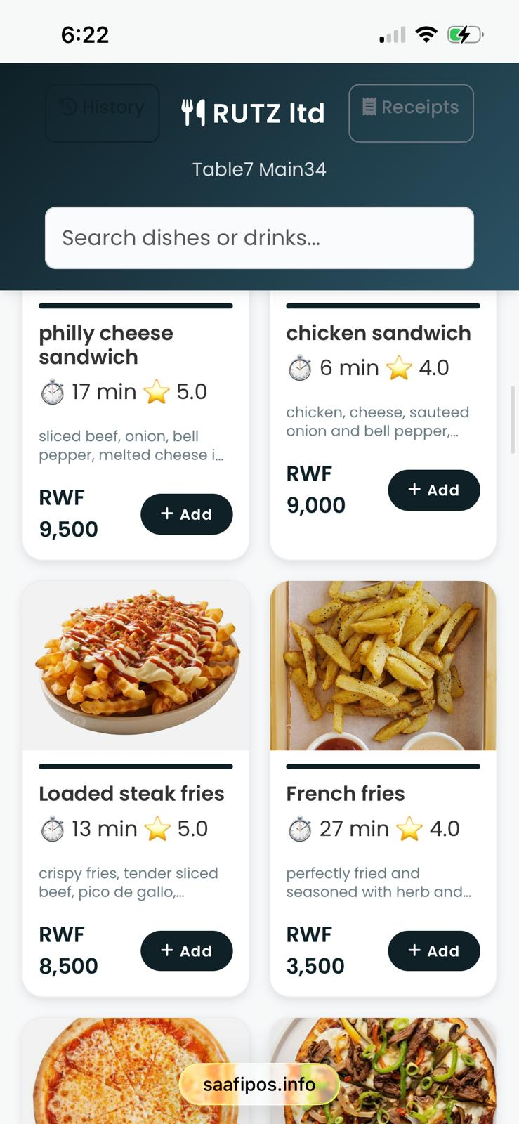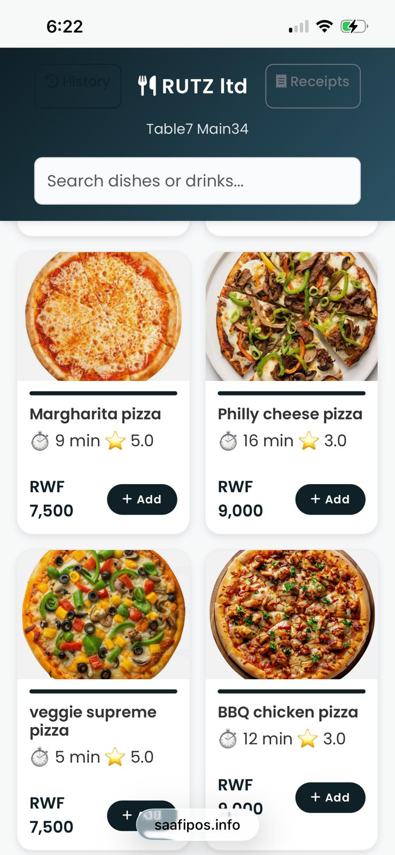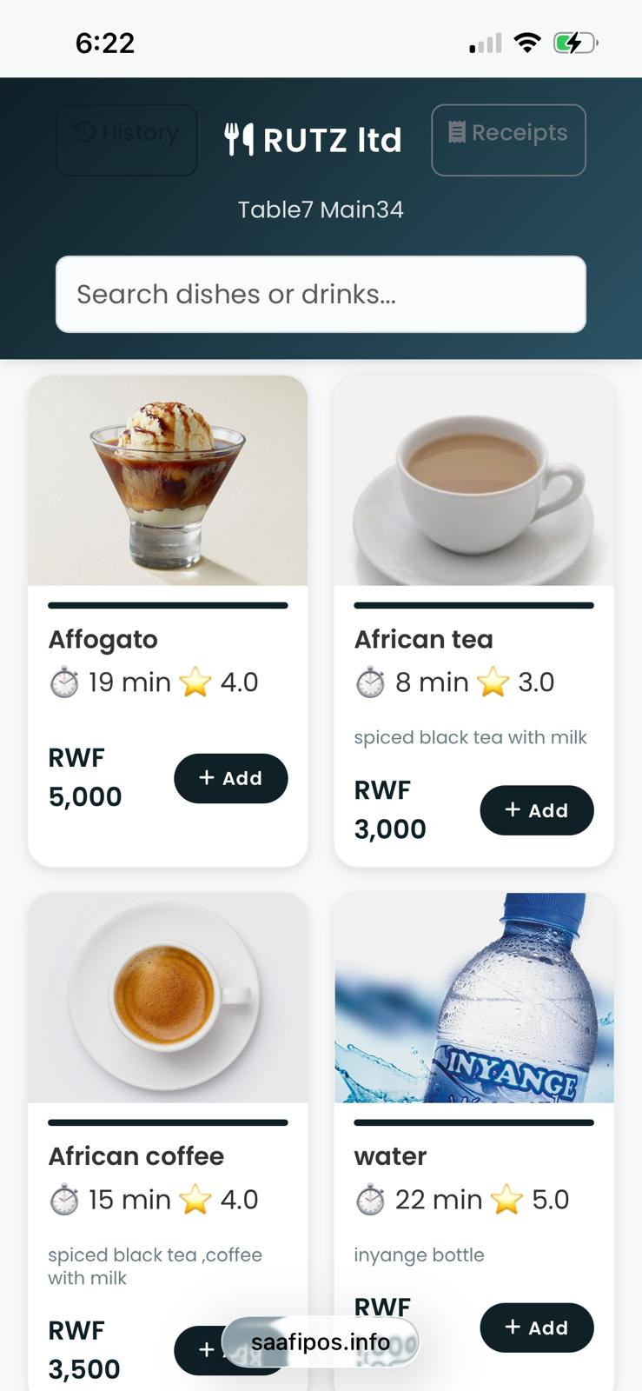

SECTION OF PREMIUM:
Gold featured for the premium section and placed where it's visible and attractive

LINE UP SECTION OF DJs
This section can be aligned in a way that's like an order of a week from Monday to Sunday. Each day must have the DJ’s name and the kind of music or songs the DJ is going to play.
NOTE: If these days are special events to happen, we have to design like an announcement line saying that: That ……..something big event …..is happening.
I think it can be designed on the home page or somewhere it will be passed like an ad, or wherever it will be seen, wherever you navigate to any page of the website.
This can make customers still see it whenever they use the website or the app.

VIP SECTION

- Bottles to choose from on the table (2 liquor bottles per table)
- For booking & Advance payment
- Reservation (Advance payment)
- Liquors Consumable
- Free snacks (chips, groundnuts,…)
- Early booking ( Advance payment and discount to be provided)
- Showing the images of VIP sections for clients to choose from per table.

CONTACT SECTION IDEA
Think of the following picture where all the details of the contact way, like creating the section but we structure it using the picture in the back ground:
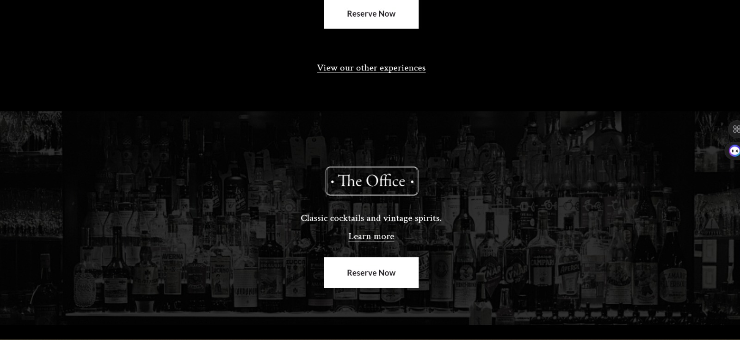

Chat GPT prompt:
PROJECT PROMPT: PADDOCK LOUNGE – WORLD-CLASS NIGHTLIFE WEBSITE (KIGALI)
Objective:
Design and develop a visually immersive, mobile-first, world-class website for Paddock Lounge (Kigali) that captures the energy of modern nightlife and converts visitors into customers through reservations, VIP bookings, and engagement.

1. Brand Positioning
Paddock Lounge is a high-energy, urban nightlife destination targeting Gen-Z and young professionals. The website must reflect:
- Vibrant nightlife culture in Kigali
- Afrobeats, DJ-driven entertainment
- Premium yet accessible social experience
The design should feel like a digital extension of the club, not a corporate website.

2. Core Functional Requirements
2.1 Booking & Reservation System
- Integrated chatbot or assistant for:
  - Table booking
  - VIP reservations
  - General inquiries
- Simple reservation form:
  - Name, Date, Number of Guests
- WhatsApp integration for direct communication
- Support for advance payments (especially VIP bookings)

2.2 Content & Engagement
- Automated or semi-automated blog section:
  - Focus: nightlife in Kigali, lifestyle, and brand storytelling
  - Include branded content such as: “Why Paddock”
- Dynamic updates for events and DJ schedules

3. UI/UX Design Direction
3.1 Visual Style
- Dark-themed interface (nightclub aesthetic)
- Use of motion (video backgrounds, subtle animations)
- Glassmorphism and blur effects for layered visuals
- High-resolution imagery and cinematic video

3.2 Benchmark Inspirations
Incorporate and reinterpret features from top global bars:
- The Dead Rabbit
  - Background motion video
  - Smooth transitions and storytelling sections
  - “What’s On” section → adapt as “What’s On at Paddock”
- Paradiso
  - Interactive hover effects revealing content
  - Dynamic UI responses to cursor interaction
- Havana Bar (Auckland)
  - Blurred imagery with focal clarity
  - Atmospheric visual storytelling
- Sunset Bar (Auckland)
  - Lifestyle imagery showing people, drinks, and ambiance
  - Emotional connection through visuals

4. Key Website Sections
4.1 Hero Section
- Fullscreen video (DJ, crowd, drinks)
- Overlay text with brand message
- Call-to-action buttons:
  - Book Now
  - View Lineup
  - Explore Menu

4.2 “What’s On at Paddock”
- Highlight current and upcoming events
- Daily or weekly highlights
- Promotional offers (e.g., drink deals)

4.3 DJ Lineup Section
- Weekly schedule (Monday–Sunday)
- Display:
  - DJ name
  - Music genre
- Highlight special events with announcement banners
- Persistent notification for major upcoming events

4.4 Cocktail & Drinks Experience
- Highly visual and interactive section
- Features:
  - Hero drink slider (high-resolution images)
  - Parallax pouring effects (video/GIF)
  - Condensation/glass textures
  - Hover-triggered drink previews
Goal: create a “thirst-inducing” visual experience

4.5 Menu Section
Inspired by RUTZ Ltd (Rwanda):
- Each item includes:
  - Image
  - Name
  - Price
  - Rating (optional)
- Clean, grid-based layout
- Focus on clarity and aesthetics (not complex ordering system)

4.6 VIP Section
- Showcase premium table options
- Features:
  - Bottle selection (e.g., 2 bottles per table)
  - Advance booking & payment
  - Included benefits:
    - Consumables
    - Free snacks
    - Early booking discounts
- Visual selection of VIP spaces (images per table/section)

4.7 Contact Section
- Background image with overlayed contact details
- Include:
  - Phone
  - Location (Google Maps)
  - Social media links

5. Interactive & Motion Features
- Animated cocktail pouring visuals
- Cursor-based hover interactions
- Smooth scrolling and parallax effects
- Optional playful micro-interactions

6. Mobile-First Optimization
- Primary focus on smartphone users
- Fast loading (optimized media)
- Sticky navigation with quick actions:
  - Call
  - Book
  - Location

7. Overall Experience Goal
The website must:
- Feel alive and immersive
- Reflect real nightlife energy
- Encourage immediate action (visit, book, or contact)
The user should feel like they are already inside Paddock Lounge while browsing.

End of Prompt

Gemini AI analysis:
Based on the strategic goals for Paddock Lounge, the following project plan outlines the development of a world-class, mobile-first nightlife website designed to capture the energy of Kigali’s premier urban destination.

1. Brand & Aesthetic Direction
The website will function as a digital extension of the club, utilizing a dark-themed, immersive interface that targets Gen-Z and young professionals.
- Atmospheric Visuals: Reinterpreting the style of Havana Bar (Auckland), the site will use professionally designed, slightly blurred imagery of crowds to convey energy while maintaining focal clarity on premium products like spirit bottles.
- Emotional Connection: Following the example of Sunset (Auckland), lifestyle imagery will showcase people enjoying drinks and views to create an immediate emotional bond with the visitor.
- Layered UI: Implementation of glassmorphism and motion backgrounds inspired by The Dead Rabbit (New York) to ensure a smooth, premium flow.

2. Core Functional Requirements
To convert visitors into customers, the site will integrate high-utility booking and content features.
2.1 Booking & Reservation System
- Integrated Chatbot: A world-class assistant to handle table bookings, VIP reservations, and general inquiries.
- VIP Workflow: Support for bottle selection (e.g., 2 bottles per table), advance payment processing, and discount applications for early bookings.
- Direct Communication: WhatsApp integration for instant inquiry resolution.
2.2 Content & Storytelling
- Automated Blog: Focused on Kigali nightlife and brand storytelling, featuring a signature series titled “Why Paddock.”
- Real-time Interaction: Interactive hover effects (inspired by Paradiso) that reveal content or change text dynamically when a cursor or finger moves over specific elements.

3. Key Website Sections
3.1 Hero & "What's On"
- Hero Section: Fullscreen background video with a slow-moving, cinematic feel similar to The Dead Rabbit.
- What’s On at Paddock: A dedicated section for daily highlights, weekly events, and special drink deals.
3.2 DJ Lineup & Events
- Weekly Schedule: A Monday–Sunday grid displaying DJ names and music genres.
- Event Banners: Persistent, high-visibility announcement lines or ads that notify users of "Something Big" happening, visible across all pages.
3.3 The Drink Experience
- Thirst-Inducing Visuals: High-resolution sliders and parallax "pouring" effects showing cocktails or bottles being opened.
- Menu Interface: A clean, grid-based menu inspired by RUTZ Ltd, featuring item images, pricing, and star ratings for top-rated selections.
3.4 VIP & Contact Sections
- VIP Gallery: Visual selection of specific VIP spaces and tables so clients can choose their preferred location.
- Gold Accents: Use of gold-featured design elements to distinguish the premium section.
- Contact Backdrop: A professional contact section using a high-quality background image (e.g., a backlit bar or bottle collection) with overlaid details and a "Reserve Now" call to action.

4. Mobile-First Optimization
Since the target audience is mobile-centric, the experience must be lightning-fast.
- Sticky Navigation: Quick-action buttons for Call, Book, and Location will remain accessible at all times.
- Micro-interactions: Subtle animations, such as bubbles or condensation textures, to make the user "feel" the coldness of the drinks while browsing on their phone.

