|  |
| --- |
| SWE449 Tools Programming |
| Procedural Terrain Tool |
| Technical Document |
|  |
| **Logan Shelton** |
| **3/16/2017** |

|  |
| --- |
| This is documentation on the procedural seeding terrain tool created by Logan Shelton. Still in heavy development. |

**Table of Contents**

* Setting up
  + Set Up Scene
  + Assigning Scripts
  + Explanation of Each Item
  + Example Set Up
* Color Map / Noise Map differences
  + Color Map
  + NoiseMap

**Setting Up**

Scene set Up in Unity:

When opening Unity and or adding the tool into Unity:

1. Create a plane.

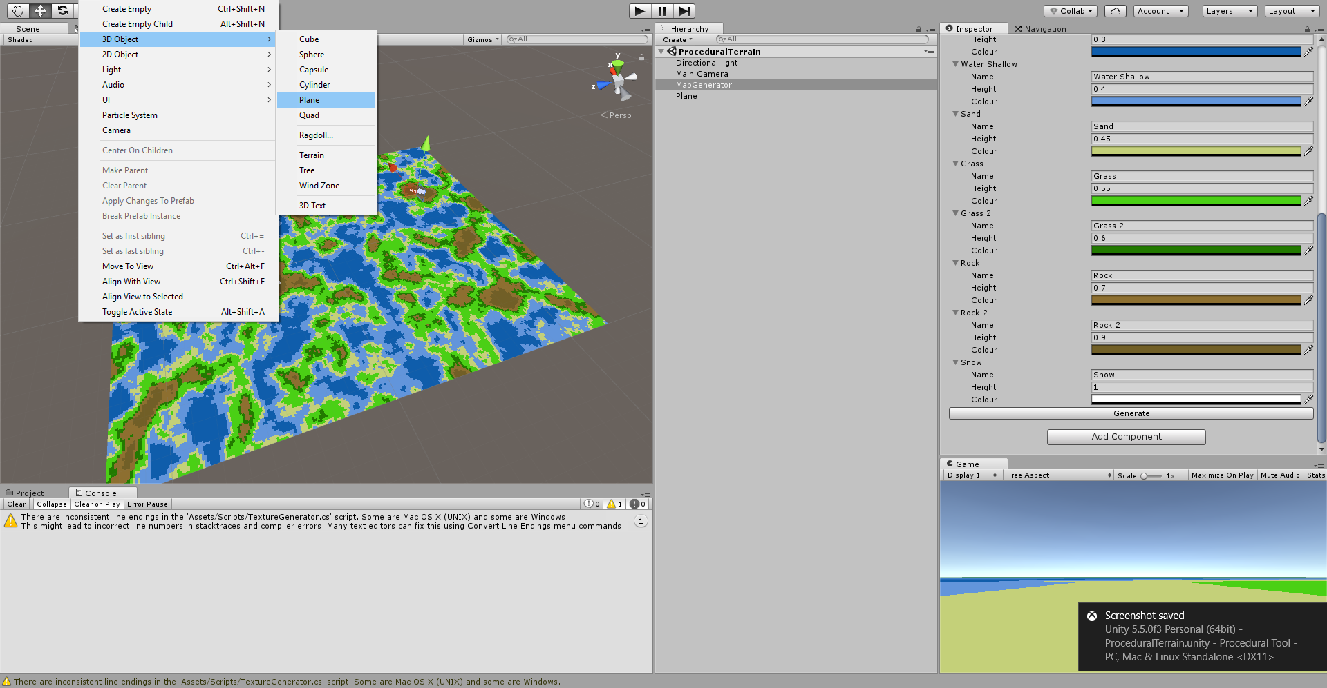

1. Create an empty Game Object:

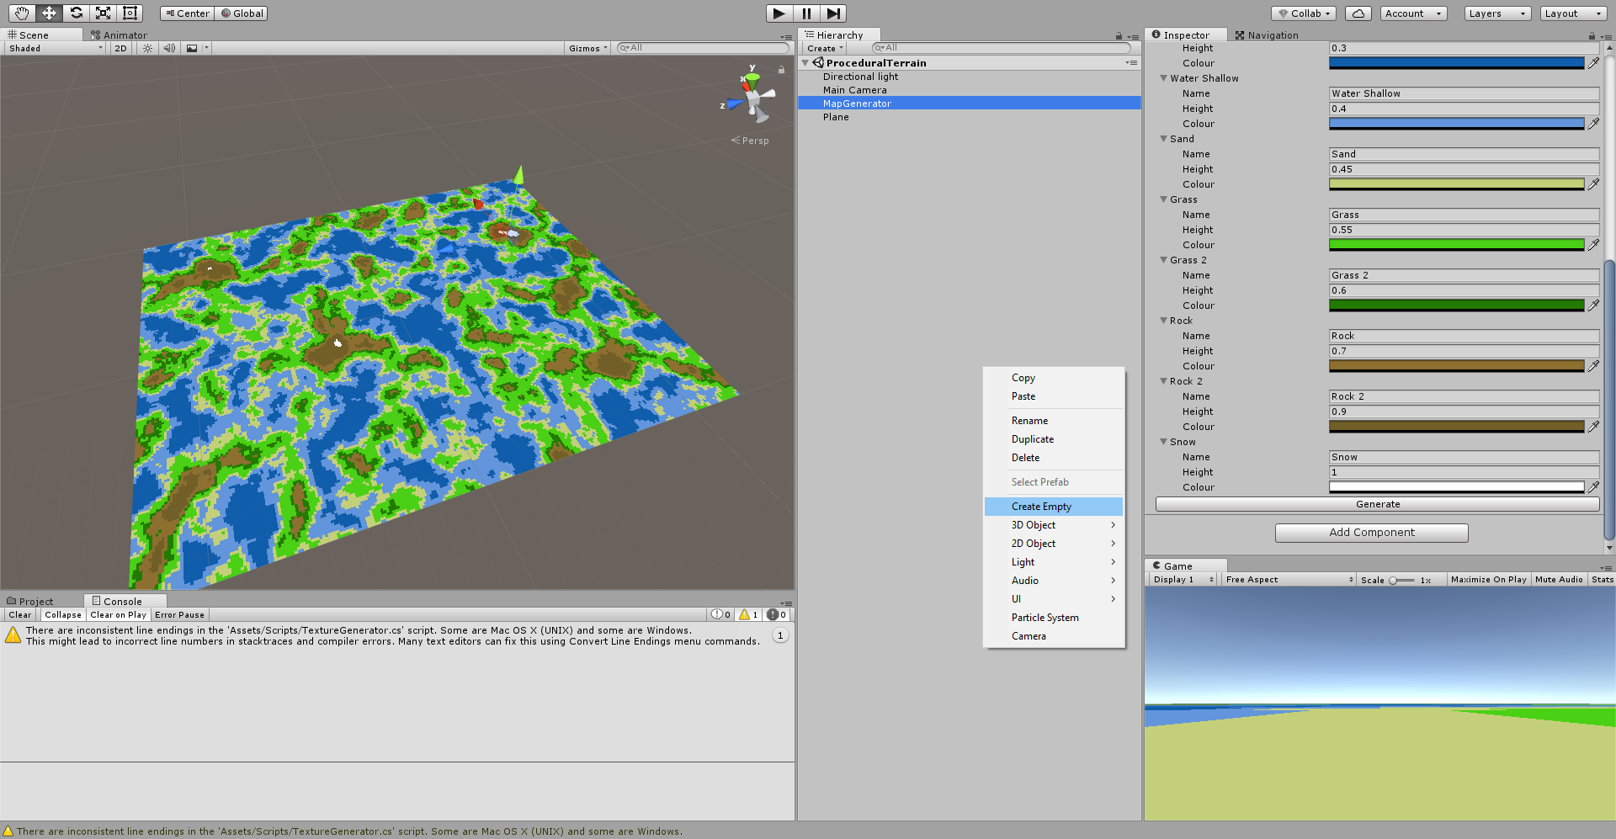

1. Name Objects:
   1. Rename GameObject to MapGenerator

**Setting Up Objects:**

* Plane:
  + Remove the collider
  + Apply Material (that you created called MapMaterial)

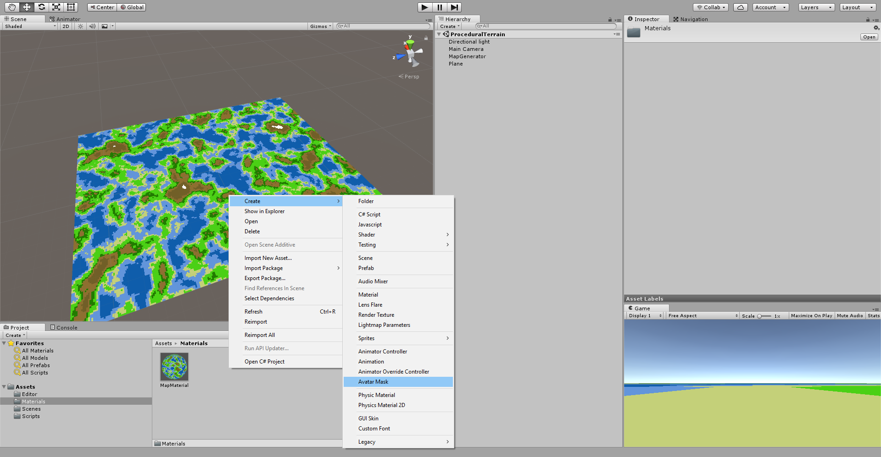

EXAMPLE:

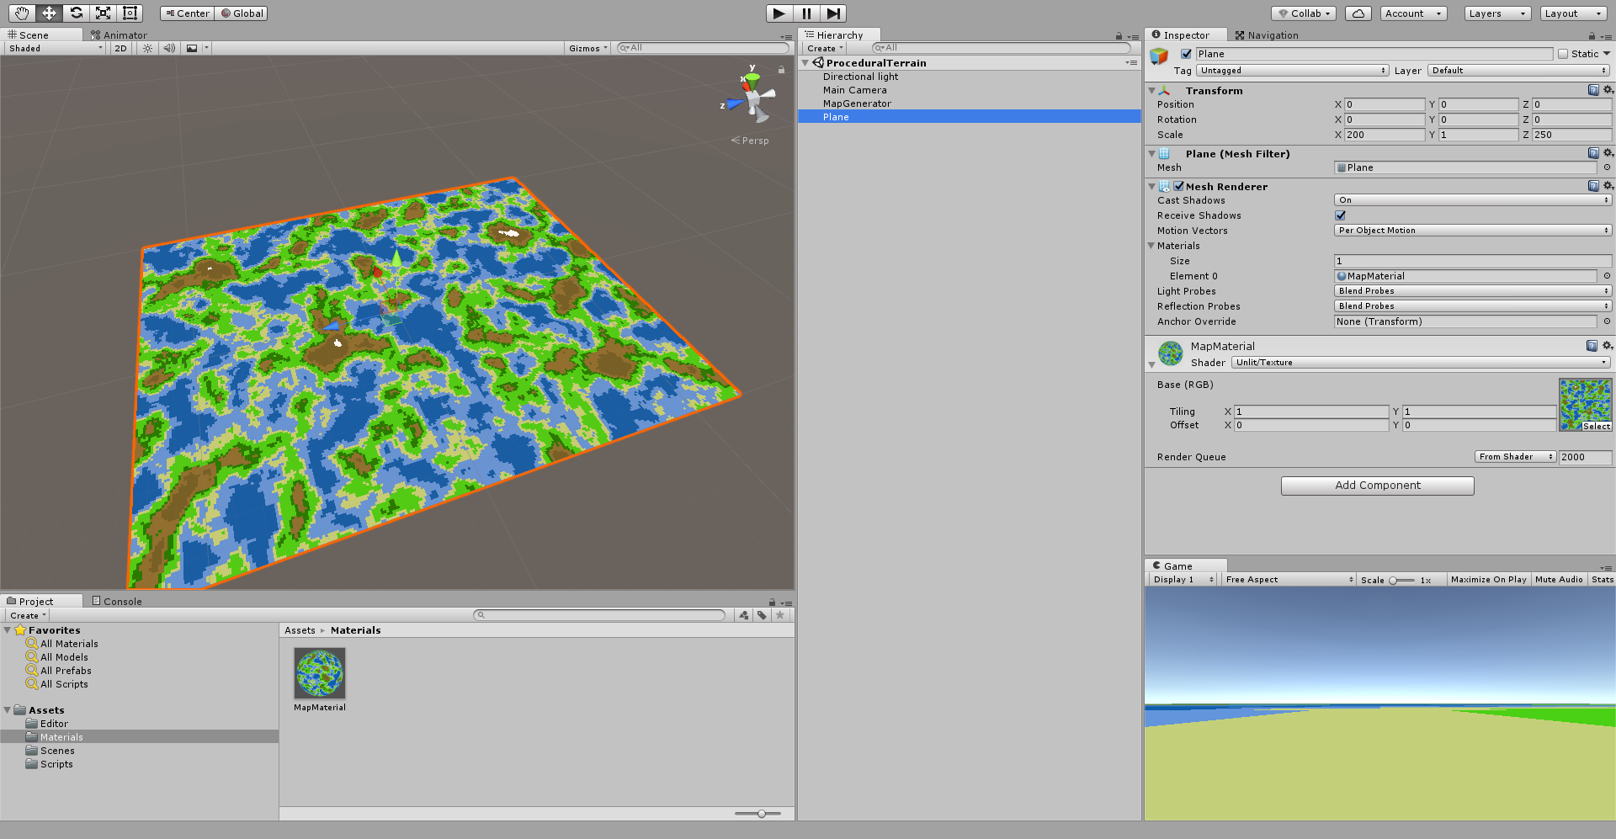

* MapGenerator(GameObject)
  + Apply the following scripts:
    - MapDisplay.cs
    - MapGenerator.cs

After applying the scripts, all you edit from here on out is the MapGenerator(GameObject).

In the inspector for MapGenerator make sure MapDisplay is like the following:

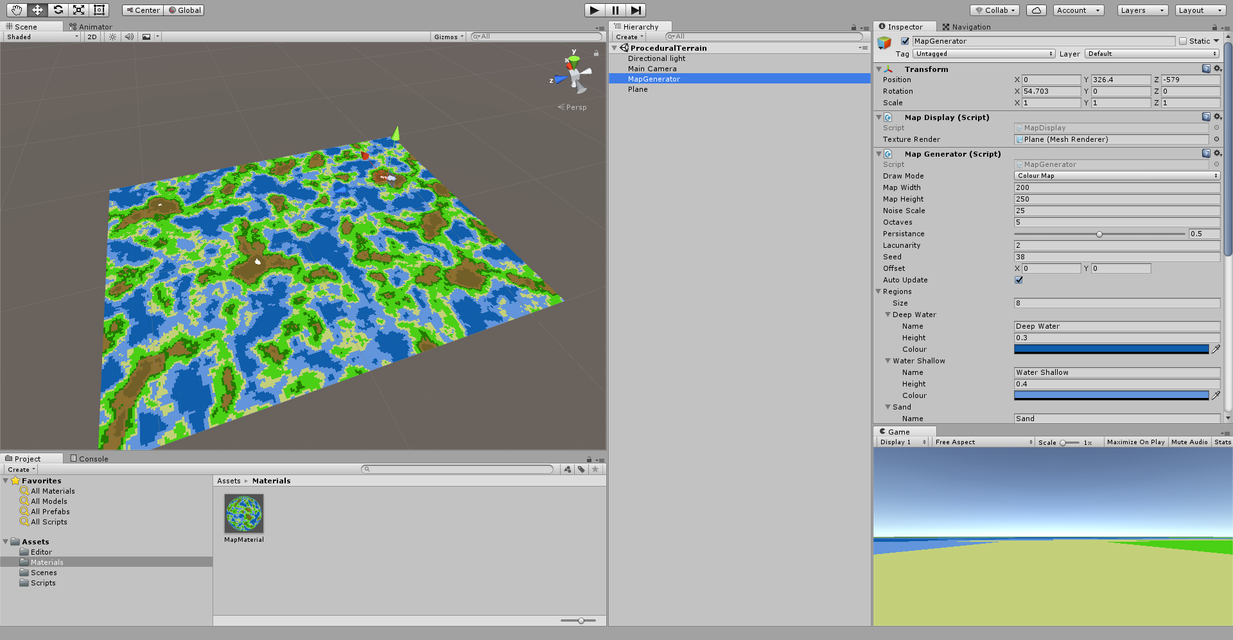

Elements in Map Generator:

* DrawMode
  + Draw Mode allows you to cycle through color, or noise map.
* MapWidth
  + The width of the plane
* MapHeight
  + The Height of the plane
* NoiseScale
  + Zooms into the plane, more into the center. Alters the map
* Octaves
  + Alters the frequency of the noise map.
* Persistence
  + Alters the persistence of the map.
* Lacunarity
  + Size distribution of the pixels.
* Regions
  + Give the regions a size of how many different regions you’d like.
  + Example: 3, rocks, grass, water.
  + Alter the color of each; add a height for that value for example if water is 0.3, anything from 0 to 0.3 is water.
  + Name it appropriately.

Example:

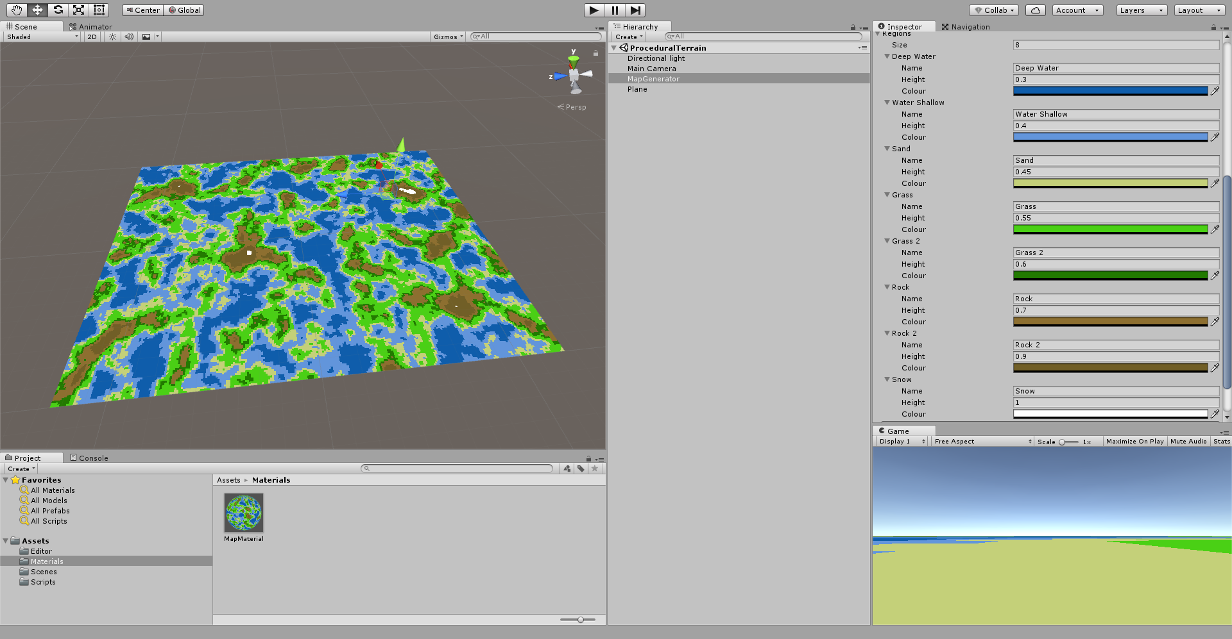

**FLOW CHART**

MapGenerator

Altered

Noise.cs   
Called

MapEditor.cs

TextureGenerator.cs

Called

MapGenerator.cs  
Called

MapDisplay.cs

Called

This renders the map

**Final Result:**

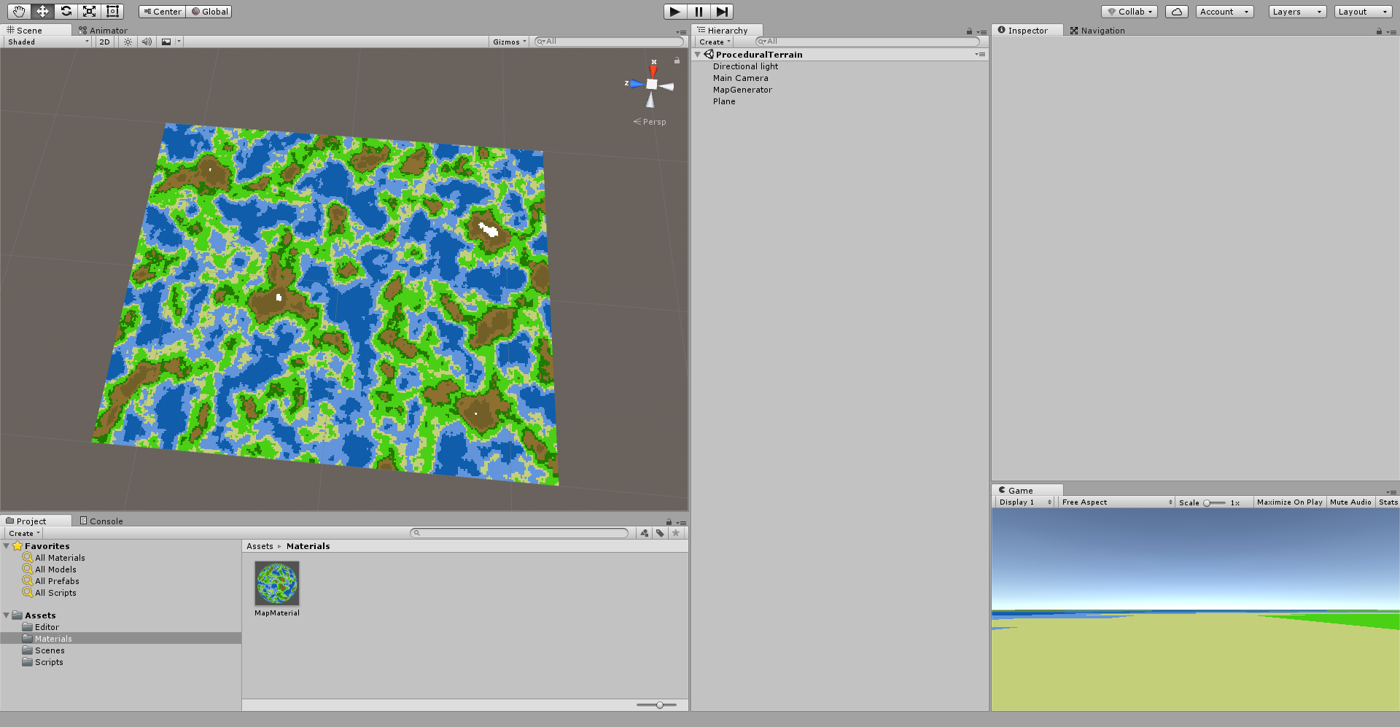

VIDEO:

<https://youtu.be/XtQ7a98xE7M>